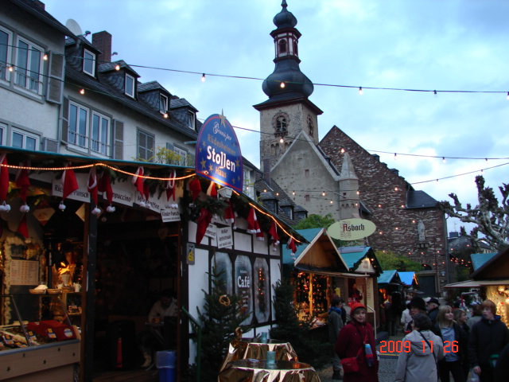

A Quick Little Christmas Trip
19-30 November 2009

Carl Lahser

Copyright © 2010 by Carl Lahser. All rights reserved. If you must copy any part of this work please give the author appropriate credit.

Published by: Pretense Press
6102 Royal Breeze
San Antonio, TX 78239
(210) 657-5139
clahser@satx.rr.com
Publications by the author:

USA Bigfooting Around – Washington state
Blue Ridge, GA
City of Angels
Galveston
New York Christmas – Hudosn Valley and NYC
Niagra Falls and Toronto
October was a Busy Month Minneapolis and the Shennadoah Valley
Portland in the Summer
San Francisco Home Exchange
Santa Fe Getaway
Shelling Trip
Summers End
Canada Backdoor to the Yukon
Do Bears do it in the Woods - Winnipeg
Enterprise II – Calgary, Edmonton, Athabasca
Enterprise North
Vancouver – Vancouver, Victoria, Inland Passage
Where Have All the Pretty Colored Houses Gone - Newfoundland
Mexico Cabo San Lucas
Copper Canyon
Flowers of the Air
Hey Momma, When we Goin Again
Mata Ortiz
Mr. Cuul in Yucatan
San Miguel
Searching for the Phantom Crown
Todo Santos Ecoadventure
Europe A Quick Little Christmas Trip Christmas on the Rhine
Dickens Christmas - Three Weeks in London
Cross-section through a Rainbow – Corfu, Athens, and Rhodes
Greek Poems
Return to Asinara Bay – Italy
Three Weeks in Berlin
China China Tour China Sings
Hong Kong 1979
Other Travel Panama Cruise
Under the Southern Cross (Under Clouds) – Machu Pichu and the Amazon
Poems Cryptic Romance
Ecoview 1 - Not Your Usual Neighborhood
Ecoview 2 - Texas
Ecoview 3 - D.C.
Ecoview 4 - St Louis to Minneapolis
Ecoview 5 – Southwest
Ecoview 6 - Green Things
Rincon de Carl
Snapshots of the North
Snapshots of Mexico
Summers End
Texas to Alaska
Traffic Games
Tyndall Beach
Walk on a Different Beach
Weather watching

Other Alamo Road – Mom’s Story
BASH – Bird/Aircraft Strike Hazard
Bessies Pictures 1930
Butterflies and Birdwatching - PIF Bird Meeting
Forty Years of Fishing – Professional History
Green Stuff Articles from the SCION
San Antonio Wildflowers by the Month
Teacher, Leafs Don’t Change Color – Growing up in the Valley
Thinking of Flying – Military history

Plays Cryptic Romance
A Body in the Trunk
A Blow for JFK
A Beard like Mine
The Black Birds – A BASH Play

Essays Broken Shoulder
Dinosaur Diving
Haiti
Hip 3 – Hip Replacement
Impossibility of Time Travel
Knee Repair

Fiction HiJaak
Stories Grampus Told
All titles are available from Pretense Press. Booksellers
are encouraged to write for seller’s information.
Printed in USA.

A Quick Little Christmas Trip
19-30 November 2009
Carl Lahser

Viking River Cruises offered a good price on their “Holiday in the Rhineland” cruise - half price. First we would fly to Amsterdam Schiphol Airport and spend a couple days in Amsterdam. Then we would sail up stream to Cologne, Rüdesheim, Heidelberg, Mannheim, Mainz, Koblenz, and Bonn then quickly back to Cologne. From Cologne we would take a bus to Frankfurt and fly back home. Carol said it sounded like fun and we could afford it and I had never been to this part of Europe so guess what? - We went. Carol called her friend at a travel agency to work the arrangements. The agency found that we could get better connections cheaper and could stay a couple extra days in Amsterdam for the difference.
It’s going to be the beginning of winter so I did not expect many birds or much easily recognizable vegetation. The list at the end of this tale should be relatively short.
Now to find background on the places we could possibly visit with a few Google inquiries:
Amsterdam. Amsterdam’s population is currently about 750,000. Amsterdam began as a trading village, Amstelledammein, in 1275. It developed during the 14th and 15th centuries. Its Golden Age began in1585 and ended in 1672. The city grew in size and importance. It was attacked by both the French and English in 1672. The city established the Republic and became a financial center. In 1795 the Republic was overthrown and Napoleon occupied the country in 1808. In 1813 the French left. There followed a period of financial recovery due in part to the Industrial Revolution and a period called the New Golden Age. 1920-1940 was a period of economic recession. WWII covered 1940-45. Since then there was rapid construction of low quality low cost housing and many of the canals were filled to make way for roads.
What is there to see? Besides the famous Red Light Districts and Coffee Houses, there are several museums (the Rijksmuseum, Van Gogh Museum, and Stedelijk Museum), the Old and New Churches and the Houten Huis (Wooden House) built at the site where lumber and firewood was delivered and sold at the Begijnhof dating to the 12th century. There is also the town hall in the Dam Square (now the Royal Palace), the Westerkerk, Zuiderkerk, as well as a large number of canal houses among which De Dolfijn (Dolphin), De Gecroonde Raep (Crowned Turnip), the Bartolotti Huis, the Huis met de Hoofden (House with the Heads), the Poppenhuis, Kloveniersburgwal 95 (commissioned by the Poppen family), the Trippenhuis (built for the Trip family), the Van Raey-huizen at Keizersgracht 672-674, and Sweedenrijk at Herengracht 462, from the 17th century. During the 19th century recession many houses were vacant and some even collapsed for lack of maintenance. Fortunately - some facades and interiors dating back to the Empire period survive today. 1813-1940 was called the Age of Recovery and Expansion. This was also the period of large-scale damage to the historical city center and some more canals were filled in to make way for new traffic roads to be built.
Individual important sites include:
The Oude Kirk in the middle of the Red Light District
Dam Square with the Amsterdam Historical Museum and the Royal Palace
The Het Houten Huis (Begijnhof) built around 1420
The canals and the Magere Brug or “skinny bridge”
Canal or “dancing “houses
Jordaan, a renovated commercial area of trendy housing
The Hortus Botanicus or Botanical Garden established in 1632
Rembrandtplein (square)

What’s good to eat?
Dutch cheeses like Edam and Gouda.
The stroopwafel (syrup waffle) is a thin sandwich of two buttery waffle layers stuck together with a sweet, gooey molasses.
Dutch pancakes, called pannekoeken, similar in texture and taste to French crepes.
Poffertjes. Smaller, puffed pancakes traditionally served with butter and powdered sugar.
Vlaamse or patat frites are our French fries.
Seafood including mussels and sole.

What to drink and where? Try the beer bike? A beer tour?
Belgium draft beers are ales (De Koninck, Palm), witbier (Hoegaarden, Dentergems) and Abbey Blonde (Leffe, Grimbergen) or Dubbel (ditto).
Bottled beers include Westmalle Dubbel and Tripel, Duvel and all three colors of Chimay.
There are three small microbreweries advertised, seasonal breweries and even a couple of contract brewers in Amsterdam. Neither Heineken nor Amstell is still brewed in Amsterdam although Heineken has opened a museum in their old brewery.
For harder stuff, A. van Wees and Bols distilleries makes spirits made to flavor or enhance food like chocolate and ice cream, genevas or flavored alcohols similar to gin, and distillates like Oranjebitter.

Cologne. Cologne’s current population is a little over one million people. It was established in 39 BC as a Roman military outpost. The next important date was 50 AD when Agrippina the Younger, wife of the Emperor Claudius, was born in Cologne and asked for her home village to be elevated to the status of a city or colonia . In 260 AD, it became the capitol of Gallic Empire. In 455, the Salian Franks captured Cologne and made it their capital city. The Catholics controlled Cologne from the 4th century until 1821. France occupied the city in 1794 and held it until 1814. It was under Prussian control from 1814 until the end of WWI. The German Nazi government took over what was a historically Catholic and Communist area. The city was bombed extensively during WWII. Reconstruction was officially completed in the 1990s.
Cologne’s Jews have a complicated history dating from 321 AD. The first pogrom was in 1349 when Jews were blamed for the Black Death. They were again evicted from the city in 1442 and allowed to return in 1798. At the beginning of WWII, on Kristallnacht (Crystal Night or the Night of Broken Glass) on 1-10 November, 1938, Cologne's synagogues were set on fire.
Things to see:
Botanical Garden, first landscaped in 1863, was completely destroyed in WWII and has been rebuilt.
Romisch-Germanisches Museum. Founded in 1946, former Roman and German departement of the Wallraf-Richartz-Museum. European and Rhenish early history, Roman city history and arts and crafts of the European mass migration times.
Cologne cathedral with its two spires 157 m. in height. It took 632 years for construction of the largest German cathedral to be completed. After the laying of the foundations in the year 1248 and making rapid progress initially, construction work gradually came to a standstill. It was only with 19th century romantic enthusiasm for the Middle Ages and the commitment of the Prussian Court that construction work resumed in 1842.
Krieler Dömchen. The smallest and oldest remaining Cologne church erected around the year 900 on the Suitbert-Heimbach-Platz.
City Gates. With the Severinstor, the Eigelsteintor and the Hahnentor, only three of the total of twelve city gates from the mediaeval city fortifications (1180 - 1220) have been preserved.
City Hall (Hansasaal). The city hall was built in 1330, with the Renaissance arcade (16th century) and tower (15th century) being added later. The building complex suffered extensive damage during the Second World War and underwent reconstruction until 1972.
Museum Schnütgen – Medieval Arts. Named after Alexander Schnütgen, who collected lots of medieval art right after 1802, when Napoleon closed the monasteries and churches.
Wallraf-Richartz Museum. Rated as one of the best in Europe for art.
Strolling along the Rhine. Stretching for 35 kilometers on each side, both banks of the Rhine are the preserve of walkers, cyclists and sportsmen and women.

Rüdesheim am Rhein. This is a wine making town of about 10,000 people. It lies at the foot of the Niederwald on the Rhine’s right (east) bank on the southern approach to the Loreley (Lorelei). This is in a UNESCO World Heritage Site.
The area was already settled early on, first by the Celts, then after the turn of the Christian era by Ubii and later by Mattiaci. In the first century, the Romans pushed into the area. They were followed by the Alamanni, and along with the Migration Period (Völkerwanderung) came the Franks. Rüdesheim was first recorded in 1074 for winegrowing, forestry, and shipping.
Things to see:
There are several museums and a distillery.
The Drosselgasse (an historic street).
Pfarrkirche St.Jakob (“Saint James’s Parish Church”) from the 15th century
Burg Ehrenfels (ruined castle)
Brömserburg, the oldest castle in the Rhine Gorge World Heritage Site
We may get there in time for Tage des Federweißen (year’s last wine festival) late October to early November and will be there for Weihnachtsmarkt der Nationen (“Christmas Market of the Nations”) 120 stalls, from late November until Christmas.
Heidelberg. Heidelberg has a population of about 150,000 people with 80% involved in services and tourism. It is located on the Necker River about 20 miles from Mannheim where the Necker joins the Rhine.
The history is long and complicated beginning in the 4th century BC as a Celtic settlement. The Romans settled here in 40 AD and remained until 260 AD when Germanic tribes took over. The village of Bergheim was settled in the 5th century and currently is located within Heidelberg.
What to see:
Heidelberg has a number of small museums and the oldest university in Germany (Ruprecht-Karls-Universität Heidelberg).
The Red Ox and the student prison
The Heidelberg Castle and Old Town.
The Old Bridge and the gate house.
Auf dem Heiligenberg is about a one-hour walk from the Old Town area of Heidelberg.
The Thingstatte, a Nazi-built open-air amphitheatre.

Mannheim lies at the confluence of the Rhine and Neckar Rivers. Rare among German cities is its layout, a grid pattern (or “quadrates”) similar to those found in North America. The grid was originally plotted in 1606 originating at the Friedrichsburg fortress, that later became the site of Mannheim Palace. Today, it partly houses the University of Mannheim.

Mainz (Mayence). Mainz is located on the west bank of the river Rhine, opposite the confluence of the Main River with the Rhine River. The 2008 population was 196,784, an additional 18,619 people maintain a primary residence elsewhere but have a second home in Mainz and it is also a part of the Rhein Metro area consisting of 5.8 million people. Mainz is easily reached from Frankfurt International Airport in 25 minutes by commuter railway.
History dates back to 13 BC when a Roman fort was built on the northern borders of the Empire. The name comes from the Latin Menus or river. After a turbulent history under the Romans, Alamanni forces under Rando sacked the city in 368. In last days of 406, the Siling and Asding Vandals, the Suebi, the Alans, and other Germanic tribes took advantage of the rare freezing of the Rhine to cross the river at Mainz and overwhelm the Roman defenses. Attila destroyed Mainz in 451. Complicated politics included Catholic and Romans, the adventures of Charlemagne and the Christianization of Germany. During the French Revolution, the French took Mainz in 1792. The French surrendered to the Prussians in 1793. In 1797, Napoleon took Mainz and left in 1814. In 1816, the German Confederation took over until 1866 and part of the German Empire in 1871. After WWI and through 1930 Mainz was again French.
What to see:
Wood market, a tower from the 14th century.
The Gutenberg Museum.
The Mainz Old Town.
The Botanischer Garten der Johannes Gutenberg-Universität Mainz, a botanical garden maintained by the university.

Koblenz. Koblenz (also Coblenz in pre-1926 German spellings; French Coblence) is a city situated on both banks of the Rhine at its confluence with the Moselle, where the Deutsches Eck (German Corner) and its monument (Emperor William I on horseback) are situated. (As Koblenz (Latin (ad) Confluentes, "confluence" or "(at the) merging (rivers)", Covelenz, Cobelenz; local dialect "Kowelenz.) In 1933 Hitler took it back. Heavy Allied bombing destroyed much of the city and General Patton took the city on 22 March 1945. The city came under the French from 1945-49 when it again became a German city.
Things to see include:
the Roman-Germanic central museum (Römisch-Germanisches Zentralmuseum).
The Antique Maritime Museum (Museum für Antike Schifffahrt) with 4th century Roman craft.
Roman remains, including Jupiter's column, Drusus' mausoleum, the ruins of the theatre and the aqueduct.
Mainz Cathedral of St. Martin (Mainzer Dom) from the 10th century. The Iron Tower (Eisenturm), tower at the former iron market), a tower
from the 13th century.
The Wood Tower (Holzturm, tower at the former
Around 1000 BC, early fortifications were erected on the Festung Ehrenbreitstein hill on the opposite side of the Moselle. In 55 BC Roman troops commanded by Julius Caesar reached the Rhine and built a bridge between Koblenz and Andernach. About 9 BC, the "Castellum apud Confluentes", was one of the military posts established by Drusus. The town celebrated its 2000th anniversary in 1992. It was part of Charlemagne’s Empire, the Germanic Empire, the Holy Roman Empire and the League of Rhenish Cities. The Teutonic Knights founded the Bailiwick of Koblenz in or around 1231. It prospered until the Thirty Years War. It became French in 1632 then Swedish and then French again in 1638 and finally retaken by the Germans. It was invaded by France in 1688. After the French Revolution, it received numerous French refugees. In 1794, it was captured by the French and by the Prussians in 1814 but given to the Prussians in the peace treaty. After WWI, it became French again but changed the spelling of its name to the Germanic for spite in 1926. It was extensively bombed in WWII.
Things to see:
Strong forts crowning the hills encircling the town on the west and of the citadel of Ehrenbreitstein on the opposite bank of the Rhine.
The Moselle is spanned by a Gothic freestone bridge of 14 arches, erected in 1344, and also by a railway bridge. The city, down to 1890, consisted of the Altstadt (old city) and the Neustadt (new city) or Klemenstadt. Of these, the Altstadt is closely built and has only a few good streets and squares, while the Neustadt possesses numerous broad streets and frontage to the Rhine.
The Basilica St. Kastor or Kastorkirche, dedicated to Castor of Karden, with four towers built in 836.
The city is close to the Bronze Age earthworks at Goloring, a possible Urnfield calendar constructed some 3000 years ago.

Bonn. From the late 1940s until 1990 Bonn was the capital of Cold War West Germany. It is a city of 315,000 on the Rhine River just south of Cologne. Since reunification, Bonn has retained a political role as "Federal City" and has established itself as an important international hub even after the Capitol was moved back to Berlin. Its university is one of the largest in Germany.
Bonn has more than one important Romanesque church:
The Bonn Münster from about 235 AD
The Doppelkirche Schwarzrheindorf from 1115)
A regional museum full of fascinating religious treasures.
It is also home to a popular non-religious attraction:
The Beethovenhaus, where Ludwig was born in 1770.
Many post-WWII administrative buildings
Let’s see. Tickets. Passport. Checked Amsterdam weather. Clothes. References. Stop the mail and newspaper. Almost ready to go.

Day 0. 18 Nov 09. We are all packed and ready to go. We have a friend coming over to house sit for the trip. The Weather Underground said Amsterdam weather will be 40’s to 50’s for the week with high clouds and little rain. Weather forecast for the week is much the same for the Rhine Valley. Carol had a cough but thought it would probably go away.
Day 1. 19 Nov 09. We flew from San Antonio to Houston on one of Continental’s little jets and had a three hour wait in Houston for a 787 to Amsterdam. Our track was over Memphis, Cleveland, down the St Lawrence crossing PEI and Newfoundland, across the Atlantic to Dublin, Ireland, then just SE of Manchester and north of London where a loop to the north took us into Schiphol Airport SW of Amsterdam.
The plane was cold at about 70°F. We had a pillow and a blanket but it was too uncomfortable to sleep.
Immigration and customs was nothing since The Netherlands was a part of the European Union.

Day 2. 20 Nov 09. The morning was clear and in the lower 40’s. A front was expected form the SW with lots of rain. Not quite the forecast I saw yesterday.
We took a van to the hotel. The driver must not like tourists since he took sharp corners and hit speed bumps like he was in a demolition derby. I told Carol to save his tip for the chiropractor.
We checked in and by the time we unpacked it was time for lunch. Dutch pea soup and an Amstell beer for 12€ (1€=1.30$). Carol had a hamburger and fries and a coke for 16€. Time to crash for a couple hours.
I was awake about sundown – about 4:30. Carol was coughing so I went out alone to get some laundry soap and disposable razors. There were a couple grocery shops and restaurants. Other shops in the area had souvenirs and all kinds of sex toys and shops that sold marijuana or cannabis in colas, chocolate, gum, lollipops and other concoctions. There were hundreds of people on streets that were already decorated for Christmas. I bought some cold waffles covered with frosting. No stroopwafe anywhere. No schnitzel either. During the trip I tried several beers including Amstell and Grolsch and noticed these were 0.33 liter (about 10 ounces) instead of 12 like US beer. There were non-alcoholic, low alcohol, and enhanced beers. Soft drinks were smaller also.
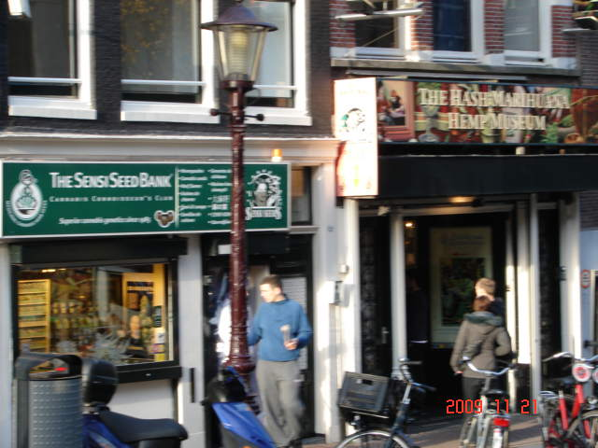
Pot Shop

Back at the room out of the drizzle the TV said the subtropical jet stream coming from the southwest over the Atlantic would bring drizzle for the next few days. The Lakes District of England had record flooding from this system. Other news included Amsterdam proposing a driving tax to reduce fuel use and air pollution. In Cologne there were student riots about the universities reducing graduation requirements.

Day 3. 21 Nov 09. We went to the hotel dining room for their breakfast buffet. Twenty € each for all you can eat.
It was chilly and blowing and Carol’s cough was worse. The hotel got her a doctor that made house calls. He said it was a respiratory infection and gave her an antibiotic and a prescription for a cough suppressant all for 150 Euros hopefully covered by trip insurance.
Meanwhile I took a walk. It was cool and gray but there was no wind or rain. The hotel doorman said it was a beautiful day for Amsterdam. Next week it would start to snow and quit in April.
Carol wanted some handkerchiefs so out I went. Down by the train station. Passed St. Nicholas Church. Along the canals to Dam Plaza where Amsterdam began. Houses were tilted and often projected out over the street. This was partially because of settling and partly because the property was taxed on the street level dimensions. Several houses had clematis or grape vines as potted plants.
Between the narrow streets and the bicycle paths there was not much left for people to walk on.
In Dam Plaza the Royal Palace and New Church were being repaired. There were a dozen mimes and several carriages attracting tourists in the plaza. One of the streets radiating off the Plaza, Kalverstraat, was a shopping street with no traffic. I stopped is several men’s store but no one had handkerchiefs. I finally found a shop that had what I wanted at 8€ each. I observed that many of the clerks did not like tourists, little subtle things like ignoring customers or handing you something and letting go of it before you could grab it.

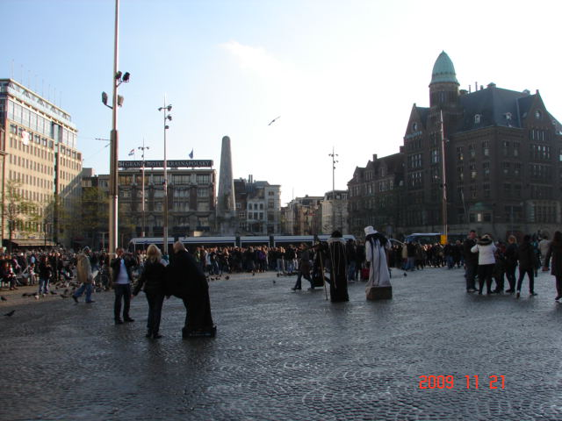
Dom Plaza

I went to the flower market and was disappointed. It was like a dozen plant nursery stalls all in a row with potted plants and lots of tulip bulbs that I could not take home. I went on to the New Market, Rembrandt Plaza where the subway was under construction and then to Waterloo Plaza with more construction. The Tripp House and the Rembrandt House were closed for the day.
I walked through the middle of the red light district and back to the hotel. The red light district is about five blocks along two canals centered on the Old Church. There were restaurants and shops selling sex toys and pot, a couple of theatres offering “soft porn, hard porn and live sex shows 24/7”, and finally about half a dozen 4X8 foot windows with young ladies wearing more than a Victoria’s Secret catalog model. There was also the cannabis museum and the seed store that sold everything needed to grow pot. Interesting. I was curious about the economics of these enterprises but could not find any information. I got back to the hotel about 1600 as the sky darkened.

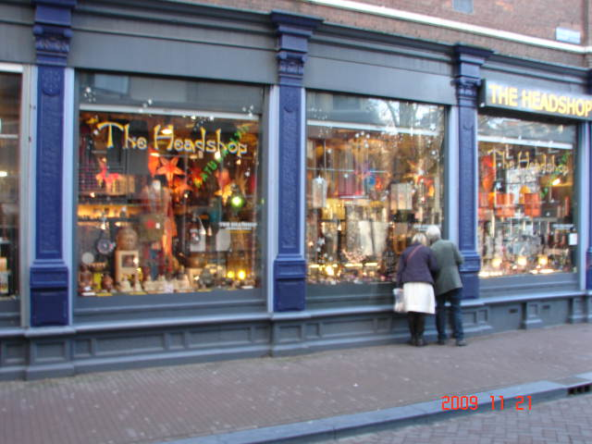
Red Light District

After the doctor Carol had gone out and done some shopping. She returned about 1700.
We went out for supper at a seafood place called the Koptic. I had mussels in tomato sauce and salmon on penne pasta. Carol had a fillet.
We walked a couple blocks in the cold and mist looking in store windows and at the street decorations. Businesses were not decorated for Christmas yet if ever.

Day 4. 22 Nov 2009. We were up about 0700 and went to the buffet for breakfast. This was the day to go to the boat so we packed up and put the bags in storage.
About 0930 we started for the Van Gogh museum. An electric train stopped about a block from the hotel. We got on. There was no one selling tickets by the time we reached our destination so we hopped off.
The museum opened at 1000 and the senior ticket was 10€ each. I really did not know much about Van Gogh so his life and works were interesting. I had seen a few of his works but was not familiar with his oriental period or his black and white sketches. He had a mental problem that could be easily treated today but the treatment might have ended his painting. He did not cut off his ear, only part of one ear lobe.
There was a display of Alfred Georges Stevens. He began in society portraits and advanced into social commentary. Very good paintings.
We walked a couple blocks in the drizzle to a coffee shop that actually served coffee. We both had a sandwich and hot chocolate and then took a taxi back to the hotel.
We could not check-in on the ship, the Viking Helvetia, until 1500 so we waited until about 1400 to take a taxi to the ship. They took our bags and we went to the lounge to wait for the rooms.
I noticed the 2 euro coins had a variety of pictures on the reverse of the coins like Gibraltar and vineyards.
I took a walking tour of the ship through all three decks, the lounge, the dining room, the library and topside from bow to stern. Our room was available at 1500. We unpacked and crashed until the tour briefing was announced at 1830.
Supper was served at 1900 (7 PM). The ship must have had a real chef. Appearance of the serving exceeded the quantity and resulted in only gaining two pounds during the trip.

Day 5. 23 Nov 09. We were up about 0630. There was a light breakfast from 0600 to 0700 and regular breakfast buffet from 0700 – 0900 American style food. A canal boat tour began at 0830.
While getting off the boat I saw several Mallard Ducks, a Great Crested Grebe, and several mute swans in the river. Crack flowers (flowers growing in pavement cracks) included Sea Kale and Feverfew.
We split into several groups and each group had an assigned frequency with a receiver for each person and a transmitter for the group guide. The range was about a quarter mile. Very efficient.
The busses took us to the cruise line passenger terminal where we boarded out boat. The route took us over the tunnel and under the train tracks and past NEMO, the city museum with a Dutch packet moored alongside. We passed the library and the train station then up canals passing the Ann Frank House and the Rembrandt house and under the Magere Brug and around the town back to the harbor.

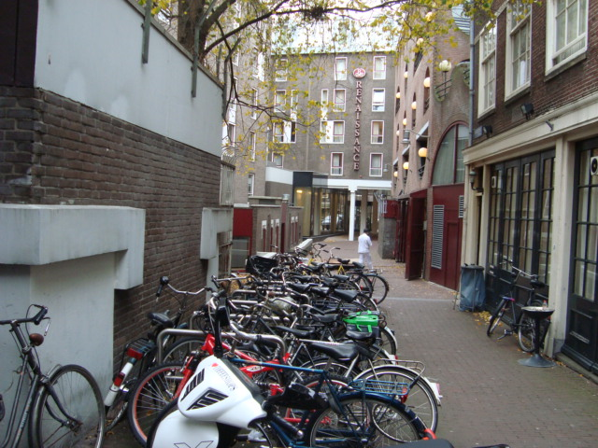
City of Bicycles

Back at the ship we had lunch and crashed. We were scheduled to see the Ann Frank House tomorrow at 0830. We were up about 18:30 PM for the day’s briefing and supper. This was a Mexican dinner that a Texan would never recognize. After a shot of blue Bombay gin I watched CNN for a while and crashed.

Day 6. 24 Nov 09. We were up for breakfast about 0730 and off to see the Ann Frank House by 0815. I had not read Ann Frank’s diary so much of the information was new. We were back at the ship about 1100.
There were several house boats moored in the canal. There are two kinds of house boats – real boats and houses built on a floating concrete slab. A house boat is expensive. The boat runs 500K to 1.5 million Euros plus the annual mooring fee, plus property tax because you live there, plus a boat tax, plus having to pull the boat for cleaning and maintenance and inspection every other year. Sewage in released into the canals and the canals are flushed with a slug of water from the Zuider Zee early every morning.

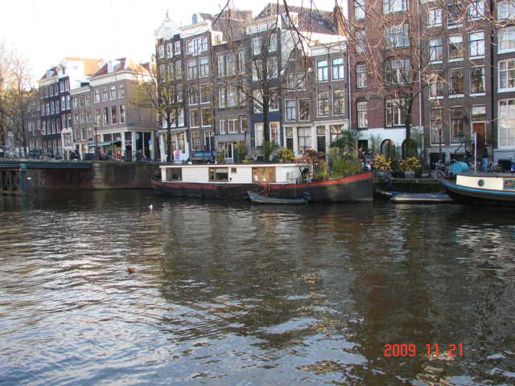
Amsterdam Canal

The guide said the canals were about ten feet deep with three feet of clear water; three feet of turbid water and 3-4 feet of silt and bicycles since a lot of bicycles are stolen (“borrowed) each year. There are more people than bikes since many people come from the suburbs. There are several large bicycle parking areas. One held about 5000 bikes and one floating garage could store about 3000.
There were some little hybrid cars called “Green Cars” although they are actually red. They rent cheap to commuters who come in by ferry.
Comparing the Amsterdam in the introduction to what we actually saw Amsterdam appears to have changed over the past few years and it would take more time than we had to see many of the sights.
At 1245 the Viking Helvetia weighed anchor and set sail up river for Cologne. Lunch was at 1300 as we watched farms, forest and villages pass by and slipping under numerous modern bridges. Utrecht. Duisburg.
Magpies were flitting between trees. Common gulls patrolled the river. Crows were crossing the river. Swifts were hunting the river’s edge. Several Shoveller and Mallards ducks were resting in backwaters.
Farms pastured sheep and cattle. There were no crops or vineyards along this part of the river

Day 7. 25 Nov 09. Overnight sail passed more small towns and a couple castles and Düsseldorf in the Neanderthal Valley then on to Cologne arriving about 1300.
Coots were paddling along shore and Cormorants sat on rocks and sand bars. Carrion Crows were perched in some trees.
On board the ship there was: an exercise session; a cooking discussion; and a half hour of tourist German. The sun set about 1630 and we charged on through the night passing minimally lighted villages. A highway and a railway were built along both banks with a lot of traffic.
Crews of many of the tugs pushing barges lived on board their tug and even took their cars and boats with them.
About 1200 we docked at the Frankenwerft along the Rheine. We disembarked at 1300 for a walking tour with the earphones. Walking along the Rhine the guide said they had annual flooding and that there were six-foot pop-up walls to handle bigger floods of over 35 feet for the thousand-year flood. Last year the water rose over 40 feet for the 10,000-year flood.
We passed a brewery and walked through one of the Christmas markets on the way to the Cathedral. The structure is sandstone and cannot be cleaned of the black mold and soot. The construction took 632 years being built in increments as funding became available. After the Cathedral we went through the Roman Germanic Museum with an outstanding collection of Roman glass and many artifacts from the Roman occupation including the tomb of Poblicius, a retired Roman soldier that made a fortune in glass.

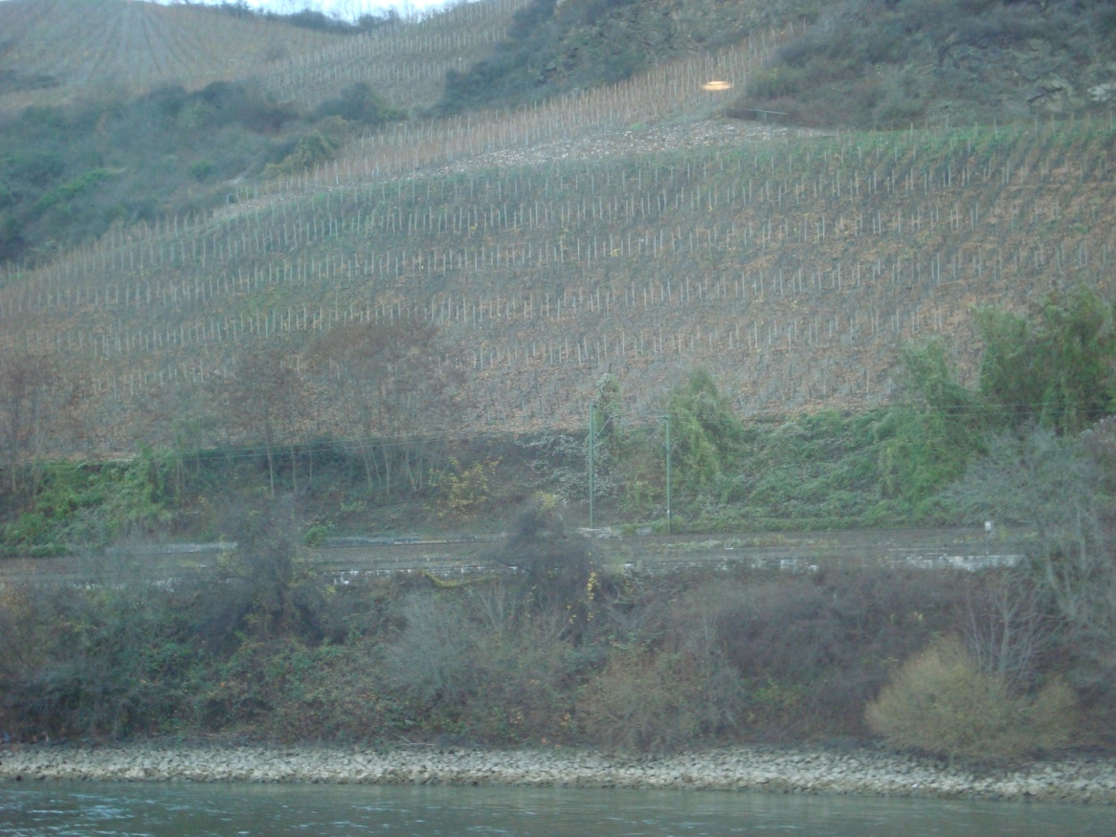
The Rhine and vineyards

Cologne Christmas Market

On the way back I stopped at two breweries to sample their beer. Both were to bitter with hops for my taste.
Back on board it was German food night. Pea soup. Beef salad. Tough venison. This was different.
W pulled out about 2300 for Rüdesheim.

Day 8, 26 Nov 09. We made a night run passing Bonn, Remagen, and Koblenz reaching the middle Rhine about sun up.
Breakfast was ready about 0730. We passed Schloss Stolzenfels and Berg Lahmeck and noticed the first vineyards on the south side of the river between Spay and Boppard. The rows were planted perpendicular to the river instead of forming terraces like I expected. Many of the vineyards looked like the workers would fall out of the fields they were so steep.
We passed several other castles including Berg Maus and Berg Katz (the mouse and cat castles). Above Boppard the vineyards were mostly on the north side with several castles. We passed the Lorelei and the Seven Virgins rocks where the vineyards began occurring on both sides of the river. About 80 KM from Cologne we passed Berg Reichenstein, Berg Rhemstein and the ruins of the Ehrenfels castle and arrived at Rüdesheim.

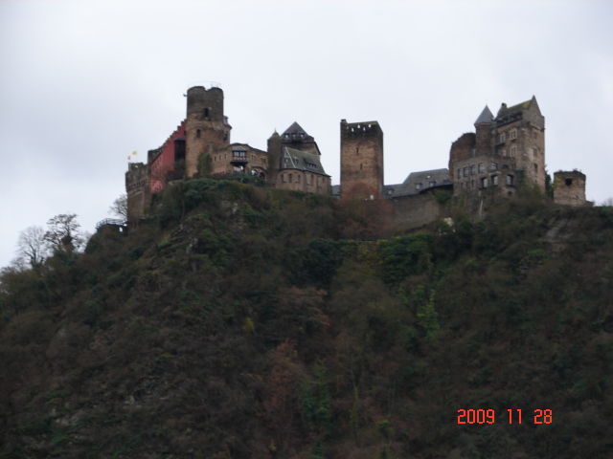
Cat and Mouse Castle

We docked in Rüdesheim about 1400. The tours began with a street train ride to the top of Old Town. We wandered through the Christmas Market and many shops for over an hour along the hilly twisting cobblestone streets. It began to get dark and cold and took about 20 minutes to walk back to the ship in a misty breeze.
I tried a cup of Glühwein. This is a mulled red wine with sugar and spices. The drink was 2€ plus1.5€ if you wanted to keep the cup.
Back at the ship we had Thanksgiving dinner. Leek soup. A pretty plate with a little turkey breast, green beans and mashed potatoes. Ice cream. Reminded me of a Thanksgiving dinner in Mexico with roast turkey, boracho beans and tortillas.

Day 9. 27 Nov 09. We left about sun up for the 15km trip to Mannheim and Heidelberg on the Necker River. We passed Wiesbaden with the Schloss Biebrich and Mainz. Other cities including Worms that had about a 6000-year history and important religious significance including where Martin Luther had refused to recant in 1521. It is also home of the Gothic Liebfrauen Church and Vineyards where Liebfraumilch originated.
We docked about 1000 at Speyer across the Rhein and several miles outside Mannheim/Heidelberg. A bus shuttled us through some of the Heidelberg University and dropped us in Mannheim for a tour and visit to the Christmas market.

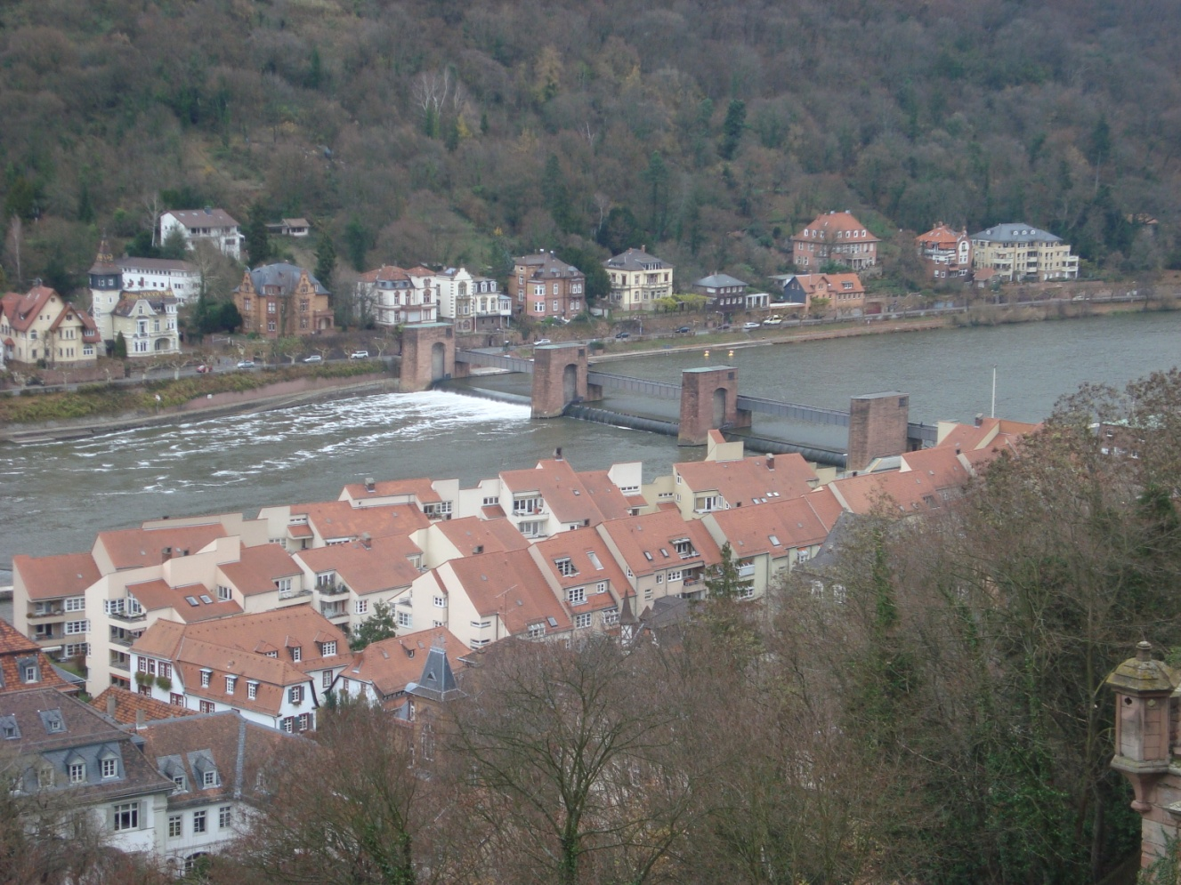
Heidelberg

We visited Heidelberg Castle in a cool overcast. The castle overlooks the city. The exterior was restored. Only some of the interior had been restored (the interior was not open to tourists but available for parties). The wine cellar was open with what was claimed to be the largest cask in Europe. The moat was still there but much of the moat and terraces had been converted to gardens. Heidelberg is the oldest university in Germany and is scattered about Mannheim.
The architecture was not particularly impressive. Mannheim was built where the Nekcar River empties into the Rhein. It is unique in Germany in having streets laid out on a grid instead in meandering. We were there during the lunch break from 1230 to 1400 when everything was closed. I took a walk across the river on the historic Old Bridge and through the gate house. The historic Red Ox bar and the student prison were not available. The Philosopher’s walk and the Nazi-built Thingstätte were not readily available across the river.
The bank and post office were closed for another twenty minutes so the exchange rate at the tourist shop was $1.60 instead of $1.30.
The bus took us back about 1530.

Day 10. 28 Nov 09. We pulled out at 0500 for a three-hour trip down river to Mainz. We had time for breakfast before arriving at 0815. The walking tour left at 0900.
The tour went through Rheingold square with several large art pieces. The city hall was built modern style and is near useless but cannot be replaced because this is a heritage site. We passed through the Christmas market that would not open before we left and toured the cathedral. This was the largest church in Germany built by leaders who wanted the largest church so the kings could be crowned there. It was built in increments when money was available. It was burned once and WWII burned its roof off and broke all the windows. The foundation began to spread and buttress walls were built to hold it up. It was built in a swamp on piles which were rotting so about 200 years back the piles were dug out and the foundation replaced. Down the center aisle were sarcophagus covers hung on the pillars. Ranking people had been buried in crypts under the church but they were all removed to a grave yard and the covers saved. On the outside of the church was evidence that the masons had not been paid at different times from the color of the stone and the detail of the carving.
We had about half an hour to get back to the ship so the Gutenberg printing museum had to be skipped along with the Roman sites and the Iron Tower and the Wooden Tower and the botanical garden.
We weighed anchor about 1100 for a short run to Koblenz and docked at Koblenz about 1700 near the German Corner (Deutsches Eck). The walking tour took place in the dark to see the Berlin wall monument and the statue of William I. The point is where the Mosel enters the Rhein. From there we walked to the Münzplatz in center of old town to the Christmas market. There were a number of old houses surrounding the square. Carol and I stopped for a chocolate for her and a glühwein for me then shuffled back to the ship. All the cities had stone streets that were hazardous in the drizzle and dark. We missed the Basilica of St Kastor and the Bronze Age site near Goloring.

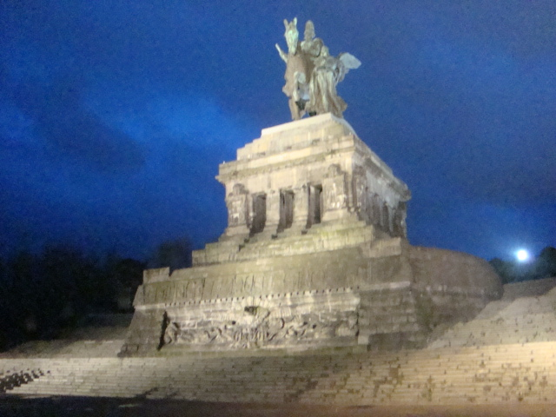
Deutsches Eck

Day 11. 28 Nov 09. The ship cranked up at 0530 for a run to Konigswinter across the river from Bonn. We boarded busses about 0830 to tour the area and visit the Beethoven House. First leg was a ride to see Petersburg palace. This had been a high security resort for VIPs during the Cold War era. The road is winding through a forest to a mountain top.
Back at the bottom we had a tour of Konigswinter and then across the bridge we toured Bad Godesberg there many government officials lived then through the former Cold War administrative area and downtown Bonn. We stopped to visit the Beethoven House. After leaving we were on the central market with no Christmas market. This would be an interesting visit with more time. Nothing was open on Sunday but a couple restaurants were opening after 1200.

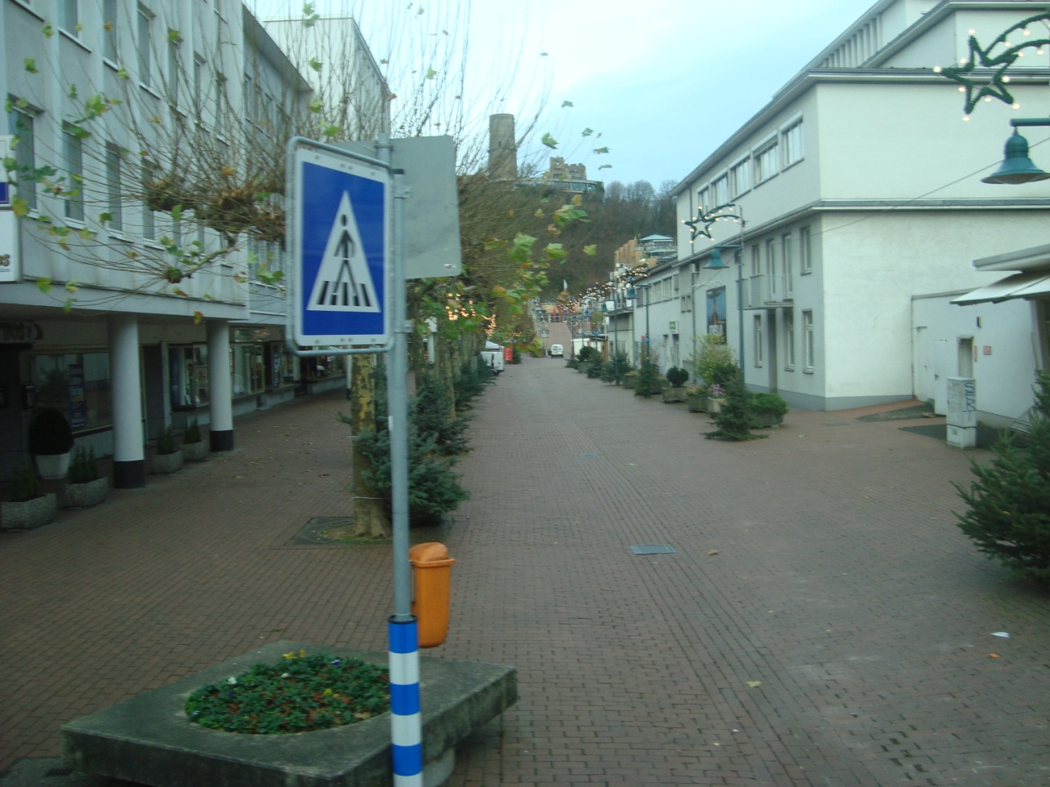
Bonn

Trash collection appears to be automated. The containers and many walls were covered with graffiti. I finally got a close look at several flowers and took pictures for later ID.
About noon we headed back for the ship. We left for Cologne about 1230 arriving at 1500. The docking area was lined with pollarded Plane trees hosting crows and pigeons.
Carol said she needed some over the counter medicine. The ship said everything was closed but there was an emergency pharmacy open somewhere but they were not sure where. Maybe in the train station? We went to the station and found many of the businesses open but the pharmacy was closed. We asked several taxi drivers but they did not know which pharmacy was open.
Back on board the ship the attendant called around like they should have done before and found the open one. They sent Carol off in a taxi with instruction to the driver. The open pharmacy had a small window in the back door and quickly filled her requirement. The taxi had waited for her and had her back to the ship in about an hour.
We went to the Captains farewell cocktail party followed by the farewell dinner and ceremony. Supper was cappuccino of mushroom soup followed by beef tenderloin with truffle crust or fillet of sole with morel sauce all followed by baked Alaska.

Day 12. 29 Nov 09. It seemed like Carol spent most of the night packing and repacking but by 0530 the bags were in the hall for pick up. We went to breakfast and waited for our bus to leave at 0730. We identified our bags for delivery to the bus and went out to the busses.
It was a two-hour ride to the Frankfurt airport flying down the autobahn. Fields of green and leafless forests. The trees had a reddish tinge like they were ready to bud out here at the start of winter.
We arrived at the airport and finally located the check-in area. At the gate we sat for about two hours before loading.

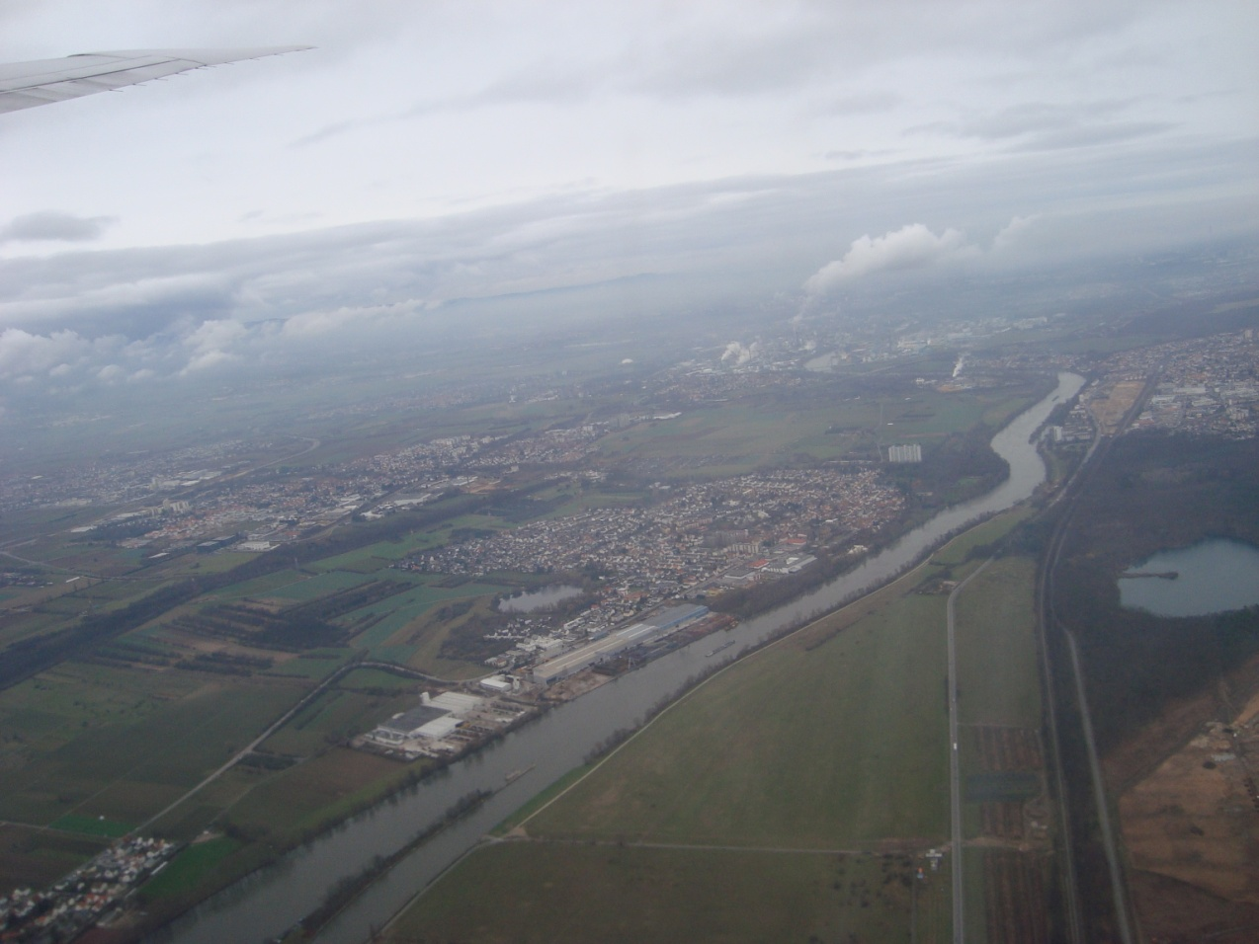
Frankfurt

Loading the plane was a real goat rope. Passengers were loaded on a bus which drove a couple miles to the plane. Everyone got off the bus and headed for one of the two boarding ramps with no regard to seating. We found our seats and waited another hour before we were off the ground.
The flight path home was Frankfurt to Amsterdam then north over the North Sea to Kirkwald, Scotland. Over the Atlantic against the jet stream to Greenland. Over the southern tip of Greenland and Labrador Sea to Hebron, Labrador. SW to Detroit and south to Houston.
It took another hour to get through customs and immigration and get rechecked to get to San Antonio. Sure wish there were direct flight out of SA to anywhere.
We walked in the door at home about 2300.
In general, this was a good trip. Accommodations and food were very good. Tours presented only a brief overview and highlights.
There were few bird watchers or plant people among the passengers and none were evident in the crew.
One other thing missing was shopping time and the lack of art in the Rhine Valley. History yes but art no.
The weather was typical for the season – cool and drizzly. Since this was an El Niño year the fall was long and warm.
One of the locals said it would begin to snow in a couple weeks and not stop until April. Brrr. Fergit it.

Biologicals

PLANTS
Platanaceae London Plane Platanus hybrida
Loranthaceae Mistletoe Viscum album
Ranunculaceae Traveler’s Joy Clematis vitalba
Urticaceae Pellitory of the Wall Parietaria judaica
Fumariaceae Yellow Corydalis Corydalis lutea
Cruciferous Sea Kale Crambe maritima
Campanulaceae Bearded Bellflower Campanula barbata
Compositae Feverfew Tanacetum parthenium
Compositae Ox-tongue Hawkweed Picris hieracioides

Birds
Grebes Great Crested Grebe Podiceps cristatus
Cormorants Cormorant Phalacrocorax carbo
Herons Great Blue Heron Ardea Herodias
Swans Mute Swan Cygnus olor
Ducks Mallard Anas platyrhynchos
Shoveler A. clypeata
Coot Coot Fulica atra
Gulls Common Gull Larus canus
Doves Collared Dove Streptopelia decaocto
Swift Swift Apus apus
Magpie Magpie Pica pica
Crows Carrion Crow Corvus corone
Jackdaw C. monedula

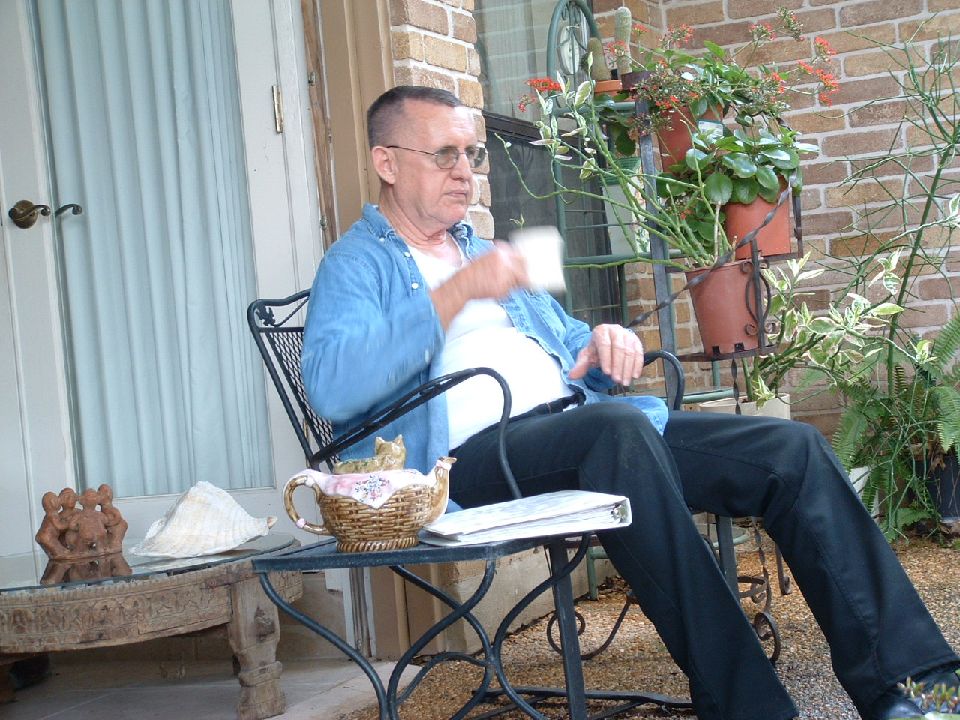

Zurückbekommen Liebenswürdig Rhineland

