Bermuda 1973

In 1973 I was living in Homestead, FL, working for a private fish hatchery. I was in the Naval Reserve assigned to the aviation group at Opa Locka, FL. I requested my annual two week active duty and, to my surprise, received orders to Naval Air Station, Kindley Field, Bermuda.

The Islands of Bermuda is a British possession about 600 miles east of the Carolinas. This is a collection of 138 islands and coral reefs in the western Atlantic surrounded by the Gulf Stream. It was discovered about 1503 and settled by British colonist about 1615.

There had been US presence on Bermuda since Lend Lease in 1941. Great Britain gave the US 99 year leases for bases in the Bahamas and on Bermuda and Newfoundland. Kindley Army Air Field including Fort Bell was begun in 1943. The base was built on the northeast end of the island group on St David’s Island by connecting several small islands. It became Kindley Air Force Base in 1947. The base served as a refueling point. In 1965 the Air Force left and this became home for Navy anti-submarine patrols and the U-2 during the Cuban Missile Crisis until 1995.

I packed my sea bag and took American Airlines from Miami to Bermuda. I arrived on Sunday afternoon and checked in with the Officer of the Deck. The OOD told me to report for duty Monday morning. I took my orders to the personnel office early Monday. I was told that my orders had been cancelled but since I was there I might as well stay. However, the base

was having a big inspection so I should check in every morning but make myself scarce.

Back to the barracks to change to civilian clothes. Catch the local bus to town. I was in downtown St George in about an hour.

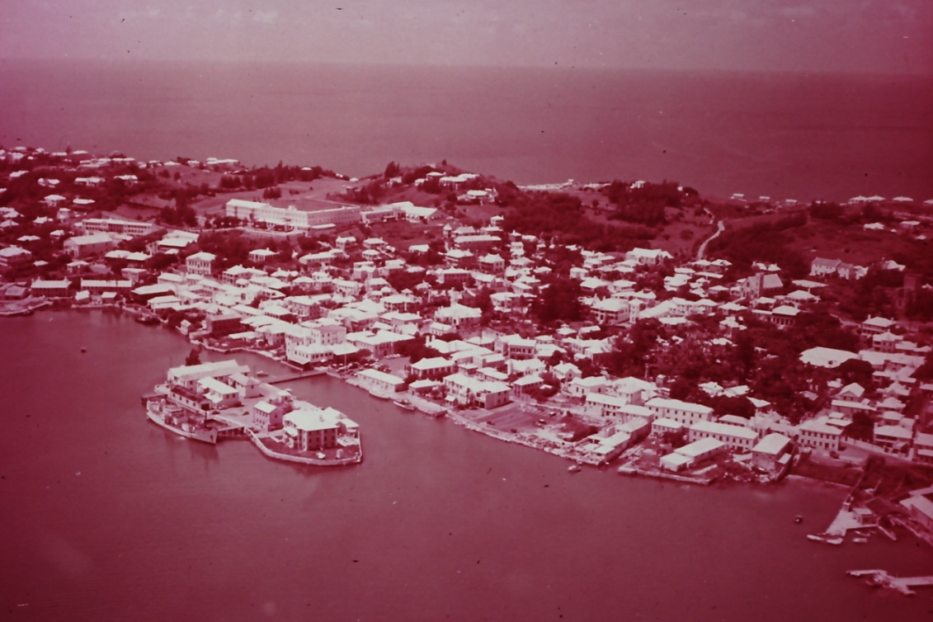
St George

St George was settled in 1612 as capitol of Bermuda. On leaving the bus the first thing in sight is the King’s Square with its stock and pillory.

Next on the tour was a short walk to Ordnance Island. During the American Revolution Gen Washington traded food for powder stored on Ordnance Island.

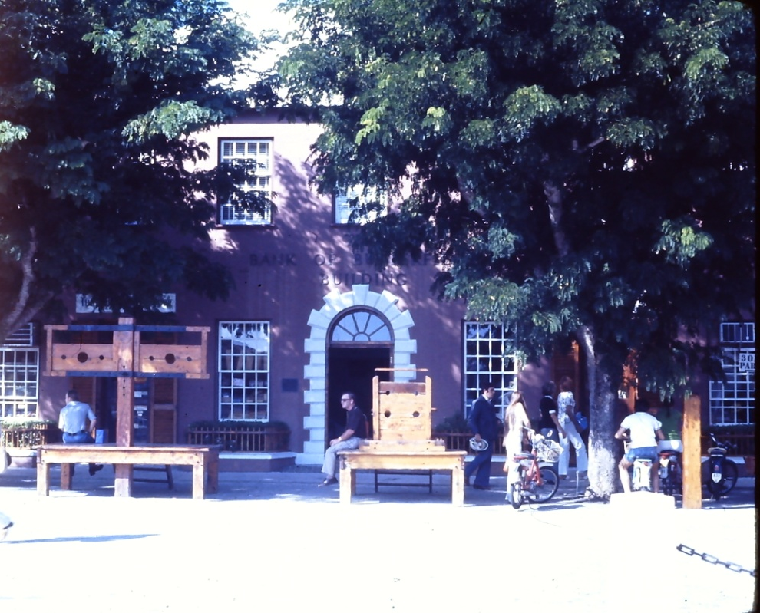
Kings Square in St George with stocks and pillory

Following the tourist trail I passed the White Horse Tavern formerly the Davenport house the town hall and visitors center, Bridge House, Somers Garden, the historical museum, St Peter’s Church, Barber’s Alley and Petticoat Lane ending on Somers Wharf.

I caught supper and found the bus back to the base.

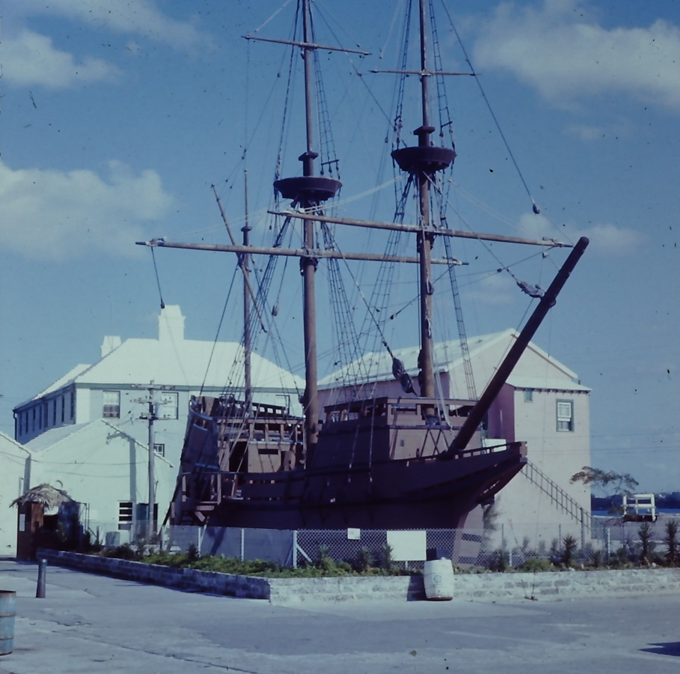

The Deliverance on Ordnance Island

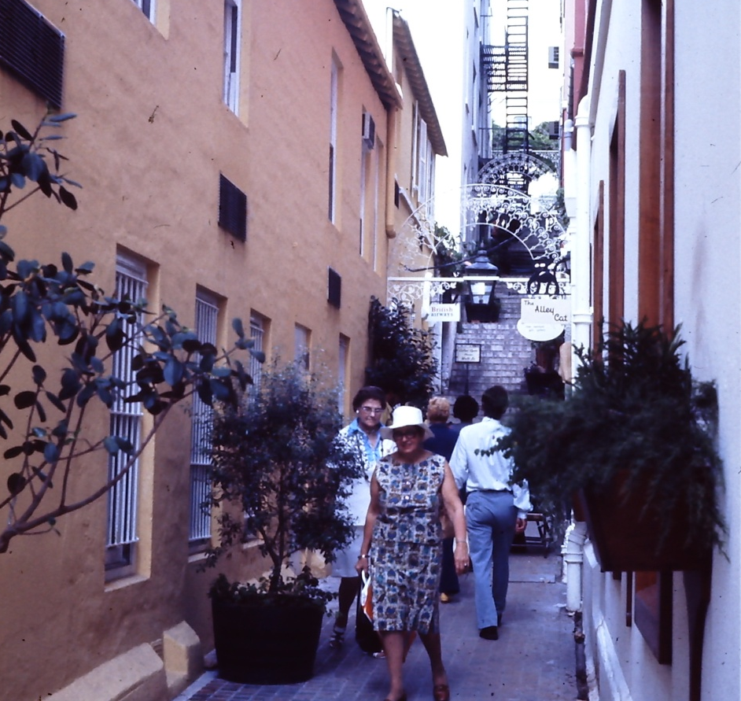
Petticoat Lane, St George

Day two came up clear and sunny. I heard hedge trimmers hard at work. The base had several miles if hedges and the grounds maintenance workers had a generator mounted in the bed of a pickup and two hundred foot extension cords connected to electric trimmers. Using this system was quieter and easier to maintain in the high humidity. Electric lawn mowers were used to cut the grass along the roads.

I checked in and was told to get lost. I took the bus to Hamilton and got to town just as a cruise ship was unloading. After walking around in the crowd for a short time I caught another bus and spent the afternoon at the botanical garden.

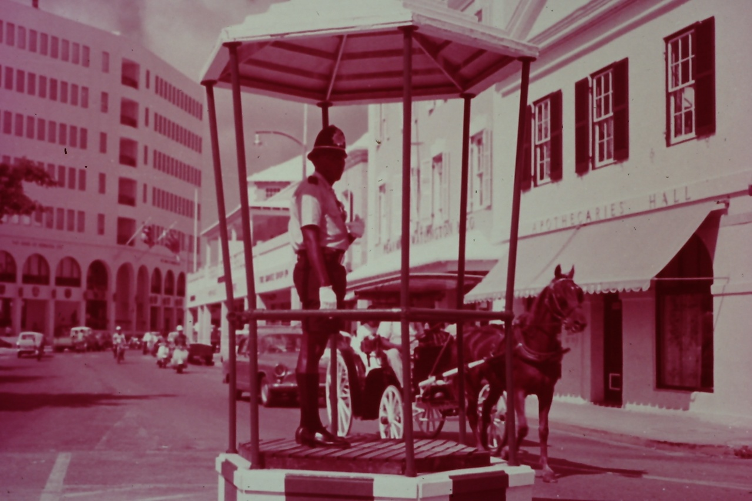
“Bird Cage” in Hamilton

It was a short walk to the garden when I got off of the bus. Along the way I stopped to look at construction site near the garden. Three guys were working digging a big hole in the coral. I asked if this was for a swimming pool and the foreman replied it was for a cistern and asked if I was a Yank.
I told him I was from near Miami and that the state had been trying for years to outlaw and remove cisterns. The health people thought cisterns were unsanitary and a place for mosquitoes to breed. He told me that most of the homes in Bermuda had lined cisterns either under the foundation or in the back yard. Water was collected into the cistern from the Bermuda roof and pumped by hand or electric pump for household use. The sanitary system was completed with a septic tank.

I asked about the Bermuda roof and he pointed out the details on a neighboring roof. The low sloping roof was made from thin limestone slabs or slates about 12 to 18 inches on a side. The slates are installed over a wooden frame and joined with mortar in over lapping rows to channel the water into the cistern. The roof was then plastered and coated with several coats of white paint to provide sanitary waterproof roof that reflects heat. The roof has little overhang to reduce potential storm damage. This is appeared to be a pretty well engineered system.

After this discussion I spent an hour roaming around the botanical garden. I was the only visitor. There were a lot of well labeled plants but the garden reminded me more of a golf course.

I caught the bus back to St George along the south coast. I stopped at the Bermuda Institute of Ocean Sciences at the Bermuda Biological Station for Research in St George. I was looking for Dr R. Tucker Abbott the famous malacologist but he was in Washington, D.C., at the Smithsonian for the summer.

That evening at the enlisted club I met a sailor that lived off base. One of his activities was digging in an old dump near his house. The dump dated
back to the 18th century and he had found several old bottles that he offered for sale. I would bet that this was somewhat illegal.

Next morning I stopped by to see how the base inspection was going and was told to come in the next morning ready for work. With one free day left I decided to find one of the pink beaches. These are corral sand colored with ground red foraminifera. Many of the beaches are private. Many have

bad rip currents. Bermuda’s strict rules (Be No beaches) do not allow sand, sea glass, or shells to be removed or leave the island. No driving.
No camping. No use of the beaches at night. No dogs. I can see the logic considering the number of tourists and the small acreage available.

I asked if there were any beaches nearby and was told there were none handy. They were mostly along the south shore. I went back to St George for a couple hours shopping and then out for supper.

Supper was at the home of the retired chef at the Officers Club. He and his wife had opened a restaurant in their home with the parlor and dining room with tables for guests. Since I was the only one there we ate in the kitchen and talked of many things while he whipped up a local fish dinner.

The next week was occupied by working in the helicopter maintenance shop overhauling jet engines. I assisted in removing and rebuilding an engine then reinstalling it and testing it to make sure everything worked properly. On the day before I was scheduled to leave I was asked if I would like to go on a check ride “to make sure the engine I had worked on were perfect”. Don’t throw me in that briar patch. Of course I jumped at the opportunity. I sat in the door for a two hour ride around the island and got a view of Bermuda that most tourists will never see. Really fantastic. Beaches. Hotels. Beautiful sea. Reefs. Sun bathers by the hundred.

Saturday morning I checked out of the barracks and signed out at the personnel office. A base taxi took me to the civilian terminal a couple hours before boarding time. I was back in Miami a little after sunset.

Carl Lahser

