Enterprise North:
Backdoor
to the
Yukon
Diary of
Otto Lahser
Written During his trip to the Klondike
A Year's Journey (1898-1899)

edited by
Carl Lahser

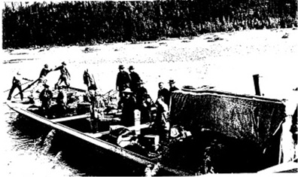
Flat bottom York boat with passengers. The Enterprise was similar but had a steam engine and paddle wheel.

Copyright 1996 by Carl Lahser

All rights reserved. If you must copy any part
of this work please give the author appropriate credit.

Published by Pretense Press
6102 Royal Breeze
San Antonio, TX 78239

Other books by the author:
Searching for the Phantom Crown
Cross-Section through a Rainbow
Backdoor to the Yukon
Ecoview 1-Nor Your Usual Neighborhood
Ecoview 2-Texas
Ecoview 3-D.C.
Ecoview 4-St.Louis to Minneapolis
Ecoview 5-Southwest
Ecoview 6-Green Things
Summers End
Bigfooting Around
Under the Southern Cross (Under Clouds)
Alamo Road
Texas to Alaska
Mr. Cuul in Yucatan
Thinking of Flying
Do Bears do it in the Woods
Traffic Games

All titles are available From Pretense Press. Booksellers
are encouraged to write for seller’s information.

Printed in USA.

Enterprise North:
Backdoor
to the
Yukon
Diary of
Otto Lahser
Written During his trip to the Klondike
A Year's Journey (1898-1899)

edited by
Carl Lahser

Enterprise North:
Backdoor to the Yukon
Diary of
Otto Lahser
Written During his trip to the Klondike
A Year's Journey (1898-1899)

In 1898 my great uncle Otto Lahser and some friends in Detroit calling themselves “the Enterprise” set out for the gold fields of the Klondike. Besides my great uncle, Otto Lahser, members listed include J. Block, Mr. and Mrs. Braund, Sid Down, Ed Gautherat, Herman Groemer, Lew Miller, J. B. Wright. . They decided to travel the “Backdoor Route”from the east through Canada rather than the western routes. Train, stage coach and freight wagon got them from Detroit, Michigan to Athabasca Landing, Alberta, where they built a steam powered wooden sternwheeler York boat called the "Enterprise". This craft transported them down the Athabasca River through Great Slave Lake and down the MacKenzie River. They sold the craft and portaged overland to La Pierre's House on the Bell River, then canoed down the Porcupine River to Fort Yukon where the diary entries stopto Athabasca Landing where they built a steam-powered York boat.
The location of the original hand written diary is unknown. Some of my earliest memories are of my father telling about his Uncle Otto's trip to the Klondike. A typed copy of this diary was given to me about 1980. The diary has been annotated for clarity and where it has been possible to confirm dates and incidents. Spelling and grammer are original. The following personnel and organizations have provided assistance: Mr. Richard Valpy at the Northwest Territories Prince of Wales Northern Heritage Center in Yellowknife NWT; Ms Anne Morton, Archivist at the Hudson Bay Company Archives in Winnipeg, Manitoba; and Ms Eileen Hendy, Marilyn Mol and Robert Tannas of the Athabasca Archives in Athabasca, Alberta; Ms Lindsay Moir of the Glenbow Museum; Dr. Adreana Davies, director of the Alberta Museun Association; and Mrs Mary Weber-Blatz, administrator of the Fort McMurry Historical Society.
My great grandfather, Charles Adolph Lahser, was a wheelwright and wagon maker from the Schwaben area of southwestern Germany near Stuttgart and spoke Swabish. He had several children one of which was Otto who was born in 1877. Otto was raised near Cheboygan, Michigan, and moved with the family to near Detroit in the mid 1890s. Otto was reported to be about six foot five inches tall, and weighed about 250 pounds. He was powerful and liked to fight and gamble. Otto was 20 years old at the beginning of the diary. When Otto returned to Detroit he and his brother, Charles,bought and developed land around Round Lake and Clifford Lake near Brighton, Michigan. Otto, who retired at 35, was reported to have been involved in a gold mine deal in Columbia and land deals in Texas and Florida. He died in 1970 at the age of 93.

Tuesday, March 15, 1898
Left Detroit via CPR (Canadian Pacific Railroad) at 12:03 AM sun time in company with members of the Enterprise, M. H & Co. The depot was crowded to its utmost capacity with our friends, who gave us a hearty send off. Arrived at Toronto (Ontario, Canada) at 8 AM - nice town. Left about 1 o'clock PM. We were to get tourist sleeper at Carleton Junction. They have our dough, but sent car on ahead of us.

Wednesday, March 16th.
No tourist sleeper. At North Bay (Ontario, Canada on Lake Nipissing 200 miles north of Toronto) they attached a Colonization car and we secured two sections, but as our baggage is not on this train, we started out on the boats without blankets. Stove in car and we had hot tea and coffee.

Thursday, March 17th.
Cold. Went past the north shore of Lake Superior. About a foot of snow. No fire in car. Laid over at Rat Portage one hour; done some shopping; nice town.

Friday, March 18th.
Cold and clear; 8 below at Winnipeg. Arrived at Winnipeg (Manitoba, Canada) at 3 AM. Changed cars; laid over 1 1/2 hours; changed cars at Brandon (Manitoba, Canada). We are going over the plains; can see twenty miles each way. Prairie chickens, rabbits and coyotes plentiful. Snow one to two feet deep. We passed through Manitoba Province and Assinobia. We can see plenty of antelope.

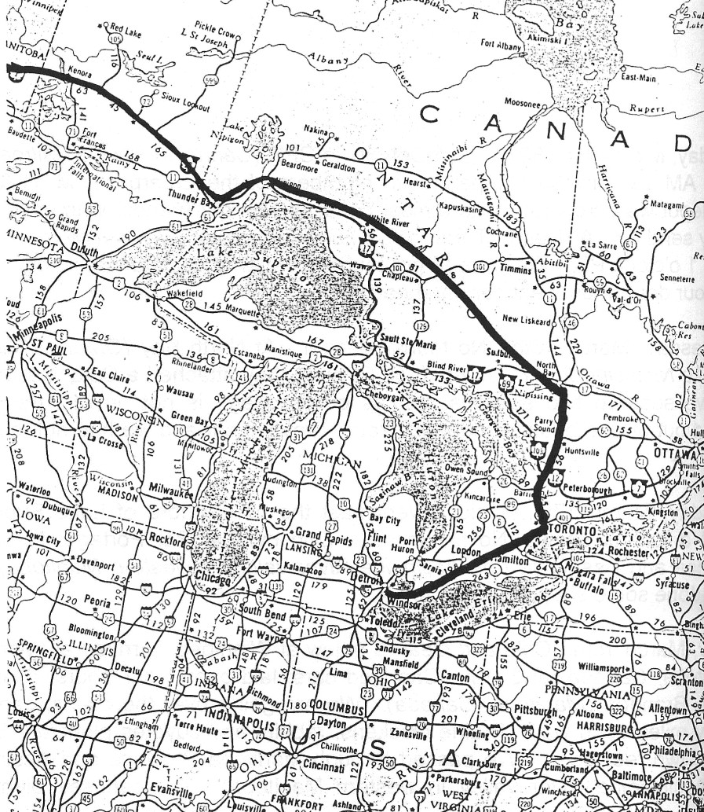
Map 1. Detroit Michigan to Winnipeg Manitoba
Saturday, March 19th.
Zero. We are wheeling through Assinobia (south central Saskatchewan, Canada), a rolling prairie; lots of fair sized herds of cattle on the prairie. We laid over at Medicine Hat (southeastern Alberta, Canada) for two hours. We meet with Indians in every town. We arrived at Calgary (south central Alberta, Canada) at 3 PM and secured quarters at the Royal Hotel. (The Royal Hotel was located ear the train station and the Hudson's Bay Company near Stevens and Center Streets. Otto was listed as a guest in the Calgary Daily Herald on 21 March 1898) After the Enterprise had given their provision order to Hudson Bay Co. (Hudson’s Bay Company (HBC)) I consented to cast my lot with them. Took a stroll about town and then a much needed rest. Temperature 50 above.

Sunday, March 20th.
Stormy, 10 above. This climate is delightful. The town is in a valley and on the south bank of the Bow River. In the AM we took a walk north, crossed the river and climbed the bank, 300 feet high. Can see the foothills of the Rocky Mountains. This is a rolling prairie, stock raising country. In the evening we concluded to send four boys to Edmonton to view the situation and secure quarters.

Monday, March 21st.
11 below. E. Gautherat, J. Block, H. Goermer and myself went to Edmonton (Alberta, Canada, about 200 miles north of Calgary ), leaving L Goermer, L. Miller and J. Wright to pick out our outfit outside of provisions. I ordered our eats to last 15 months. We were particular to get only the very best that could be procured, bacon and salt pork, fat and heavy olive oil, hard wheat and pastry flour, plenty of dried fruits and assortment of staple foods which we figured would carry us through, with the addition of fish and game, picked up enroute and for which we were well prepared with gill nets, rifles and shotguns and plenty of ammunition.

(March 22-26.
ON THE TRAIL TO EDMONTON)

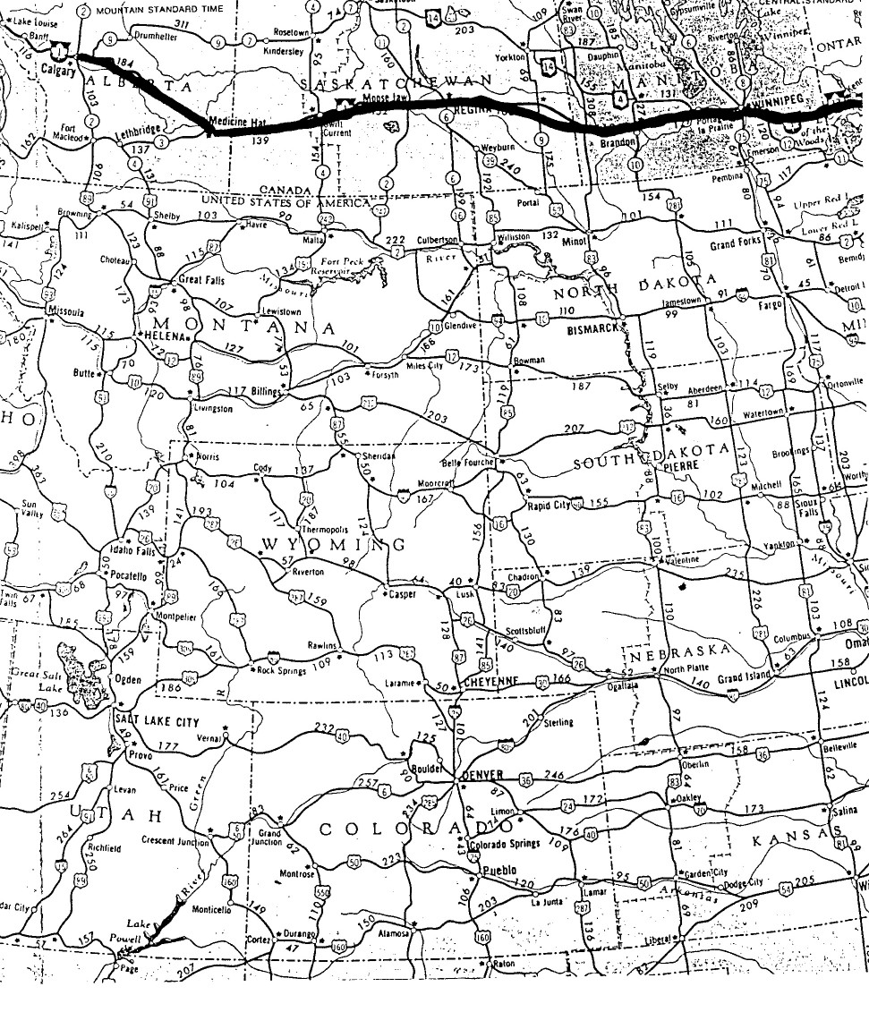

Map 2. Winnipeg, Manitoba to Calgary, Alberta
Sunday, March 27th.
30 below here in Edmonton. Edmonton proper is a couple miles north of South Edmonton, situated on the high banks of the Saskatchewan River. HBC fort is one mile down river. Visited Salvation Army at night. (Both were on the north side of the river).

Monday, March 28th.
A little below zero. I took L. Miller, H. Goermer, and J.B. Wright over to see Mr. Potter and they arranged for a course of lessons in placer mining (possibly in the Strathcona area. Possibly an employee of the Walker Lumber Company that had mining interests and built boat for use on the Saskatchewan River. Placer mining was mining by washing, dredging, pumping or other hydraulic methods). Our freight from Calgary arrived tonight.

Tuesday, March 29th.
Zero. I took out free miner’s certificates for the N.W. Territories $10.00 and British Columbia $5.00. Made our final purchases of traps, mining tools, etc. Went over to Edmonton in afternoon. H. & L. Goermer and J.B. Wright left at 8 PM, bound for the landing 96 miles. (Athabasca Landing now called Athabasca. HBC trading post on the Athabasca River)

30 March to 2 April.
ON THE TRAIL TO ATHABASCA LANDING. (Athabasca Landing Is about 90 miles north of Edmonton. There was a good HBC toll road for stage, wagon or sleigh. Freight cost $0.75 to $1.00 per 100 pounds. Another trail followed the Tawatinaw River.)

Sunday, April 3rd.
I arrived at Athabasca Landing at noon; I broke away from the sleighs and walked the last 15 miles. Lew Miller, E. Gautherat and J. Block arrived at 2 P.M. An extra stage brought S. Down and Mr. and Mrs. Braund. This is all the gang. (A Mrs. S. Brown is listed a Appendix IV of J. G. MacGregors' book, The Klondike Rush Through Edmonton, 1897-1898, as passing through Edmonton and making it all the way to the Yukon. Braund = Brown. Appendix III lists the Enterprise with 8 people passing through Edmonton. On page 168 there is a note that Mrs. Brown had a baby at Ft. MacPherson before making the crossing to La Pierre’s House in March of ‘99. This was confirmed by Mrs. Craig as quoted in Melanie Mayer’s Klondike Women. The "Enterprise" is also listed in the Edmonton Bulletin of 23 Aug. 1898 as leaving Athabasca Landing with 8 people and ten tons cargo.)

Monday, April 4th.
30 to 50 above. We spent the day fixing up the camp. (Camp was probably on the Tawatinaw River near the Athabasca since the water in the Athabasca would be silty.) The population of this town consists of Klondikers. The only buildings are the Hudson Bay Co. post and a boarding house, also two saw mills. The town is situated on the south bank of the Athabasca River. (According to MacGregor, Athabasca had two hotels, a restaurant, a butcher shop, half a dozen boat yards, four general stores, a barber shop, two bakeries and a Solomon Moses general store. This was apparently a couple months later.)

Tuesday, April 5th.
Five of us went across the river and cut and lugged over enough wood to last us for our stay here; we also went to the saw mill 3 miles up river (bigger trees grew several miles up river) to get figures on lumber; price $31.50 per (1000 board feet?) feet delivered at landing. Braund got sick and we kept fire all night, she could not go to the boarding home. (This may have been morning sickness resulting from her pregnancy.)

Wednesday, April 6th.
30 above. We ordered our lumber from HBC and the most of it was sawed today. Braund still sick.

Thursday, April 7th.
We received the bulk of our lumber; went across the river and got four posts and planted them in the ground, on the shore next to the HBC's barn, to build our boat on.

Friday, April 8th.
35 above. We worked on the boat, got our keel and placed it face down on the posts.

Saturday, April 9th.
Warm. The snow is going fast, but they still haul on sleighs from Edmonton. We worked on the boat and built a dry kiln (to dry the fresh cut lumber).

April 10th, Easter Sunday.
Nice warm weather. Put in a quiet day
in camp, that is, as quiet as the dogs would allow - some well matched dog teams here.

Monday, April 11th.
We put in a good day on the boat. Went across the river for sweeps, oars and pike poles; lumber is drying in good shape. We held a meeting at 8 P.M. and accepted the resignation of L. Goermer as captain. I was elected to fill vacancy. Braund out today.
Tuesday, April 12th.
Warm. Went across the river to cut timber and firewood. We got out Braund's punching bag and attracted a crowd of 25.

Wednesday, April 13th.
We got the use of Mr. Fraser's steam box (A steam box was a portable steam generator used to bend wood for the boat); also put on some of sides and bottom of boat and took a snapshot of her. After supper, we got out the bag and also had a tug of war, 75 men participating in sport. We had seven 1 1/2” x 8” x 30 ft. boards stolen last night.

Thursday, April 14th.
Warm. Burned 330 ft. boards last night. L. Goermer was in charge of it. Ice on river getting thin. A team smashed through last night. Hot game with bag.

Monday, May 2nd.
Warm. We have the boat ready for machinery, which we expect almost any day. Our 8 x 10 tent arrived today. Two loads, belonging to Lyster party, arrived today. We unloaded the same. (The 4 Apr 98 Edmonton Bulletin reported that Dr. W.J. Lister, E.H. Sargent and C.A. Howell of Detroit owned the Michigan Northern Mining Company with capitol stock of $25,000. To explore the Peel

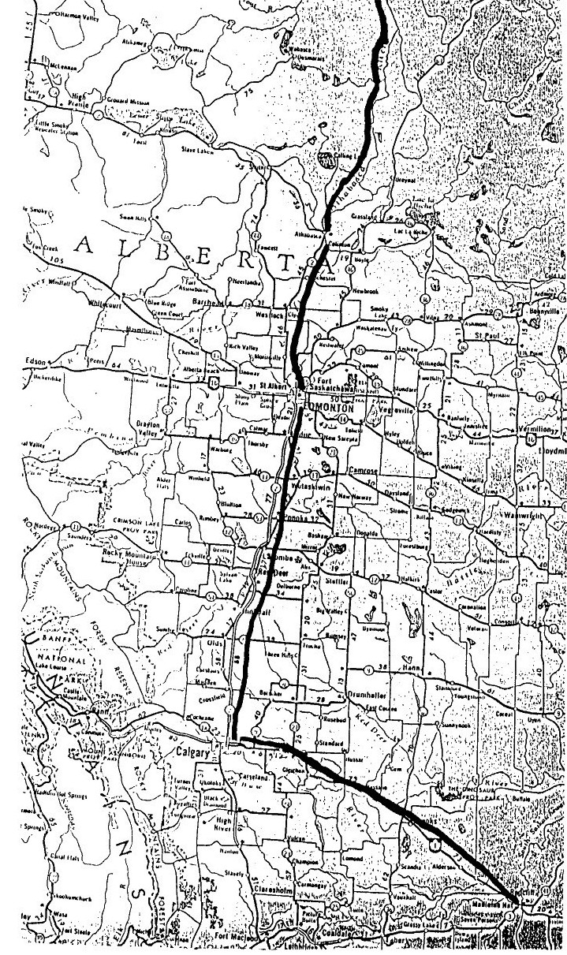
Map 3. Medicine Hat, Alberta through Calgary, Edmonton and Tthabasca Landing to near Ft McMurray, Alberta

River, they had a special screw-driven steel boat prefabricated in Detroit in 12 transverse sections for shipping and to allow portaging. It was 36 feet long with a two foot draught and weighed 2500 pounds and could carry 12 tons. It had a 16 hp engine. Dr Lister, with six others, was also reported bound for the Laird River in the Yukon Territory on the "Dr. Lyster" with 7 tons of cargo. The Laird was navigable to the lower end of Laird Canyon near Watson Lake and the Cassiar gold field.)

Tuesday, May 3rd.
Warm. Dr. Lyster, of Detroit, arrived at 10 A.M., having walked from foot of big hill. He ate dinner with us. Our boiler and engine arrived at 3 P.M. We had teamster drive to edge of boat and we put her in from wagon with skids and rope.

Wednesday, May 4th.
Clear. We worked on boat. Sid and Braund fitted up engine and boiler.

Thursday, May 5th.
Clear. No work on boat.

Friday, May 6th.
We put in the day fitting up boat.

Saturday, May 7th.
Clear; strong west wind. We fitted up boiler and engine and borrowed pipe enough from Dr. Lyster to connect them. In 30 minutes, with wood - not the best - we had 250 lbs. steam, The engine ran well and turned the big wheel. (MacGregor states it was a sternwheeler. "Very strongly built and manned by some practical sailors from the Great Lakes. She sport a big staff and pennant." As reported in the Edmonton Bulletin, the "Enterprise" was a stern wheeler, 50 X 10 feet, drawing 18 inches.) We decided to try her up stream tomorrow, if the wind is down.

Sunday, May 8th.
Heavy west wind. We are short some provisions, purchased at Calgary. We also want to make a few at Edmonton and want our mail looked up. It was proposed we send JBW to Edmonton by stage, which leaves here Tuesday AM. He and Sid Down consented to walk there and will start tomorrow AM. Will return by next Saturday PM. (The snow was gone so the return trip was probably made on horse drawn wagon.)

Monday, May 9th.
Clear. Sid Down and J.B. Wright left early this AM for Edmonton.

(No notes for 10-14 May.)

Sunday, May 15th.
Clear. We helped Dr. Lyster launch his steel boat. Will mention here that the water is lower at the present time than it was ever known to be, which will make it difficult for us and very dangerous.

Monday, May 16th.
Clear. We lined (pulled up stream by lines) our boat up to HBC warehouse and loaded our outfit. (This indicates that their camp was on the Twottenow Creek to the east of town. HBC owned the land between the Twottenow and Mud Creeks.) The stuff purchased at Edmonton by J.B. Wright, which should have been on stage Saturday PM, has yet not arrived. The stage has probably been discontinued. Dr. Lyster has consented to bring it on for us and we pull out tomorrow AM. In the evening, we went on the trip of Dr. Lyster's steel boat. They were trying the Sparrow at the same time, and we gave her the "go by." (The "Sparrow" was a 60 foot propeller ship owned by George T. Leitch with 15 persons from Minneapolis with 7 tons of cargo. It was wrecked on Grand Rapids.)

Tuesday, May 17th.
Clear. We had breakfast at 5 AM and pulled out of the landing at 5:50 AM. We stopped once for wood and before night we had passed seven rigs that had left on Sunday and Monday. We were hard on the bottom once; no damage. We stopped at 7:45 PM. Made 80 miles.

Wednesday, May 18th.
Clear. We steamed out at 6:30 AM. Arrived at Pelican Rapids
(about 120 miles down the Athabasca River) about 2 PM. We tied
up about one mile above and went down to investigate. We went down the right hand side of the bank within 15 feet of the bank. We got aground at foot of rapids; got off again and tied up for the night. J.B. Wright and I crossed over to the mouth of Pelican River and stoned a big mess of fish in the shallows.

Thursday, May 19th.
Cloudy. When we pulled out we came to more rapids, worse than Pelican. They were very numerous, rough and rocky, but we shot through them all. We went through the Dr. Jule Fow (Joli fou) rapids at AM. We saw boats in trouble all around us. We ran into more bad rapids between 11 and 12 o'clock. We were hung up on the rocks for three hours. We lightened about three tons and got in to our waists and made a channel. We broke one rudder and tied up for the night and put in a new one. Very exciting; made from 20 to 25 miles.

Friday, May 20th.
Clear. Pulled out at 7:30 AM and broke the new rudder going through first rapids. We ran about 8 miles, tied up at head of rapids and picked up our rudder but concluded to go on with only one. Going through the next rapids we struck several times, lost the other rudder and tied up about 8 miles above Grand Rapids at noon (160 miles from Athabasca Landing). Several parties are tied up here, among them the "Hamilton Boys" (an 8 person party from Hamilton,
Ontario, Canada), "The Sweeper Man Party" (Not identifiable). Miller, Down, and myself got into one of the dinkies and went down to Grand Rapids; they look desperate. It rained from 2 to 6 PM. We had lunch with four Winnipeg boys (Three groups of four were listed for Winnipeg) and returned on foot at 10:30 PM.

Saturday, May 21st.
Cool. We held a meeting with the members of the other outfits and concluded to help each other. We pulled out at 10 AM with one rudder and a sweep. Lost rudder #4 and tied up one mile above the
island. We spent the afternoon sizing up the rapids. There is an island a half mile long in the center of the river. There is a drop of 67 ft. in 3/4 of a mile. The channel is on right hand side with hardly room to line a boat down between the boulders. The tramway on the island
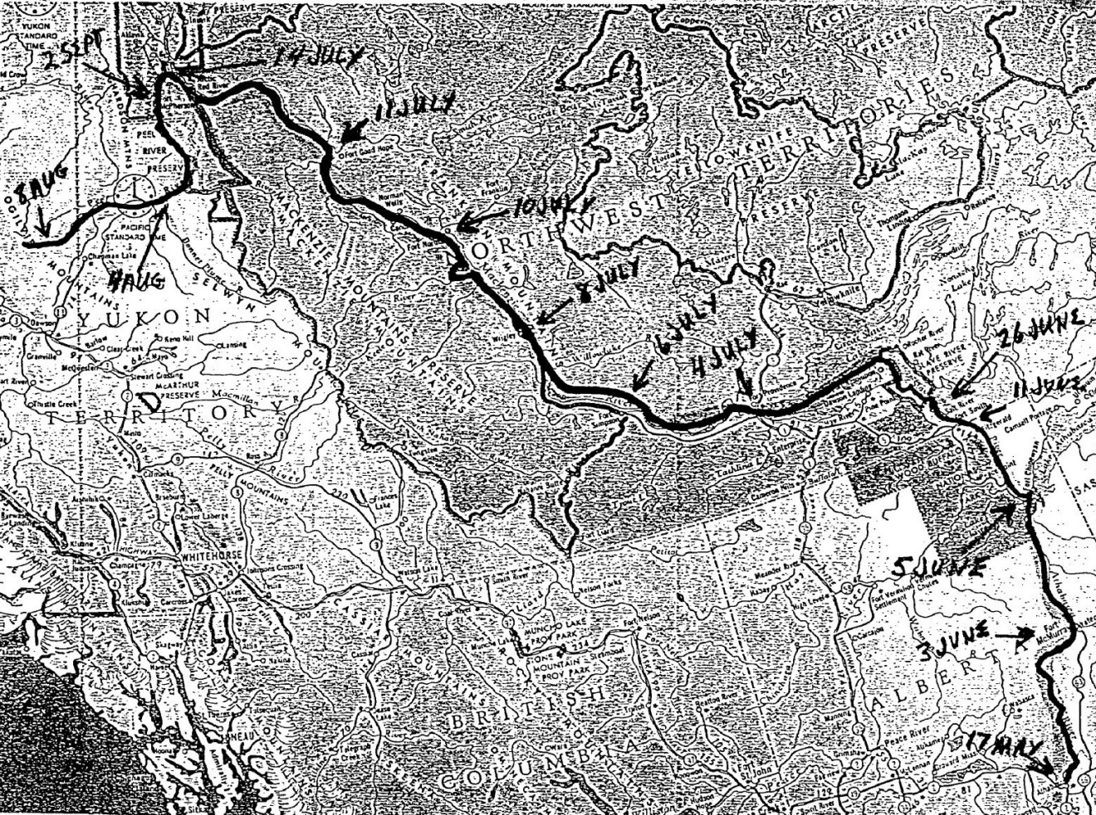

Map 4. Athabasca Landing, Alberta, down the Athabasca River to Great Slave Lake, down the McKensie River to Ft. McPherson and up the Peel River
is owned by the Hudson Bay Co. The car is supposed to hold about one ton, $500 per load. The rapids appear to be nasty and can be heard for miles. Water raised 2 1/2 inches.

Sunday, May 22nd.
Clear. We tried to hire Captain Short (Captain Short was also called Captain Shot, since he was the first to shoot the Grand Rapids. Also spelled Shott. Actual name was Louis Fousseneuve from Lac la Biech. He was born in St Boniface, Manitoba, in 1841 and died in Athabasca, 14 May 1914.) to guide us to McMurry (Fort McMurray) and he said he would on his next trip. (He charged $25 per trip but increased his charge to $100 per trip later in the season.) Will return in 10 days. Water raised 4 inches. (Water rose because of the thaw. High water was needed to get over many of the rapids and falls on the river. The Athabasca flows almost straight north for about 180 miles then turns east for about 80 miles to Ft McMurray. Then it flows north past Fort Mackay almost 200 miles to Lake Athabasca.)

Monday, May 23rd.
Clear - cool. Ed, Jack and myself took one of the dinkies and went to the island. Saw Billy Smith, also Billy Connors (Connors was a prominent trader from Edmonton who owned a trading post at Fort Smith). We disconnected boiler and engine and put Enterprise in shape to handle her with oars and sweep. I went out hunting and found signs of moose and bear. At 11 PM we were attracted by a pair of eyes in the brush, but did not shoot as some of the boys were sleeping on the bank. Water raised 5 1/2 inches.

Wednesday, May 25th.
We were busy running up and down the river all morning. We hired the three stranded Frenchmen's boat to lighten ours and about 5:30 PM our guide and his crew came to take us over to the island. We were rigged with four oars and a sweep and we tied up at head of island without a hitch, but no go with the smaller boat, into which we loaded 3,000 lbs. A young Breed attempted to guide her over and he hit about every rock in the river. Before we got to the island, we had nearly the full load in small boats and most of us had a free bath thrown in, but we did not lose any of the outfit.

Thursday, May 26th.
Clear. We arose at 4 AM and packed 400 lbs. each before breakfast. Four of us poled the Frenchmen's boat over to the Police shack. By 4 PM we had complete outfit packed to the north end of the island, a distance of half mile. Old Captain Campbell gave us a treat. After supper, we went to look at our outfit and missed nearly all our bacon. We found them in Mr. Hendrick's boat, (Possibly the Fargo parties' screw steamer, "Hendricks") tied up in small eddy; it was taken by mistake. The policemen took a photo of us while eating dinner. We got our big boat over just in time, as water lowered seven inches in last two days.

Friday, May 27th.
Clear. We arose as 4:15 AM and took the two dinkies over on the tram car. HBC men were sleeping. After eating, our guide and crew came to take our boat through rapids. The water was low, and we had a hell of a time. Didn't have help enough, and she clambered all over the rocks, until we finally lost our tracking line and as she went down and out the other end. Some of us manned the oars and pulled her ashore in the small eddy. They let down from head of island a buoy with rope attached, and we pulled her up to foot of island and loaded up the outfit and pulled back to small eddy. (Another description of crossing Grand Rapids is in "The Beaver" of March 1948, "Paris to Peel's River in 1892" by Grace Lee Nute.) Just as we were going to bed, along came the guide and took us through the little Grand Rapids to Big Eddy, two miles below, where we tied up with the balance of the fleet.

Saturday, May 28th.
Clear. We ate Breakfast at 5:30 AM and pulled out with balance of fleet, 14 boats in all - large and small. The guide was at the head in Connor's boat. We all followed in line, one boat getting hung up shortly after the start. The fleet tied up at 10 AM and waited two hours for the other boat. When we came to a bad place, we would tie up while guide would pilot a boat through, come back and head for fleet with one of our small boats to find a channel. He took all but three boats through, only puncturing two. We tied up at head for night. A better looking country here than that above Grand Rapids.

Sunday, May 29th.
Clear. The guide will not take us through until after 3 PM, as his religion gives out at that time. Took us through all OK and we tied up while the others repaired their boats. We caught a mess of fish for supper.

Monday, May 30th.
Clear. We pulled out at 6:15 AM. Sailing was smooth until we reached the Holier (currently called Brule or Burnt) Rapids. At 10:30 AM we tied up and took the balance of the fleet through separate. They were bad ones, but we came through without a mishap. There are many rapids, and bad ones to, that have no name. The water is getting lower ever since we left Grand Rapids. We swamp our small boats occasionally. Asphalt (The oil sands have been mapped and developed for crude oil extraction) here in abundance.

Tuesday, May 31st.
Cool and cloudy. We pulled out at 6:30 AM. Went through the Drowned (Currently called Boiler Rapids named after the HBC lost a boiler in the rapids), Middle, Stony, and Long Rapids. They are all bad. We struck one rock in Long Rapids. We were following the guide's boat and they struck the same one. We were piloted through Stony Rapids. One of our small boats filled with water and we cut her loose. At 4 PM we tied up at head of Crooked Rapids. Guide took all but three boats through.

Wednesday, June 1st.
Cool. Breakfast at 5:20 AM. Frost last night. Guide came after us at 8:30 AM. Crooked Rapids were swift water, also very low. Good scenery. We struck once. We tied up below, and while there, Billy Clark, with seven boats, went by. (Clark with a party of six from Toronto on board the "Nellie") We pulled out shortly after and overtook them, nearly all hung up at the Little Cascade. Four of our fleet were hung on Cascade and one above it. Hardly any water and only a narrow place to go through; we were close behind guide and he pointed out just the spot and we slid over OK. I went to the rescue of some of the boats that were hung up. We lined Conor's and our boats down to Big Cascade, unloaded and let them down a six foot drop and loaded up again. As usual, we had a lovely time with our skinned fingers.
Thursday, June 2nd.
Clear. We put the balance of fleet through the same performance as our own, all turning in and doing the job up quick. Had to portage about 100 feet. We pulled out between 2 and 3 o'clock and went through Mountain and Moberly Rapids; very swift. We arrived at Fort McMurray at 7:30 PM. The HBC Post is located on the high flat right hand bank. No other buildings. We shaped our cargo, so as to put up boiler and engine in AM. Wrote letters. Mosquitoes awful thick.

Friday, June 3rd.
Clear. We arose at 4 AM, made two rudders, chopped firewood, and connected boiler and engine. Took a snapshot of Steamer, Graham, pulling in to McMurry on her first trip up. (of the year. HBC's SS Grahame, the first steamer in the Mackenzie River basin began trade in 1883.) We pulled out at 12:30 P.M. The river is nice all along, with islands numerous. We had not gone 25 miles, when we overhauled Connors and Billie Dalztie boats, with the guide Suzie (Cree Indian. Name appears to be a corruption of Josie or Joseph) aboard, also Hendricks towing his two boats with his screw wheel steamer. As we passed them they kindly invited us to take a tow. We stopped to wood up and then Hendricks came along with Billy and Connors also in tow and again invited us to take a tow. We like to be agreeable, but preferred a line in front, which they finally consented to give us. After repeated attempts, Mr. Hendricks could not tighten his towline to keep out of our way. We threw it in to him and he was compelled to drop out. We gave his men orders to let go his two boats and we took Connors and Billy and went ahead. Made 50 or 60 miles. Tied up at 9PM.

Saturday, June 4th.
Cool and cloudy. We got away at 5 AM with two boats in tow. Made two short stops and tied up at 9 PM. The river's banks are picturesque and lined with wild flowers. Good channel if you can keep off the sandbars.

Sunday, June 5th.
Clear. Pulled out at 5 AM. Passed all the fleet that came through with Suzie. No more Hendricks. We are in luck to have a guide, as it is a trick to get out into Lake Athabasca. Had to feel our way single file. When we were well out in the lake, we blew a whistle and were guided in by a beacon light. Island numerous along shore. We tied up at Chippeweggan (Fort Chipewyan) at 1:30 AM on 6th.

Monday, June 6th.
Strong wind. Through a racket between Mrs. Braund and Miller, which occurred last night, Mr. and Mrs. Braund decided to quit party. We were until Tuesday at 9 AM trying to come to an understanding. It was decided to take Mrs. B. to Fort McPherson as a passenger, her interest in outfit, outside provisions, to pay her fare. Her husband will provide for her there and her interest in the Enterprise will stop. (This appears to be about the time the crew found that Mrs. Braund was pregnant. In Klondike Women, Mrs. Braund reported the men did not like her cooking and threw dishes at her.) A woman could not stand the hardships so far, and surely not what is to come. HBC Post here. (Diary of Elizabeth Taylor quoted in "The Beaver" article in March 1948, from her trip to Ft McPherson in 1892 argues this point.)

Tuesday, June 7th.
Cold and cloudy. Windy. This is by far the largest settlement between here and Edmonton. It is built on rocks of granite and has a large HB Post, a saw mill and some quite pretentious houses built of hewed timber, a Roman Catholic mission and school and a Church of England mission and school, also Indian tepees galore. (Miss Taylor had documented her two hour stay and tour of the facility as, "the Hudson Bay enclosure, at each end a large warehouse of whitewashed logs, then the Factor's house, clerk's houses, blacksmith's, flag staff, observatory, all built of hewn logs. Then a long line of white houses where the employees and their families live, all on the river bank. Then the Church of England missionary's house and next to it the school house and church." Not much change in six years) We settled our difficulties and pulled out against a head wind and current at 9:30 AM. Made one stop for wood and tied up at 11 PM. Made about 25 miles.

Wednesday, June 8th.
Cool and windy. Frost last night. Hardly any darkness, only a twilight which lasted an hour of so. (Their location was about 150 miles south of the Arctic Circle which crosses the MacKenzie River north of Fort Good Hope. The twilight nights get shorter and become 24 hours daylight at the circle.) Pulled out at 5 AM. (They were on the Slave River which forms the eastern boundary of the current Wood Buffalo National Park and discharges into Great Slave Lake at Fort Resolution.) We have aboard Mr. Frazer, brother of the Frazer at Athabasca Landing, and a NW Mounted Policeman named Trotter. We are taking them to Smith's Landing. We reached the mouth of the Peace River, shortly after our start. Strong current from here down. We arrived at Smith's Landing at 6:50 P.M. We hired Suzie to take us to Fort Smith. Price to him $20.00 and 4 oarsmen for $20.00.

Thursday, June 9th.
Clear and warm. We thought we had Suzie hired, but he came around with his cousins and demanded $20 for himself, $20 for one oarsman and 40 skins each for other three. We told him to go to Salt Creek, and tomorrow I will go down the river and see my old friend, Savayard, who is the best guide in the country. There is bad water for 16 miles - it is that far by land from here - to the fort, with a drop of 240 feet. There are three portages to make, boats and all, one of 490 yards, one 3/4 of a mile and the other over a hill a 100 feet high.

Friday, June 10th.
44 at 3 P.M. Cool, windy and a little snow. There is another way to go to Ft. Smith, to make a 20 miles portage. The HBC is charging $1.00 per hundred to take outfits over.

Saturday, June 11th.
Cold and snow. Steamer Grahame arrived about 6 AM with a few horses and oxen and a dozen Klondike outfits in tow. [Passengers and cargo between Smith's Landing (now called Ft Fitzgerald) and Ft. Smith was by ox wagon for a 16 mile trip.] I returned with Mr. Savayard at 2 AM. He is our guest and will guide us through next Monday. It snowed a little all day. Played the great American game of baseball and attended a concert.

Sunday, June 12th.
Snowed all day. Put in the day knocking around principal hangout, Connor's store.

Monday, June 13th.
Cool. We pulled out with four other boats and rowed 6 miles, with the exception of one stop, where we were piloted through separate. Shortly after 11 AM we reached the first portage of 490 yards. We packed out outfit over and after they all did the same, we tackled the "Enterprise" to portage her. She had to come up a steep incline, about 25 feet high. When up about 15 feet, the tackle broke. We, with the assistance of the other crew, about 25 men in all, got her over in 5 hours, with boiler and engine in.

Tuesday, June 14th.
Clear. We finished portaging boats, loaded up and started for the next portage, where we arrived at 5 PM. This consisted of three portages, boats and all, the first to a creek, about 120 yards away, which we followed for over a quarter of a mile. We then put over rocks, 10 feet high, for a distance of 100 feet, went through the creek again for a couple hundred yards and then up an incline of 100 feet, and from there a portage of 200 yards to the river. We always work from 4 to 5 AM and 10 to 12 PM. Mosquitoes terrible.

Wednesday, June 15th.
Clear. We started on small boats through the creek, which was very swift. One of them was swamped with 1000 lbs. of flour, which was all saved, and after running several more small boats through, we started the "Enterprise". This is a new way to make this portage and the channel was only from 5 to 7 feet wide in places and we had a hard time of it, digging away banks, cutting brush and falling trees. We worked hard all day, portaging boats and outfits and quit at 10:30 PM. The crowd, outside of myself, didn't sleep a wink - mosquitoes.

Thursday, June 16th.
Warm. Heavy showers at noon. We put in the time from 5 AM to 10 PM, working like braves. We loaded about 1 1/2 tons of the Lady Hamilton (Name not listed, but a Hamilton party of 8 from Hamilton had an unnamed boat) and our own stuff in their large canoe. When within 100 yards of Rock Portage she struck a snag which punched a hole in her middle section. She swamped and her cargo was wet before we could unload her. The worst damage was done to canoe. We also portaged quite a lot of stuff the length of the island. Some stuff was wet from rain which came on suddenly. Mosquitoes bad.

Friday, June 17th.
Clear. We were a good part of the day putting boats over last portage and loading up. We left her and had a hard pull to Mountain Portage, the last pull being across current and against heavy wind, for one hour. We reached the Mountain at 8 PM. We sized up the situation and found a hill about 120 ft. high and about 500 or 600 ft. from water to the top and a steeper ascent on the other side. A boat, as large as ours, had never gone over. We turned in early, as there was a good wind and no mosquitoes.

Saturday, June 18th.
Clear. We started early and portaged our outfit half way up the hill, taking out everything except the boiler. We washed and scrubbed her from stem to stern and found the old devil all there and not leaking a drop. We cut some skids to improve the portage. We spread out and dried the stuff, wet and on the last portage and helped some of the others portage.

Sunday, June 19th.
Clear. We were up at 5 AM and put in snubbing posts on portage, snaked out of the river some long skids and by that time the other crews were up and we all went to work portaging the boats. Our own, we tackled about 10:30 AM and put her on top of the hill before dinner, afterwards running her down to the river. The roadway was just wide enough to get her through, with a little force. By supper time we had all the boats over. After supper, we portaged our entire outfit to the boat and loaded it, winding up the job in a heavy rainstorm and going to bed good and wet at midnight.

Monday, June 20th.
Heavy rain and wind. We expected to pull out early, but were prevented by rain.

Tuesday, June 21st.
Heavy rain and wind. Called the cook at 3 AM but were fooled like, you know. One of the parties, traveling with us, consists of nine Hamilton boys. We met them about eight miles above Grand Rapids, where they concluded to stay with us good fellows.
Wednesday, June 22nd.
Heavy rain and wind. Same as the day before.

Thursday, June 23rd.
Clear. Waited for the other boats and did not get away until 7 AM. We had a hard continuous pull until 10:30 AM through all kinds of bad water and through currents, running in every direction, to a portage about a half a mile long. We only lightened two tons. We then managed the oars with 10 men and we pulled through a narrow, dangerous, rocky channel, dodging rocks on every side. Loaded up and had a hard pull of about two miles to Fort Smith, which is on left hand bank on a hill, 100 feet high. We arrived there at 4 PM. (Fort Smith is on the border of the Northwest Territories. Miss Taylor described Ft. Smith as "4 or 5 small log houses plastered with mud ".)

Friday, June 24th.
Rained all morning. Sid and Sam took engine to HBC shop and cleaned it. In the PM we worked, getting boat ready and raising the stern wheel six inches. William Dalgliest (possibly Dalgleish) asked for a ride to Peel River, which was granted. (The Peel was about 800 miles down stream.) His party is going up the Laird. (The Laird River was about 300 miles down stream at Fort Simpson)

Saturday, June 25th.
Clear. We dried out all the provisions that were wet on portages. We put boiler and engines in place and got up steam and took a back. We received word that four HBC scows were swamped in Boiler Rapids and some mail lost. McKinley, the HBC man, has gone to Smith's Landing for the mail. We are hanging back on that account, also to get our stuff from Dr. Lyster. We heard he was in the Big Eddy June 8th.

Sunday, June 26th.
Showers. We cleaned and loaded boat, overhauled damage, and by dinner time she was in ship shape. We cut wood and steamed up and tied up to the old Wrigley (an HBC steamer). We are going to tow Mr. Campbell and party, of Windsor, through with us. We pulled out at 3:30 PM, with one of our men aboard, to get some salt up Salt Creek.

Monday, June 27th.
Showers. Laid around and played cards. McKinley arrived with mail at 8 PM. We sorted all the mail, which was wet; some of the boys got letters and newspaper clippings. We pulled out at 9:15 PM and ran to Salt River, 20 miles. The Salt was too far up to go after, so we wooded up and pulled out.

Tuesday, June 28th.
Light showers. We kept going all day, only stopping for wood. The river is strewn with islands and its banks are beautiful and inviting and lined with flowers, but as soon as you pull to shore the mosquitoes jump on you and begin to chew.

Thursday, June 30th.
We steamed out at 1:30 AM. For about ten hours we went very near South. A large circle appeared around the sun, the sky turned black and the wind began to pick up. We headed for the shore and give her hell and amidst the flashes of lightning, we ran into a small bay and dropped anchor. A storm came up, which we could not have lived in.

Friday, July 1st.
Dark and stormy. West wind. We steamed out at 1:30 AM, going eight or nine miles, then we were glad to get back to a sheltered bay; we anchored and put a line to shore. A German party of 11 (Apparently did not start at Athabasca. Some parties came overland to Lake Athebasca) and another party of four, put in at the same bay.

Saturday, July 2nd.
Wind easy. We pulled out at 3 AM. A dead sea rolling; run 12 hours and reached the mouth of the McKenzie River. All kinds of islands. River 13 miles wide. We struck trying to get in for wood. A few hours later we anchored at the mouth of a river and picked up wood. Caught a 75lb pike with drag net. Rain storm at 7 PM, after which we pulled out.

Sunday, July 3rd.
Clear. Rain at 5 PM. We were stopped several times by rain and wind, but made a good run late at night and in the early morning of the 4th, went through rapids; must have made from 12 to 15 miles.

Monday, July 4th.
We passed Fort Providence at 2:30 AM. Made good time through a swift current, until 5 AM, when we stopped for wood. This is an elegant day, but we had a heavy rain storm at 4 PM. Later, we traded tea for moose meat. McKenzie River is a winner and about a hundred miles from mouth it narrows down with a good current.

Tuesday, July 5th.
Rain. Rained all day and night and we had to tie up.

Wednesday, July 6th.
Strong west wind. We pulled out at 5 AM. Wind blowing hard. We had consort lashed to side, but she took water so fast that we had to drop her to the stern to save her. We came in sight of Fort Simpson at 10 AM and put in shore to look over situation. The fort is located on the left hand bank at the mouth of Laird River. The wind was too hard and we had to put in opposite the fort. It calmed down, and we steamed across at 8 PM. A nice fort; reading room, library and pool table, vegetable garden and inter-ocean reporter.

Thursday, July 7th.
Warm west wind. We did a little shopping and called on Mr. Springer of Chicago; gave him an item on "Enterprise". Took on some wood, put in a new rudder post to replace one broken last night. Put in new steering gear. We hustled some vegetables. Concluded to take Mr. Campbell to mouth of Peel River. Pulled out at 2 PM and kept moving.

Friday, July 8th.
Clear. We were hung on a sand bar for two hours. The only fort at which we did not stop was Fort Wrigley, which we passed. They hoisted their flag as we passed by; it is on right hand bank and almost obscured by an island. Sun set at 10:30 PM.

Saturday, July 9th.
Clear. We stopped for wood at 5 AM. At 9 o'clock we got on gravel bar. Got off at once, but were two hours getting Campbell's boat off. We have passed seven outfits since leaving Simpson. One party had gone 10 miles past Gravel River and were tracking back. They claim a pan was washed at mouth with seven colors. They also claim that you can go up 200 miles and in two days cross to the McWilliam. Pulled into Fort Norman at 5 PM. Some of the parties here have sent men overland to prospect Gravel River. Left at 9 PM.

Sunday, July 10th.
Cloudy and windy. Wind sprang up at 5 AM and at 11 we were compelled to tie up as wind is dead ahead. Fort Norman is on right hand bank at mouth of Great Bear River. Mr. Hudson made us a map of river to Good Hope, two rapids and two ramparts. Snow on the mountains. Wind died down and we pulled out at 7 PM.

Monday, July 11th.
Clear and windy. We made the rapids and ramparts OK. Fort Good Hope is at foot of ramparts on right hand bank just below. After leaving fort, we crossed the Arctic Circle at 4:32 PM. We moved slow on account of wind.

Tuesday, July 12th.
Cloudy, rain and snow. Heavy wind. We stopped after midnight and took on a good supply of wood and pulled out as it calmed down at 1:30 AM. We tied up on account of wind at 6 AM. Pulled out again at 8 PM. We passed Grand View in evening. A stretch of river four or five miles wide and 15 long - straight.

Wednesday, July 13th.
Clear. We took on wood at noon and went through lower ramparts. At 11:30 PM we sighted the French Catholic Mission at mouth of Red River. We pulled in and got a map of channel to Fort McPherson from the priest. (About 60 miles.) Did a little trading with the Indians. This is the last night that the sun appears to view all night. Can see it for 44 days at McPherson.

Thursday, July 14th.
Pulled out at 1 AM and reached delta of McKenzie about 7 AM. Dropped Campbell. After going 10 miles, reached the Peel River. Passed many outfits and reached Fort McPherson at 10:15 PM. (Confirmed in Klondike Women. Mrs. Emily Craig speaks of meeting Mrs. Braund. The Braunds left the Enterprise and joined the Craigs up the Rat River to Destruction City.)

Friday, July 15th.
Clear. Fought mosquitoes until 3 AM and slept until noon. Mrs. B refused to get off as agreed so Sam decided to quit party. We were all day sorting out their outfits.

Saturday, July 16th.
Finished sorting out outfit. Made a copy of De Sainville's map
of Peel River as far as explored by him - 190 miles. (Count E. de Sainville made this map in 1888. Copy of map in The Golden Grindstone-Adventures of George Mitchell Oxford Press 1935.) Got up steam and pulled out at 5 PM. Run all day and night. Made Dalgliest a member of party.

Sunday, July 17th.
Clear. We ran all day and tied up at 11 PM. Passed outfit with skin boat turned over.

Monday, July 18th.
Clear. Started at 10 AM. Lined our boat through swift place. We tied up about 9:30 PM. Traveled four miles.

Tuesday, July 19th.
Warm. We pulled out at 7 AM. We tried to cross to opposite channel, but current caught us and we were in luck to get back to shore without losing much. We also tried it among the sandbars - no go. We worked around to right of sandbars and tried to cross, but were washed on a gravel bar. After hours of work, we got her off and made to where we started from. We then tried it down left hand channel - no go. We wooded up and went back among the sandbars; tried again, failed and tied up.

Wednesday, July 20th.
Warm. We put in the day bucking the currents and made a little headway.

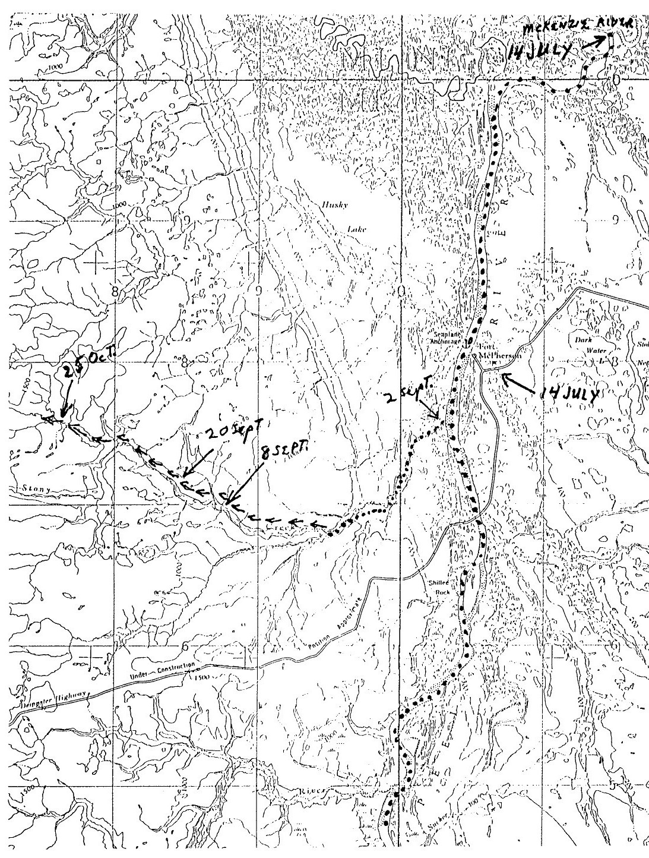

Map 5. Ft McPherson, Peel River and Stony Creek
Thursday, July 21st.
Clear. Same as yesterday.

Friday, July 22nd.
Clear. The going ahead is getting harder each day.

Saturday, July 23rd.
Clear and cool. After repeated attempts to go ahead, we concluded we would go back a couple of miles and try left hand channel. We tried that one and tried again and seriously thought of disbanding the "Enterprise", but finally voted to go back to right hand channel. Had to use block and tackle to get there. At the place we had failed before, we tried in every conceivable shape, even lightening her a couple of tons. Worked late at night and decided to tie her up for good, leave two men with her and take seven men with two months provisions and small boats and prospect headwaters of Peel. At lottery, it fell to S. Down and L. Goermer to remain. We put up emery wheel and started to grind.

Monday, July 25th.
Spent the full day washing and mending clothes, sharpening tools, making oars and getting outfit ready.

Tuesday, July 26th.
Warm. Rain at 5 PM. We were in till 4 PM getting outfit ready and loaded. As we were eating supper, rain began to fall heavily, but it quit and we pulled out at 7:30 PM. We tracked until 11 PM, ate supper and slept on gravel bar.

Wednesday, July 27th.
Clear. Light showers. We pulled out at 10 AM, ate dinner at 3 PM and supper at 9 PM. Made 12 miles. We passed Dr. Brown's party camping ground; they are four days ahead of us.

Thursday, July 28th.
Showers. We pulled out at 11:30 AM. Hard tracking against a heavy current all day. At 3 AM we overtook Dr. Brown's party of four men and another party of two men. They left McPherson 10 days ahead of us and decided to build small boats. The only people ahead of us now are 10 men, who started from McPherson 19 days ahead of us. We put up at 9 PM and made eight miles.
Friday, July 29th.
Showers. We put out at 9:40 AM. Tracking good in some places, bad in others. Current very swift. Put out at 7:40 P.M. and made 10 miles. (The McAdams party reported meeting part of the "Enterprise" party near the Trail River on this date. This appears to be Downs and Groemer who had remained with the "Enterprise". The McAdams diary reported that the "Enterprise" had been sold to HBC at Fort Norman.)

Saturday, July 30th.
Showers. We pulled out at 10 AM. In the evening, one of the boats got away from us, but the other one picked it up. We put up at 8:30 PM, opposite Falling Stone. Made 12 miles.

Sunday, July 31st.
Showers. It being Sunday, we did not start till near noon and quit at 7 PM. Made eight miles.

Monday, August 1st.
Showers. We had to get up in night and cover stuff. Rain started at 9:45 AM and in two hours we were at mouth of Good Hope River. We came on to a beaver on the bar, but let him go. It was a young one. About one mile above Good Hope, we ran into a raging current, waves five feet high. High rock banks, but we track on gravel bars. Put up at 7:30 PM. Found four colors (nuggets). Made eight miles.

Tuesday, August 2nd.
Showers. We broke camp at 9:45 AM and turned in at 8:30 PM. Same high rock banks, 400 to 800 feet high, raging current, but eddies numerous. We did quite a bit of rowing. Made eight miles.

Wednesday, August 3rd.
Showers. Pulled out at 10:40 AM and turned in at 8:30 PM. Hard pull from start to finish. Made 10 miles.

Thursday, August 4th.
Pulled out at 11 AM. Went through ramparts and rapids and turned in at 9 PM near the mouth of Bonnet Plume River. We caught up with the other people. 3 parties in all, 10 men. Four, called the Baudette party, are from around Bay City, Mich., and all 10 are from U.S. Hard pulling. Surrounding country, mountainous.

Friday, August 5th.
Showers. The other crowd sent 7 men up the Peel to prospect and expected them back shortly, so we rested on our oars. Found two good colors opposite here. The other party went up 15 miles. We will pull out in AM.

Saturday, August 6th.
We pulled out at 10 AM and quit at 8 PM after a hot day run and camped at Indians winter camp, at foot of a sort of ramparts. Got a few colors. Made 15 miles.

Sunday August 7th
Showers. We pulled out at 10 AM and in short time were at last branch of Peel River, explored by Count De Sainville. It is the Windy River, runs south, with very swift current and large volume of water flowing out, but more riley than that of the Peel, which is as clear as crystal. We followed the river as far as the Count had explored. High rock banks and rock bottom. We climbed a hill 1000 feet high and drew a map of Peel as far as we could see, probably 123 miles. It runs west and south into the mountains. We turned at 9:30 PM at mouth of a creek on the left. Made 12 miles.

Monday, August 8th.
Rain. We arose at 8 AM and prospect the creek where we slept, also one on the right a few miles farther up. River narrowed down to 50 to 100 yards wide. Current very swift. Rock bottom and no colors. Passed some stages. Had an exciting time shooting at an animal (Possibly a grizzly bear). Made 15 miles.

Tuesday, August 9.
Showers. We got an early start and by noontime were as far up the Peel as anyone could get with boats. The river narrows down to 100 feet. Scenery grand beyond description. We packed up an outfit for four days and started on foot. In an hours time we were up to the wildest kinds of falls imaginable: White Horse rapids could not begin to compare with this grand canyon of the Peel. There are several continuous falls, one of 100 feet high. We put up at 8 PM made 8 miles. Went to sleep on rock banks to sound of rushing waters.

Wednesday, August 10th.
Showers. We ate slapjacks and started early. On account of the roughness of traveling and no sign of color, we concluded this would be our last day. We had to climb like mountain goats and wallow through moss to our knees. We shot 8 partridges for dinner. Made 12 miles and quit at 7:30 PM.

Thursday, August 11th.
Clear. We started for the boats. I was with Johnny and Horm. We scared up a moose and got so far from the trail that we had to put up for the night.

Friday, August 12th.
Warm rain. Went to camp early in AM and we started on return trip. At the mouth of Windy, we found a communication from Bay City boys. They went up the Windy on 10th. We made the mouth of Bonnet Plume and put up.

Saturday, August 13th,
Clear, showers. We broke camp early and put up at mouth of Good Hope River at 9 PM. We chased a beaver several miles but did not get him. Shot some loon.

Sunday, August 14th.
We pulled out and met several outfits below our camp: among them were some of the Hamilton party, which is split up. We went 2 miles up Good Hope after geese. From there down we met and talked with a good many people, in fact had a very sociable time. We had supper with Big Jim and Ernie and ran onto Mr. Campbell and Sid at 11:30 PM. They were camped with another party. We stayed all night. Our other boat made a short stop and went on a 3 AM. (Possibly the McAdams, Huron Imisk, Idaho, Brown or Peacock parties.)

Monday, August 15th.
Clear. We met three more parties, one the Hendricks party, and arrived at the "Enterprise" at 2:30 PM. Held a meeting in the evening and decided that E. Gautherat and JB take the "Enterprise" to McPherson and sell her, while balance of the party would build two small boats to go up the Peel. (The Eben McAdams diary reported it caught up with the "Enterprise" group about 100 miles up the Peel near the Trail River on July 29 and that the "Enterprise" had been sold prior to this time to the Hudson Bay Company at Ft Norman.)

Tuesday, August 16th.
Showers. We unloaded "Enterprise", sawed her down four boards, sorted out Billy's outfit as he decided to go over the Rat River. Ed and JBW. pulled out at 5 PM. (The Rat River appears to be a tributary of the Porcupine River and located about 75 miles overland from the Peel River.)

Wednesday, August 17th.
Clear. We got word that Billy has changed his mind about going over the Rat and has left his outfit with some Hamilton boys, a few miles below here.

Thursday, August 18th.
Clear. The boys did not return from McPherson until Wednesday, August 24th. While they were away we got our two scows built. We had to move the outfit and tent on account of rising water.

Wednesday, August 18th.
Rain. Ed, JBW and Billy arrive this AM, having sold the boat to Mr. Whittaker, the missionary. We have decided that the chances of getting over to the Stewart River on one Indian's word is very slim. We have also lost so much time that the season is too far advanced to track up Windy River, the water being too cold for the men to stand. We are therefore going back to McPherson and make a winter portage to La Pierre's House where we know there is a track. (La Pierre's House was a trading post on the Bell River, a tributary of the Porcupine River and about 59 miles from the Peel River. It was established in 1846 on the Rat River and moved to the Bell in 1872. It was abandoned in 1893.) JBW found out at the Fort that we had gained a day while steaming up the Peel. I have corrected it in this diary by starting properly on this day. We arrived back from our trip up the Peel on Sunday, not Monday.
Thursday, August 25th.
We loaded our boats and pulled down Peel about 12 miles and pitched camp at an eddy, where we caught fish in abundance. Our cook refused to cook for the boys.

Friday August 26th.
Every man cooks his own slapjacks on several different bonfires. We called a meeting and Miller insisted that J.B. Wright do the cooking. He would not let the party ballot and elect one and as the majority rules, and not one man, we were preparing a ballot, to "bust" or "no bust", when a compromise was made by a motion to elect 3 cooks. That was different and no cause for an election, as H. and L. Goermer and JBW volunteered to cook. We are catching all the fish we want.

Saturday, August 27th.
Clear. Went to a lake near by and shot 5 ducks, but was driven back to camp by black flies. Heavy rain at night.

Sunday, August 28th.
Clear. Did nothing but eat and sleep.

Monday, August 29th.
Clear. Same as yesterday. We will pull out tomorrow.

Tuesday, August 30th.
Light showers. Pulled out a 9:30 AM and tied up at 7 PM. Caught 4 fish.

Wednesday, August 31st.
Clear. Pulled out at 11 AM and tied up at 7 PM. Heavy wind late at night, also rain. Darkness sets in before 9 PM.

Thursday, September 1st.
Rain at night. We run 8 hours, put up on a sandbar, opposite Indian camp.

Friday, September 2nd.
Clear. Pulled out at 7 AM. Both scows and a canoe using sails. Fair wind and good sport. At 3 PM we pulled into the mouth of Little Nell Creek, where starts the winter portage. We found the Toronto boys camped there. We had been looking for them. We pitched our camp next to theirs. Heavy rain all night.

Saturday, September 3rd.
Rain all day. I went hunting with one of the Toronto boys and got 7 ducks. An old Californian by the name of Brown pulled in this afternoon. We invited him to supper and a bed in our tent which he accepted.

Sunday, September 4th.
Clear. Some of the boys went to Fort to attend church. Shot a few ducks from tent door. Ice formed on water left in wash basin last night.

Monday, September 5th.
Clear, rain at night. Went duck shooting in afternoon. We got 11 ducks and caught an 8 pound salmon trout in gill net -- a beautiful fish.

Tuesday, September 6th.
Warm. Water raised enough last night to float one of our scows off and into the Peel. English "Bobby" picked her up.

Wednesday, September 7th.
Clear. Sid and I went shooting. Got 12 ducks, Billy, Johnny and Herm helped Brown up the creek with his outfit. They did not return at night.

Thursday, September 8th.
Windy. The boys returned from up creek at 9:30 PM. They took Brown up about 8 miles and claim we can take 1200 pounds that far in a scow.

Friday, September 9th.
Windy. Seven of us went to McPherson to get our tent from Braund. He refused to give it up and a wrangle, we took it.

Saturday, September 10th.
We left H. Goermer at camp to cook. We went up the creek with two scows, loaded with 122 pounds each. We left camp at 8 AM and arrived 8 miles up at 12:30 and rowed all the way back, making the return trip in 2 1/2 hours. We tracked only a small part of the way, rowing the balance. The further up you go, the swifter it gets. Frost at night.

Sunday, September 11th.
Clear. We left camp at 8 AM. Made same time as yesterday. Toronto boys took a load up to within 2 1/2 miles of us.

Monday, September 12th,
Cold. Rained mostly all day. Laid up account of rain.

Tuesday, September 13th.
Cold, light showers. We got away at 10 AM, with the two scows loaded with the balance of our outfits, making two rather heavy loads and as the water had raised 6 inches, the current is swifter and it made rather hard work. The first boat arrived at 5 PM. We put up tent and rolled in.

Wednesday, September 14th.
Cloudy, rain. Did nothing today.

Thursday, September 15th.
Cloudy. Light showers. We improved our sleeping apartments. J. Block went to McPherson and traded oil for moccasins.

Friday, September 16th.
Clear. Did nothing.

Saturday, September 17th.
Cool. Snowed in evening. Four of us took 1000 pounds of provisions about three miles up the creek in a scow, while JBW overhauled the pork and bacon and found it in good condition.

Sunday, September 18th.
Cool. Snowed all day and last night.

Monday, September 19th.
Clear. We wrangled with each other as to the best way and time to get over the trail. Toronto boys returned the scow we loaned them. We let them take canoe.

Tuesday, September 20th.
Clear. Below freezing last night. Snow tonight. We held a meeting in the morning and decided to build a shack in the spruce timber half a mile from here and to live there until spring. But, in the meantime, to portage on the first half what we do not require here, as far over as we can get. Started on shack.

Wednesday, September 21st.
Snow at night. We got the walls of the shack completed today. Inside dimensions 16X22.

Thursday, September 22nd.
Light snow. Cold. Worked on shack in afternoon. Dark 6:30 P.M.

Friday, September 23rd.
Snow. We worked on shack.

Saturday, September 24th.
Clear. J. Block and H. Goermer went to McPherson for mail and returned at 7:30 PM without any.

Sunday, September 25th.
Clear. Laid up today.

Monday, September 26th.
Snow. Worked on shack.

Tuesday, September 27th.
Snow. Worked on shack.

Wednesday, September 28th.
We have to carry stones for fireplace from the creek 200 yards distance, and for good clay, a half mile down the creek - one mile from here - carry it a half mile.

Thursday, September 29th.
Snow.

Friday, September 30th.
Snow. Worked on shack.

Saturday, October 1st.
Clear. We moved into shack. Billy and J. Block went for mail. Did not arrive.

Sunday, October 2nd.
Clear. We fixed up the camp. One year ago yesterday the thermometer at McPherson registered 7 degrees below zero.

Monday, October 3rd.
Cloudy. Put in a quiet day. Sid and JBW shot 18 muskrats and we ate them.

Tuesday, October 4th.
Cloudy. L. Goermer, Billy, Sid and I started to build toboggans.

Wednesday, October 5th.
Clear. We continued to work on toboggans. It is understood Billy is going over this fall. Herm and Lew talk the same way.

Thursday, October 6th.
Worked on toboggans.

Friday, October 7th.
Snow. There is a great deal of dissatisfaction in the party. Miller and Ed will listen to nothing, but go in the Spring. Rather than have a continual wrangle, I have decided to go over with Sid, Johnny and JBW as soon as possible.

Saturday, October 8th.
Worked on sleigh.

Sunday, October 9th.
Clear. Put in all day on toboggans.

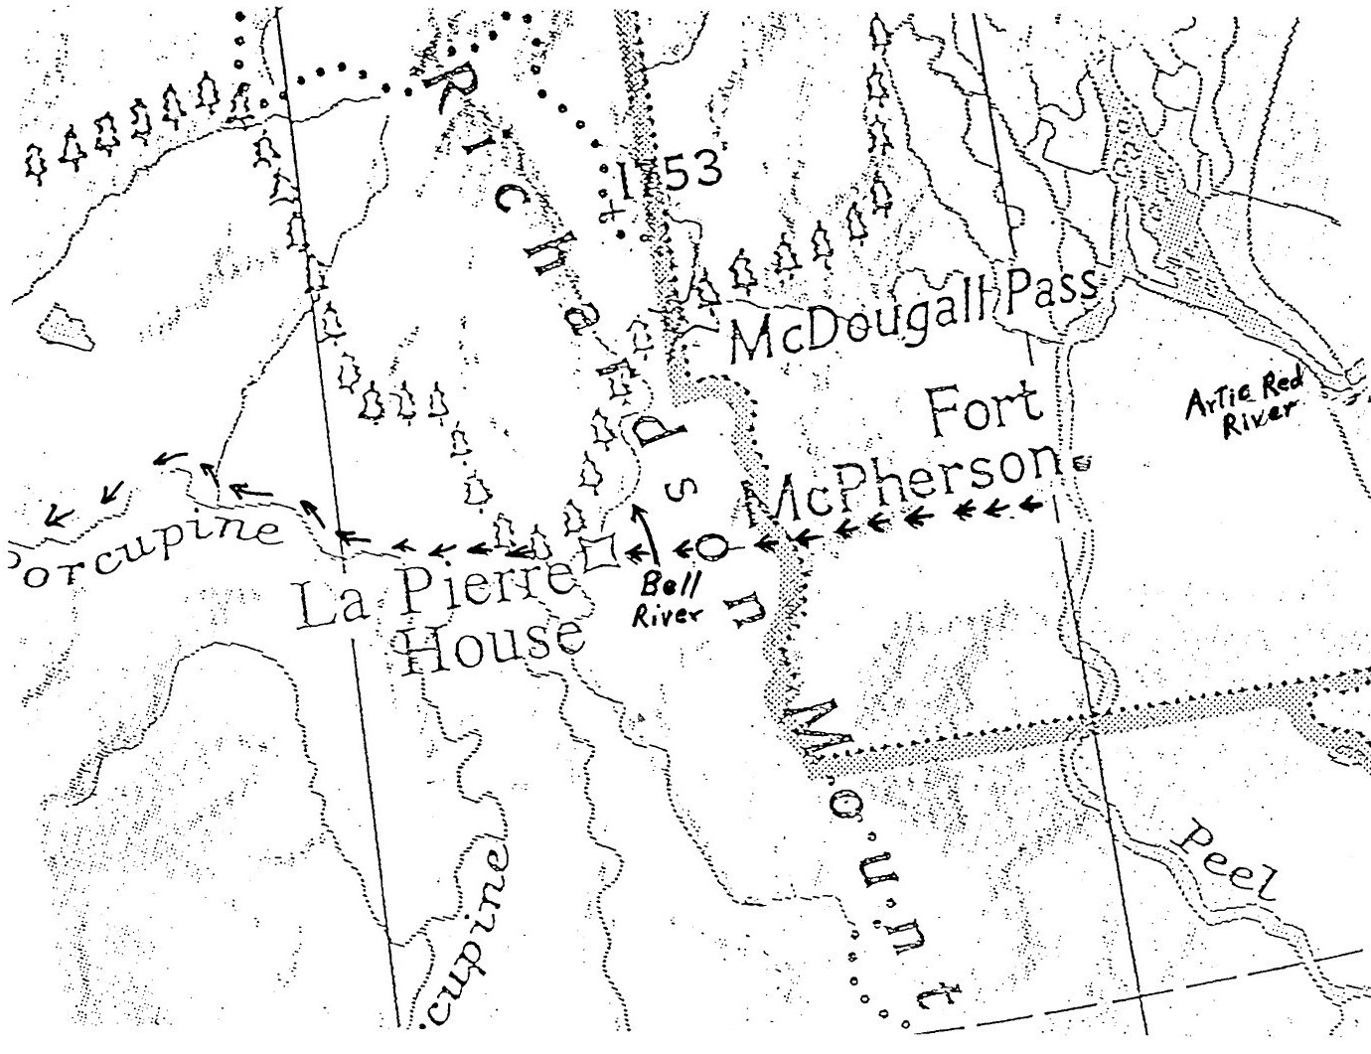
Map 6. Ft. McPherson to La Pierre House
and down the Porcupine River
Monday, October 10th.
Worked on toboggans, About zero tonight.

Tuesday, October 11th.
Put out a few snares.

Wednesday, October 12th.
Zero, clear. Set 17 more snares, some as far as three miles away.

Thursday, October 13th.
2 below zero. Sid and I went to visit Toronto boys.

Friday, October 14th.
Clear. Rabbits went around snares galore.

Saturday, October 15th.
J. Block and Billy brought mail from McPherson. Scow was frozen in at mouth of Peel and McKenzie. They brought us (not me) 44 letters and some papers. We got word of Gen. Shafter's battle at Santiago. (General Shafter's Battle for Santiago de Cuba was fought 2 - 6 July 1898. Admiral Sampson destroyed the Cuban fleet off Santiago on 3 July.) Also, got a miniature American Flag from J.B.W.

Sunday, October 16th.
Storm at night. Rabbits regularly now.

Monday, October 17th.
Stormed at night. Went the round of snares. Was visited by 3 Toronto boys and in the evening we held a meeting. All difficulties settled. We will all go over the trail as soon as possible. H. & L. Goermer to do cooking. When anyone drops out of party, he will get an equal share of everything.

Tuesday, October 18th.
Snow day and night. Toronto boys will make a start tomorrow with 100 Lbs. each. Almost a foot of light snow.

Wednesday, October 19th.
Clear, stormy at night. We dug up our snares and in afternoon
JBW and myself went up creek in search of Ptarmigans. On our return trip, about 1 1/2 miles from camp, we met Alf Davidson. He was fagged out and did not think he could make camp. I put my gun on his toboggan. JBW did the same and I told him to get on and I would pull him (Alf). We had not gone far when JBW's gun went off and nearly took a finger off Alf's left hand. We got him to camp and Sid dressed the wound. Ed, Johnny and Charlie, of the Springfield party, made an attempt to cross the Peel and get a doctor but could not make it. The balance of the Toronto party were all pretty much played out and straggled along at all hours.

Thursday, October 20th.
Light snow all day and night. Sid and I went to McPherson and returned with Dr. Lang who dressed Alf's hand and found the bone of one finger broken. Can save the finger.

Friday, October 21st.
Light snow all day. We were visited by a man named Bell from Rat River. He is going out to Dawson City in a few days; will carry mail and bring back information. Will charge one dollar per head.

Saturday, October 22nd.
Clear. 20 degrees below zero. Ed, Billy and Johnny went to the fort with doctor; bought a stove.

Sunday, October 23rd.
24 below zero. Frank Davison collected letters for Bell to deliver at Fort. While there he secured a room at the missionaries for Alf who will stay there for six weeks or until his hand is well. Frank will continue on the trip with the boys.

Monday, October 25th.
11 below at 9 PM. Mr. Firth delivered our stove with a dog team; he also took the canoe for which he gave Billy $30.00. Some of us pulled our first toboggan load to waterhole - 100 lbs. We will pull 5 miles tomorrow.

Tuesday, October 25th.
23 below. We all pulled out at 7 AM and were back before 10 AM. After dinner we loaded 150-160 lbs. and pulled to water hole.
Johnny froze his nose.

Wednesday, October 26th.
24 below. We made two trips, all of us except Billy and Ed who went to the Fort with the intention of buying a dog team to take them to Fort Yukon. They cannot stand the idea of working so hard and Ed is afraid of freezing to death.

Thursday, October 27th.
Windy. We all made one trip with the exception of Billy and Ed who again went to McPherson. We loaded and pulled to water hole.

Friday, October 28th.
20 below. Ed bought the missionary's dog team for $130.00, the full amount of the note we held against him for "Enterprise". They will be delivered tomorrow. We made two trips today. Sid and JBW went through 3 1/2 miles beyond the cache and pitched big tent - good shelter - good wood.

Saturday, October 29th.
20 below. We made a trip to cache but concluded we would live in shack until Monday. Ed and Billy arrived with dog team, all 21 dogs, good harness and toboggan, a Whittager missionary and an Indian named Davis to guide them over the mountain. They will pull out Monday.

Sunday, October 30th.
Most of the boys are suffering with a bad cold. Wrote letter today.

Monday, October 31st.
We broke camp and pulled through to our tent where we will live until further notice. Sid and I took up the rear, took out windows, etc. Ed and Billy pulled out this AM. Mr. Stone, the doctor ( Dr Lyster) and party went by on their return from La Pierre's House. They were hungry.

Tuesday, November 1st.
I made a trip to shack to pick up stuff left behind. There is still a load left at shack.
Wednesday, November 2nd.
Nine dog teams, with fish from La Pierre's House passed our camp before 8 AM. JBW went through to shack for load. The balance of us made two trips. Sid sick - layed off half day. The Indians brought a note from Ed. They laid up at foot of mountains with a sick dog; they say the distance is 30 miles from our tent.

Thursday, November 3rd.
We all made two trips with the exception of Sid who is sick.

Friday, November 4th.
We all made two trips. Indians went by on their return trip. A Porcupine River Indian, named William Husky, says there are 40 men at Old Crow River digging; 430 more at Black River near Fort Yukon. Crow River is about 140 miles from here - was he talking for a meal? That is the question.

Saturday, November 5th.
Some of us on the pull 3 1/2 miles above here. Van Natta, Bob Smith and Mr. Brown are camped there. Mr. Brown decided to try it this fall and is traveling with Van and Bob.

Sunday, November 6th.
Windy. We worked only a half day.

Monday, November 7th.
Wind blew hard last night and made the trip hard pulling. Made two trips. Names of Toronto outfit: Frank Davison, Alfred Davison, at Fort; Jack Par, Arthur Reinboden, Thomas Moody, William Henry, Charles Smith; other people on trail - Robert Brown, Robert Smith, Frank Van Natta, James Wilson, James MacDermand.

Tuesday, November 8th.
We made two trips. Will break camp in AM.

Wednesday, November 9th.
We arose early and made 2 1/2 miles above our cache. Good wood - good shelter.

Thursday, November 10th.
Made two loads.

Friday, November 11th.
Two trips about 200lbs each.

Saturday, November 12th.
About 3 inches of snow fell last night which made the pulling hard, but we cleaned up the cache and now have everything up to the tent.

Sunday, November 13th.
Put in day mending and resting.

Monday, November 14th.
It having snowed for the last few days, the trail was in bad shape in AM and we could only wiggle with 100lbs, in PM regular load.

Tuesday, November 15th.
We each made two good loads.

Wednesday, November 16th.
Same

Thursday, November 17th.
Storming with high west wind. Too stormy to work. Four loaded dog teams through to La Pierre's House. We traded tea for about 30 lbs. venison; Toronto boys game. Indians went on, wind to their backs.

Friday, November 18th.
Stormed same as yesterday.

Saturday, November 19th.
Where the wind had struck the creek it laid the ice bare. L. Goermer and JBW went 1 1/2 miles beyond cache, near mouth of a creek and selected camping site and cut wood. Sid went scouting ahead and Van Natta to locate the last timber this side of the mountains where we could build a shack. They report 7 miles above our cache as the place. We would have pulled further today but supposed we were at the last timber.

Sunday November 20th.
We moved today. The Indians, on their return trip, stopped in with a note from Mr. Firth (HBC post manager), telling of Ed and Billy's safe arrival at La Pierre's House and their departure from there in good order. David also dropped in today from the other direction with a letter from Ed. They say the mountain is a terror; they had to make two trips of their load. The trail on the other side of the mountain is very bad with a big drop off and they followed a creek for only six miles. They advise us to get as far as we can but not to attempt to cross this year.

Monday, November 21st.
Made two loads each.

Tuesday November 22nd.
Snow at night. Made 3 loads each.

Wednesday, November 23rd.
We cleaned up cache and pulled 2 1/2 miles further up. Alf Davison came up for some medicine - hand doing nicely. A band of hungry Indians pitched their teepees along side our camp. They are from Peel River.

Thursday, November 24th.
Ten below. Thanksgiving day. We each made one trip. We had three guests for dinner, Mr. Brown, Smith and Van Natta. Had roast venison, plum duff and mince pie.

Friday, November 25th.
Pulled two loads.

Saturday, November 26th.
Sid and I, with some of the Toronto boys, went to pick a camping spot. We also intended to get wood but we were glad to get back to Van's tent as Sid froze his nose and fingers and nipped my toes. The balance of the party made two loads. Johnny Block froze his cheeks.
Sunday, November 27th.
We laid in.

Monday, November 28th.
49 below. We each made one load.

Tuesday, November 29th.
We moved today. Miller, J. Block and I went ahead.

Wednesday, November 30th.
I was appointed to look up a site for a shack and did so on the left side of the creek 50 yards back in the timber. The others pulled up loads. Miller, J. Block and I were picked to build shack while L. Goermer, Sid and JBW pulled up outfit.

Thursday, December 1st.
We are building in connection with the Toronto boys, each one 14X16 inside. Ptarmigans are plentiful. Daylight at 8:50 AM and darkness at 3 PM.

Friday, December 2nd.
JBW., Sid and L.G. appointed on wood committee. They helped us carry big logs today. Six dog teams passed on way to La Pierre's House. L. Miller went to bed, complaining of cramps in his stomach.

Saturday, December 3rd.
Wind and snow at night. Did our regular work. Miller awoke with cramps in stomach and rheumatism in his legs.

Sunday, December 4th.
We did no work. Miller no better.

Monday, December 5th.
Trail bad today. We all carried logs. In AM Miller is no better. We wait on him.

Tuesday, December 6th.
Dog teams stopped on their way from La Pierre's House. Miller still in bad shape. I made him a pair of crutches.
Wednesday, December 7th.
Warm wind from northwest. It thawed all day and rained half the time, freezing at night. We still get enough birds to get a few meals ahead.

Thursday, December 8th.
High NW wind. We did the regular thing.

Friday, December 9th.
The trail was in good shape today and the boys brought 300 lbs. each. Miller no better.

Saturday, December 10th.
Eight or ten inches of snow fell and blocked trail. We worked on shack. Mr. Brown paid us a visit. Miller slightly improved.

Sunday, December 11th.
No work today. Went shooting and got 13 birds. Miller better.

Monday, December 12th.
We have killed 60 birds today and have more than half that number on hand. Miller better.

Tuesday, December 13th.
Wind and snow in AM. The Sleigh gang got 15, 75.

Wednesday, December 14th.
We did our regular work, besides getting 10 birds. 85.

Thursday, December 15th.
Sid and I took a shotgun each and went up the creek for a couple of days hunt. I slept with Jimmy and Mack Brown while Sid stopped with Van and Bob.

Friday, December 16th.
Snow. We took a trip up to Brass House. The trail up in this locality is a fright. I got 9 birds, which we gave to the boys up here and returned home.

Saturday, December 17th.
We did regular work.

Sunday, December 18th.
Put finishing touches on shack. Miller still in bad shape.

MISSING DIARY ENTRIES 19 Dec to 8 Feb.

Thursday, February 9th.
Mending pants most all day. Herman and John making mitts.

Friday, February 10th.
Indians came from Fort with dog teams bound for La Pierre's House. They told us that some moose were down the valley about 9 miles; we started down and saw where they had been about a week ago, so we came back tired out.

Saturday, February 11th.
Mending pants all day.

Sunday, February 12th.
Sewing on wooden buttons on pants and packing my dunnage.

Monday, February 13th.
J.B.Wright, Sid Down, J. Block, H. Goermer and myself went up Big Hill, put up tent and cut wood.

Tuesday, February 14th.
Six of us went up to the Big Hill and pulled up half of our stuff. Five dog teams stopped at our cache for the night.

Wednesday, February 15th.
Went up to Big Hill and pulled up remainder of our stuff. Husky dogs got in our cache and ate about 60lbs of our bacon. Had great sport. Riding down hill, one of the Toronto boys' toboggan got out of the track and ran into a tree nearly breaking his leg.

Thursday, February 16th.
Didn't do anything today.

Friday, February 17th.
Mending moccasins most all day. Six birds.

Saturday, February 18th.
Pulled a load up the Big Hill. A man, named Greg, stopped here over night on hid way to La Pierre's House with dog team, from Rat River. He reports 3 men dead and 11 down sick with scurby. 255 birds with today's shoot.

Sunday, February 19th.
Passed the day quietly. Had last dinner out in shack. Had plum duff and birds; for supper we had canned corn and chocolate. It’s the last until we get over the mountains. (No more canned goods.)

Monday, February 20th.
Intended to move this morning but the wind started to blow and its blowing a hurricane yet and its getting colder.

Tuesday, February 21st.
Milder. Wind is still blowing. Started at noon and got to the foot of Big Hill in time for supper.

Wednesday, February 22nd.
All hands pulled 100 lbs. 6 miles. It was a nice clear day but cold.

Thursday, February 23rd.
We all made a load each.

Friday, February 24th.
Six loads went up the line. I am nearly knocked out with a lame knee tonight.

Saturday, February 25th.
All hands went up the line and came back tired. Trail drifted full. Stove nearly blinds us with smoke. It got too bad and play "freezeout". Living in a tent when its 40 or 50 below zero is no fun.

Sunday, February 26th.
Went up to our upper cache; hauled 3 loads of wood 3 miles to our last camping place. J.B. Wright, H. Goermer and Frank Davison started back little too late; got half way up Big Hill and nearly froze. Their faces froze in bad shape and were as white as snow when they came in. The wind is howling and it’s most awful cold; can hardly keep warm in the tent. Its a dire case of freezeout this night when the fire goes out.

Monday, February 27th.
Started out and thought we would have to turn back. Froze my cheek and nose. The boy's faces are as black as my old hat.

Tuesday, February 28th.
Did not go out today, too cold. Hard wind blowing. Going to bed with clothes on - all I got. My overcoat too small to go over all my clothes, so will put it on top bed.

Wednesday, March 1st.
Pulled up camp at 8:30 AM. Had a hard day of it. Some of the boys bushed. Did not get into camp until 9:40 PM.

Thursday, March 2nd.
All of us went to top of summit, except Sid and J.B. It's a hard pull. We started with 50lbs on our toboggan and found it could be bettered by putting on 100lbs.

Friday, March 3rd.
All hands took a load up to summit.

Saturday, March 4th.
Wind blowing hard. Did not go out. Four Indians stopped here on their way to Fort.

Sunday, March 5th.
All went to the top with 100lbs. Nice day. Sun shone most of day.

Monday, March 6th.
All made load today.
Tuesday March 7th.
Colder and wind blowing some. All went up with a load. J.B. froze his nose on his way home, in bad shape.

Wednesday, March 8th.
Could not go out today. Wind blowing most awful hard and cold; cannot keep warm in tent today. Sometimes it seems as tent and all would go up with the wind. Run short of wood in PM. Burnt some of our extra toboggans. Wind let up toward evening. Gave us time to rustle some dry willows.

Thursday, March 9th.
Took last of stuff to top of summit. Wind blowing hard this evening.

Friday, March 10th.
Pulled up tent at 7:30. Toronto boys helped us to the top of summit and some of them helped us over the falls. Wind in our favor, blowing hard in our back. This is our longest move - 15 miles.

Saturday, March 11th.
Could not go out today: Wind too cold.

Sunday, March 12th.
We went over to the other side and helped the Toronto boys over summit and falls.

Monday, March 13th.
Went up to the summit. Could not get a load. Some of us got to cache but could not tie on our loads, too cold. Wind blowing at a great rate. All had to come back 7 miles. J.B. on sick list.

Tuesday, March 14th.
What a difference there is between this morning and one year ago. All of us went up to summit but J.B. We pulled all of our stuff down to the foot of falls. Falls is a 35 ft drop. Lew Goermer fell and broke his arm.

Wednesday, March 15th.
Hauled five loads to tent. Lew feeling easy.
Thursday, March 16th.
Stuff all down to tent except three loads.

Friday, March 17th.
St Patrick's Day. Thanksgiving day for us. We had this day for rest. We had the best we had for dinner. It's a great satisfaction to know that we are over the mountains at last. Got 34 birds this afternoon.

Saturday, March 18th.
The boys went down the line with a load. I went hunting and got 37 birds.

Sunday, March 19th.
Hunting in the morning. 15 birds.

Monday, March 20th.
Moved camp 9 miles. It was the hardest pull we have had. The water was over the ice in too many places; lots of springs keep bursting out. Toboggans would freeze on bottom and pull like a ton. We all got our feet good and wet.

Tuesday, March 21st.
Did not work; Wind blowing hard.

Wednesday, March 22nd.
Made two trips. Nice day. No water on ice.

Thursday, March 23rd.
Made one trip. Wind blowing and drifting.

Friday, March 24th.
Did not go out.

Saturday, March 25th.
Two trips. Fine day.

Sunday, March 26th.
One trip. Nice day.

Monday, March 27th.
One trip except one of the boys. He went back to get a load that was left behind. Got in the water and came back empty.

Tuesday, March 28th.
Made three loads to foot of last hill. Wind blowing.

Wednesday, March 28th.
Moved camp for the last time. Nice weather, sun out all day.

Thursday, March 30th.
Sid and Van hauling deer (Possible caribou). Four dog teams passed on trail bound for the port. (La Pierre's house)

Friday, March 31st.
Did not do very much today. Getting ready to divide up. There is one in the party we have to get rid of - it’s a redheaded guy by the name of Miller.

Saturday, April 1st.
Did not do much.

Sunday, April 2nd.
Spent the day quietly.

Monday, April 3rd.
Commenced dividing up.

Tuesday, April 4th.
Finished dividing at noon. Alf Davison and myself started for the Porcupine. Stopped at the La Pierre House the first night.

Wednesday, April 5th.
Second night, within six miles of the Porcupine. Got my feet wet and froze them both.

Thursday, April 6th.
Found that we could not haul our stuff to the Porcupine so made up our minds to stop here and build boats.

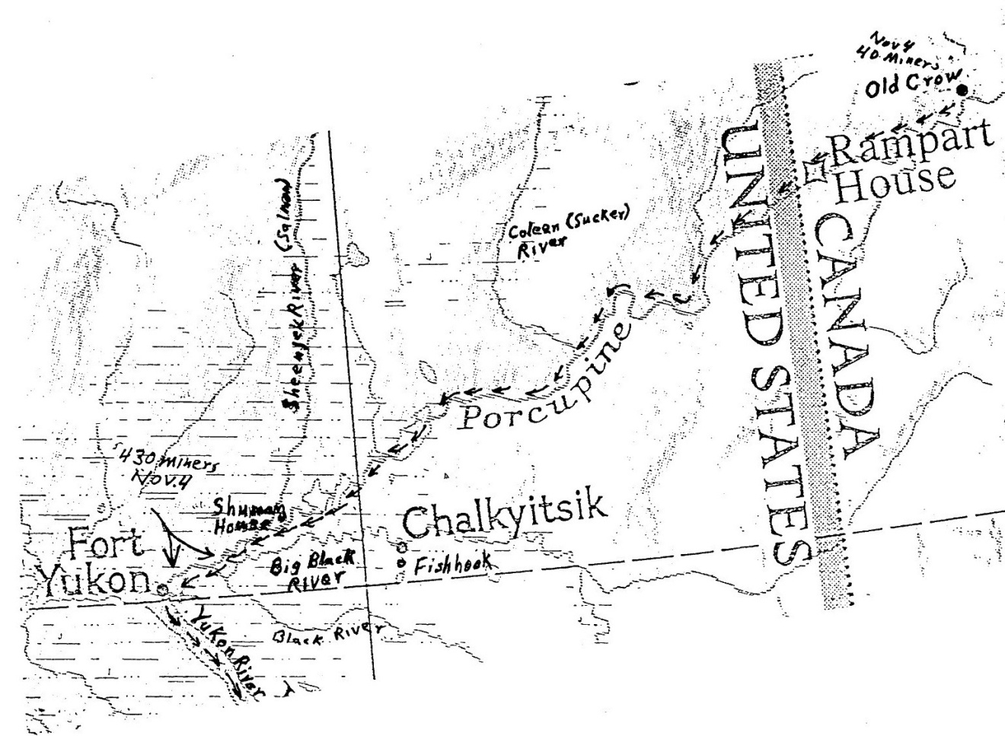
Map 7. Porcupine River to Old Crow, Rampart House to Ft Yukon
Friday, April 14th.
Got a lot of fresh meat.

Wednesday, April 19th.
Started for the Rat River. Stopped at La Pierre House over night.

Thursday, April 20th.
Started with three Indians this morning. Got out about four spells. (Rest periods) Stopped at Indian teepee and had dinner. Started out on trail once more. Got to McLaren's shack at about 9 PM. Had supper and stayed over night.

Friday, April 21st.
Got to the miner's camp at noon; had a good time. I got acquainted with a good many from Athabasca Landing.

Saturday, April 22nd.
Stayed around there all day. They held a miner's meeting on one of the miners and took all his stuff from him.

May 29th.
Broke camp at 5 PM and made portage over 200 feet of ice, boats and all. At the next bad place, there was a winding ten foot channel through ice seven foot thick. Water very swift. Johnny and I made an attempt to go through and were swamped. Lucky to get out of hole. Our stuff was wet but we saved it. Put up to eat at midnight.

May 30.
Kept going ahead and put up to camp at 4 AM. Started again at noon. Rough water and sharp turns. Reached the Bell River. Went a few miles. Met ice jam and broke it. It jammed several times but force of water behind it carried it out. Drifted about 5 miles and met another jam. Camped.

May 31st.
Arrived at La Pierre's House at 3 AM. Fired a salute and sung a song. Stopped and said goodbye. Made a few miles and was stopped by a big ice jam.

June 1st.
Passed three rivers and reached the Porcupine River at 7:30 PM. Stopped at Indian camp. There were 12 boats in line. The La Pierre House Push following us out. We pulled across the river and put up to cook. Started about 11:30 PM with five boats lashed together. Swift current . Strong wind.

June 2nd.
Made Old Crow at 11 PM. (Old Crow, Yukon Territory, Canada, where Old Crow River enters the Porcupine River.) Put up to sleep and wait for better weather.

June 3rd.
Pulled out at 6:30 AM. Good sailing all day. Went through ramparts and rapids. Swift current. Fine scenery. Reached Ramparts House (Old Rampart, Alaska. On the Porcupine River where the Rapid River enters the Porcupine) at 5:30 PM. Met miners that came from Dawson (Dawson City, Yukon Territory, Canada. About two hundred miles up the Yukon River) to prospect. Stopped all night. To go down with them in AM.

June 4th.
We pulled out late in AM. Jack Rae seen a bear (Probably a grizzly bear). Fun all night. Sixty miles off Ramparts (Old Rampart).

June 5th.
River full of islands. (Near mouth of Sheenjak River) A great many channels. Bad head wind.

June 6th.
Bad day all around. Alf Davison accidentally shot himself through arm and leg with shotgun. Sid dressed the wounds and Frank, Jack Rae and myself put him in my boat and started for Fort Yukon which we made in less than 6 hours, a distance of about 30 miles. We took him to the Episcopal Mission House. Minister redressed the wounds and, as good luck would have it, along came a steamer, Straton, and minister (Possibly Peter Trimble Rowe, Episcopal bishop of Alaska) took him to Circle City (Circle, Alaska) to hospital.
June 7th.
Boys got in today. Sid and Jack lost boat and all. Also, Lou and Horm Goermer lost theirs with most of my provisions. We all unloaded and moved into a shack.

June 11, 1899.
To keep this diary required a great deal of time and pains and, after the reverses of the last few days, I think it will take me all my time to keep myself, hence this conclusion:
Since I have left Detroit I have used my best endeavors, poor as they are, to keep a correct account of all the most important events of this trip. There is a great deal more between the lines than is written down and a reference to almost any day when we were on the go would furnish a story that would fill this book. As to whether or not our trip was a failure is a question. We are in the same boat with thousands of others. We took a route which was advertised to be a good one and, to a person on the outside, looked feasible. But since we have reached Fort Yukon where we can converse with people who have come in from all the different routes, we find that any other is a pleasure trip compared to the way we came. Therefore, we consider ourselves in luck that we are here at all. We came through a country that was supposed to be good territory in which to look for the yellow metal and did also abound with game. We do not know anyone who has been successful as regards to gold nor did weslaughter a lot f game but have had the opportunity to do a great deal of trading for meat with the Indians which made our outfit last out. The only riches I have gained has been in experience and satisfaction of meeting with and surmounting difficulties of which there were many. We had the pleasure of successfully coming through a succession of bad waters for obstructions to navigation the world has no equal. We also have the credit of bringing the first steamboat thru for Athabasca Landing to Fort McPherson, Peel River. We were received at all different Posts (Hudson’s Bay Company posts) with surprise at our being on earth as many old heads had expected us to come to grief in many places. After going up the Peel River as far as the steamboat could cope with the swift currents we took boats and went on a prospecting trip, pulling our boats thru raging currents, ramparts and rapids, until we came to impassable barriers in the shape of gigantic falls whose beauty would quicken the heart of any nature lover. From there we walked two days further up than any white man had ever been until we were satisfied that there was nothing there for us. We went up the Peel to look for gold. We did not find any but on our way back we met over a hundred men going up to take the same chance of getting over the Rockies and into the head waters of the Stewart River. We considered it too long a chance or impossible and it was lucky for us that we so decided as we interviewed people today who arrived from the first steamer from Dawson City. We find that many a poor fellow has left hisbones in that locality. Dr. Brown, who left Fort McPherson with ten men, has arrived at Dawson with two, the others having starved or frozen to death.
After coming down the Peel River our next move was to get west of the Rockies with our outfit. We were too late to attempt the summer portage and Mr. Firth, the BC manager (John Firth was post manager from 1893 to 1920), said we could not pull by hand over the water trail. We had learned by experience that what the HBC fogies did not know of the capabilities of intelligent white men would fill a large size book, so we set to work to do another trick never performed by white men. The distance from McPherson to La Pierre's House is 62 miles as the crow flies and about 85 miles by trail. We pulled our outfit to a creek four miles from McPherson. Then we built a shack on ground that was virtually a cake of ice. We also built a large fireplace and the more fires we built the harder time we had to keep it from sinking through to China. We built 15 toboggans and, in October, we started to pull over the trail. Before the first of December we had knocked off 26 miles more. We then put up another shack where we put in a fairly good time for a couple months. We located in a good place for hunting ptarmigan and I killed a great many. We always had plenty to eat. They are a good preventative for scurby.
On February 21st we quit the shack and started over the mountain this time making 44 miles to within 8 miles of La Pierre's House on the Shoot River. Pulled 70 miles in all.
On our first trip in November the thermometer at McPherson reached 42 below zero. In the latter part of February it went down to 58 below but was supposed to be 5 to 10 degrees colder in the mountains. We lived in an 8 ounce duck tent but did not suffer much. We reached the Shoot River April 1st and built boats. From there to Fort Yukon we took more chances than the boys who went to Cuba.
We hear that the Klondike is as rich as it ever was reported to be but there have been no new finds of any importance and the lucky members who staked first are immensely rich and the others are becoming poorer. From all reports the Canadian officials are worse than the most corrupt and it is impossible to stake a claim where there is a possible chance of there being any gold. We have done some tall hustling in the past few days to get enough grub to live on.
On Saturday we chopped and carried to the bank, a distance of over a quarter mile, three cords of wood which we sold for $18 worth of grub. That was all we could get rid of as the market is glutted with wood. We have several more strings to pull but the future does not look exceedingly bright. We are living with the Toronto boys who are sharing with us. We have the satisfaction of knowing who our friends are and that we are in God's country under the protection of Old Glory.
Signed - Otto Lahser
June 11, 1899

Who is Who

Baudette party 4 from Bay City on Peel
Bell Man from Rat R.
Block, Jack or Johnny Enterprise member
“Brass House” Unknown. Probably a trading post.
Braund, Sam & Mrs. Enterprise members
Brown, Dr Robert Party of 4 on Peel. Left overland for Dawson with ten and arrived with 2
Campbell, Capt Windsor party
Clark, Billy 6 from Toronto on “Nellie”
Connors, Billy From Edmonton. At Ft Smith trading post
Dalztie, Billy Party
Dalgliest, William Late joining Enterprise member
Davidson, Alf Toronto party
Davis Native guide Ft. McPherson
Davison, Frank Toronto party
de Sainville, Count Explorer. Mapped Peel R. 1888
Down, Sid Enterprise member
“Dr Lyster” Boat of the Lyster party
“Enterprise” Boat and group name
Firth, John HBC mgr. Ft. McPherson
Fraser Athabasca Landing
Frenchmen stranded group
Gautherat, Ed Enterprise member
“Grahame” HBC steamship
Goermer, Horm Enterprise member
Goermer, L. Enterprise member
Hamilton Boys 8 from Hamilton, Ont.
HBC Hudsons Bay Company
Hendricks Fargo party & steamer
Henry, William Toronto party
Hudson HBC man at Ft Norman
Huron Imisk Party on Peel R.
Idaho Party on Peel R.
“La Pierre’s House” HBC post on Bell R.
“Lady Hamilton” Boat of Hamilton party
Lahser, Otto Principal character
Lang, Dr. FT McPherson
Leitch, George T. Minneapolis. Owned “Sparrow”

Lyster, Dr Dr W.J. Lister. Detroit group. Owned
“Dr Lyster”
MacDermand, James On Peel R.
McAdams, Eben Party on Peel R.
McKinly HBC man at Ft Smith
Miller, Louis Enterprise member
Moody, Thomas Toronto party
“Nellie” Boat of Billy Clark
Par, Jack Toronto party
Peacock Party on Peel
Potter Edmonton
Reinboden, Arthur Toronto party
Rowe, Peter T. Episcopal bishop
Savayard Cree guide
Short, Capt Cree guide, Louis Fousseneuve, AKA Captain Shott or Captain Shot. Guide on Grand Rapids
Smith, Billy Group on Athabasca R.
Smith, Charles Toronto party
Smith, Robert On Peel R.
“Sparrow” Boat of George Leitch
Springer Reporter at Ft Simpson
Suzie Name corruption of Joseph or Josie. Cree guide at Fort McMurry
Savayard Ft Smith
Sweeper Man Unidentified party
Toronto outfit: Frank Davison, Alfred Davison, Jack Par, Arthur Reinboden, Thomas Moody, William Henry, Charles Smith
Trotter RCMP officer
Van Natta, Frank On Peel R.
Whittaker Missionary at Ft McPherson
Wilson, James On Peel R.
Winnipeg Boys Any of 3 groups from Winnipeg
“Wrigley” HBC steamer
Wright, J. B. Enterprise member

Bibliography

Grahe, Angus. The Golden Gringdstone - Adventures of George Mitchell related by Angus Grahe. Oxford Press 1935.

MacGregor, J.G., The Klondike Rush Through Edmonton, 1897-1898

Mayer, Melanie J. Klondike Women - True Tales of the 1897-98 Gold Rush. Swallow Press, Ohio University Press

McAdams, Eben. trip diary

Nute, Grace Lee. “The Beaver” Mar 48. “Paris to Peel’s River in 1892”. Taylor, Elizabeth. Diary of trip to Ft McPherson

Webb, Melody. Yukon, the Last Frontier. U. Nebraska Press, 1993.

(Back Cover)

My Uncle’s Cabin

Uncle Otto went north
By the backdoor route in the spring of ‘98
Down the MacKenzie and the Porcupine
And up the Yukon to confront his fate.

In September the group built a cabin
Near the Peel on Little Nell Creek.
It housed eight burly prospectors
And measured 16 X 22 feet.

For a winter trek to La Pierre’s House
They made sleds and lots of snow shoes.
The built another cabin in November
Near the treeline where the winter was blue.

The trek was over in March '99
Then canoes down the Bell and the Crow.
They reached Ft. Yukon in June of that year
And still had a long way to go.

He headed south in ‘02 with a poke full of gold.
With adventure, he’d had his fill.
“We took more chances than the boys in Cuba”
That had just taken San Juan Hill.
Carl Lahser

