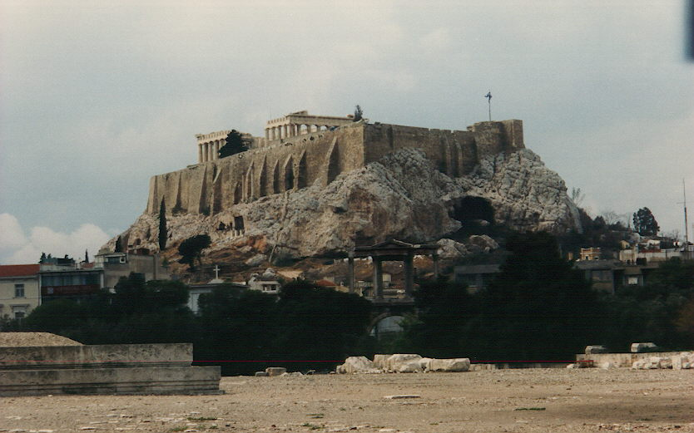

Poems
from beyond the Rainbow

by
Carl Lahser

Copyright © 2012 by Carl Lahser. All rights reserved. If you must copy any part of this work please give the author appropriate credit.

Published by: Pretense Press
6102 Royal Breeze
San Antonio, TX 78239
(210) 657-5139
clahser@satx.rr.com
Publications by the author:
USA
Bigfooting Around – Washington state
Blue Ridge, GA
City of Angels
Galveston
New York Christmas – Hudosn Valley and NYC
Niagra Falls and Toronto
October was a Busy Month Minneapolis and the Shennadoah Valley
Portland in the Summer
San Francisco Home Exchange
Santa Fe Getaway
Shelling Trip
Summers End
Canada
Backdoor to the Yukon
Do Bears do it in the Woods - Winnipeg
Enterprise II – Calgary, Edmonton, Athabasca
Enterprise North
Vancouver – Vancouver, Victoria, Inland Passage
Where Have All the Pretty Colored Houses Gone - Newfoundland
Mexico Cabo San Lucas
Copper Canyon
Flowers of the Air
Hey Momma, When we Goin Again
Mata Ortiz
Mr. Cuul in Yucatan
San Miguel
Searching for the Phantom Crown
Todo Santos Ecoadventure
Europe A Quick Little Christmas Trip Christmas on the Rhine
Dickens Christmas - Three Weeks in London
Cross-section through a Rainbow – Corfu, Athens, and Rhodes
Greek Poems
Return to Asinara Bay – Italy
Three Weeks in Berlin
China
China Tour /China Sings
Hong Kong 1979
Taiwan
Other Travel
Panama Cruise
Under the Southern Cross (Under Clouds) – Machu Pichu and the Amazon
Vietnam and Cambodia
Poems Cryptic Romance
Ecoview 1 - Not Your Usual Neighborhood
Ecoview 2 - Texas
Ecoview 3 - D.C.
Ecoview 4 - St Louis to Minneapolis
Ecoview 5 – Southwest
Ecoview 6 - Green Things
Rincon de Carl
Snapshots of the North
Snapshots of Mexico
Summers End
Texas to Alaska
Traffic Games
Tyndall Beach
Walk on a Different Beach
Weather watching
Other
Alamo Road – Mom’s Story
BASH – Bird/Aircraft Strike Hazard
Bessies Pictures 1930
Butterflies and Birdwatching - PIF Bird Meeting
Forty Years of Fishing – Professional History
Green Stuff Articles from the SCION
San Antonio Wildflowers by the Month
Teacher, Leafs Don’t Change Color – Growing up in the Valley
Thinking of Flying – Military history
Plays Cryptic Romance
A Body in the Trunk
A Blow for JFK
A Beard like Mine
The Black Birds – A BASH Play
Essays
Broken Shoulder
Dinosaur Diving
Haiti
Hip 3 – Hip Replacement
Impossibility of Time Travel
Knee Repair
Fiction
HiJaak
Stories Grampus Told
All titles are available from Pretense Press. Booksellers
are encouraged to write for seller’s information.
Printed in USA.
Exploring Greece is like looking at a cross-section through a rainbow. Each chapter is distinct, a different hue. By the way, Helen of Troy was supposed to have hanged herself with a rainbow after being exiled after the Battle of Troy.

As our 29th anniversary approached in 1996, we began to plan something special for number thirty. We began looking for a place to go for two weeks in the spring of 1997. I had been to Greece in 1962 so we chose Greece - a week on Homer’s Corfu followed by a week on the Crusader’s Rhodes with a day or two in Athens.

Looking Back to 1962
Corfu afternoon
Glofs’da Beach
Off and Running in the Present
Airport Jewels
The Alps from the Air
Monaco Memory
Stopover in Rome
Historical Perspective on Athen’s Weather
The Heptanese
Byron’s Contribution
How Do I Get to Corfu
Cotfu
Days of Conquest
The Mount Pantokratos Overlook
A Byzantine Reminder
Fanos
Similarities
Olive Groves
Athínai
Akrí Soúnio
Sing
Pentalic Marble
Rodos
Cold Stony Beaches
Dream of Lindos
Retrospect
Return to Glifa’da Beach

Looking Back to 1962

Corfu Afternoon

In the shade of a large Valonia oak near the customs house
with the Venetian-style new fort looming overhead,
we listened to Greek music at a mesedhopolía,
feasted on a pikilía of mezédhes like
feta cheese, dried squid, and roasted lamb,
and sampled licorice-flavored oúzo to excess.

We were anchored off the commercial Port.
The Pindus mountains and Albania,
an ancient and Cold War adversary,
lay just two kilometers across the strait.
carl July 62
*****
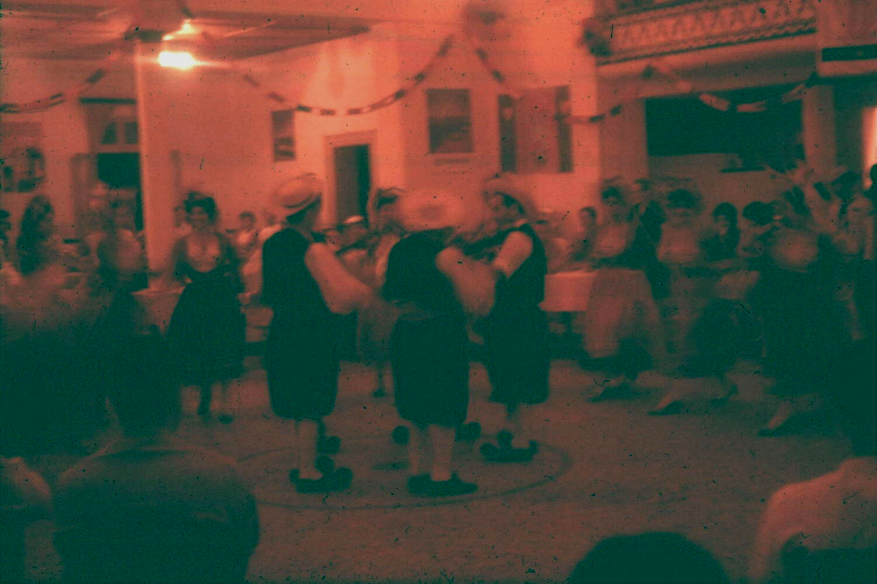

GLIFA'DHA BEACH

Four thousand years of
beachcombers,
philosophers,
soldiers,
poets and kings
trod this beach.
Their eyes have feasted on
hills covered with oak and olive trees
good anchorage in the Saronic Gulf
fair country girls
as they approached Athi'nai from the south.
Forty civilizations spilled their blood and seed
on this beach and on these hills.

I came as a warrior,
but my summer was spent in peace
in a small family hotel
on the shore looking south and west across the Gulf.
Up each day to catch the morning sun,
awakened by the soft knock of the maid
who left croissants and jam and tea on a terrace.

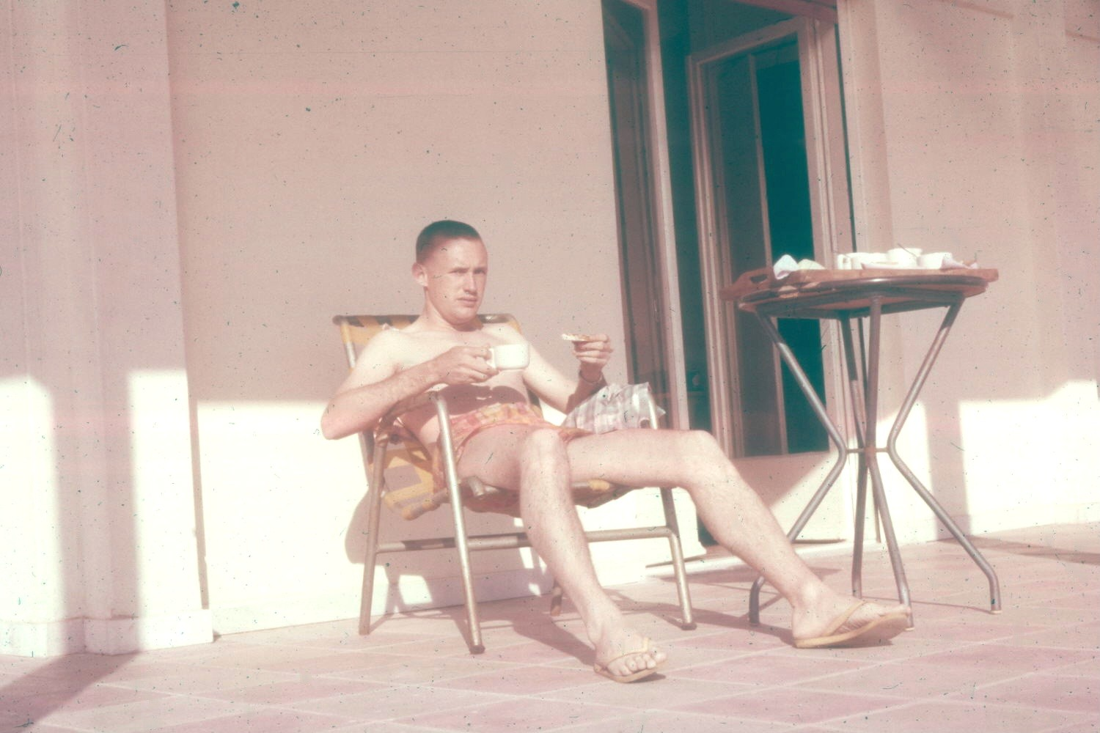

Alone in the pastel dawn
I watched the sky soften and the fog lift
and, seeing the yellow and white Caroline
anchored a mile off shore,
wondered if Jackie Onasis was joining me for tea,
waiting for the sun,
listening to the gentle slap of wavelets
at the changing of the tide.

I watched as fishing boats returned silently
with lamps trimmed, oars and nets shipped.
Baskets of squid and cuttlefish were the reward
of those who correctly answered the nymph’s question,
"How is it with Alexander?" “He lives and reigns still.”

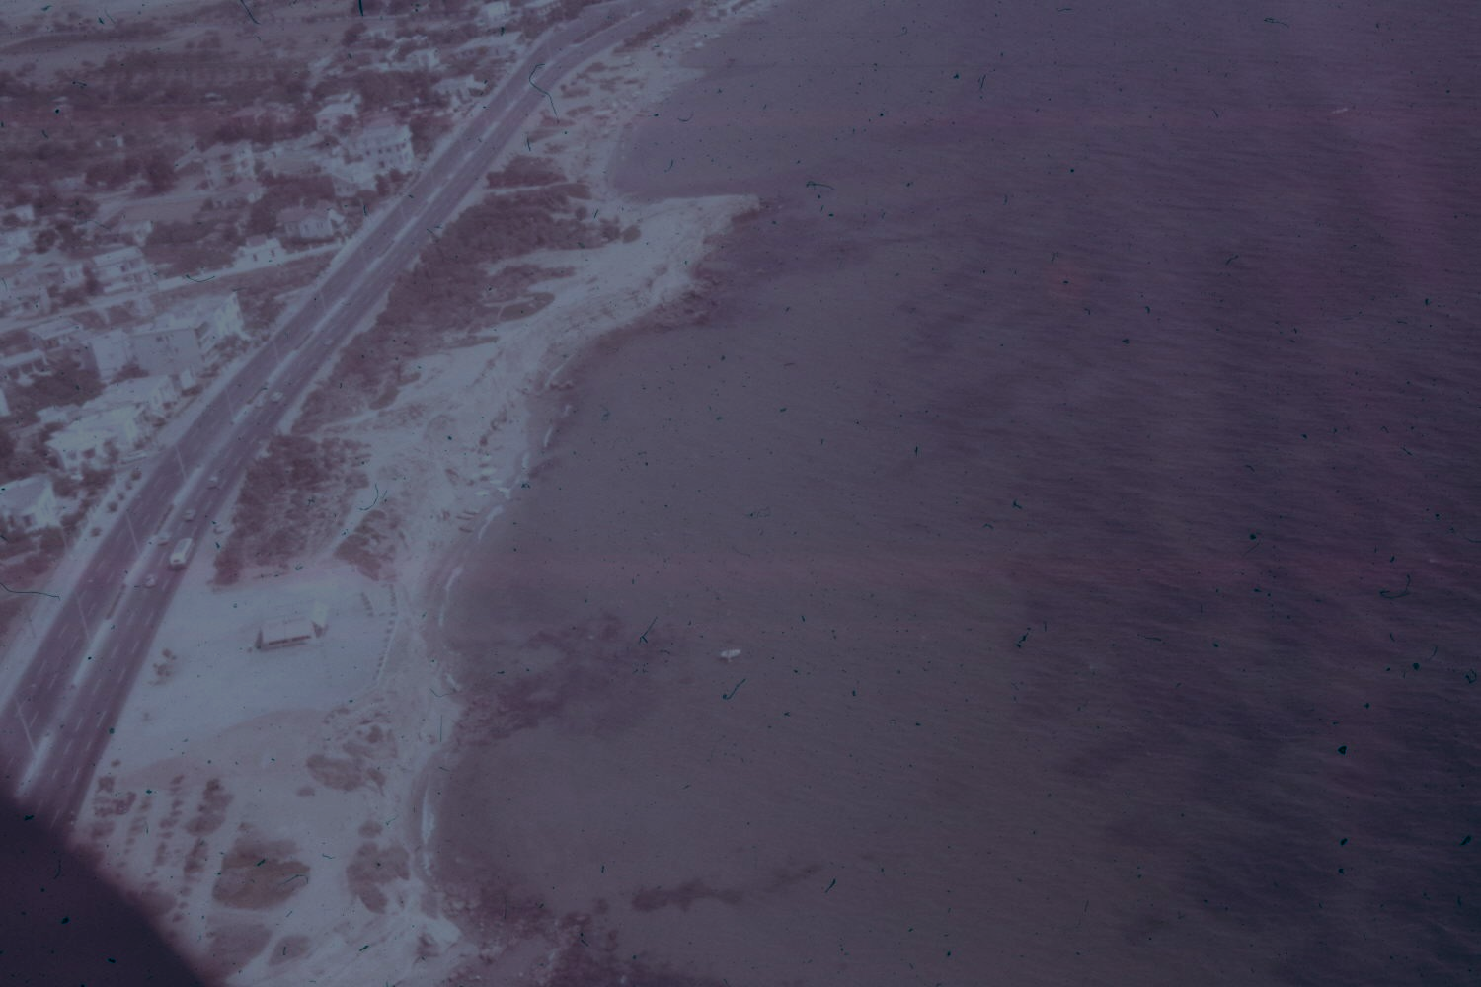

My war went well as I dressed for the day's flight.
Like Icarus of old we strapped on our wings
and chased the wind east to Keá and A'ndros
to Sa'mos and Ephesus
then north to Ankara over forested mountains
to the Black Sea beaches.

We raced the sun west across the Bosporus
and down the fields and pastures of the Ergene Valley
to Xanthi and Dráma.

Banking left, we drifted southward
to Thessalonniki and across the Gulf of Thermaikos,
across the bottomless blue Aegean under a cold clear blue sky,
over a hundred rocky islands and narrow beaches
to Athi'nai.

Warm nights of oúzo and retsina,
slabs of white feta cheese made from goat’s milk,
raw squid, and fried fish cakes with garlic sauce
beneath spreading oaks,
bif stek and stuffed grape leaves
in tavernas where no Greek was spoken
and drachmas got dollars in change.

Overcast nights were like a large room with carpeted walls.
Warm breezes filled with the smell of acacias and the sea
as lights of the Caroline disappeared into the dropping mist.
I waited on the beach for the dawn when we flew again.
Carl July 62
*****

Off and Running in the Present

Airport Jewels

An airport ramp, halogen lit.
Aircraft;
fuel trucks;
baggage carts;
all part of a warm tangerine glow.
A glow that fades into
to the blackness of night on the airfield.

The airfield lights come on-
sapphire blue braids of taxiway lights;
white diamonds of runway boundry lights;
a string of carnelian lights down the centerline;
ruby lights marking the threshhold;
emerald intersection lights -
a collection of jewels displayed
on a black velvet drape of night.
*****

The Alps from the Air

Those narrow twisting roads through steep, green valleys
and around snow capped peaks of mile-high mountains
present a different aspect when seen by Phineas Fogg.
Days of driving in thin, crisp air scented with evergreens
took minutes in sterile shirt-sleeve comfort.
*****
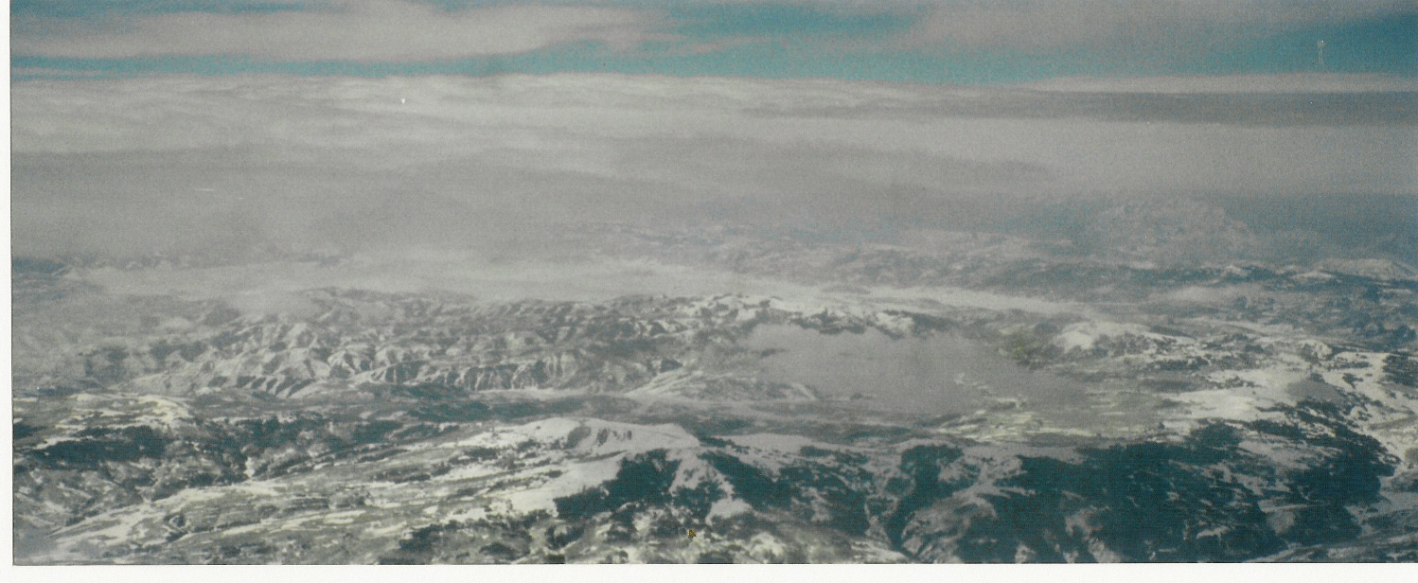
Alps from the Air

Monaco Memory

The little beach below the Prince Albert Museum
spawned a magic maid with long black hair
She tossed stones into the sea
so her full-size poodle would let us talk.
She and the poodle disappeared
over cold sweet vermouth.
*****
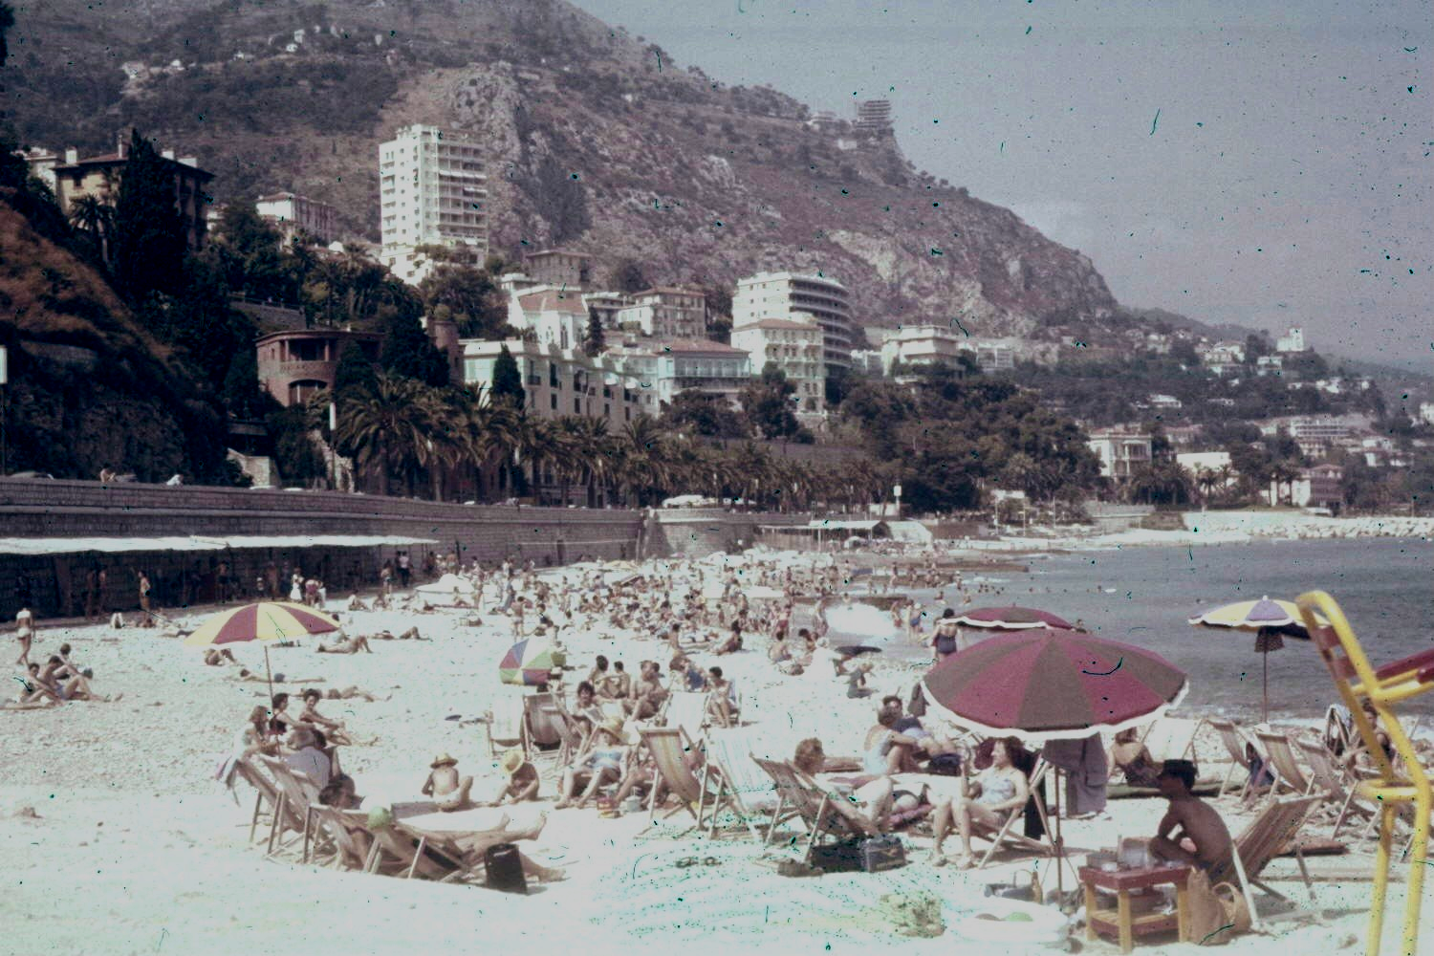
Monaco Beach
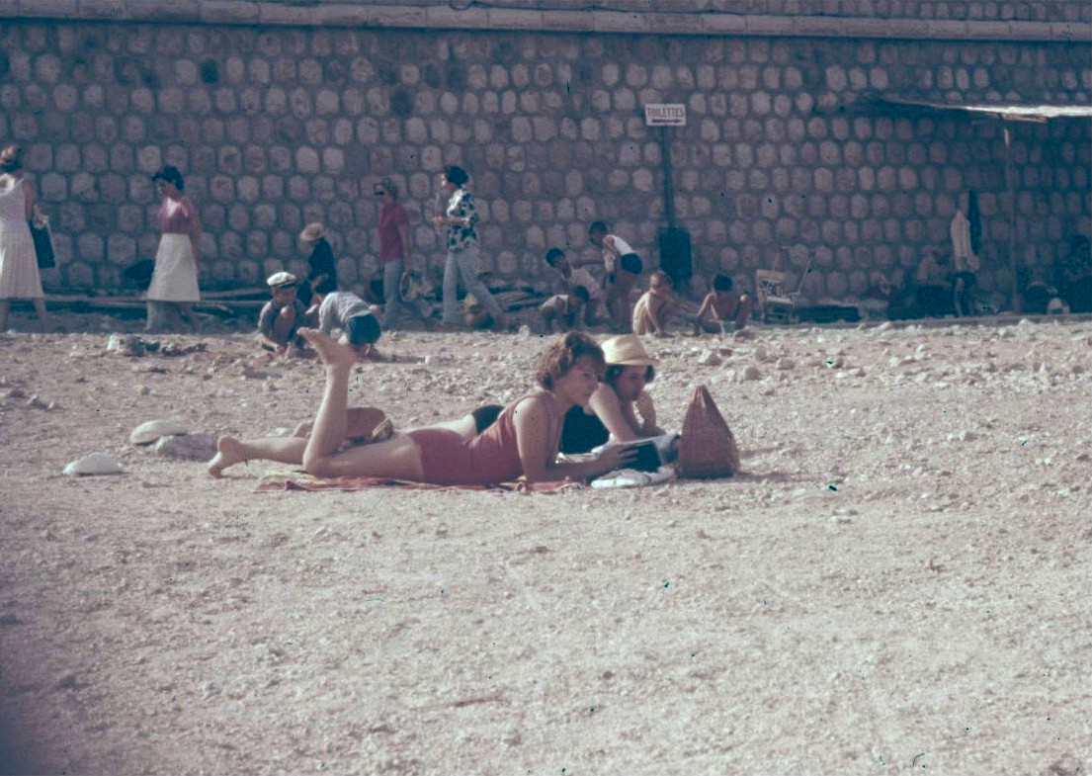
Soaking up the Sun in ‘62

Stopover in Rome

Once all roads led to Rome
but our short path led
to the departure terminal
where CNN said
it was much too cold for togas.
*****
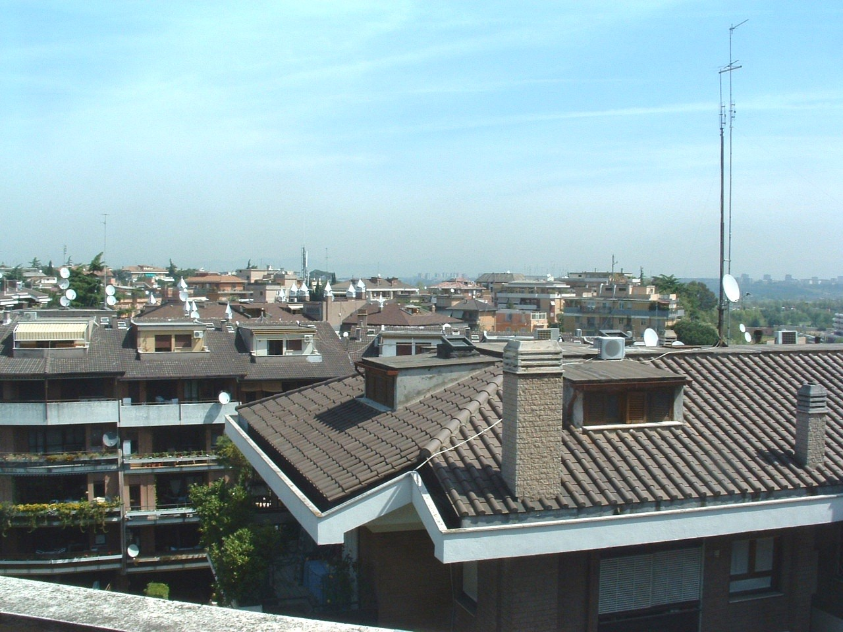
Rooftops of Rome

Historical Perspective on Athen’s Weather

A cold April mist blowing off the Hymettas Hills
veiled the other side of the airport
as we stood waiting to board our flight
in the year of 1997.

In April of the year 1841
Hans Christian Andersen made a note’
“Heavy rain clouds hung
across the mountains of Hymettos:
the weather was gray and cold.”

Politics may change but not the weather.
*****
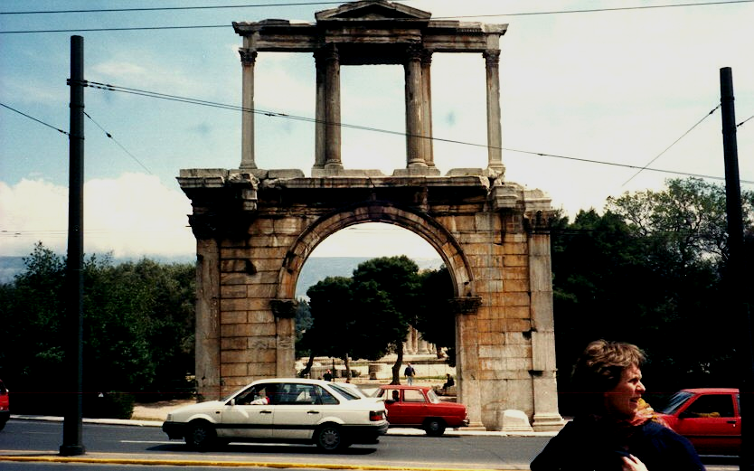
`Hadrian’s Arch

The Heptanese

The Eptanisos or Seven Islands,
jewels in a bright blue Ionian Sea
below the cold, dark Adriatic.
Homer’s setting for Odysseus’ adventure.
Stepping stone for Venetian conquest.

Kephallénia, the Homeric Same,
with mile high Mount Aínos and Byron’s touch.

Ithaca, the home of Odysseus
near Stavrós overlooking Pólis Bay.

Lefkás, where Sappho, for the love of Phaon
threw herself from the Leucadian Rock
the Cove of Phorkys where the Phaeacians
put Odysseus ashore.

Tiny Paxi with the Monastery of Panayía.

Corfu, home of the Phaeacians and Lawernce Durrell.

The northern Othonian Islands
Erikoúsa and Mathraki and Othoni
One supposed to be Homer’s island of Fanos
where Odysseus met Calypso.

Myth and beauty and three thousand years of recorded war.
*****

Byron’s Contribution

Lord Byron came to look at Greece
but stayed to lead and die

An inflamed European fleet at Navarion Bay
sunk a superior fleet, the Pahsa’s pride

Then Greece, inspired, its freedom won
the art world’s loss bought freedom not denied
*****

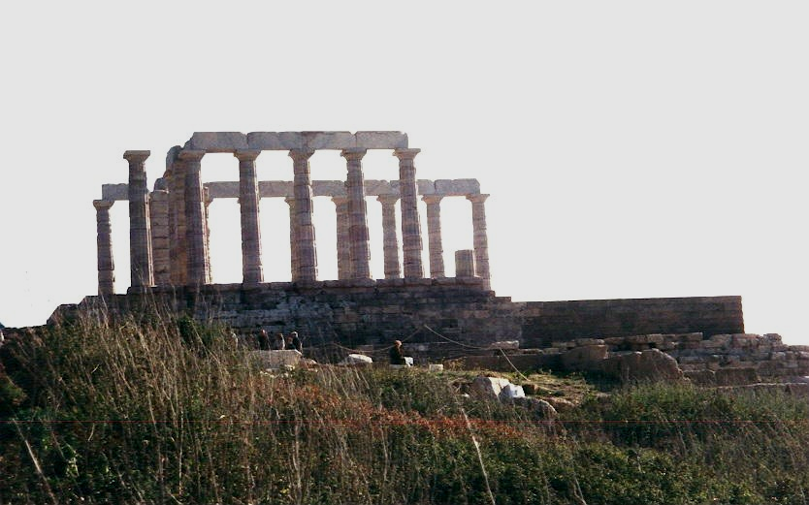
Sunio

How do I get to Corfu?

The flight is short over 4000 years of history
First to Atki Posidonos, now called Piraeus,
surrounded by the Hymettos Hills.
Mount Parnassos glows white against gray clouds.
Like Icarus we skip over wakes on the Gulf of Saronica
where Pharoes, Persians and St Paul once sailed
to Salamis where the Persian fleet still rests.
Snow covered mountains like a picket fence
crowd the northern fringe the Gulf of Corinth.
There is Náfpaktos where John of Austria beat the Turks
and Cervantes lost his arm.
Below on Mount Zygos Lord Byron fought and died.
Westwards lie the isles of Lefkas and Ithaca and Kerkyra.
But where is Corfu?
Turn right and go a thousand years.
*****

Kérkyra (Corfu)

Days of Conquest

For three thousand years
more time has been spent on war than peace
and a sea of tears has been shed
for the dead of a dozen cultures,
the bloody message clear -
freedom will always live in Kérkyra
*****
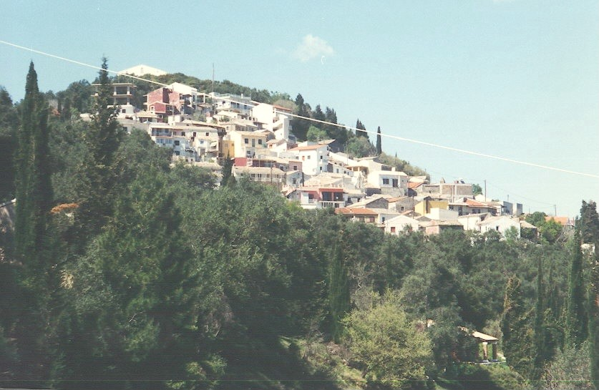
Agios Nickloas

The Mount Pantokratos Overlook

Phaceans, Spartans, and Byzantine Turks
to this very vantage point trod
to watch for Vandals, Venetians and others from the north.
Priests, in the Holy name of God,
built monasteries and temples and chapels
and tramped these stony hills unshod.
All paused to briefly contemplate
the soft Mediterranean view
and were awed.
*****
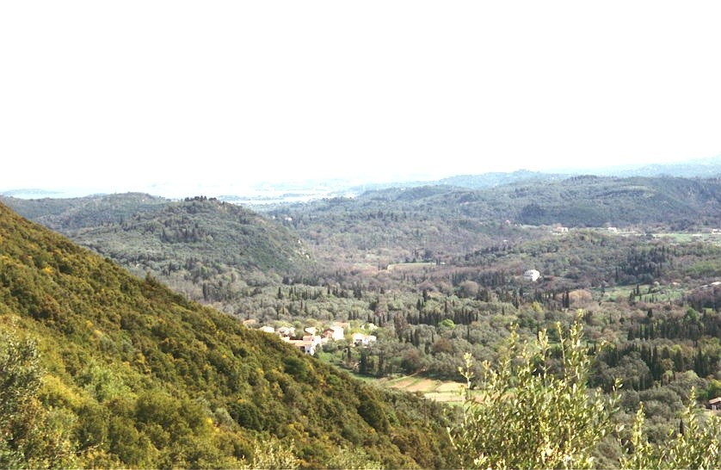
View from Mount Pantokratos

A Byzantine Reminder

Standing in an olive grove
At the end of a rutted road
A relic of the Crusaders
Stands wasting away
Eroded buttresses and walls
With sun and wildflowers
Slowly erasing history

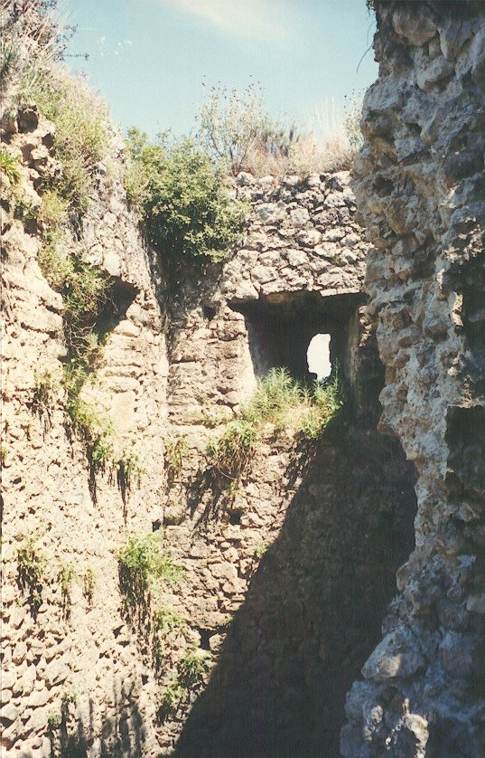
Archer Port at Gardiki Byzantine Fort

FANOS

Northwest of Kérkyra
shipwrecked Ulysses
on a shingle beach
met Calypso
and his time stopped.
Othoni ne Fanos
barely visible
from Mount Pantokratos
*****

Similarities

The old rounded hills of Corfu like south Texas
but cloaked in Valonia Oak instead of Live Oaks
covered by Arbutus instead of Yaupon
punctuated by spring pink Judas trees and almonds
instead of Redbud and Mexican Buckeye
fields of yellow mustards
look like the hillsides in central Texas
Looks almost like home except for the olive trees.
I could paint a landscape
and you couldn’t tell where I was.
Texans and Corfiots appreciate similar beauties.
*****

Olive Groves

A million olive trees with leaves so thick sun does not penetrate
trunks looking like a braided bundle of sticks
black plastic sheets still spread with the last gleamings
or rolled in the tree’s crotch waiting to be put up
short stone sheds looking like a troll’s home house the oil presses
the season is about over and the groves are quiet
****
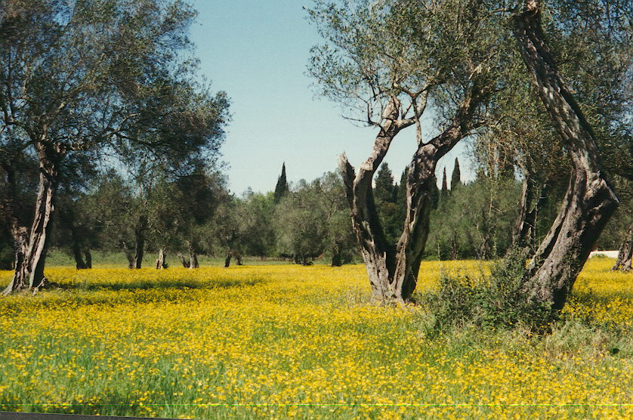
Olive Grove and Mustard Flowers

Athínai (Athens)

Akrí Soúnio

The traffic cop of the ancient world
sat on this point and
reported all that moved
in the Eastern Sea.
A temple was built to assure
protection of the patron saint.

Now, reconstructed for the umpteenth time,
the point and temple
have become a vista
an object of beauty
a historic site of significance
drawing strangers
from lands unknown
to the builders of Akri Sounio.
*****
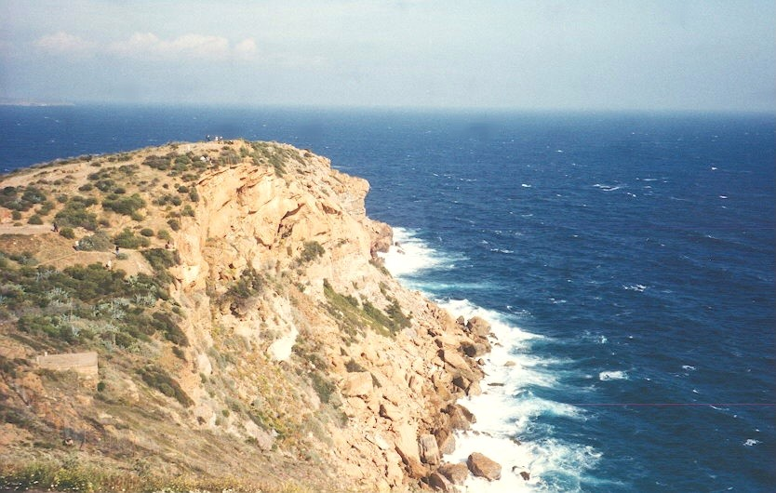
Akri Sounio

Sing

Recall ancient wars and the stories of old
sing songs of protest and martyrs bold
sing of storms and weather fine
sing happy songs of love and wine
sing summer songs when the days are cold.
Sing!
*****

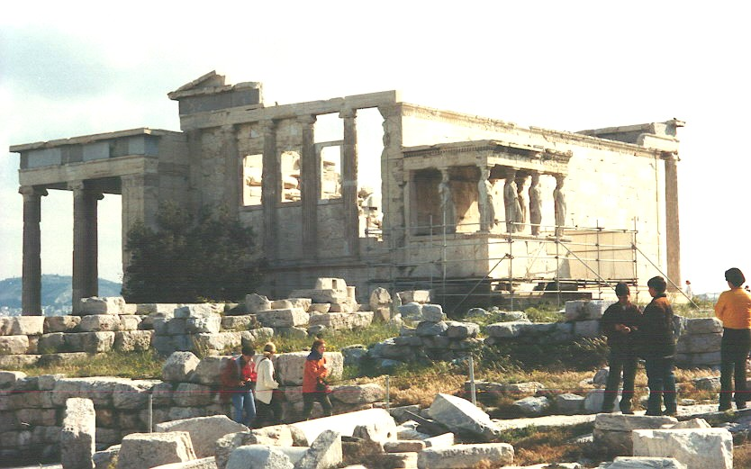
Erecthion

Pentelic Marble

Pentelic marble.
Sexually fluted and curved.
Tan and smooth as summer’s maids.
Warm and sensual to the touch.
Eternal.
Cold as the sea
that hid the Greek and Persian fleets
off of Salamis.
Soothing as a worry stone.
Aesthetically pleasing.
Pentelic marble.
*****

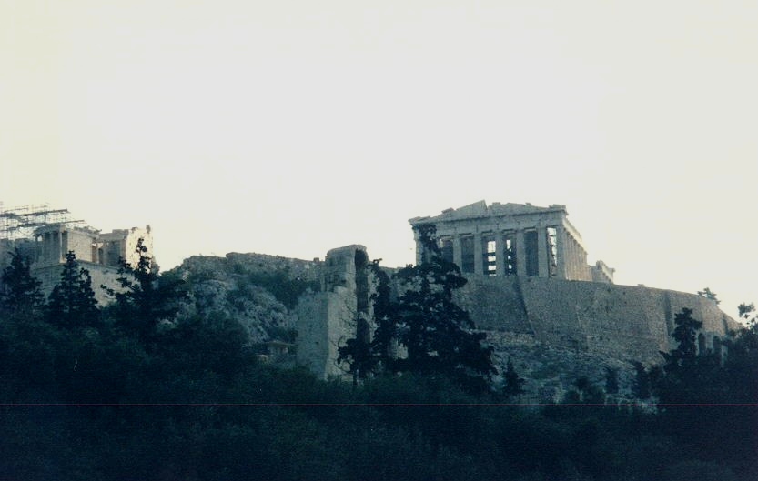
Acropolis

Rodos (Rhodes)

Cold Stony Beaches

Cold morning mist on the shingle beach at Kremasti
and the snowcapped Carian mountains in the distance
takes me back
to other cold, rocky shores
that were waiting for the sun.

Cobbles clicking in the surf on Argentia and Topsail
in Newfoundland with ice floes hidden in the mist.

Seastacks peeking from lowering clouds
off a beach of metamorphic stones
on the Straits of Juan de Fuca and Hą’Long Bay

Low waves slopping on volcanic Icelandic beaches
with fishermen's voices carrying through
the Gulf Stream’s steamy fog

Waiting.
Waiting hopelessly for a summer sun
to lift the leaden skies
and break the hyperborean spell
*****
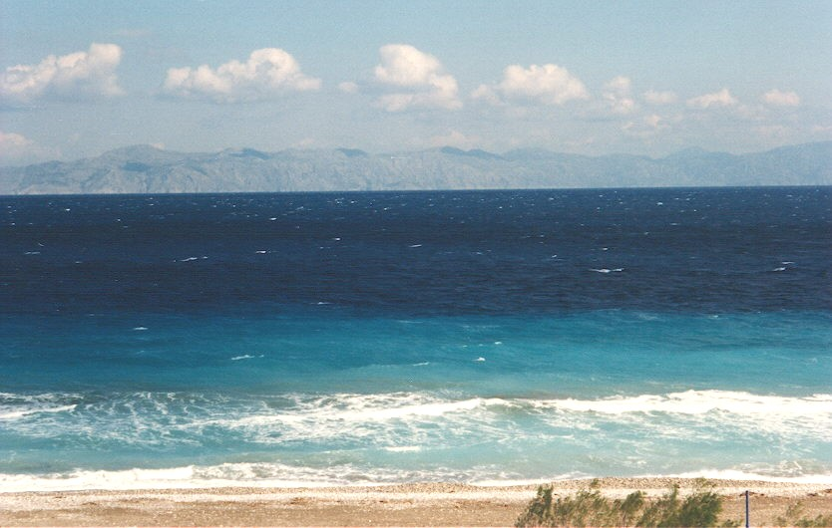
Kremasti and the snowcapped Carian mountains in Turkey
Rhodes, International City

The city‘s history lives in Greek mythology
But historically for 3,000 years it was
Occupied by Minoans, Achaeans, Dorians,
Macedonians, Carians and Egyptians
In days B.C.

The Colossus of Rhodes was finished in 290 BC and destroyed in 225 BC.
It lay on the beachcursed by the Oracle of Delphi until AD 635.

Rome, Arabs, Saracens, and Crusaders,
Ottomans, Italians, and Germans
Today it is the Greeks
History moves on and on.

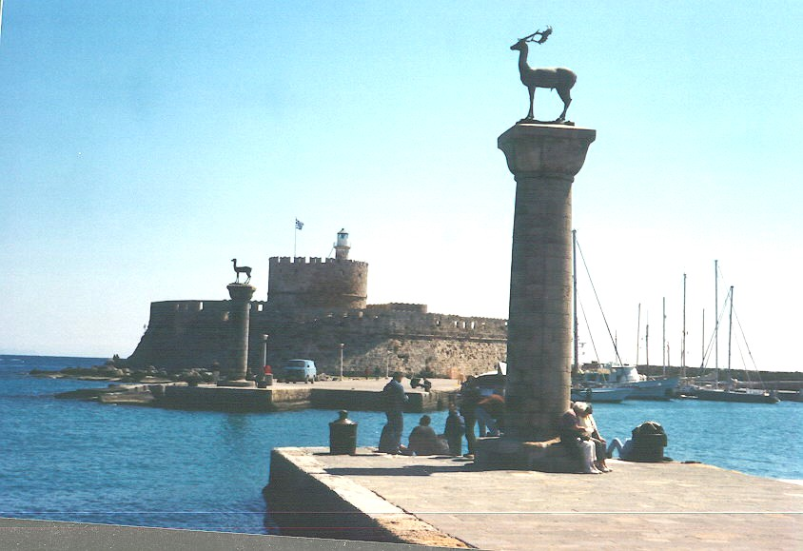
Site of the Colossus of Rhodes
Dream of Lindos

Dream of Lindos at moonrise.

The beach with lapping waves
whispering to fishing boats
leaving with lanterns lit.

And of Lindos town, below the Acropolis,
waking from siesta and preparing for the evening
its white walls glowing in the moonlight.

Of the columns and walls on the Acropolis
losing themselves against the black sky
as scud crosses the moon.

Of night swimming in St Paul’s harbor
with a candle in the chapel
to guide you back to shore
The Acropolis backlighted by the rising moon.

A Lindonian dream.
*****
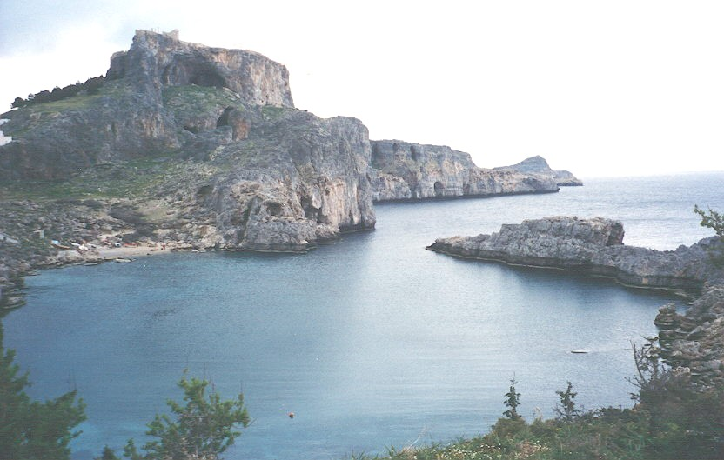
Lindos Acropolis and St Paul’s Bay

Retrospect

RETURN TO GLIFA'DHA BEACH

For forty years
tourists,
developers,
soldiers,
and politicians
trod this beach.
Their eyes have coveted those
hills covered with oak and olive trees for condos
good anchorage in the Saronic Gulf for pleasure craft
fair country girls of myth
as they approach from Athi'nai to the north.

Forty civilizations
that spilled their blood and seed
on this beach and on these hills
have been replaced with the greed and trappings
of yet another culture.

I had come as a warrior in 1962
and my summer had been spent in peace
in a small family hotel on the beach
looking south and west across the Gulf.

The hotel has disappeared beneath a resort complex.
The quiet road has become
a six lane divided high speed highway
lined with buildings.
The beach, extended half a mile with construction rubble
was covered with sand, hotels, and expensive homes

Up each day, waking to catch the morning,
I had been awakened by the soft knock of the maid
who left croissants and jam and a pot of tea on the terrace.
This time I was wakened by a computer driven telephone
and the noise of traffic.
Boiled eggs, watered orange juice and luke warm tea
were available in the dining room.

I watched a cold April morning sky
get light without the softening sheer of fog.
The yellow and white yatch, Caroline, was gone
along with Aristotle and Jackie O.
The quiet beach and the fishing boats are gone.

My war went well.
I returned to GLIFA'DHA as a visitor.
I found the quiet village a bustling suburb of malls and botiques;
Athens grown four fold and more to over four million souls;
the slum called the Plaka below the Acropolis,
once set for razing, become the yuppy dream,
a place of quaint housing and trendy tavernas.

Today’s flight is on Olympic Airlines
but from the same airfield I flew from in 1962.

Nights of Ouso and racci and retsina,
white goat cheese, raw squid, and fish
are still available - for a price -
but the spreading oak is gone.

Pizza and Greek salads have
replaced bif stek and stuffed grape leaves
in the bars and restaurants.
Now Greek and German and Italian and English
are heard
and the drachma is a stable currency.

Carl April 97

Would I make this trip again? In a heartbeat. Would I stay longer? Please don’t throw me in that briar patch! A couple months at different times of the year would work. We saw a lot but had to leave a lot for next time. The homework helped but the desire to see and do things was constrained by season, weather, time, terrorist activity and, maybe, money.

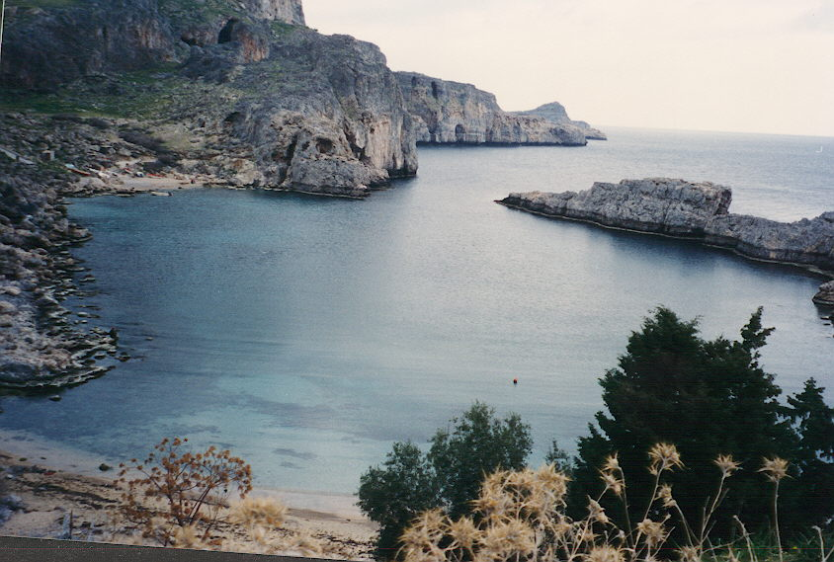
St Paul’s Bay Rhodes

