Greenland 1979
The U.S. had military bases in Greenland since the beginning of WWII. In the summer of 1979, two events of significance to me took place. The first was an oil spill that spiraled out of control. Second and more significant to me was my IG inspection trip to Sondrestrom and Thule Greenland. Greenland has changed considerably since then but the following is the way I saw it.

Oil Spill.

The Military Supply and Transportation Service (MSTS) is the Navy transportation branch. They contracted tankers and cargo ships that kept the US military supplied. One of the contracted tankers on the way to Sondre Stromfjord Air Base, Greenland, hit a growler (large ice flow), sprung two hull plates and lost 800 barrels of fuel oil.

In normal English, this means a US Navy had contracted a civilian tanker to move fuel oil and jet fuel to resupply Sondrestrom Air Base for the following winter. While entering the Davis Strait, it had hit an iceberg that punctured one of the storage tanks and lost 33,600 gallons of fuel oil into the ice cold water of the north Atlantic. Following standard procedures, the captain had stopped the ship, begun to transfer fuel to other tanks, and flooded the leaking storage tank with sea water to a level above the leak to stop the spill. Then he reported the accident.

This is when I got involved. I was in charge of the Oil Spill Prevention, Control and Countermeasures (OSPCC) for Air Force Aerospace Defense Command which operated Sondrestrom. Normally, MSTS would send me an information report of the spill and the ship would sail on. This time was different. Things had just gone wrong big time. The King of Denmark was visiting Nuuk (Godthab), the capitol of Greenland. He was informed of the spill and requested to be taken out to see it. An Air Force plane from Sondrestrom took the King out for a look. Then the King said, “Who is going to clean up this mess?”

Want to guess the donkey this load was about to land on? The words went from the King’s lips to his aide’s ear then through diplomatic channels to the Pentagon to our four-star then down the chain of command to me. My boss asked how long would this cleanup take. I replied that it would probably take a couple weeks to get a response team on scene and that most of the lighter oil components would have evaporated before we even got started and only a few barrels of tar would be left. He said to make a good show of it and make the King happy.

It was lunch time, so I called down the hall to our friendly environmental legal expert and asked if he might like a Mexican dinner. He said he could not take a bribe, but a consulting fee might be appropriate. Over lunch we discussed my panic of the day. His advice was to run home, jump in bed and pull the covers over my head. I told him to expect a call as soon as I got the pot boiling.

On the way back to the office, I dropped in to see my favorite contract specialist. She had been working contracts for almost forty years and knew where enough bodies were buried to fill several cemeteries. She was called Granny partially because of her longevity and age and partly because of her numerous grandchildren and great grandchildren. I told her of my problem. She said she had never worked for a king before and this sounded like fun. She would be waiting for a conference call.

Back at the office, I called three oil spill experts I had met a various conferences. The first said they only worked in the Pacific. The next said they had everything they could handle for the next six months. My last call was to a retired Navy Commander who had a company in Norfolk that performed tank cleaning and oil spill cleanup operations and had done a few jobs for Uncle Sugar. We discussed the problem and options and time lines. No mention of money yet. I asked if he could scratch up a proposal. I would call him back in two hours for a conference call with the major players.

My boss and his boss and Granny and the lawyer were in our conference room when the Commander and his troops got on the line. I outlined the problem. The Commander told us what should be done and what they could do. This was followed by Granny and the lawyer who gave us why it could not be done. The contractor pared down his equipment list and said he could have it in Norfolk the next day if we could get him space on a Navy destroyer. They could be on site in about ten days, but there would probably be nothing left. I suggested getting the stuff to Dover AFB in Delaware, and we might have better luck getting it on an Air Force C-141 and be in Greenland the next day. My boss had been stationed at Thule and said there were numerous gravel airstrips along the coast left over from WWII, and we could probably hire a couple fishing boats for local transportation. We decided that service contract was the way to go. Granny was grinning and our lawyer looked like he was going to be sick.

It was day five after the spill by the time we got the equipment to Sondrestrom. It was transloaded onto a C-130 and flown down to the coast. We had contracted a local modern scallop boats to make the 200 mile trip to the tanker for the price of last year’s catch plus 25%. Everything was ready to go. The King was being kept up to the minute.

Everything came to a stop. A Danish Navy frigate had arrived on scene and found that the spill was essentially gone. We sent the contractor out to the spill site just to make sure. He collected less than a hundred barrels of tar balls. When he returned, the Danish government took possession of all his equipment under the Status of Forces agreement that said nothing the Air Force imported could be exported.

The King was happy and so was everyone in my chain of command. The lawyer got a commendation. Granny set a record for the largest service contract of the year. The contractor was happy and well paid. He told me if I ever needed a job to call him. I got to keep my job.

IG Visit to Sondrestrom
I had several conversations with the contractor on maritime oil spill prevention. His first recommendation was to require double hull tankers for all contracts. His second recommendation was to require a spill recovery kit and crew training for all contracted ships until the first recommendation could be implemented.

My report aggravated the Navy supply people who seemed not particularly interested in the environmental aspects of an oil spill. To them, it was all economics. They said this delay had cost a bundle. There were no double hull tankers available for contracting, and if there were any they would cost a lot. However, they did ask the specifics of the oil spill kit and what training was available.

I quickly provided a list of training sources, costs for training, and a list of clean up equipment providers. I recommended one company that had a palletized cleanup kit consisting of an inflatable Zodiac boat with outboard motor and a thousand feet of oil spill boom. I had seen it demonstrated in San Diego. This kit was designed to be carried on the tanker for use in spill incidents at sea. My recommendations disappeared into the depths of bureaucracy, and I cannot say if they were ever implemented.

This generated enough interest in Arctic oil spills that I was included as a special inspector on the Air Force Inspector General team to look at fuel storage and delivery, the spill and countermeasure plans and other environmental topics at Sondrestrom and Thule. It was leaving the following week.

About a dozen of us met at the Philadelphia airport and took a shuttle bus to Dover AFB. The next morning, we boarded a Air Force C-141 for a twelve hour flight that included a refueling stop at Goosebay/Happy Valley Air Base in Labrador. There was a Canadian WWII Lancaster bomber sitting of the ramp. Temperature was about 20˚F with clear blue sky.

It was mid May, and Sonderstrom is located just south of the Arctic Circle. It was still daylight when we landed about 10pm. Weather was a still 20˚F with fluffy white clouds in a dark blue sky.

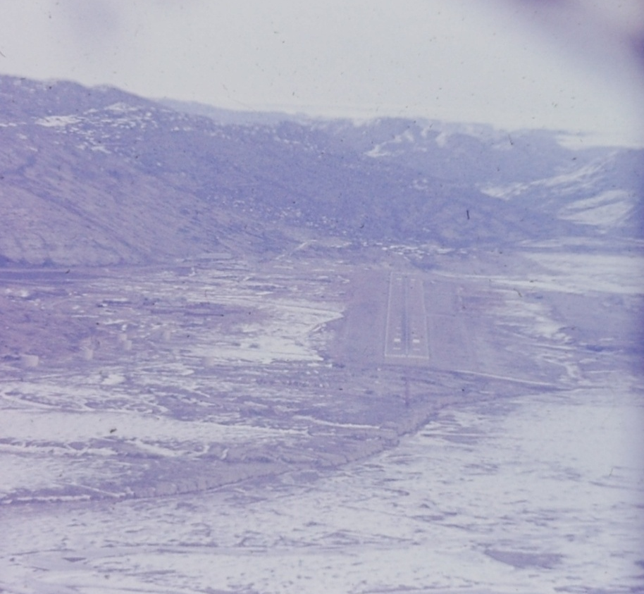
Sondrestrom
One of my collateral assignments was to review airfield waivers. The base had one of the world’s worst runways with a big hump in the middle and a big black mountain at the east end. These defects were still there.

We offloaded near base operations where a bus was waiting to take us to the Arctic Hotel. On the way to the bus, we passed a memorial to about twenty of our coworkers who had been killed in a crash about a year before.

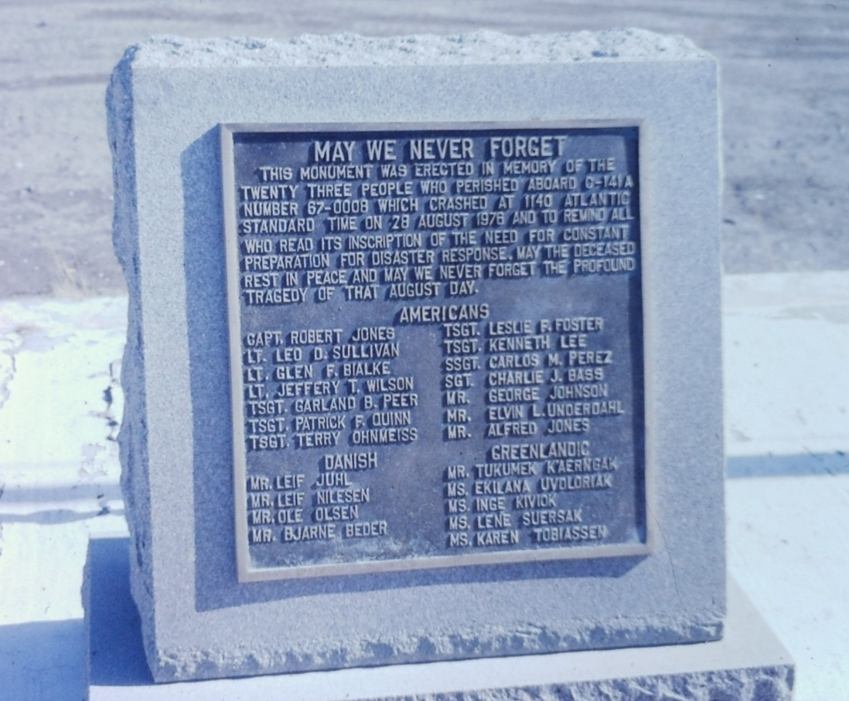
Memorial

Our quarters were much like any other hotel with the exception of black-out curtains. The 24-hour daylight had a negative impact on some people when they wanted to work around the clock.

Next morning, after our briefing, I spent the day with contractor personnel from the Danish Arctic Contractor (DAC). We looked at the water treatment and distribution system and sewage disposal. Water and sewage lines were insulated and electrically heated. Raw sewage was piped downhill to the Fjord in a wire wrapped wooden pipeline.

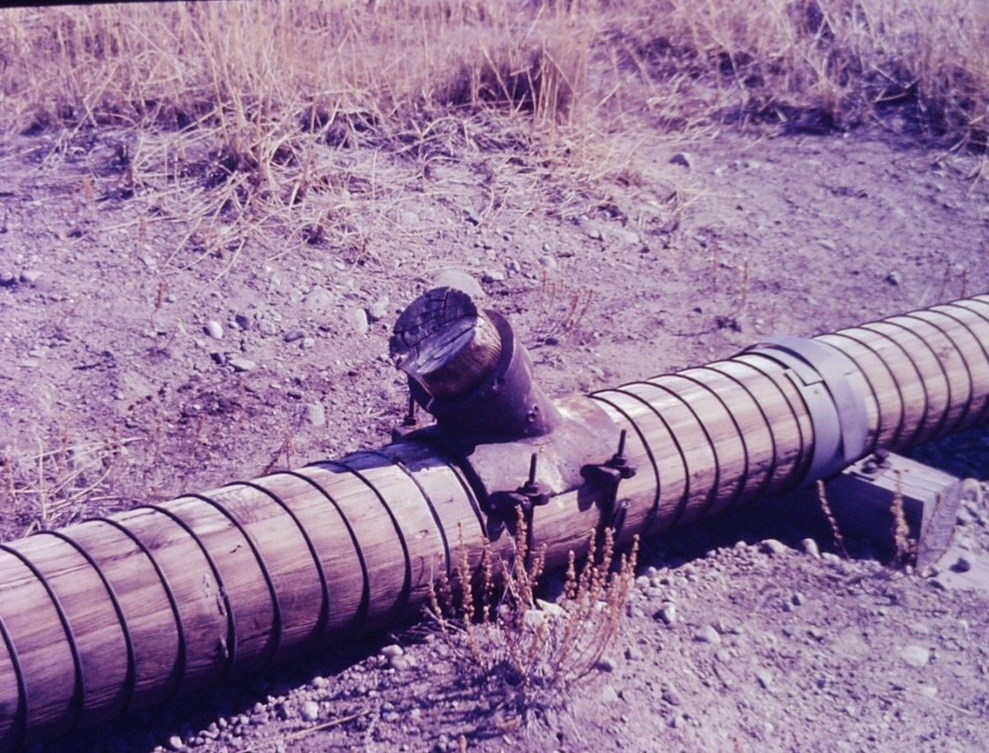
Sewage line

We passed the salvage yard. The base had a problem with vehicle availability. If anything broke and was not available through supply it could not be cannibalized from another junked vehicle.

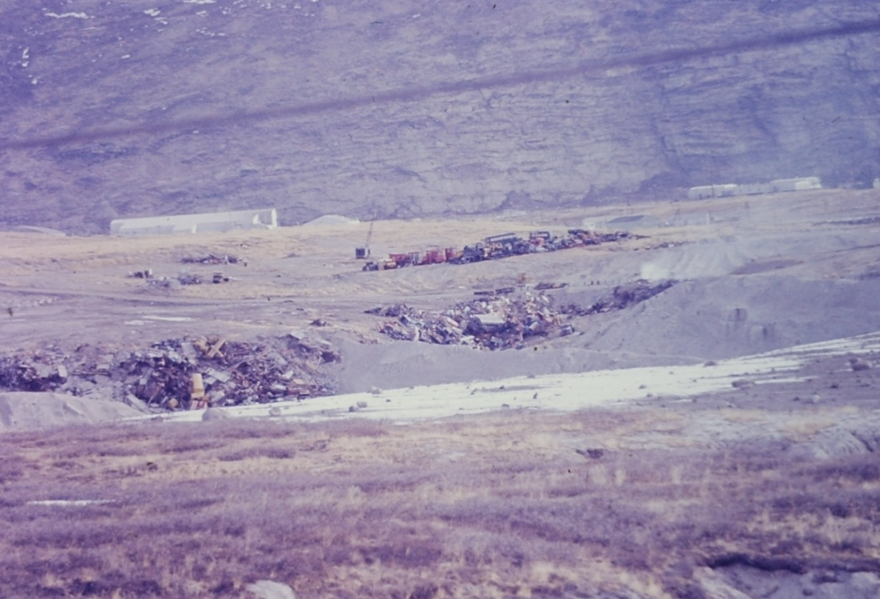
Salvage yard
After lunch, we looked the base fuel storage tanks for the barracks. The tanks had no containment dikes. At the solid waste disposal and the salvage yard, I noted the fluids like fuel, oil and transmission fluid were not drained from the salvaged vehicles.

Water was pumped from Lake Ferguson a couple miles south of the main base. No treatment was required. There was a large fuel storage outside the pump house with no dike.

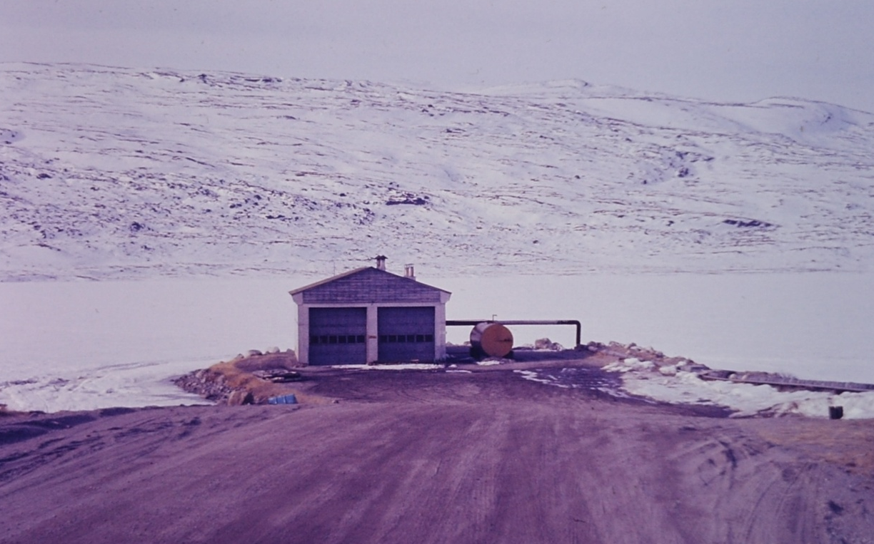
Lake Ferguson Pump House

The environmental regulations conformed to the Danish requirements under the Status of Forces Agreement.

The ground was still covered with snow. Dried clumps of Festuca grass and small dry Blueberry and Potentilla bushes were common plants.

Lunch had been with the Danes at the NCO Club. I was blond and had a crew cut like the DACs so the waitress asked for my order in Danish. She was embarrassed and the DACs thought it was funny.

After lunch, we drove to the quarry. There had been a major problem a couple years previous when the wrong explosive had been used and destroyed most of the quarry equipment.
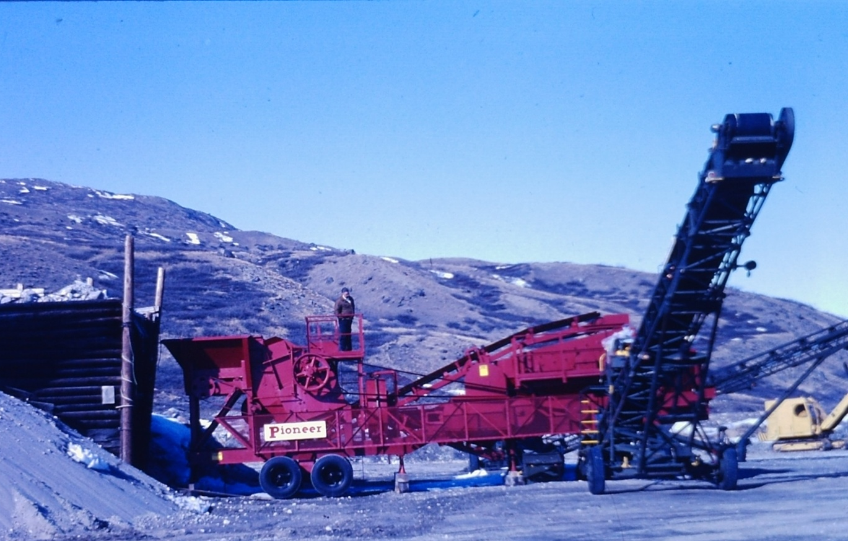
Quarry

After the evening team meeting and supper at the Officers Club, it was still daylight. Time for bed anyway. I spotted an Arctic fox from the window.

The next morning we drove out to the fuel farm. This was on a rocky point about five miles west of the base. The fuel line ran beside the road. Tankers came up the fjord and attached a line to a floating buoy and pulled in the transfer line. The fuel was pumped into several large fuel tanks sitting on solid rock with no dikes. Offloading the fuel was hazardous with a 4Kt current running most of the time and chasing an oil spill would be impossible.

Beyond the entrance to the fuel farm was another five miles of road to Kangerlussuaq, commonly known as Kellyville. This was the site of a group of radio telescopes. I did not know of this site or the rocket launch site about five miles east of the base did not get to visit since they were not Air Force facilities. So far as I know, there was no environmental assessment made for this rocket launch site or the one at Thule or for the toxic materials in the burned rocket fuel that was spread over the icecap and the north Atlantic.

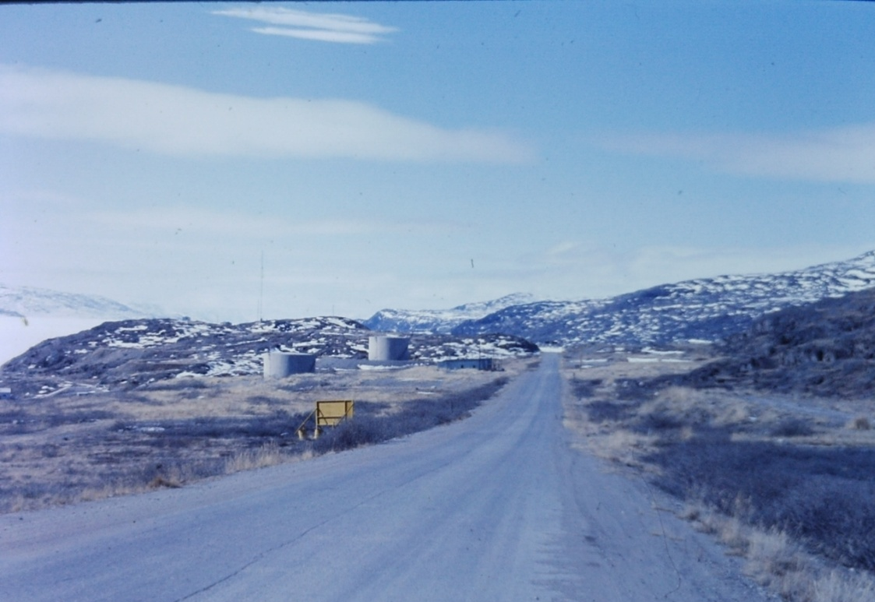
Fuel Farm

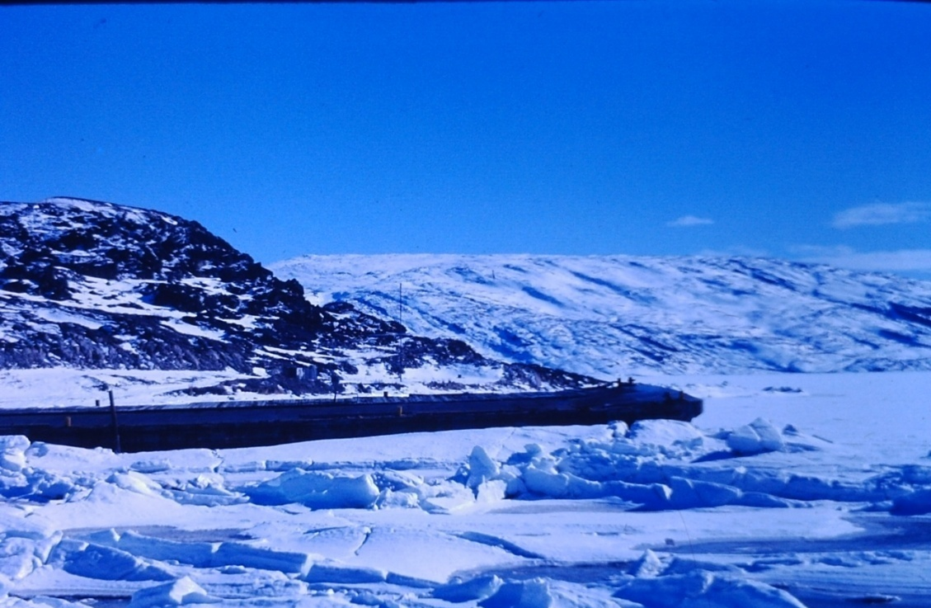
Port (Camp Lloyd)

The next morning I was invited to fly out on the icecap to our DYE 3 radar site in a ski mounted LC-130 from the Maine National Guard. It is located at 65°11′N 43°49′W on the ice cap at an altitude of 7600 feet about 100 miles east of Sondrestrom and DYE 2. The DYE sites were part of the four Distant Early Warning (DEW) sites on Greenland. Between 1971 and 1981, the site was also used as a base to drill an ice core to bed rock at a depth of 2,038 meters.

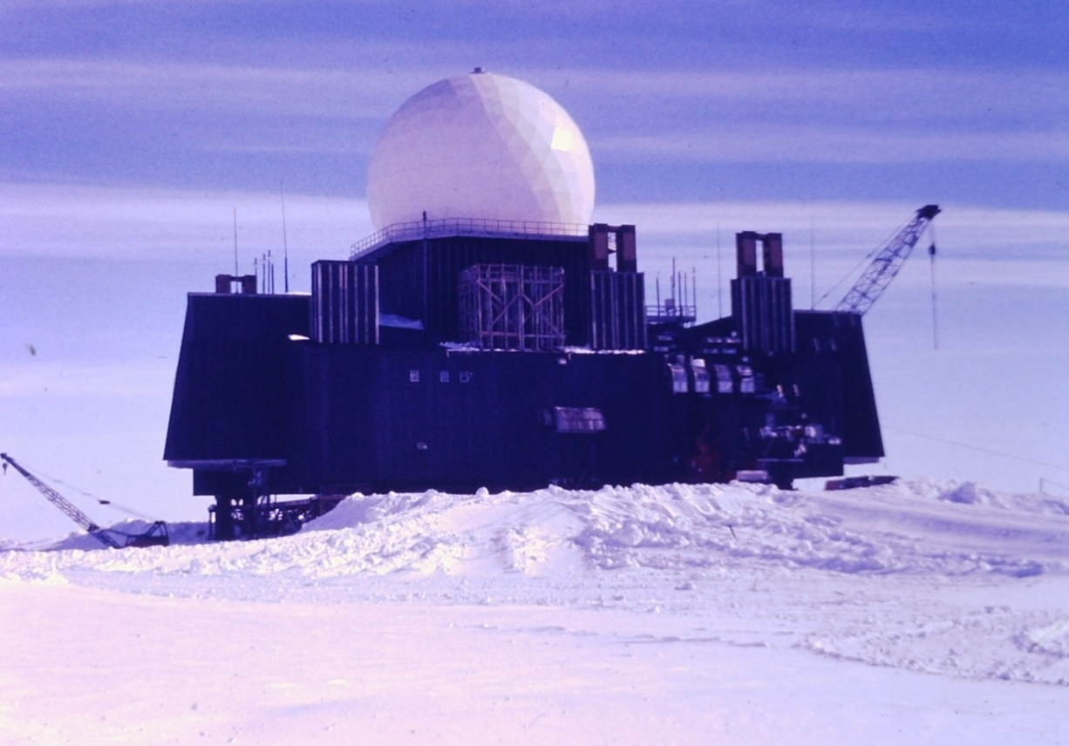
DYE 3
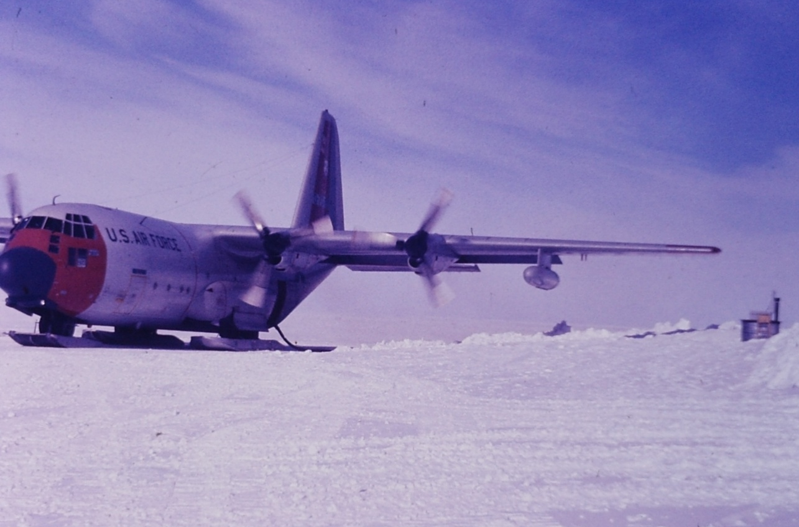
LC-130
After about an hour’s flight, a small dark speck became visible that grew into the radar site.

The site had been completed in 1960. Snow accumulation was projected at 3 feet a year with 100 mph winds piling up drifts. The site was built to be 20 feet above the surface and raised as required on 200 foot jacks. In 1978, the jacks had been used up so the site was moved about 300 feet and installed on top of new jacks.

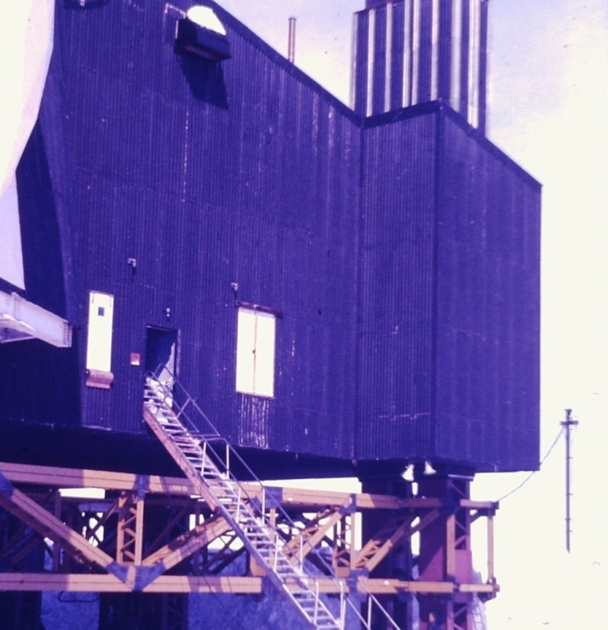Front door
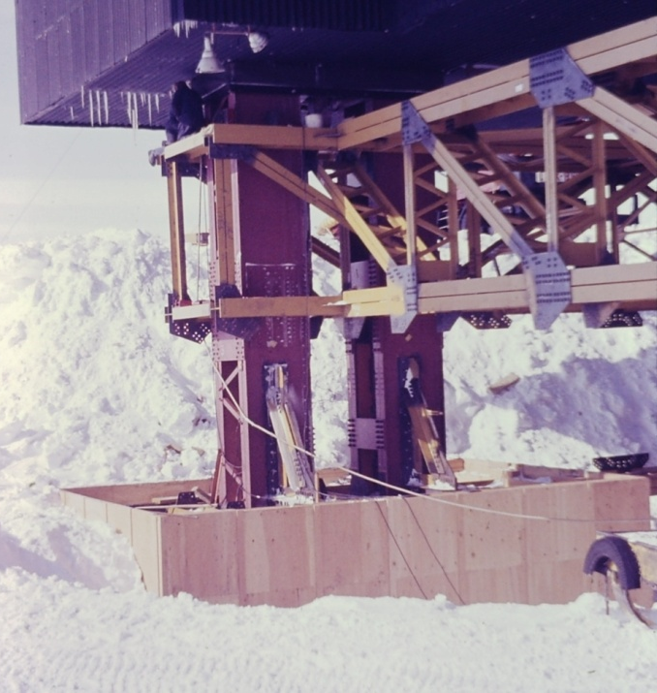
New jacks
We got off the plane with the temperature a bright sunshiny 0˚F. While cargo was unloaded, the site manager took us on a short tour of the installation. got with the installation engineer for the engineering tour which included the new and the recently abandoned fuel and sewage tunnels, the water collection system and the new jacks. The old tunnels covered by snow to a depth of about 200 feet had been abandoned.

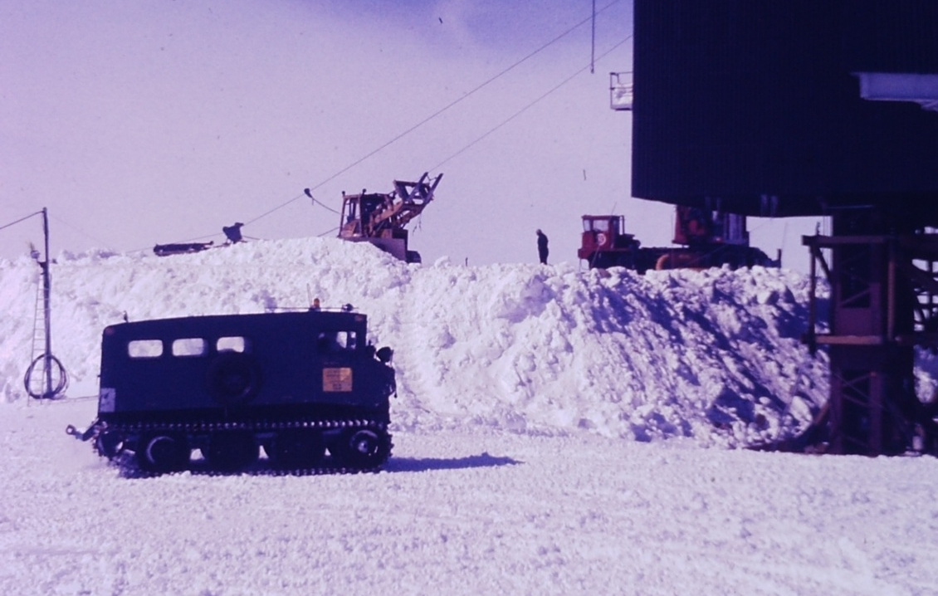Snow Cat
the Water Collection Dragline
Snow was scooped up and melted for drinking water. Fuel oil tanks were buried for protection from the wind and extreme low temperature.

The movement of the station had been fortuitous in that the line-of-sight alignment with DYE 2 was improved.

When the plane was ready to return, we loaded up and made a takeoff across the ice. On the way back, we flew over DYE2 then turned southwest over DYE1 before returning to Sondrestrom.

The following day I got with the installation engineer and flight safety officer to review installation air space waivers.

At the east end of the barracks were two sun screens of a sheet of plywood cut in half and lined with aluminum foil. The open end pointed southwest. Troops came out in swim trunks and soaked up the sun.

That evening we packed up and got on a C-141 for a trip to Thule.

A little after midnight I drove out to the fuel farm to see the midnight sun. The sun was approaching the horizon to the northwest and dusk was approaching. The sun disappeared for a few minutes and peaked over the northeast horizon. We were just south of the Arctic Circle and even with no sun in the sky I could still read a book at two in the morning. No complete darkness.

Thule at the Top of the World
After a couple hours flight almost 700 miles straight north, we landed on a long smooth runway at Thule Air Base and taxied up to operations. One of the first things I noticed other than the temperature of -10˚F was the runway taxi lines were bright orange. I was told this was to allow the lines to be seen through a foot or more of ice.

After we checked in at the North Star Inn, we were each issued a parka and a pair of insulated boots. We were given a weather briefing which was interesting. Storms came in phases as weather slid down off the icecap. Phase 1 was called when winds exceeded 25 mph, visibility was a mile and wind chill below 0˚F. Nonessential work stopped. Phase 2 came with 78 mph wind, visibility at a half mile, and wind chill -40. Emergency outside work only and only in groups. Phase 3 no outside work, wind to 115 mph wind chill to -70. Phase 4 was 140 mph plus with zero visibility and wind chill colder than -70. There were 2” guide ropes between buildings. Marker posts were every 10 feet linked by line. Phase shacks were every quarter mile. All buildings were built off the ground to prevent permafrost thawing and the building sinking due to weight and body temperature. Only the hangars were on the ground and they had a redundant cooling system to keep the permafrost frozen.

The North Star Inn was much like a walk in freezer with the exterior walls and doors about four inches thick. The rooms were furnished in modern modular with a window, drapes and blackout curtains. Toilet and showers were down the hall. The toilet was unique in being submarine plumbing to handle the vacuum flushing mechanism.

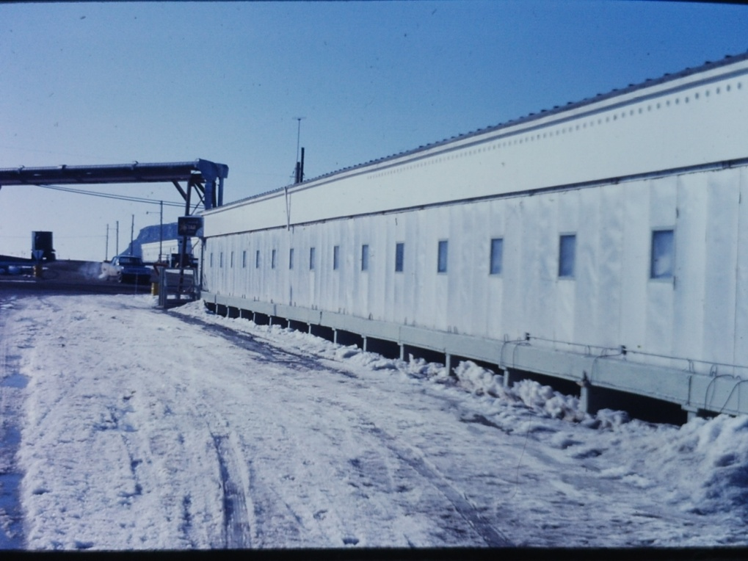
North Star Inn

It was about 10˚ when the team rolled out for briefing. After the briefing, I went to the DAC manager’s office to wait for my guide for the day. I noticed a Pothos ivy vine circling the room twice and asked about it. The manager said his wife sent it with him when he first began to work in Greenland in the mid 50s. I asked why he wanted to work up at the top of the world. He said he got six weeks off every year and all his pay was tax free. I asked if that was a big deal and was told the Danish taxes for everything including total health and education were about 80%.

The military sanitation superintendent took me on a comprehensive tour of the water, wastewater and fuel systems. We drove out to look at the water source, pump plant and pipeline. Next item of interest was a trip across base looking at the distribution lines and dumpsters. We ended the day at the harbor where the fuel was offloaded and the raw sewage was run through a bar screen and grinder before being discharged into the sea. On the way back to the North Star Inn, we drove through the tank farm with the tanks flattened on the windward side. I noticed one tank was marked as containing JP-7 to service the SR-71 Habu or Blackbird. Then to the new and old landfills.

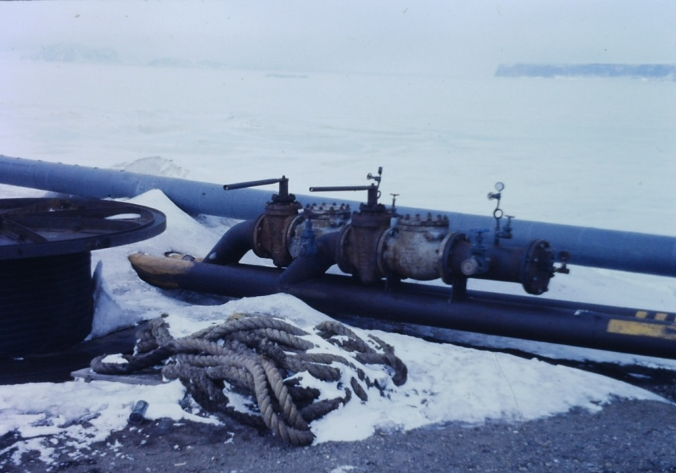
Fuel valve No Containment
Sewage Discharge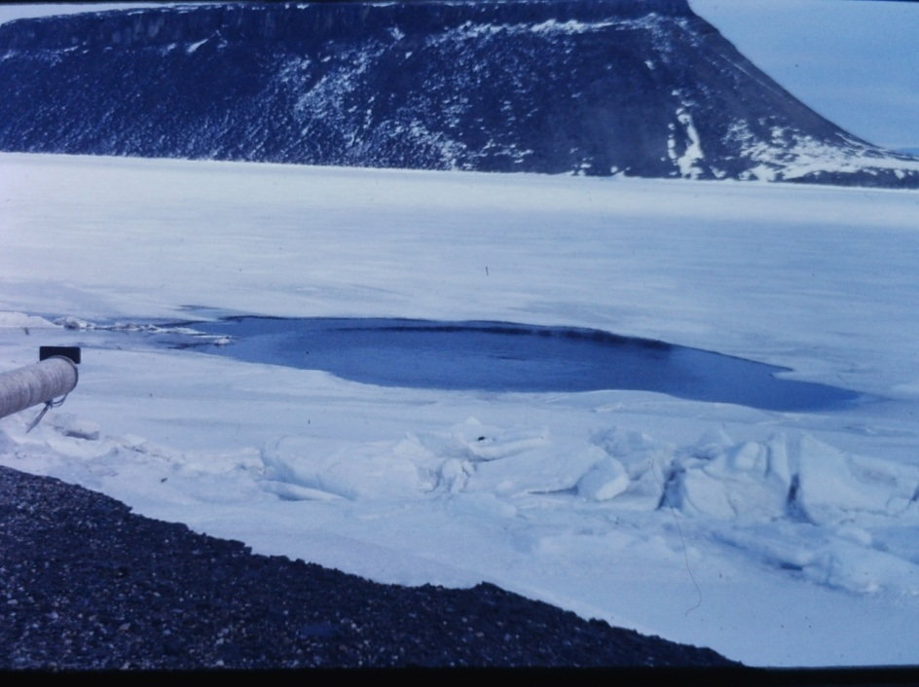
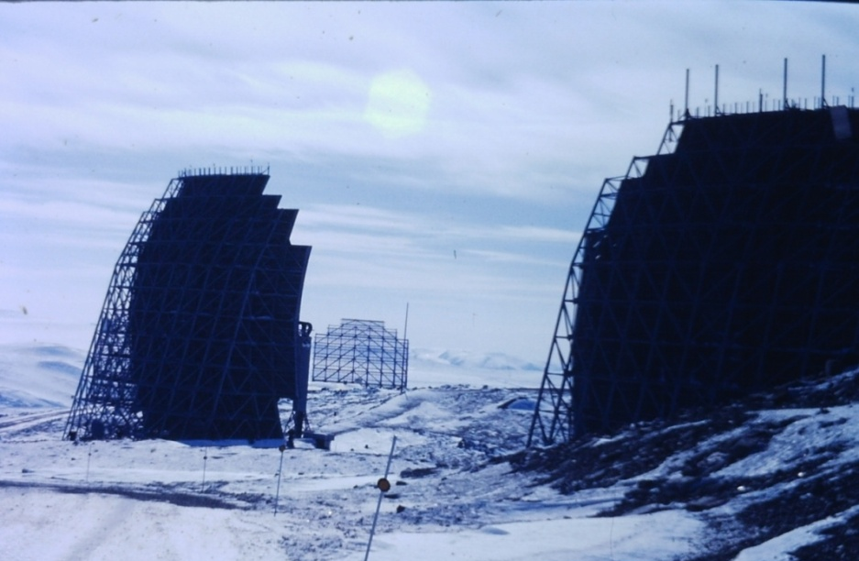 Abandoned Antennas

Next day’s tour included the old troposcatter antennas and excess property waiting disposal including several miles of abandoned fuel line. We drove up to P Mountain for lunch and a tour. The view of seven different glaciers was impressive. There was a mynah bird in the bar that was foul mouthed in several languages.

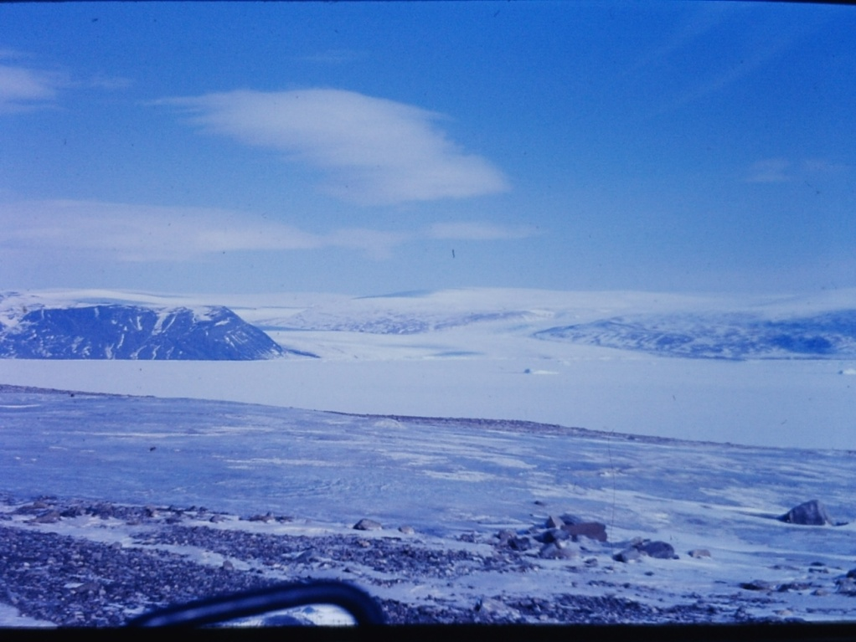
View from P Mountain North Star Bay and Dundas Mt

After lunch, we went out to look at the P Mountain sewage discharge. This was a large pile of solid waste. There were several Ravens (Corvus corvax) and Thayer’s Gulls (Larus thayeri) the first birds I had seen in Greenland.

On the way down to the base, there was a flock of gulls sitting on the snow. The Sergeant said this was often a prediction of a phase storm in the next day or so.

I asked if we could visit Camp Tuto. I was told that the camp had been closed for a couple years as the icecap had moved forward and literally destroyed it. Camp Tuto was about ten miles from the main base. It had been built in the early 50’s with a hard surface ramp to provide access to the ice cap for vehicles building Camp Century. Camp Century, a hundred miles east of Thule, and Camp Fistclench, about 200 miles SE of Thule, were prototypes of a 1500 mile system of under the ice nuclear missile bases called Operation Iceworm, It was found that the ice sheet moved too much, and the prototype sites only lasted about two years.

We returned to the base late on Saturday afternoon and found about 200 Inuit had set up camp on the ice of North Star Bay. This was the annual homecoming of the Thule natives to the land now occupied by the base. They were given an allowance to shop at the exchange and commissary. On Sunday, there would be a multilingual church service followed by the dog sled races.

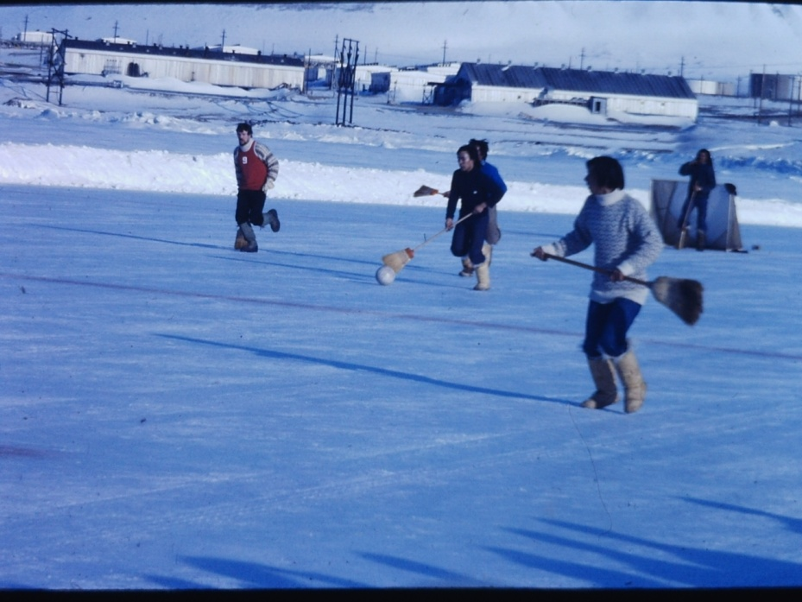
Inuit Mukluk Hockey
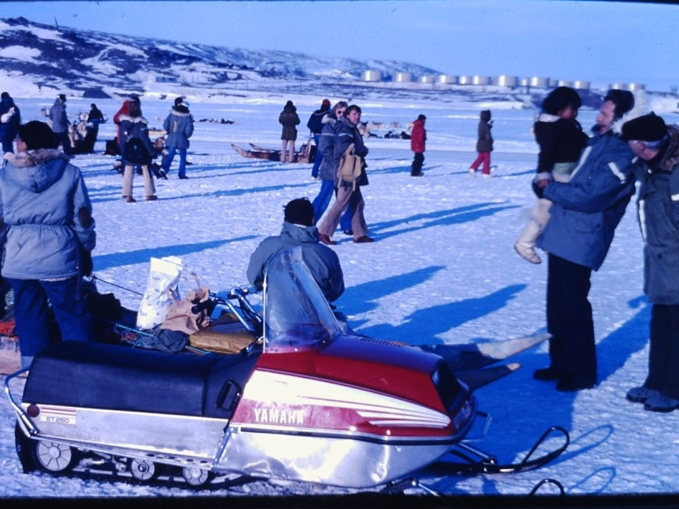
Visitors

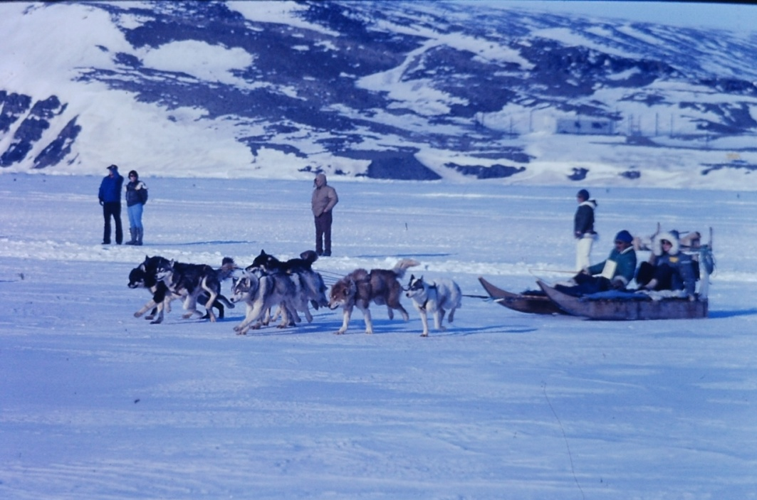 Dog Sled
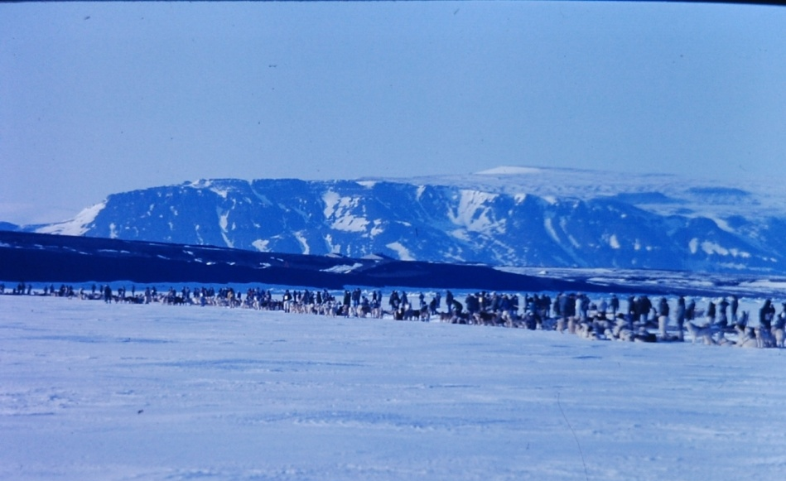Get Ready
Around Dundas Mt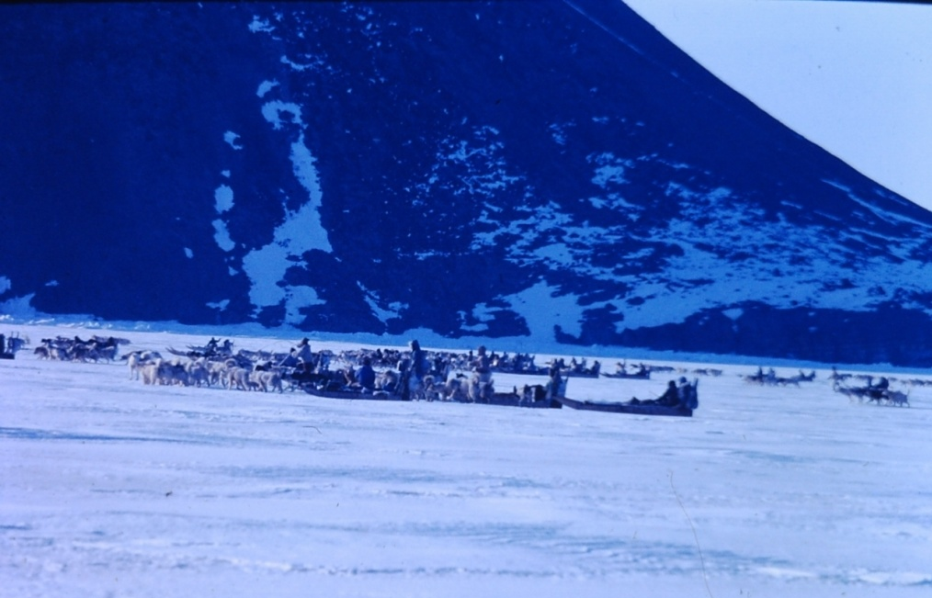
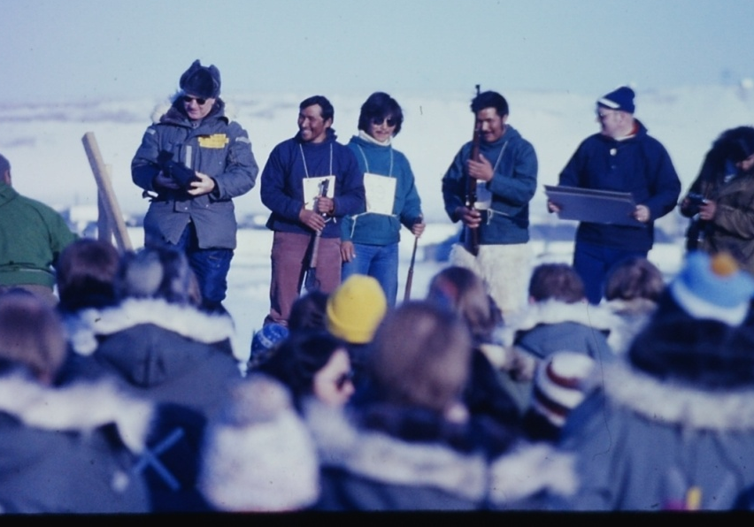
The winner

The dog teams got ready while we socialized with the natives, especially the kids. Once the teams were ready, each sled had a GI on board, and all 16 teams were sorta in line, a gunshot set them off. They took a 30 mile run out around Dundas Island and back. The winner got a new shotgun. There was another hour of swapping tobacco and jokes, and the natives took off for home.

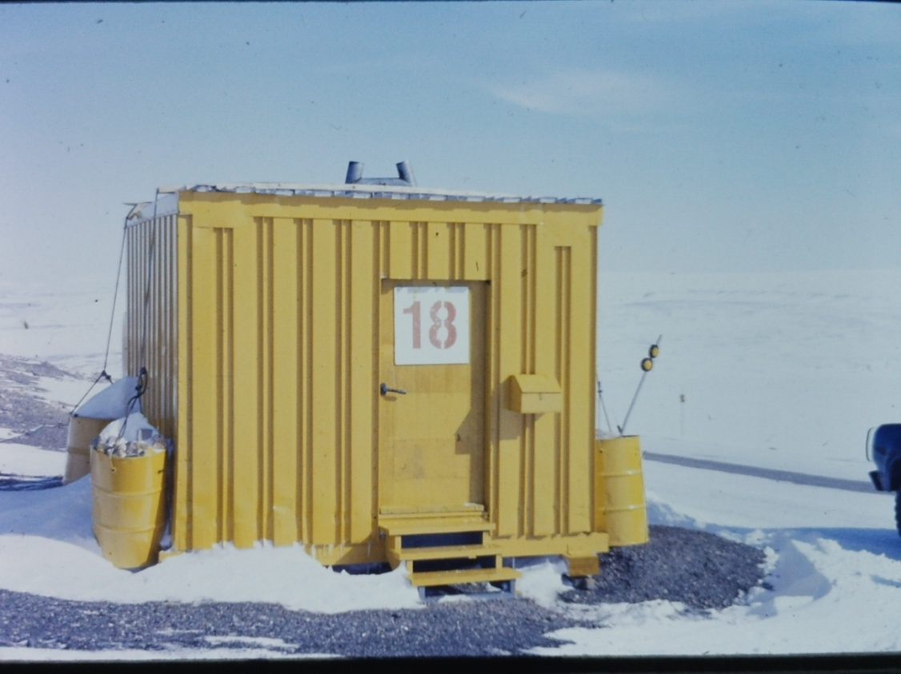
Phase Shack

That evening, the base emergency speaker system announced Phase 1 was in effect and everyone should seek shelter. We were in the North Star Inn so I watched the storm progress through my window. First it began to snow and blow. Then Phase 2 was called and the snow began to blow sideways. Phase 3 was called and the building across the street disappeared in the horizontal blowing snow. After a couple hours, the PA announced the storm was over.

At the briefing next morning, we got the word that a C-141 would be leaving in the late afternoon and we should be ready to go. It did not quite work that way. The plane came in and picked up a container of radioactive waste and that was all. We were told there would be another plane in about 24 hours.

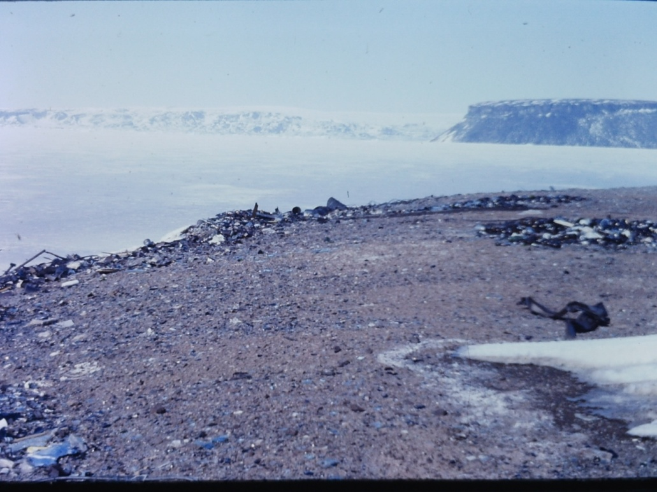
Old Dump

This delay allowed me a quick trip to look at the old solid waste dump. All the trash and anything non-burnable had been dumped into a small canyon which was being washed out to sea. It was interesting to walk along the beach at low tide below a twenty foot wall of trash. Cans and bottles with readable labels. News papers and letters from the 1950’s. All being eroded by the wind and the sea.

Back at the North Star Inn I wangled a phone call home. Three minutes. There was a lag of a second or so since the call went to P Mountain then to a stationary communications satellite 22,000 miles over Chile then down to California where it was sent by landline to Colorado Springs. Interesting to actually experience the delay. Everyone was allowed a call a week. There was also an amateur radio club that made calls.

Next day, the plane came and we went straight to Goosebay/ Happy Valley then to Dover and home.

A couple months later, I had expanded my trip report into a proposed Arctic Oil and Hazardous Waste Plan for our two bases. About a year later I saw that my basic plan had been adopted as an Air Force Plan and a couple years later it came out as the DoD plan. My name never showed up on any of them.
.

