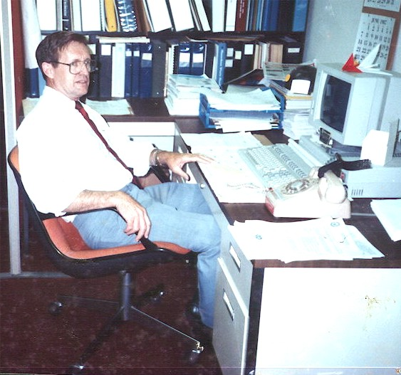
un Jubilación
A blueprint for my Retirement
Carl Lahser

Un jubilacion is the Spanish term for retirement or receiving a pension. Since I retired, I have written several poems about my retirements from the US Air Force and Federal Civil Service. Since then, time has flown. Hammocks. Shade. Walks around the block. I have just turned 77.

Blueprint for Jubilación
(My Retirement)

1: Birthday morning
2: Night time
3: Wheels – An old man’s Time Machine
4: Heat
5: Glimpses
6: How to Embarrass the Kids
7: Hong Kong Chestnuts, 1978
8: Hą Long Bay, 28 Oct 2011
9: General Store, May 2000
10: Night
11: Jamaica Palace

12: Maybe there is a God –A Daydream

13: Summer Madness is Finally Here
14: Another Fine Birthday
15: 81

Un jubilacion:1

Birthday Morning

I woke up with the sun
the beginning of year 77
on the 4th of November 2013

I was up but the sun
was still hiding
behind jet stream clouds
blowing in from Mexico

For breakfast,
the panaderia down the street
sold me a small tres leches cake

En mi jardin
I put on a jazz tape
sliced the cake
squeezed a glass of fresh, cold orange juice
and sang Happy Birthday to me

A blue jay joined in
along with a Monarch butterfly
heading south for the winter.
The sun broke out
heralding a good, good new year.
CARL 4/11/13

Jubilation:2

Night time – Ticking of the Clock
Dozing before the TV was pointless.
So, it’s off to bed at 10 pm
I’m awake at 1:13 am.
Then, the lying clock says its 3:21
and my bladder agrees.
Gird chimes in that supper is talking back.
I answer the call and take a Tums.
It’s back to bed
‘til 4:37 when the clock lies again
and again at 5:27 when my bladder
issues a first warning.
A loudmouth mocking birds begins
atop a tree out front
making the rounds, marking his territory.
Suddenly, it’s 6:46
when the school bus begins its growling run
and I used to get up for work.
Now it’s 7:47 when I once sat down at my desk.
My bladder gives a final warning.
I throw off the covers and my feet hit the floor.
Time to put out the trash,
pick up the paper
and figure out what to do today.
Is this what I must look forward to
for the next thirty years?
Carl Jan 2003

Jubilación :3

Wheels – An Old Man’s Time Machine

Driving home from my volunteer work
I came up behind a time machine -
like the DeLorean in “Back to the Future” -
a white Ford Shelby Cobra GT 500 convertible.
Top down.
Driven by a cool blond.
It took me back 60 years.

Back then, I was driving a jade ’49 Ford convertible
with pinstripe trim
along the new Los Angeles Freeway.
She left me in her engine’s rumble
at the exit for Hollywood

The blond ???
The Cobra, however, was a new $60K machine.
What would I do if I had caught it?
Carl 07/14/15

Jubilación :4

Heat
As a kid in the Rio Grande Valley in Texas,
summer nights began at 90 degrees plus.

North African mornings
began at 113º with flies and 80% humidity.

A Thule Phase hit -30ºF,
70-mile winds pushing horizontal snow
and zero visibility.

SW Arizona afternoon heat reached
117º and humidity at a dry -3%.

Considering this sampling
Where would I like to spend eternity?
I will probably stay right here.

Carl 24 Feb 2013

Jubilación :5

Glimpses

I saw her in a Christmas crowd
she vanished in a sea of bobbing heads
I called to her in the Plaka in Athens
she turned and spoke to me in Bulgarian

I bought her favorite drink from across a bar in St Louis
she was gone before the waiter arrived

Countless glimpses of her over sixty years -
in airports; on busy city streets; on passing busses.

She must be gone.
Consumed by time.
Absorbed in space.
Existing only in a tiny corner of memory.
Unchanged in all these years
as I grow older.

Jubilación :6

How to Embarrass the Kids
In late November, it’s still warm.
One afternoon, a blue-black cloud forms in the north.
A Blue Norther’s on the way.
Quickly wrap the pipes.
Water the garden.
Lock up the chickens.
Take jackets to school for the kids.
“How embarrassing,” say the kids
(but how good it feels).

Carl 111213

Jubilación :7

Hong Kong Chestnuts, 1978
Part of my retirement plan is to sit in the shade
Watching the leaves rustle against the clear blue sky
Looking back, reliving memories.

For instance, a walk down Nathan Street in Hong Kong,
at dawn, past Kowloon Park, with my wife and son.
No one is in sight except a chestnut vendor a block away
warming his hands as his chestnuts begin to roast.
No one else is out in the cool, white morn.

The chestnut man eyes us warily
and greets us in English with a Shanghai accent.
I show off and reply in Mandarin and warm my hands.
Then, I purchase a bag of hot chestnuts
and put one hot nut in each of my son's jacket pockets.
The old man grins and wishes us well.

Carl080815

Jubilación :8

Hą Long Bay

In the fall of the year,
after the monsoon,
my wife and I cruised Hą Long Bay, Vietnam.

Vįnh Ha Long
Bay of the Descending Dragons
2,000 emerald karst islets spit out by protective parents-
jewels and jade that sprang up as temptation
before the enemy fleet.

Hą Long – the place where mother dragon lived
Bάi Tú Long – where her children lived

A quiet black night on the Bay
watching Scorpio wheel overhead.
hearing halyards slapping the wooden mast.
listening to the creaking wooden hull.

Quiet and a pot of tea.

28 Oct 2011

Jubilación :9

Amazon General Store
May 2000

Memories of a trip down the Amazon,
an anniversary trip.

On bluff 30 feet above the Apayacu River
a few miles from the Amazon,
sits a lone general store.

Bright blue planks and a thatch roof,
corrugated tin walls and awning
No window screens.
A sign says they sell
cerveza, gaseosa and curichi
but no chocolates.

Log steps lead up from the river
where kids splashed in the muddy water
and played in beached pirogues.

In the distance, a thatched house.
Hammocks full of kids hung on the porch.
Pigs and chickens under the house
to keep snakes at bay.

Mosquitoes fill the air.
Chiggers fill the grass.

The sky looks like it might rain.

Jubilación :10

Night

Night enters through my window
altering the velvet blackness of the walls
diluting the inside darkness
The invading night adds:
1% starlight,
3% light of a sliver moon,
20% stray ribbons of coolness,
10% sounds of a distant train,
7% rustling of unseen night life.
Stir gently.

Barely illuminating pictures hanging on the wall:
framed views of an alien world of light,
snapshots of people and lighted landscapes,
the alien night sucks up all but the gilded frames.

Perhaps I should go out into the night,
bathe in the night,
inhale the song of a mockingbird atop a mesquite tree,
join unseen life in the night,
instead of lying here immersed in darkness,
warm and waiting for the dawn.

Jubilación :11

Jamaica Palace
A new eatery opened in the mall.
Jamaican cuisine and drinks.
Jerk Chicken.
Curry goat.
Green bananas.
Ginger beer.
On Saturday, Ackee rice and salt cod.
Bob Marley music.
Who could want better?

I asked the cook if he had any Belafonte music.
He said he had never heard of Belafonte.
I said I had several calypso albums.
He said he had no phonograph
and went back to the kitchen.
Never heard of Belafonte?
Lord Invader?
Mighty Zebra?

The waitress said her grandmother
loved Harry Belafonte
and the other calypso singers.
And had a record player!

Goodness! Am I that old?
Or is this cultural erosion?

Jubilación :12
Maybe there is a God - a Daydream

I went out this morning
to put out the weekly trash
when a neighbor’s junkyard dog
ran out ready to bite my ass

One of my hot-rodding neighbors,
just then, came roaring by
and put that ornery junkyard dog
into the big kennel in the sky

The car jumped the curb and bent its frame
and he was hoppin' mad.
No more will he roar by at 50+
and that makes me really sad.

In one fell swoop the car is off the street
and the dog is under the sod.
There is neighborhood peace and quiet again.
Maybe there is a God.

Carl 6/7/16

Jubilación :13

Summer Madness Is Finally Here

It looks like a long, hot summer already.
The temperature has started to climb.
Militants have started to riot.
The destitute are turning to crime.
It’s too hot to sleep or work
and they'd kill you for only a dime
if it wasn't so damned hot.
Maybe some other time.

The weather is dry.
The sidewalks fry.
Lawns and trees cry.
Cold weather's a lie.
I want ice cream pie

I've run out of rhymes and patience so
Ihopetheycanfixmydamdedairconditioner NOW!!

Thank heaven for ice water and mesquite tree shade
while I wait for the bad news.

$500!!!
It better be one Hell hot summer
or I'm gonna be mad.

Jubilación :14

Another Fine Birthday {80}
The painter Constable said,
“Nothing is ugly in this old world. “

Shouting girls on one side of the street
exude sexual defiance
in the way they challenge boys across the street
with their loud laughter.

Two mustached nuns dressed like penguins
walking side-by-side like penguins
in a flat-footed way
wave shyly as a passing Lowrider toots its horn.

A homeless woman sitting on a bus bench
eating potato chips out of her purse
mumbles to everyone and
holds up a finger to a passing police car.

Snotty infant paddles rapidly along the sidewalk
in nothing but a T-shirt and screaming
his sister runs after him waving a diaper
shouting for him to come back this very minute.

Time races and creeps and crawls
Minute by minute
Until another year has passed.
4Nov17

Jubilación :15

81
I am walking.
Walking through the neighborhood.
The sun is shooting upwards
into a clear blue sky for the first time in weeks.

Leaves of red oak and live oak
Pile up along the curb.
Acorns lie scattered
along the streets and sidewalks.
A flock of Mourning Doves pecks acorns flour
From acorns crushed by passing cars.

Grackles, heading south, are singing the sun up
Preparing for their flight to Mexico.
Blue jays, migrating from someplace else, are screaming.
Imported Fire Ants are building new mounds
To replace mounds the recent rains destroyed.

I am 81 years old today,
contented as 81-day babe.
I see on this glorious day that I’ve been falling
Deeper and deeper in love with life
And now I swim like a fish in a tropical sea.

Happy Birth Day to Me.

Carl 4Nov1018

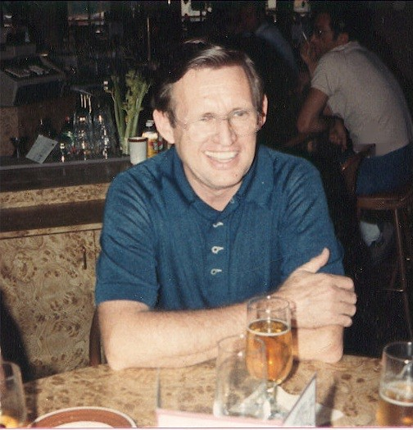
Retired!

