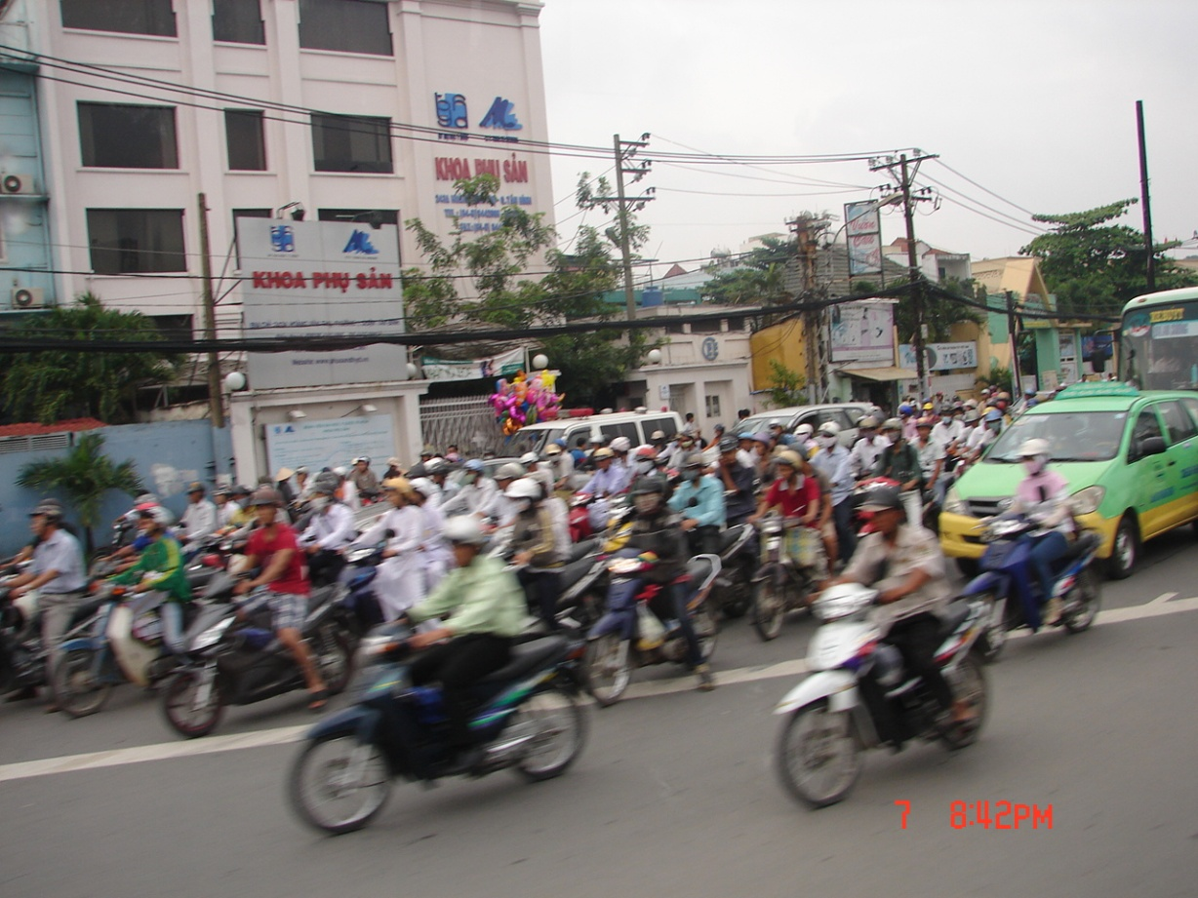

Poems
of
Cambodia and Vietnam
2011

Carl Lahser

Contents
Hą Long Bay
Water Puppets
Typhoons
Scooter Heaven
Snack Time
Sidewalk Market
Fish Market
Mekong River

Hą Long Bay
Hą Long Bay, Vietnam
Vįnh Ha Long
Bay of the Descending Dragons
The 2,000 emerald karst islets
Were spit out by protective dragons
And jewels and jade
Sprang up in front of enemy ships

Hą Long – the place where mother dragon lived
Bάi Tú Long – where lived her children
Islets swathed in a hundred kinds of trees
Protecting Haiphong
Protecting Vietnam

A quiet night on the Bay
Watching Scorpio overhead
Hearing halyards slapping the mast
Listening to the creaking wooden hull
Quiet and a pot of tea.
Carl 28Oct11

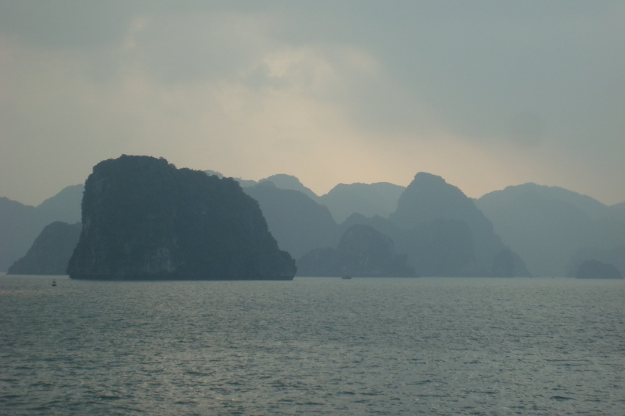

Water Puppets
In Hanoi live the water puppets
In a pool telling farmer’s stories
Mounted on rods beneath the surface
Operated by puppeteers waist deep
Hidden artists and three foot actors
Carl26Oct11

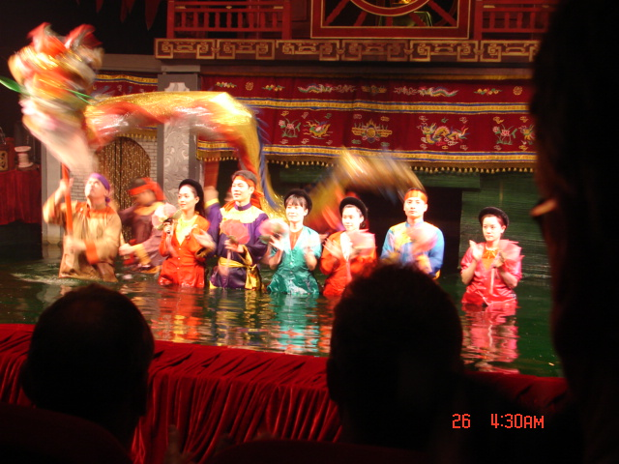

Typhoons

Typhoons, teeth of the Southeast Asian gods
A storm one hundred thirty years ago
Hit the Gulf of Tonkin
Decimated Haiphong
Killing 300,000 in the Red River Valley

In April 2011 a storm hit Saigon
On24 September Typhoon Haitang hit Hanoi
On 30 September Typhoon Nesat hit Haiphong
On 9 Oct Typhoon Banyan hit Hong Kong
The Mekong rose 30 feet
And 3000 people were killed
Most of Thailand was flooded

Water will still be standing for months
Tong le Sap Lake was 70 miles wide

Quiet and humid
And a falling barometer
Need to listen to the weather man
It’s coming.
Carl 10Oct11

Scooter Heaven
Southeast Asian streets
Hanoi, Saigon, Phnom Pehn
A writhing sea of
Motor scooters,
Motorbikes,
Rickshaws,
Pushcarts
Cars,
Busses
Ox carts
Old women with a loaded yokes

Crossing a street
Walking into traffic with your hand raised
Walking at a steady pace
While demons fly past
Emerging on the other side unscathed.
Wheee!
Carl 26Oct11

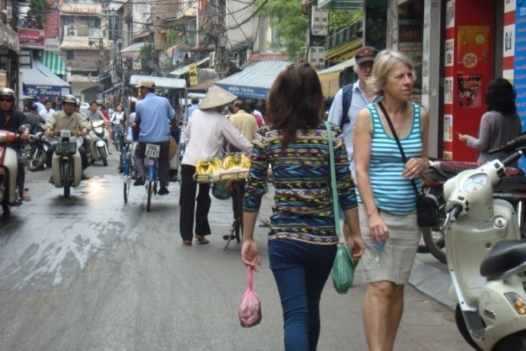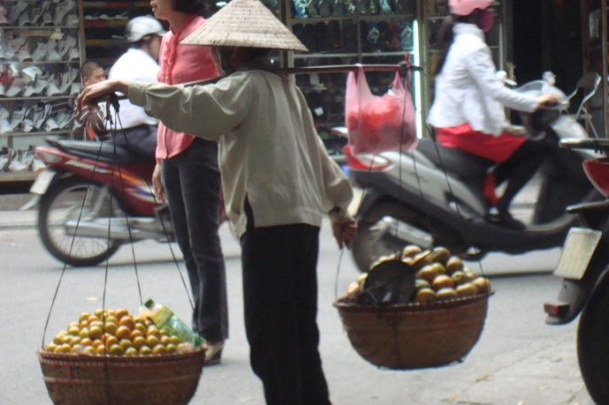

Snack Time

Sidewalk cafes
With red or blue plastic chairs
And knee-high plastic tables

Serving tea and pho
Talking news
Telling jokes
Oblivious as the world flows past
Carl26Oct11

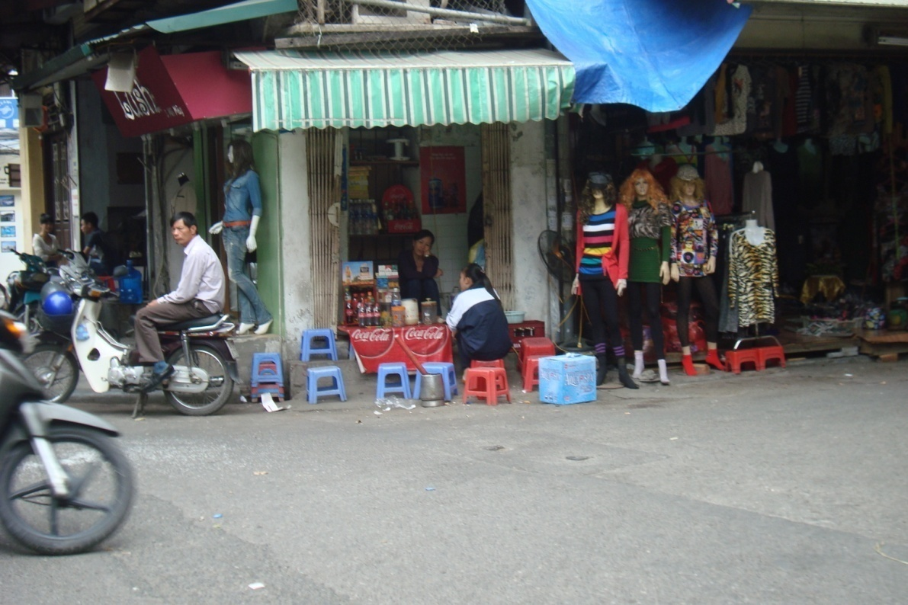

Sidewalk Market
Bok Choy
Dichon
Water morning glory
Taro roots
Peeled pineapples
Leeches
Rice
Sitting on the sidewalk
Resting on low tables
While the old women sit
Talking or dreaming of better days
Carl27Oct11

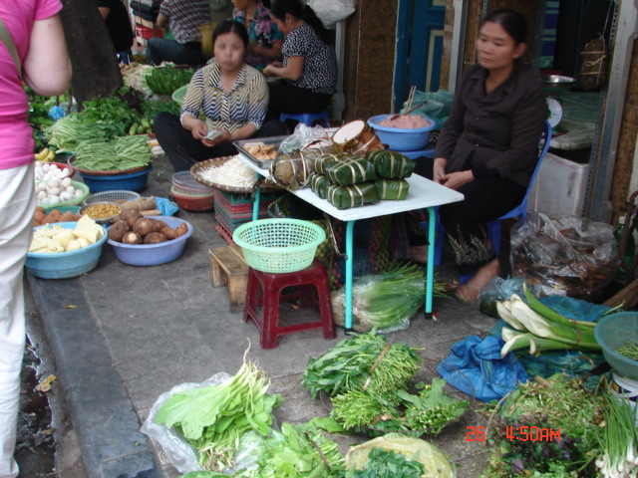

Fish Market
Crabs and eels
Catfish
Snails and turtles and frogs
It’s all edible, Joe
I clean it for you, Joe
Right here on the sidewalk
30Oct11

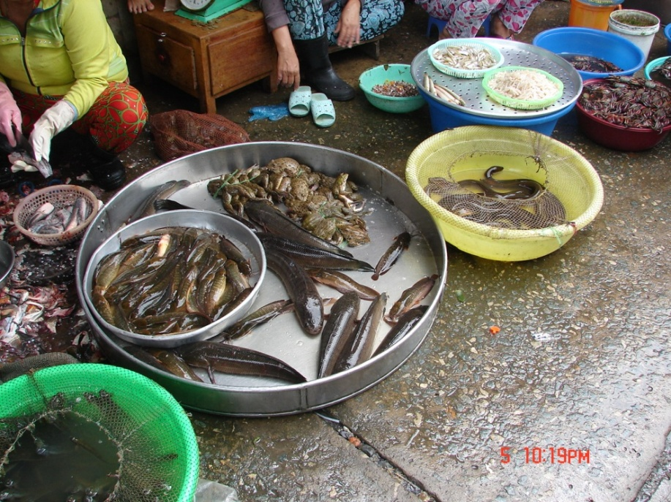

Farm House
In a clearing off the road
Beyond the family shrine
Past the tethered water buffalo
And jackfruit trees
A house on stilts
With hammocks strung between the posts
A loom on one side
Lightning rods for the monsoon
A lotus and Nagas on the roof ridge
Thatch roof
Blue shutters
Waiting for the monsoon to slaken
Waiting for the Mekong to recede
Carl 31 Oct 11

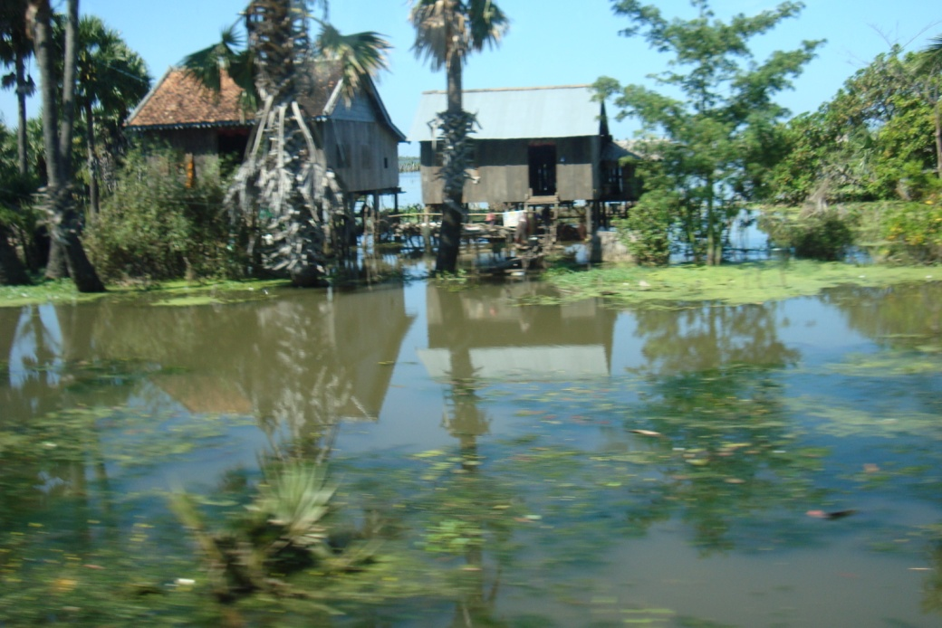

Mekong River
A mile wide and fifty feet deep
The Mekong flows from China
Then between Laos, Vietnam, and Cambodia
Essential highway

Suddenly the halyards beat against the mast
Evening monsoon clouds slide in
Cool and loaded with rain
Sheet lightning highlights tall clouds
Humidity and rain fill the night

Overcast daylight drips humidity
It is light but the sun forgot to rise
Don’t breathe too deeply
Or you will drown
Carl 26Oct11
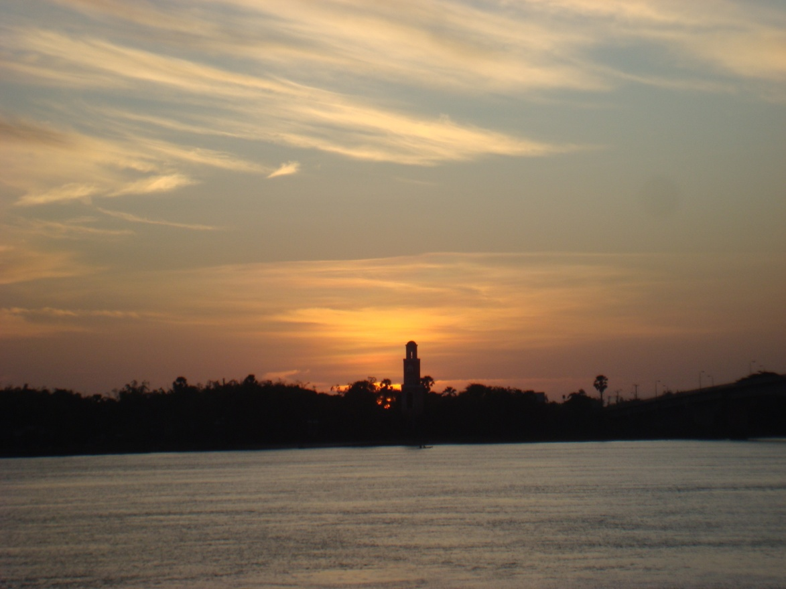

The River is Dropping
Typhoon rain and wind
Rushed up the Mekong valley
Raising the water level thirty feet
Backing up into Tong le Sap
Tripling its size

Six weeks later the river was falling
The farmers were following the river down
Fishing in the water
Planting the silt covered banks
With pole beans, bananas,and taro

Time flows onwards.
carl30Oct11

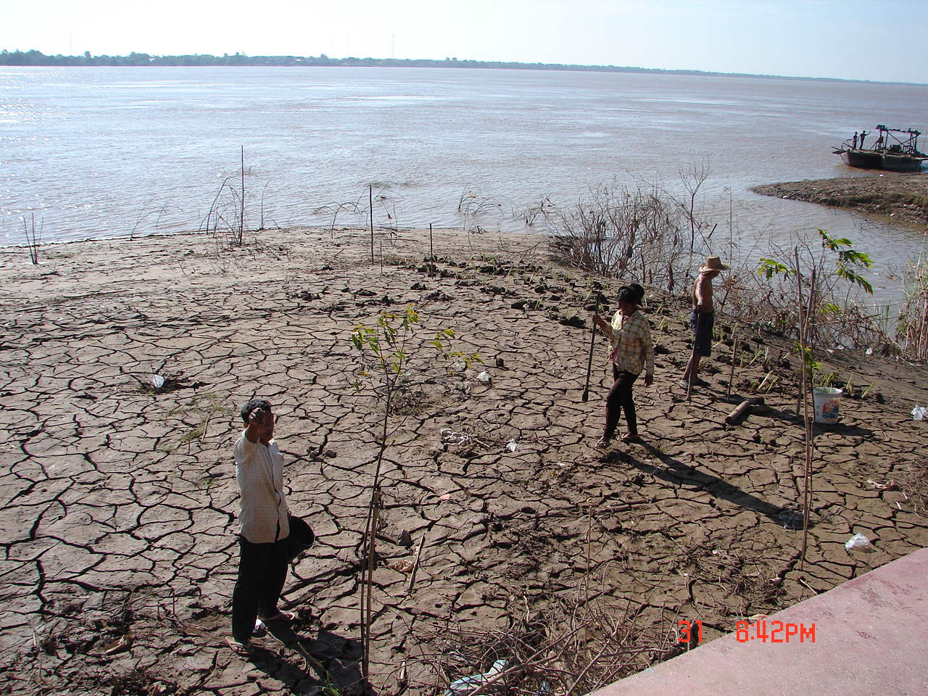

The Killing Field
An overcast morning
At the end of the monsoon season.
I visited the reborn Phnom Penh,
The City of Ghosts.
I stopped at the Russian market
For a wide-brimmed hat
Anticipating a short trip to Choeung Ek
To see the Killing Field.

15km south
Through thinning businesses and homes
Behind the houses ran the river
Where rice and morningglory were raised

Passing through Choeung Ek
We found the glass-faced memorial stupa
Filled with unidentified skulls
0f 8000 victims executed
And buried in the Killing Fields

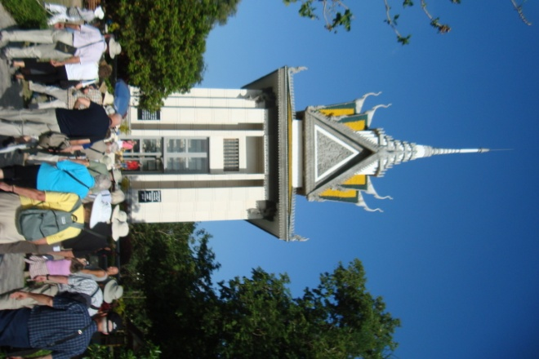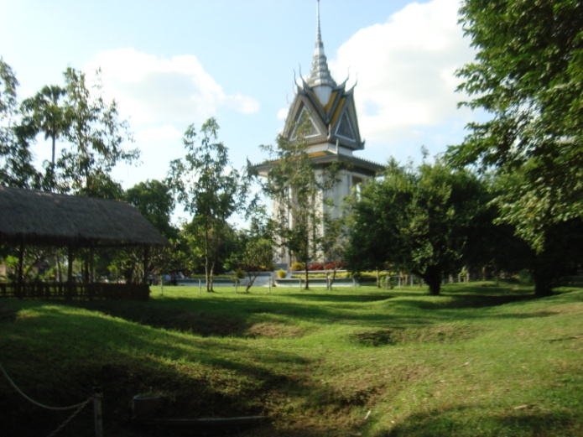

Under a gloomy sky we walked among the burial pits
Grown over with green turf and trees
Looking like a tough golf course
Pits containing remains of
Men bludgeoned to death to save bullets
Women unclothed
Children smashed against the killing tree
Pits containing rags and bones and teeth of the victims

Remains of 8985 people have been exhumed
Many were brought alive from Tuol Sleng,
The secret service headquarters,
Up to 300 a day for killing

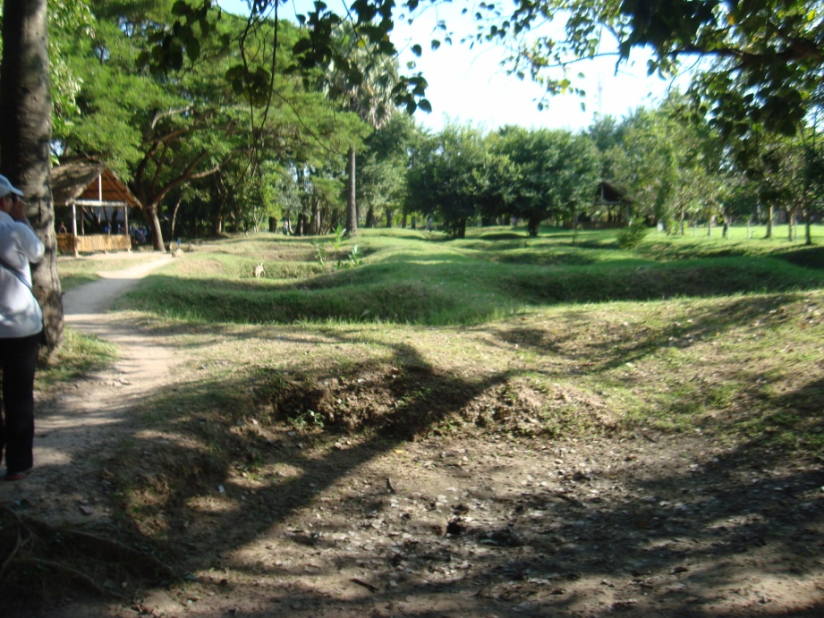

Under grey sky and a weak sun
This is a monument to cruelty and insanity
And the indifference of the outside world
A memorial to gentle poor people who did not resist
A lesson to future generations
Who think selfishly only of themselves
Who ignore corruption, tyranny and repression
Who do not participate in government
Carl2Nov11

Tuol Sleng (S-21)
In the outskirts of the City of Ghosts
Sat the Tuol Svay Prey High School
When Phnom Pehn’s people
Were ordered to leave town
And sent to the countryside
To meet Pol Pot’s dream f
“Return to the old agrarian ways”
The school was desecreated,
Degraded, and modified
To serve as a Khmer Rouge interrogation and torture center.

Tuol Sleng, secret department S-21
1975 to 1979
Run by Comrade Duch
14,000 men, women and children were “processed”-
Tortured and the majority killed
Grisley place.
Carl2Nov11
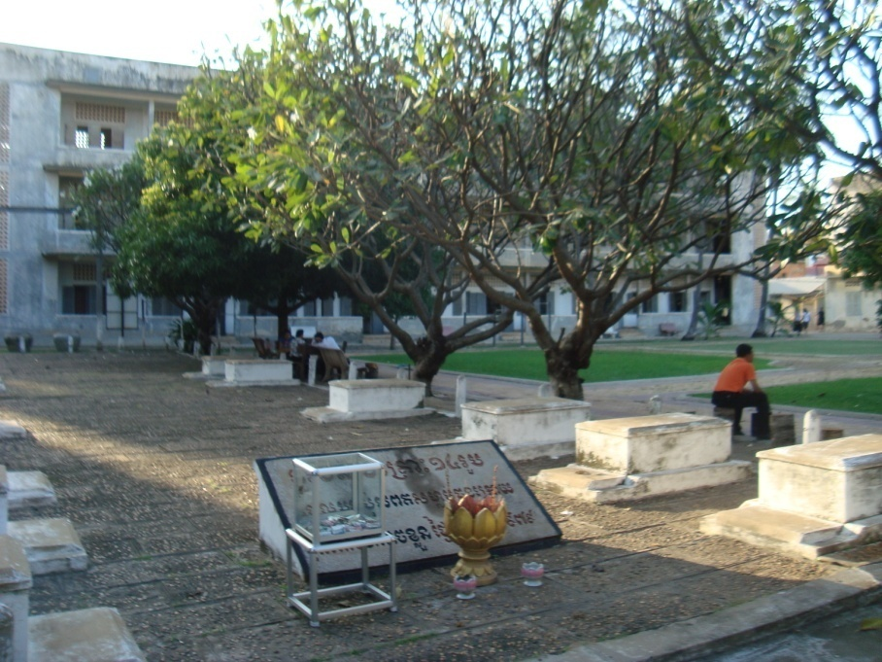

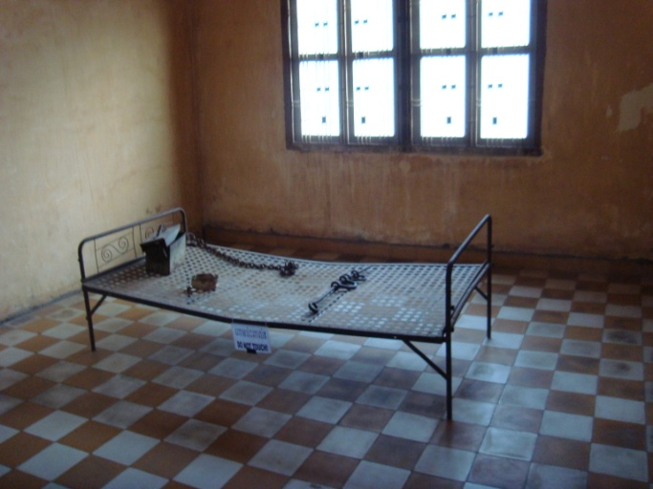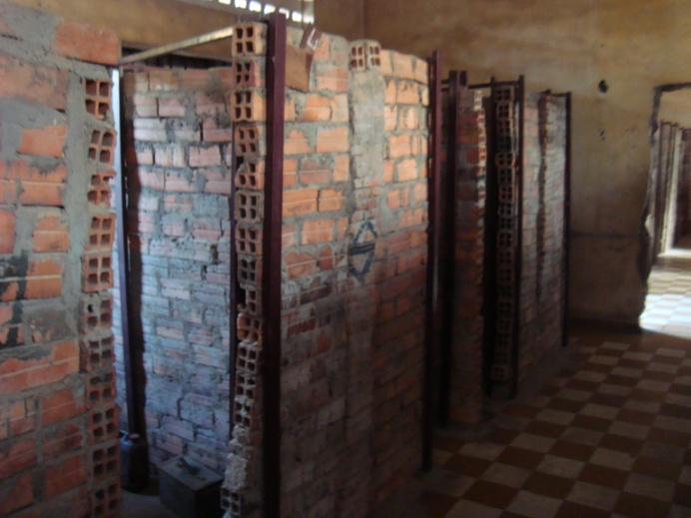

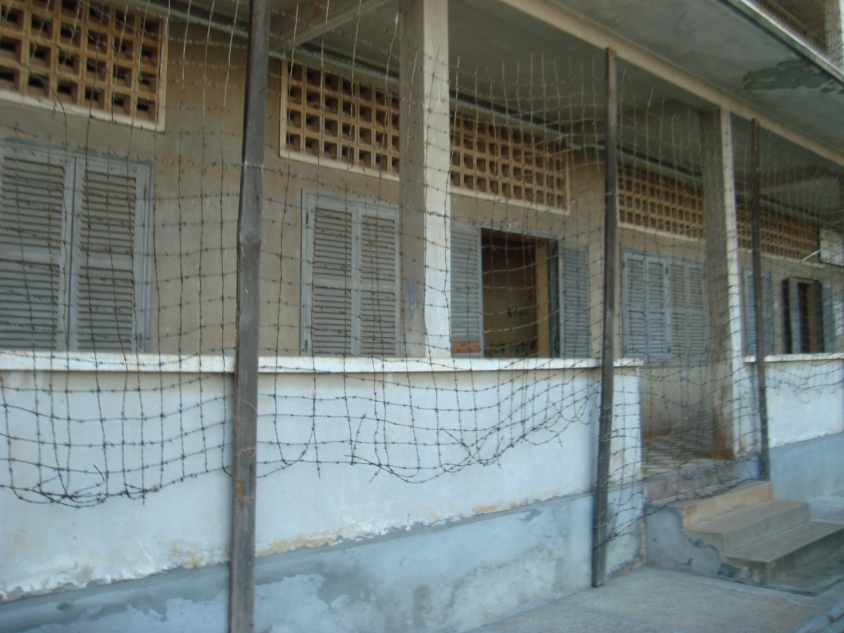

Ox Carts
Out in rural Cambodia and Vietnam
The Ford F-150 and Toyota Tundra
Are replaced by the ox cart
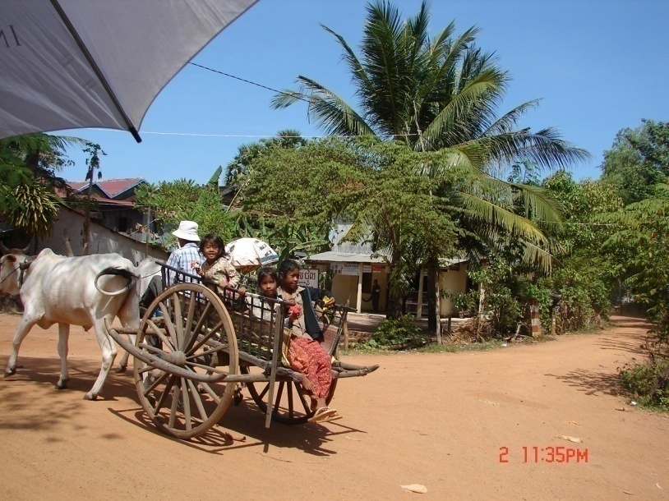

Off to the market
Out in the fields
Decked out for holidays
Jouncing along trails
And unimproved roads
Carl2Nov11

Rubber Trees

A rubber tree produces latex sap
The water is removed leaving
Raw rubber.

Ford and Edison had rubber plantations
In Brazil, Malaysia, and Vietnam.
Japan’s coveting Malaysian rubber
Started WWII.
The US wanting Vietnamese rubber
Caused another war.

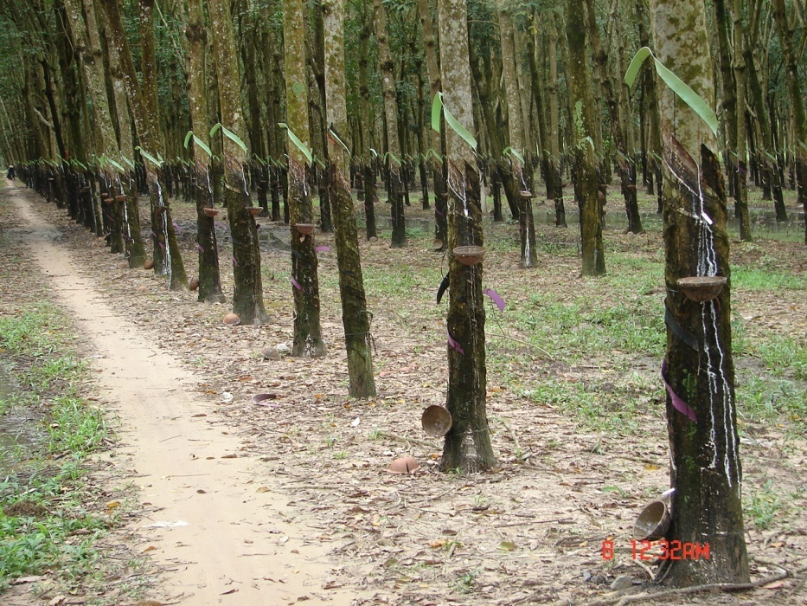

Most rubber is plantation raised
Young plants produced from cuttings or seeds
Are planted in rows and tended

At seven year trees are slashed for 30 years
A spout leads the latex to a collection bowl
A plastic ribbon is tied above the slash
To divert water from the bowl
The latex is boiled or roasted
To remove the water
Then shipped out for further processing
Wild rubber came from Mexico to Brazil
Where natives were enslaved
To collect and smoke raw rubber
They were mutilated or killed
For missing their quota

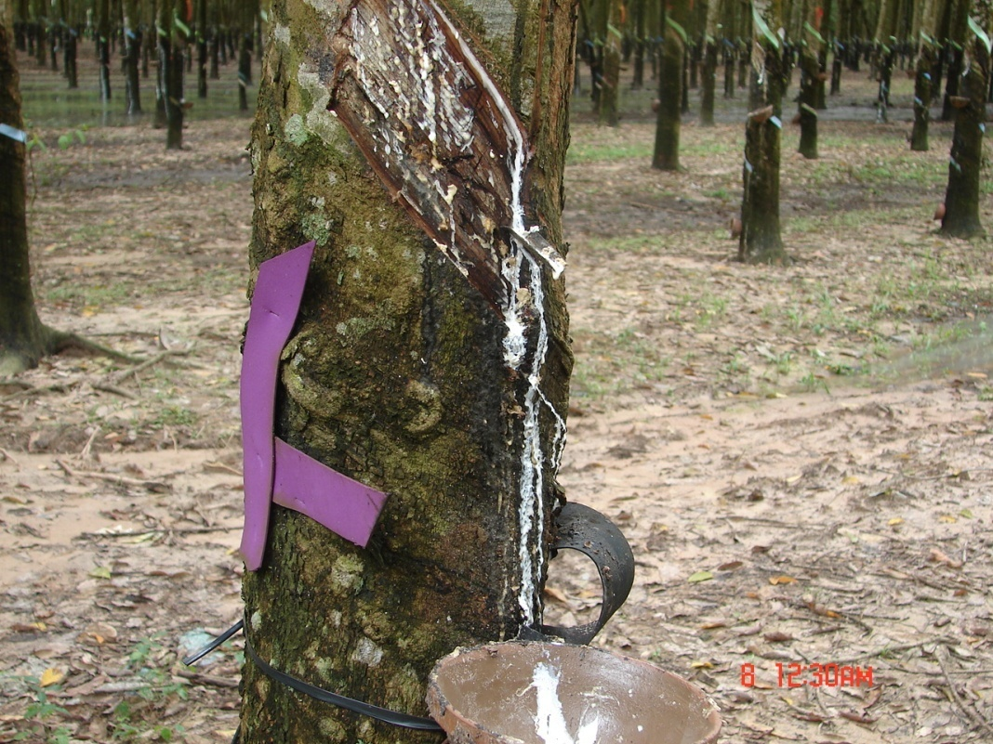

Carl8Nov11

