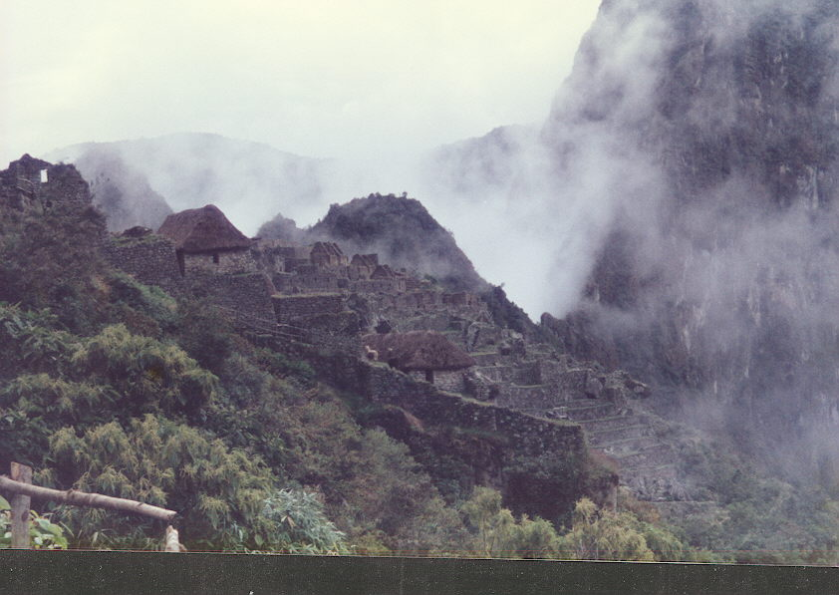

Under the Southern Cross
Hidden by Clouds
by
Carl Lahser
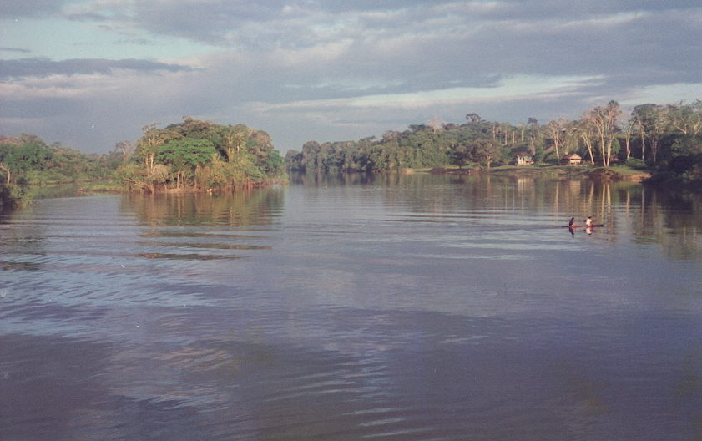

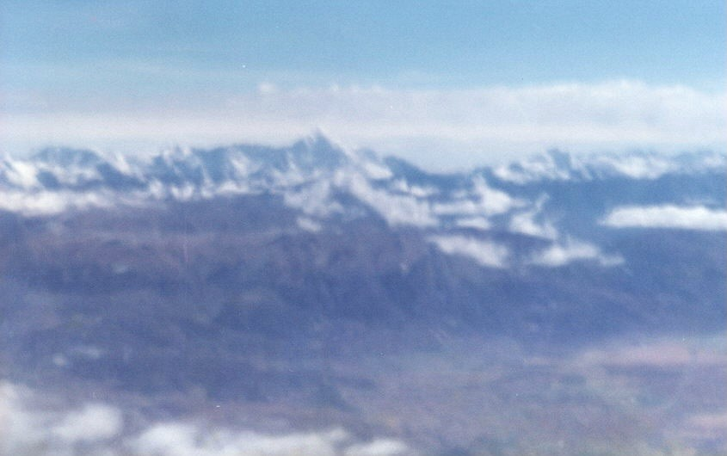

SOUTH AMERICA
JUNE 1990
MACHU PICCHU, the AMAZON, BUENOS AIRES

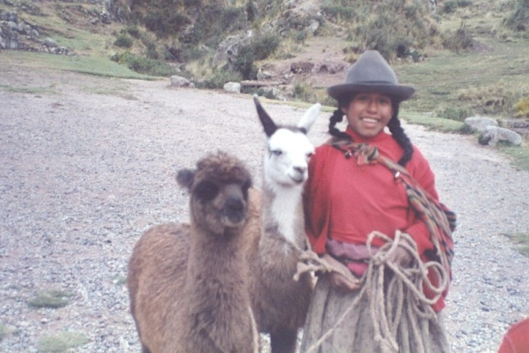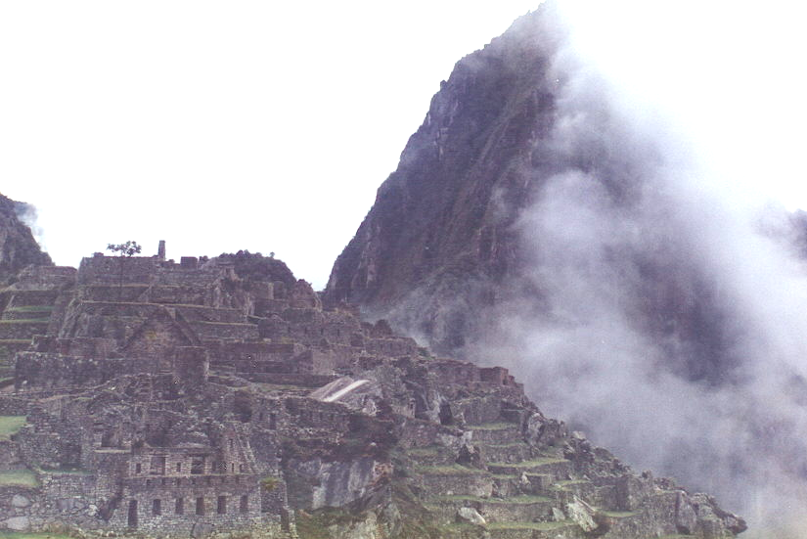
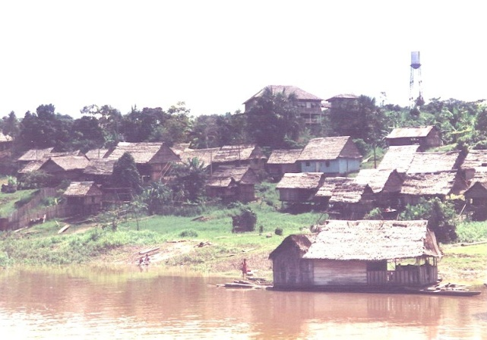

TABLE OF CONTENTS

Forethoughts

8 June. San Antonio to Lima

9 June. Lima to Cuzco

10 June. Cuzco to Machu Picchu

11 June. Machu Picchu to Cuzco

12 June. Cuzco to Iquitos

13 June. Iquitos and Amazon Camp

14 June. Down the Amazon

15 June. Farther Down the Amazon

16 June. Offload at Leticia and Back to Lima

17 June. Lima to Buenos Aires

18 June. Buenos Aires

19 June. Buenos Aires and Return to Lima

20 - 23 June. Lima to Miami to Orlando and San Antonio

Afterthoughts

Poem List

Title
Where Would I Like to Go
San Antonio Airport
Lima - Welcome to Yesterday
The Bread Man
Boarding Time in Lima
Andes Sunrise
Cuzco
Hotel El Dorado
Broken Church
Orchid Smuggling
Cloud Cycles
Mercantadores
TheConquistador’s Excuse
Amazon Sunrise
The Belm Market
Belem
Amazon Morning
General Store
Leafcutter Ants
Army Ants
Jungle Drinking Water
Pevas Fast Food
Crossing the Amazon
Caballo Cocha
Termite Swarm
Counterpoint

Forethoughts

WHERE WOULD I LIKE TO GO
You ask where I would like to go.
Swim in the tropics?
Play in the snow?

I would like to dive Cancun
Study old temples
And walk the beach in the moon

Or go off to the desert
to capture some snakes
And look at the cactus
And walk the dry lakes.

Or look at the flowers
as we walk through a park
Hear rippling water
and the song of the lark.

Or off to the north and the Eskimo
W here the caribou wander
And there’s plenty of snow.

I'm peripatetic but you must understand,
I won't go anyplace
I can't hold your hand.
*****

Preparation.
In March 1990, we received a small inheritance from Carol's aunt's estate and decided to take a once-in-a-lifetime trip. I suggested Cancun or Baja both with beaches. Carol disagreed. We looked at the Inland Passage to Alaska or a trip down the Mackenzie River in the Northwest Territories and the Yukon which would follow the footsteps of Uncle Otto's trek to the gold rush in 1898. After looking at brochures and prices and much discussion, we settled on a trip to Machu Picchu and a three day ride down the Amazon. Carol decided that since we would pass through Miami that we should see Disney World. We did our homework, bought a camcorder and extra batteries and got the recommended shots.
Planning and preparation should be fun and a learning experience itself. It should be an important part of any trip. To check out the current political situation in Peru, Colombia, Brazil and Argentina I called the Air Force Office of Special Investigations (AFOSI) and got their anti-terrorism brief. I next checked medical area intelligence reports for the area. These reports consisted of the Disease Vector Ecology Profile (DVEP) prepared by the Defense Pest Management Information Center and the Monthly Disease Occurrence (Worldwide) from the Armed Forces Medical Information Center. I also called the Communicable Disease Center (CDC) Malaria Hotline [(404) 639-1610].
For background information and historical setting, I read or at least browsed through a number of books:
The Amazon by Hakon Mielche (William Hodge & Co, 1949) is about his 1948 trip up the Amazon to Manaus, Brazil.
Vagabonding Down the Andes by Harry A. Frank (Century, 1917) covering his 1917 trip was out of date and did not cover the area of our trip.
Ten Keys to Latin America by Frank Tannenbaum (Vintage Books, 1960), A History of Latin America by George Pendle (Penguin Books, 1981) Social Change in Latin America Today by the Council on Foreign Relations (Vintage Books, 1960) provided insight into social changes.
Slaver in Paradise, the Peruvian Slave Trade in Polynesia, 1862-1864 by H.E. Maude, Everyday Life in the Incas by Anin Kendall (Dorset Press, 1989), Carnival and Coca Leaf: Some Traditions of the Quecha Ayllu by Gifford and Hoggarth (Scottish Academic Press, 1976), and Sicuanga Runa, the Other Side of Development in Amazonian Ecuador, by Norman Whitten (U. Illinois Press, 1985) provided insight into the development in the Amazon.
The United States and Argentina by Arthur Whitaker (Harvard Press, 1954) covers history and relations with Argentina.
Two travel guides, The Visitor's Guide to Peru (Moorland Publishing Co., 1989) and the earlier Peru Traveler by Selden Rodman (Meredith Press, 1967) give valuable travel information.
Books on birds consulted included A Guide to the Birds of Panama by Robert Ridgley (Princeton Press, 1976), Guide to the Birds of Venezuela by Meyer de Schauensee (Princeton, 1977), The Species of Middle American Birds by Eisenmans and F. M. Chapman's My Tropical Air Castle (1929) and Life in an Air Castle (1938).
Plant books were less abundant. I used general references such as Graf's Exotic Plant Manual, 4th ed., and general family keys. I did not have access to Croat's Flora of Baro Colorado Island (Stanford, 1978) or Schultes and Raffauf's The Healing Forest, Medicinal and Toxic Plants of Northwest Amazonia (Discorides Press, 1990) but probably would not have needed them.
Our travel agent arranged tickets and reservations through Tara Tours for Lima, Machu Picchu, and the Amazon with a side trip to Buenos Aires and a Disney World stopover on the way back.
Passports and our visas for Brazil finally arrived. We were packed and ready to go on the 8th of June, 1990.
*****
8 June. San Antonio to Lima. Our trip began well. The Checker cab was a few minutes early. The driver said they had two cabs on duty at Ft Sam every morning. United Airline was on time from San Antonio to Dallas-Ft Worth International and from DFW to Miami.

SAN ANTONIO AIRPORT, JUNE 8 1990
We arrive at the terminal
In the predawn dark
It's to DFW and Miami
For a South American lark.

The dimly lit terminal,
Florescent lit gloom,
Feels more like embarking
On a trip to the moon.

An international check in
With passports in hand
Two hours before boarding?
I don't understand.

They check passports and tickets
And hand back a boarding pass.
It's off to the gate to watch
Airport lights through the glass.
*****
In Miami, our run of luck hit a small snag. We had super saver tickets for a United flight connecting with Aeroperu to Lima. Aeroperu had changed its schedule, and United said "You better be ready when we are." United was not responsible for the actions of Aeroperu and would not allow a ticket change. Our travel agent rebooked us on an Eastern Airline flight that left Miami about the time Aeroperu should have departed. This should have been a warning about Pizarro’s idiot children’s airline.
It sounds simple except the travel agent had not completed her part of the action. After waiting in line for half an hour at the Eastern international gate in Miami, the Eastern clerk told us to go back to Aeroperu. They needed a "fin" or voucher for Aeroperu to pay Eastern which is normally handled by the travel agent. This required a trip to the opposite end of the terminal and an unsatisfying encounter with a bellicose Aeroperu employee. She told me there was no plane to Lima today, and that I "should have caught the plane last night." I resisted the temptation to play the ugly American and finally got my vouchers. This satisfied Eastern Airline's bureaucracy and away we went.
It was a smooth and uneventful flight through the night over the Bahamas, the Windward Passage, and Curacao then across Venezuela and Colombia and half the length of Peru. We arrived in Lima about ten o'clock at night Lima time (eight in the evening by my internal clock).
Lima, from the air, was not exciting. Few lights were visible giving no clue that a large city was present. The airport looked like San Antonio's airport had looked twenty years ago - no jetways and only two concourses. Passengers embarked and offloaded using a ramp hand pushed up to the plane and then walked to the terminal.
*****
The first fun thing to do in Peru was to go through customs. For some reason the customs inspector decided my camcorder should be declared as professional equipment. It took some discussion for them to determine that I was a tourist and not a journalist or other professional. In the end, I did not have to pay any duty.
It was a little after 2300 when our guide from Tara Tours met us outside customs. We got the baggage loaded in a thirty year old Ford and headed for the Lima Sheraton. Our guide's English was adequate but the driver spoke only Spanish. The two were totally absorbed in the World Cup soccer game on the car radio. Discussion of anything was out of the question over the energetic announcer of the game. Anyway, there was not much to see at that hour on the half-hour ride to the hotel.
Our chariot to the hotel was an old 1960 Ford Galaxy gas hog. Appropriately enough, we ran out of gas on the way to the hotel. Another car stopped to ask if there was a problem. After a short discussion, the other driver opened the trunk of his car. He produced the Peruvian version of our famous west-side credit card - a plastic gallon jug and about four feet of rubber hose. After getting a mouthful of gas, our driver succeeded in siphoning about half a gallon of gas from the other car's tank into the jug. This was put in our car. The gas was paid for, and we were off again. But first, a stop at the local gas station was in order. Gas was 20,000 Intes per liter or about $2.00 a gallon twice the at home price.
The road into town from the combination airport/navy air base was a four-lane divided highway with a raised median. Shoulders of the road were dirt and lined with Eucalyptus trees. The Eucalyptus trees had the bottom four feet of the trunk whitewashed for visibility.

Lima - Welcome to Yesterday
The approach from over the Pacific at night
Gave no clue that we were near
A city - Lima - the capitol of Peru.

No jetway here, it’s down those stairs
And a hundred yard walk to the terminal.
Then baggage and customs games.

The tour guide met us
In a 1960 Ford Galaxy.
The driver spoke no English
And had the World Cup Soccer
Broadcasting to the world.

It’s after midnight and we are out of gas
So flag down another cab
And siphon a gallon of gas.
Echoes of the 1960's.
******
The street traversed what appeared to be an industrial area with block-long, ten-foot high, concrete block walls. Some of the walls had guard towers. It is possible that this was some of the military or port complex.
These walls and every other wall we saw had lots of decorations, political posters and advertisements and slogans in the form of graffiti. This was already Saturday morning, and the national election would be held on Sunday. The travel agent had not mentioned being in Peru in the middle of a potentially exciting South American election.
There was no breeze. The humid air was thick with exhaust fumes and photochemical smog. Temperature was about 55 degrees F (12 C). (Almanac records report Lima's average weather to be calm and humid with infrequent rains. This warm, muggy and pollutant-laden air creates a warm polluted bubble or inversion under the cool blanket of air drifting down from the Andes. The resultant acid smog was thick, irritating and very corrosive to Lima's old architecture and outdoor statuary.)
***
We finally arrived at the Sheridan hotel. As the guide was checking us in, the desk clerk asked if we wanted a black or white room. "What does this mean?" I asked. "With or without a view, naturally," was the haughty reply. I replied, a bit testily, that it was after midnight and dark. Besides we had a 5 AM wake up to get out to the airport for the 7 AM plane to Cuzco. All we wanted was a place to sleep.
We were assigned a "white" room on the fifth floor. It was complete with a hot shower and CNN on the TV giving a rundown on the upcoming election. The view, however, was not impressive. The room overlooked one of the main streets, Passeo de la Republica, and the Plaza de Armas, a World Heritage Site. There was no traffic and very few lights in sight at this hour. ( If we could have seen the Plaza we would have had a view of the cathedral and the government buildings. On the southern corner of the plaza Pizarro had been assassinated. In the center was a 15th-centuary bronze statue of a trumpeting angel.)
While Carol prepared for bed, I went down to the lobby for supper and to use our complimentary drink tickets. It was almost one o'clock in the morning. All food service was closed for the night except room service, so I went to the bar. There, with an Aeroperu flight crew, I had a Coke and one of the hotel's famous Pisco sours. Thankfully, the flight crew was not the crew for our flight to Cuzco in about five hours.
It was 11 PM by my time and time to crash.
*****

9 June. Lima to Cuzco. Five AM came early. Oh dark thirty and four hours sleep. At $120 per night plus 13 per cent tax and a 20 per cent overhead charge, the cost of sleep was outrageous. There was also an expected 10-20 per cent tip and a flat 10,000 Inti (20 cents) charge per bag carried each way. Maybe I’m just a cheapskate.
A continental breakfast, courtesy of the hotel, was served in the hotel snack bar. This consisted of a selection of toast or rolls, strawberry jelly, fresh (very tart) orange juice and coffee, tea or milk. The snack bar menu listed a hamburger for 200,000 Inti and 150,000 Inti for our breakfast (at the time the exchange rate was 55,000 Inti to a dollar). The hotel's idea of local food included baked sea bass with spicy sauce and deep fried steak with bananas.
*****
Our guide arrived at 6 AM accompanied by a couple from Florida. The "limo" was a rattle VW van that had room for us or the bags but not both. The bags went first with the guide and tickets. We had almost an hour to get acquainted with the other couple. By the time we got to the airport, the guide had our bags checked and boarding passes ready.
The road out to the airport didn't look much better in the early dawn than it had six hours before. Not much traffic was on the road and what was consisted mostly of vehicles dating from the 1960's and 70's. Most of them had the "well used" look with lots of dents and rust. Items like turn signals, wipers and lights appeared not to work. The state of repair of the streets and vehicles did not appear to matter much since the street was not lighted. I don't know what they did on unlighted streets. Many cars and trucks proceeded without lights until they met another vehicle. The only vital item appeared to be the horn. Although most of the signaling at night was done with light or hand signals, much of the daytime signaling was done with beep from the horn.
*****
Bread peddlers (literally) on three-wheeled bicycles with baskets filled with fresh good smelling bread were roaming the streets looking for predawn customers. The less wealthy were standing in line at the bakeries to get the price supported bread. The price went up at 7 AM. After 9 AM, the bakeries could charge whatever the traffic would bear. The regular price of half a dozen rye-and-barley flour rolls was 2,000 Inti (two cents each.)
The Bread Man
A lone old man
On a three wheel bicycle
Sold cheap bread
From the basket on the bike
At a floating price of a nickel a loaf.

The peons’ stood in line
From seven to nine
For price supported bread
At two cents for rye and barley rolls

At nine AM the price went up
To what ever the market would bear
And the man on the bike went home.
*****
When we arrived at the airport, our luggage had been checked and our boarding passes were ready. The status board showed no schedule changes so we went to the boarding lounge. About 120 people were crowded into a small space with only 30 seats and minimal standing room. Happily, almost no one smoked.
About twenty minutes to boarding time, everyone was required to go outside onto the parking ramp to identify personal baggage to be loaded on the plane. Then, everyone returned to the lounge to await the boarding announcement. At the announcement, everyone crowded up to the gate for the walk across the ramp to the plane. The Peruvians were no different from Americans in that respect. Everyone has reserved seating, so what is the hurry?
Boarding Time in Lima
A hundred people waited
For a 727 to Cuzco
We were called outside to identify
Each piece of baggage to go.

Then back inside to wait some more
While bags were hand-carried to the plane
A hundred yards across the tarmac
in sunshine or in rain.
The plane was an old 737 with no overhead storage or adjustable seats. Later in the flight the stewardess served dinner roll size sandwiches of roast beef or tasteless local cheese and reconstituted orange juice. Just prior to landing we were served a small cup of syrupy coffee.
Our plane taxied past the co-located Peruvian Naval Air Station on our way to the active runway. The Navy had C-130's, Caribous, French helicopters and several miscellaneous high-wing aircraft. There was also a Huey with some kind of antenna in front of the rotor that looked like a shark's fin.
Punching through the clouds we found the morning sun backlighting the Andes. We were over the clouds, so the Pacific Ocean was not visible. Snow pack was the reverse of our northern mountains being on the south slopes of the mountains. All of Peru is south of the equator. Lima is 12 degrees south of the equator at sea level and Cuzco at 14 degrees south at 11,152 ft. The date was 5 days before the equinox and the middle of the South American winter.

ANDES SUNRISE
Above the clouds the Andes appeared
Back lit by a morning sun
White snow on southern slopes and a blue-black sky
The Peruvian morning has begun
*****
*****
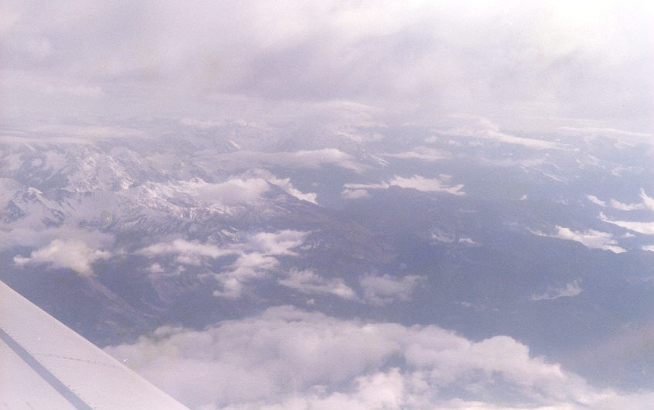

Peru has always been relatively unpopulated. Several large population centers are separated by vast expanses of sparsely populated mountains and jungle. There are the high, dry cordilleras or mountains and the hot, humid and generally unhealthy jungles. The Spanish called the mountain inhabitants caudillos and considered them superior because of better living conditions, more and better food and relative freedom from insect borne diseases.
The coastal and lowland Indians were called costenos or the coastal people. The costenos were relatively smaller people, less healthy and less volatile. The Spanish elite tried to have the best of both by working in the coastal cities but living in the mountains a couple hours away. Commuting to work is nothing new.
*****
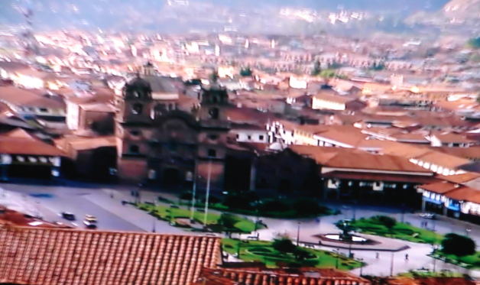

The flight to Cuzco took about 30 minutes. The clouds were quickly left behind. Snow-covered Andes Mountains were ahead and below us framed by a dark blue sky.
Suddenly we were over a high valley. Cuzco, the Quecha term for the navel or center of the Quecha world, occupied the valley floor. The pastel colors of photographs of the area are correct. The roofs were brick red being constructed of reddish clay tiles. The houses were tan adobe block. Hillsides were a patchwork of green fields of winter crops and golden fields of rye and barley ready to cut. Fields and pastures were outlined with dark green lines of Eucalyptus trees.
We passed over the length of a runway that ran half the length of the valley. Then, the plane banked sharply and landed.

CUZCO

Two miles above sea level
Sits Cuzco in a valley,
The navel of the world,
Capitol of the Quecha empire

Red tile roofs on tan adobe walls
Set in green pastures and
Golden fields of barley and rye
Surrounded by mountains
3000 feet high
*****
*****
We walked to the terminal and were met by our tour representatives. I watched the unloading of the 727 from inside the terminal. It was all done by hand. Baggage was stacked unbelievably high on a single wagon and then pushed by several old men to the terminal.
The trip to town was in an old VW bus. Egress from the airport was a narrow brick street. This became a divided street, Avenida del Sol, with Eucalyptus trees and trees they locally called "Retama" planted on the median.
*****
Arrival at the Hotel El Dorado included being ambushed by about twenty peddlers selling coca leaf tea, wool goods, carvings, brass, etc.
The hotel was originally built in art deco style but had been remodeled by various earthquake repairs. The four floors were clustered around a central patio. Much of the patio was occupied by a central elevator tower with stained glass windows. A giant bronze condor hung from the skylight in the roof.

Hotel El Dorado, Cuzco
An art deco structure
Where a huge bronze condor
Hangs in a sky lit atrium.
The elevator passes stained glass
Windows on each floor
Decorated by earthquake residuum
******
Cuzco is over two miles above sea level. With this in mind, our guides recommended a pot of hot coca tea and a couple hours rest to speed the acclimatization process and prevent altitude sickness. It worked for me.
*****
With all the talk about cocaine and the coca leaf, it was interesting to learn that the Spanish were responsible for this vice being available to the public. In the pre-Columbian Inca days, the common man's vice was alcohol in the form of chicha, a corn mash beer. Chewing coca leaf was a privilege reserved for the elite. The puritanical code enforced by the Inca on drinking, eating, sex, and dress served the Inca well. But after the Conquest, the Spanish had everything to gain by keeping the Indian population sedated and chewing coca leaf combined with tobacco and distilled spirits worked quite well.
It was also interesting to learn from our Air Force Intellegence people that the level of cocaine picked up from chewing occasional coca leaf or drinking coca tea would not be detectable by current chemical screening tests.
*****
After a rest and lunch, we started on a tour of Cuzco with shopping. We entered a compound containing several boutiques selling pottery, wool, fabrics, jewelry, and leather. These shops had very good quality merchandise.
Cuzco had been the political, military and religious center of the kingdom of Tahuantinsuyu. The people called themselves Quecha. It was here the Inca or king-priest ruled. The Quecha or Inca Empire had replaced its predecessors a bare two hundred years before the Spanish found the New World. According to legend about 1200 A.D. Manco Capac married his sister, Mama Occlo, and disposed of his three brothers founding the Inca dynasty. With a sacred llama and a golden staff provided by his father, the sun god, he entered the Cuzco Valley thrusting his golden staff into the soil. Whenever his staff disappeared into the soil his followers were to drive out the indigenous population and build a city. Seven generations later the Inca or Emperor, Pachacuti Inca Yupanqui (1438-71), and his son, Topa Inca Yupanqui (1471-93) had inherited, conquered or pacified about 380,000 square miles. This was 2400 miles of what are now Ecuador, Peru, western Bolivia, and northern Chile.

*****
Next stop on the tour was the monastery of Santo Domingo. It was built on the foundation of the Qorikancha, the Quechua Temple of the Sun. The Spanish had entered Cuzco in November of 1533 unopposed. They stripped all the gold from the Quecha shrines. Twenty per cent of this gold was melted down for shipment to Spain, some went to decorate the new monastery and the remainder was split amongst the conquistadores.
The Spanish built the monastery on part of the original foundation. Some of the stone walls were also retained that the Spanish merely plastered over. Frescoes with religious subjects were painted on the plastered walls. To get back at the Spanish the Indian artists who had been forced to paint Catholic religious scenes put Indian features and clothing on many of the religious figures.
During restoration of the monastery after the earthquake of 1950 the original Inca temple plaza and some of the original temple walls were found intact. In many ways the Indians had been better architects and craftsmen than the Spanish. The temple had been erected using polished stones cut and stacked without the use of mortar and keyed to prevent their moving during an earthquake. The walls are slightly inclined. Windows and doors were trapezoidal and double-framed. Some of the original Inca art was found to be in good condition under the plaster. The stones were trimmed so as not to allow a credit card to be inserted into the joints. It is still a mystery how the stones weighing as much as 20 tons were jockeyed into place. Probably the general population did manual labor during the time they were not tending the crops. This was the system used by the Mayan.

Broken Church
Monastery of Santo Domingo
Or Qorikanchu, the Temple of the Sun?
The 1950 earthquake undid
What Spanish hands had done.

The Quecha architects built
For earthquake shocks
Polished stones were cut and stacked
Trapezoidal double framed windows
Were set in the set in these rocks.

The earthquake peeled off
The four hundred year old facade
Revealing the plaza and temple
Dedicated to the sun god.

A crèche in the wall
Held sacred dead Inca bones
Illuminated by Inti Raymi,
The summer equinox sun.
*****
The Sacsayhuaman Fortress was the next stop. Situated about two miles from downtown Cuzco the fortress is about 200 meters (600 ft) higher and overlooks the valley. It was begun during Inca Pachacuti's reign and completed by Topa and his son, Huayna Capac (1493 - 1525). The construction was said to have required part-time labor of twenty thousand Indians for eighty years. It had an obvious strategic value to the Quecha considering the fierce jungle tribes to the east and it provided a symbol fit for the Inca. It also served to keep the lower class busy during the slack farming season. Some of these stones weigh as much as three hundred tons. The stones were mined nearby with stone axes and shaped in the quarry then dragged to the site on log rollers and assembled. (They never invented the wheel.) The three walls are about 1800 feet long and angled to allow crossfire. The original observation towers were destroyed by the Spanish. The fortress had underground passages, reservoirs for water and storerooms for food and weapons that would have allowed the defenders to survive long sieges.
Scaffolding for the pageant of Inti Raymi was being erected in the center of the fortress commons. This Quecha festival celebrates the summer solstice. It was combined with the Catholic festivals and has now become a Quecha homecoming occasion.
A grass from Kenya (called “African grass”) had been planted on the site in the 1930's to prevent erosion. A number of alpine wild flowers including lupines, dandelion, mouse ears, and verbena grew among the stones. Some of these plants may be imported exotics. Eucalyptus trees introduced from Australia for firewood invading the hills and replacing some of the original forest.

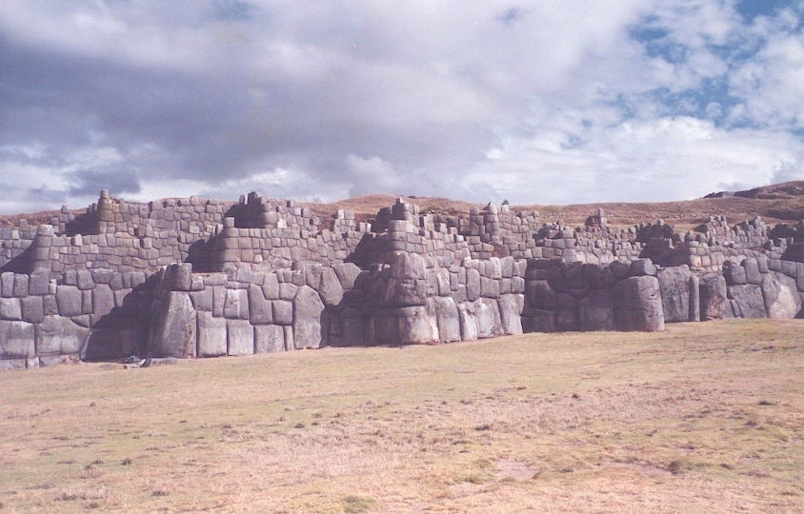

*****
The puma was the totem of Cuzco. Looking down on Cuzco from the fortress you could see the outline of the old city in the shape of a puma. The fort was the head and the tail curved outward towards the airport. Legs were formed by the main roads out of the city. The city had out grown its historic boundaries but the main roads still mark the principle features.
*****
The last stop was the so called "Inca Baths". This structure was probably part of the water distribution system for Cuzco. Water for drinking and irrigation was impounded and distributed through a series of stone lined canals and hollow log aqueducts.
*****
When we got back to the hotel, Carol had a case of altitude sickness - upset stomach, headache. She had refused the coca tea and hit the street shopping immediately on arrival. She wasn't up to supper.
To add to the fun the electric room heater did not work. Even better, the hotel did not have a converter to reduce their 220 volt system to 110 volts so I could recharge the camcorder batteries.
*****

10 June. Cuzco to Machu Picchu. At 0500, roosters began to crow. We packed the essentials for an overnight trip to Machu Picchu and cleared out of the room. The remaining bags were checked with the hotel until the odyssey resumed. Our continental breakfast in the hotel dining room was of orange or papaya juice, toast and strawberry jelly, tea or coffee.
While we waited for the guides Carol cashed some traveler’s checks and bought more Intes. There was a small army of peddlers at the hotel entrance that sold almost anything you could want. Carol attacked, was overwhelmed and forced to buy more jewelry.

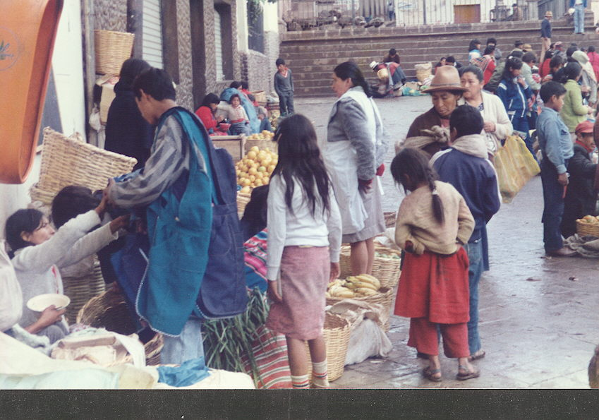

The guides arrived and took us to the Santa Anna train station. The area in front of the train station was an open market. There were a lot of stands with fruits, clothing, leather goods and household articles. It was Sunday and Sunday is the principle market day when everyone is in town shopping. It was also Election Day. It was bad planning by our agent to miss market day but this appears to be the normal itinerary. Most tours only allow two or three days to see Cuzco where a week is needed. Time. Money. Interest.
*****
Transportation into the mountains was an electric excursion train with lots of windows. It was supposed to leave at 0700 but this was Election Day and everything was behind schedule. This especially built one car train was complete with a restroom and a snack bar.
Two Peruvian soldiers were on board armed with Uzi machine guns. It was not widely publicized that from the headwaters of the Urubamba River to it junction with the Amazon was in the “red zone” where the communist Sendero Luminosa or Shining Path Maoist guerrillas were in control.
The trip to Machu Picchu took four hours. The first leg was a ride up seven switchbacks from Cuzco at 3400m (11,152 ft) to the head of the Anta Valley at almost 13,000 ft.
This was typical of the few passes crossing the Andes. Most of the passes are similar to this one--a narrow, winding strip of rocky woodland typically along the course of a mountain stream rushing down from the heights. The foot and mule paths of the past have largely been replaced or are shared by railroads and, more recently, vehicular roads. Steep, circuitous foot trails, stamped out by the passage of countless bare feet, eroded by wind and water over millennia are still the communication links for isolated villages to the outside world and the connection between the jungle and the ocean. It’s that or high priced helicopters that have trouble with the altitude.
The Anta Valley was rolling farm country that gradually became the valley of the Urubamba River. The gorge contains high desert vegetative communities. One community is Cerus peruvianas and the red-leafed bromeliad, Puya, stuck to the bare granite walls. Some of the walls were near vertical. Many of the hillsides were crossed by ancient foot trails or held the terraces where crops continued to be raised.
A fellow passenger claimed familiarity with the area. He said he was a retired US Navy officer and a member of the New Orleans Orchid Society and talked of the old days and smuggling orchids and other plants back to New Orleans.

Orchid Smuggling
A retired US Naval officer
Bragged about smuggling orchids in his hat
And has them growing in New Orleans.

He feels no remorse.
The challenge and the prize
Were paramount in his eyes.
*****
The Urubamba River is the source of the Amazon. At this level it was cold and swift and raced through a rocky canyon with steep granite sides. Several villages subsist along the river with fields and irrigation systems dating back a thousand years. Terraces and old structures were visible high on the canyon walls. We passed one of the few remaining Indian foot bridges that was still in use. A proposed highway to Machu Picchu may proceed along much of this same route some day.

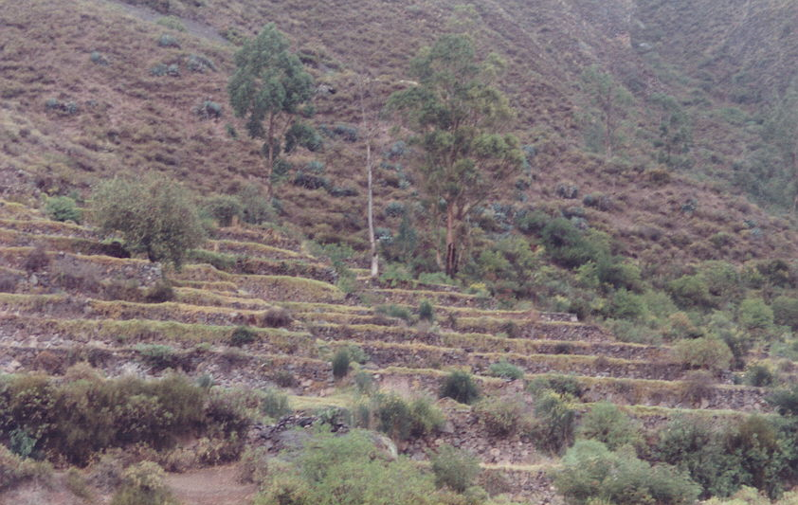

The last few miles along the river were through a high, wooded cloud forest valley with tall trees thickly covered with epiphytes. We reached the power station on the river that fed electricity to Cuzco; then, a village with a hot spring and, finally, the station at Machu Picchu.
The space for the station shouldered its way into the till at the base of a sheer granite cliff. This massif was tilted almost ninety degrees to the horizontal and rose nearly 2000 ft. almost straight up.
Vendors waited on both sides of the track to pounce on the unwary tourist. After running the gauntlet of vendors, we boarded busses for the trip to the only hotel. The road up the mountainside was 8 Km of switchbacks and climbed 1200 ft to intersect the old Quecha trail from Cuzco to Machu Picchu.
*****
We checked in and found our room. It had hot water, flush toilet and a shower. There was no TV or telephone except in the lounge and neither was very reliable.
We went down to sit on the veranda and eat the sack lunch the tour agency had packed for us. The lunch consisted of cheese sandwiches, fried chicken, an orange, a boiled egg and a bottle of Coke with no opener. (By chance, I had bought a brass llama bottle opener from the gang at the hotel.)
We sat on the terrace in the cool, damp air and watched the convection clouds form and disappear. Warm currents of saturated air rose from the valley gradually cooling until the water vapor suddenly condensed and became visible. They rose several hundred more feet until they were blown away or became too heavy to fly and plunged back into the abyss to begin the cycle over.

Cloud Cycles
Thin wisps
Suddenly appear
That float
And grow
And rise
But then
Like gorged birds
Crash
A thousand feet
To the clouds below
*****
American adventurer Hiram Bingham discovered Machu Picchu in 1911. He thought it was the sacred city of Ucabamba where the Inca had escaped and held off the Spaniards for 35 years. He discovered a group of skeletons that he interpreted as females and decided that these were the Virgins of the Sun who waited on the Inca. All this has been reinterpreted and decided that this was a luxury retreat for the Inca and his staff and that the Spanish never found it.
It appears that the builders of the site came from the farming village of Patallata several miles downstream on the Urubamba River. The question of how the stones were transported to the mountain top was solved by the on-site quarry. Estimates calculate that the construction took about 50 years probably started by Pachacuti Inca Yupanqui (1438-71) in the early part of his rein.
The tour of Machu Picchu began after lunch. It was conducted by a Quechua Indian in English and Spanish. The thinking about the origin and uses of Machu Picchu has changed since Hiram Bingham found the site. They now have several Indian versions of the Spanish invasion that differ in many respects from the Spanish version.
The most recent details of building Machu Picchu say that draining the mountain and terracing had been necessary to stabilize the mountain side since there is about 76 inches of rain and the site is bounded by two faults. They begun at the bottom worked their way upwards. A complex drainage system had to be built to provide drainage and water for drinking and farming.
The old, rounded mountains diffused lighting like the false dawn from an overcast sky, the cool, damp afternoon, the thin air, and the wandering clouds all served to make the visit memorable. The site gave the impression that it had been there forever but recent restorations made only a few months before they were indistinguishable from original Quecha rockwork. There was no horizon at times with the end of the world just beyond the rock terrace retaining wall. Then, the mist would clear, and the whole mountain top of bright yellow-green grass and grey stone structures appeared in the foreground against the dark green of Huaina Picchu. All this sharply contrasted with the bluegreen mountains across the valley.

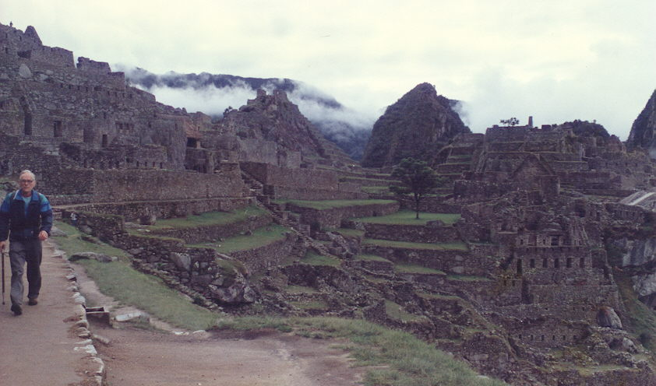

Machu Picchu supported an interesting introduced vegetative community. Peach trees and strawberries grew along with dandelions, pepperweed, and several native beans.
An abundance of mosses, liverworts, lichens and ferns thrived in this cool, saturated environment. Venus flytrap plants, Dionaea sp., grew in crevices in the rock wall. Gladiolas, naturalized at some time in the past, flashed a vivid red. Several species of native Begonia were in pale pink bloom.
About sundown, I took a walk down and around a couple switchbacks. Another Solanum, S. muricatum, also called Pepino, was common along the road. It grew to be 8-10 ft tall with pale blue-white flowers. The potato, Solanum tuberosum, originated in these mountains.
There were a couple small yellow mallows and small yellow composites. A tall flower that resembled Pentstemmon and a pretty speckled Calceolarius were growing along a stream. Fuchsia magellanica was growing at the base of the road cut along with several orchids. A bush had flowers that looked like Lapageria sp. or a large cigarette flower. I heard an occasional toad or tree frog call and several birds were settling in for the night. By the time I got back it was dark. Bats and goatsuckers were diving around the only street light.

*****

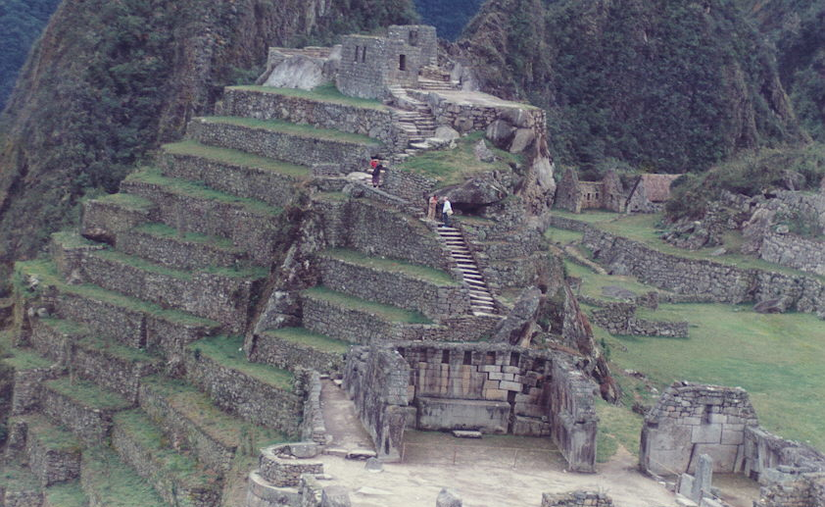

*****
As we waited for the dining room to open a couple other guests and I discussed local politics and such with the three soldiers. This had been Election Day and the guards were ready for anything with their machine guns. The communist Sendero Luminosa or Shining Path Maoist guerrillas were active and their favorite targets were small remote power plants, large electric transmission towers and isolated tourist.
I asked one of the guards to point out the Southern Cross but the clouds were in the way.
Carol still wasn't feeling well so I had supper and turned in.
It began to rain and rained softly all night.

*****
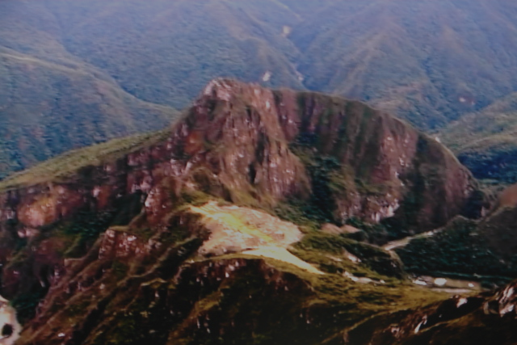

11 June. Machu Picchu to Cuzco. It was still raining at 0600 and 0700. By 0800, the rain had stopped. Carol still wasn't feeling too well, but we took a walk down the road to the first switchback. It was light but completely overcast with visibility at a half mile. White morning glories were open covering an old building. Growing in mud and standing water in and along a narrow drainage channel beside the road were Hydrocotyle, three species of Oxalis (probably O. carnosa, O. hedysaroides and O. herrerae), a clover, sow thistle (?) and an Acanthaceae that looked like shrimp plant (Belopherone sp.). We went back to the hotel and checked out, and Carol spent most of the day sleeping.
The clouds came and went, but Machu Picchu was not visible. I had wanted to get up early and photograph the sun coming up over the site, but the sun never came up.

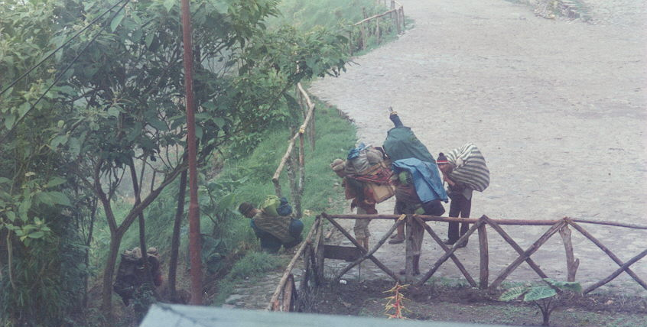

*****
About noon, a group of barefoot Indians came down out of Machu Picchu. They had huge packs. Bundles or wooden crates were slung across their backs contained in colorful wool blankets. I asked the guard who they were and where they were going. He told me that they were "Mercantadores" or porters. They carried almost everything needed to and from the mountain villages on their backs. There were no roads in the mountains only the old trails. The trail down to the railway was 2 KM straight down the hill and the descent took these hardy people about 20 minutes. Then they gathered at a camp ground near the river for a rest and a meal before beginning a three day trek by trail to Ollantaitambo.

Mercantadores
A dozen men in knee high pants
And sleeves rolled up above the elbow
Came out of the mist
With crates strapped to their shoulders
Or huge packs slung in a colorful red cloth
Knotted over their forehead.
Barefooted or with leather sandals
They walk the Inca trails
Between the small farming villages
Providing everything needed
From the outside world
And the latest gossip, too.
Ten miles a day two miles high
Coca leaf makes the time fly.
*****
I asked Carol if she could handle the bags and come down on the bus. She said she could, so I packed two cameras, binoculars and notebook and started down the trail after the Indians.
In a couple minutes, the Indians were out of sight. I took my time looking and shooting pictures. The trail was a series of short, narrow switchbacks. Some of the trail was pounded several feet into the hillside by bare Indian feet. There were also a number of stone stepped descents. The stones were inserted into the hillside to form a stairway. The trails were maintained by families as part of their taxes. The trail, as a whole, provided very stable footing.
Imagine the work of building and maintaining this trail! Clearing the right-of-way must have been arduous. Keeping the jungle growth from reclaiming the trail was and will continue to be labor intensive. Laying stones for steps that weighed up to a couple hundred pounds each required a great deal of labor. These stones were carried up from the river by hand and set in place. Switchbacks had originally been dug by hand using sticks and stone tools. Slaves probably did all the work and then were forced to use the trail to carry everything needed for commerce.
In some places, ferns similar to Bracken (Pteridium sp.) draped over the trail. There was a cool, damp, organic smell like fresh potting soil. Other sections of the trail were open to the sky with fantastic views of the jungle covered, faulted granite monolith across the river standing on its edge, of clouds rising and falling on the temperature changes and of the river valley below. Several isolated parcels of ancient terraced fields predated the structures on the top. Crops once raised remained visible as if they might still be used as well they may.
Bare granite inclines beside the trail were covered with the red bromeliads, Puya alpestris, recently past their peak bloom. A few Puya were still in bloom with stalks of dark blue flowers.
At least three different orchids were in bloom. What looked like wild ginger was also just past blooming. Coffee berries were bright red on their trees. Begonias (B. coccinea?) were in bloom everywhere. Tall grass dominated and stabilized the steep hill sides.
Vegetative communities gradually changed from tropical alpine to the tropical cloud forest. Wish I had more references and time.
Farther down the trail the tropical trees and vines became more common. There were masses of ferns that looked like Boston fern. On the wet rock walls were polypodium ferns, mosses, liverworts and selaginella.
Along the trail near the bottom was a delicate evening primrose with perfect half-inch wide pink flowers. A vine with four inch long heart-shaped leaves sprouted two-inch purple flowers. A single Indian Paint Brush (Castilleja sp.) grew in the course grass at the end of the trail.
Along the river, strawberry plants grew with tiny yellow fruit. Oxalis, Hydrocottyle, ferns and a different specie of Begonia with large, crenate leaves sprouted from the base of the river's high water berm. Tall, bare trees covered with epiphytes grew in open shade along the water's edge. Hibiscus and small bushes of several small mallows grew in cultivation along with kapok, bread fruit, pumello, papaya and coffee.
It took me almost an hour to loaf down the trail looking and shooting pictures. Other than the Indians that had disappeared, the only humans I saw were two little boys who ran up and down the trail racing the busses coming down the switchbacks. They hollered at the busses as the busses crossed the trail and the tourists hollered back.

*****
It was time for lunch so I bought two bananas, a pumello and an Incacola for about fifty cents. Inca Cola is not bad. It's the Peruvian equivalent of a Mexican soda called Bimbo or our own Mountain Dew.
It was a couple hours before the bus was due so I visited with the vendors and talked with the kids. Two little boys pointed out plants and birds and played songs on their flutes. I watched birds [small sparrow-like birds, some small, all white Least Terns (Sterna albifrons), and a Mountain Wren (Troglodytes solstitalis)], listened to the sound Urubamba River with its rushing white water and walked along the river's edge to pick up some stones for the collection.
The sun had disappeared behind the mountains when bus got in about 5 PM. The train left at 5:30 in the dark. We passed the overnight camp of the mercantadores.
There was little to see on the way back to Cuzco in the swinging headlight of the train but a slow, cold mist. We arrived in Cuzco about 8:30.
*****
Back at the hotel in Cuzco, the TV in the lobby announced that Fujimori had won the election. The Sendero Luminosa guerrillas set off a bomb near the Cuzco military barracks in protest.
We had supper and went to bed early so we could be up at 5 AM to begin the next leg of the trip.
Our room was on the top floor this time. It had a vaulted ceiling and stained glass windows. A tile dido had once run around the room but most of it had been shaken loose by earthquakes. There was a crèche with nothing in it and a funny little door that opened into a closet half the size of the room.
*****
12 June. Cuzco to Iquitos. A local rooster and the alarm both went off about 0500. We finished packing and checked out right after breakfast. I was getting the bags down to the lobby when I heard someone fire off a clip of bullets from an AK-47 automatic rifle. I mentioned it to our fellow guests but no one else admitted hearing anything. The staff indicated that such things happened occasionally.
Breakfast was good or maybe I was hungry. During breakfast, we noticed that much of the hand carved wooden trim in the dining room had been painted over - such a crime.

*****
Transportation arrived at 0800 for our 9 o'clock flight. On the way to the airport, we noticed that trucks were stopping to pick up passengers. Our driver explained that the bus drivers were on a protest strike.
Our route took us by the military barracks where the bomb had gone off. There was no obvious damage, and no one had been injured.

*****
Our airline, Aeroperu, was right on schedule - an hour late.
The flight was smooth, and the mountains were beautiful. Long shafts of sunlight pierced the clouds at times. Snow was heavy on the southern slopes with large snow fields hanging precariously over several deep, narrow valleys. The valleys were generally oriented east-west with a silver thread of a river snaking along the valley floor. As we went farther northwest towards Lima less snow was visible on the Pacific slopes.
We crossed several deep valleys - the Apurimac R. that feeds the Amazon; the Ica with the cities of La Oroya and Ica; the Pisco River in the Acucacu Valley to Pisco; the Canete and Huancayo Rivers; and the Paracas Peninsula under the clouds. Then out over the Pacific Ocean for the approach to Lima.
The abrupt changes in topography and altitude are a unique feature of the Andes. The wealthy could work in the heat and humidity of a tropical jungle farming community on the valley floor near sea level but be in the cool, dry, barren mountains in a couple hours.
Out over the Pacific the plane turned to begin its approach into Lima. We were in the clouds and never saw the water.

*****
The plane arrived an hour late but, to make up for it, the plane for Iquitos was rescheduled from 1100 to 1300 then to 1500. Since we had several hours, our guide took us into Lima to see at least some of the sights.
One of the last pre-Inca cultures developed near Lima. Chancay, located on the coast 35 miles north of Lima, was the artistic center of a subculture of the Chimu Empire. The kingdom was known as the Cuismancu. Its principal city was Cajamarquilla just up the Rimac River from Lima. Chancay was famous for the moon goddess statues, textiles with bold geometric designs and for black-on-white pottery with "optical" checkerboard designs of dots and lines. This culture existed from about 1000 to 1400 AD.
Lima was Pizarro's capitol of the new world. After sacking Cuzco, Pizarro decided that the Quecha capitol was not suitable for his administrative center. He needed communication with Spain, so he established Lima which translates as "City of Kings." Lima was ten miles from the anchorage, later the seaport, of Callo on the delta of the Rimec River. This is one of the few river valleys on the Pacific side of the Andes capable of supporting a large population.
The Plaza de Armas was the site where Pizarro was supposed to have drawn the map of the new city on the ground with his sword. That was in 1535. This was the second time Pizarro drew a magic line. Eight years before, in 1527, he had drawn a line for those who would accompany him to Peru. Thirteen accepted, and the rest returned to Panama. Pizarro and his group found Tumbes on the Incas northern frontier. They saw advanced architecture and a well-organized government. Fine wool textiles and worked gold and silver were more than enough to convince him that more would be available farther south.
Pizarro returned to Spain in 1528 and got the backing of King Charles V. He returned to Panama in 1528 as Governor and Captain-General of Peru and adelantado or agent of the Church and King. He was accompanied by his four brothers and some volunteers from his home town of Extremadura, Spain. In late 1530, he left Panama with 180 men and 27 horses for Ecuador. They marched south long the coast until November of 1532 when they arrived at the Quecha capitol of Cajamarca.
Atahualpa, the Inca, had recently won a civil war defeating his cousin and imprisoning him in Cuzco. Pizarro requested an audience during which a priest lectured Atahualpa on the supremacy of the Pope and the King of Spain. At a signal, the Spanish fired on the crowd and took the Inca prisoner. For two months, the Quecha Indians brought gold to fill a room as a ransom for Atahualpa. Pizarro then accused Atahualpa of treason, condemned him to death and baptized him. The Inca was executed by strangulation, and Pizarro headed for Cuzco.
*****
The government palace and the main post office of Lima front on the plaza as does the present cathedral. The city was virtually destroyed by the earthquakes of 1687 and 1746. A new cathedral was built each time on the original foundation.
We toured the cathedral and saw Pizzaro's tomb. In 1537, Pizarro had defeated Almargo, one of his oldest friends, and had him strangled. In 1541, Pizarro was assassinated by a band of Almargo's men. Francisco Pizarro, an illegitimate child of peasant background, ruler of all South America, died at an old age of near 70 years.
Pizarro was a late bloomer and a victim of serendipity. Columbus and later explorers had killed or enslaved most of the Indians on the Caribbean islands. Cortes wiped out the Aztecs and northern Mexican culture. Alvarado killed a million Mayans and subjugated Central America. But there were still rumors of gold, and Pizarro wanted his.

The Conquistador's Excuse
The Conquistadors consuming greed
was disguised
and excused by the need
to convert or kill the infidel
who would not accept the Catholic creed.
European diseases
gave genocide God's speed.
*****
The forty year old Pizarro was an illiterate farmer from Trujillo, Spain near Estremadura. He joined the gold rush in 1510 and met Cortes, a distant relative, in Hispaniola but decided to join Balboa. He was with Balboa in 1511 when the Pacific was discovered. He was shown some gold trinkets and a drawing of a llama.
In 1523, Pizarro was in Darien (Panama) under the supervision of the incompetent Pedrarias Davila, Balboas' successor. Pizarro owned a parcel of swamp and a repartimento of belligerent Indians. Frustrated, he joined forces with an old friend, Diego de Almagro and a priest, Hernando de Luque, in outfitting the first of three explorative voyages along the coast of Ecuador.
The first and second voyages were near disasters. The third voyage landed on the Island of Gallo in 1527 where his famous line in the sand separated men from boys and launched the conquest of the Incas.
The Cathedral contained massive and intricate carvings in its many chapels. The work must have occupied many Indian sculptors for a lifetime. The museum in the Archbishops' palace holds carvings and paintings by Indian artists. The Indians portrayed Mary and Christ with Indian features.

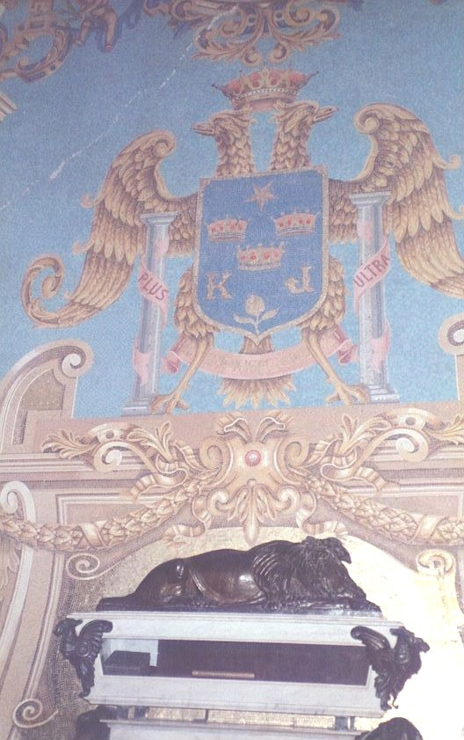
*****
Next stop on this whirlwind tour was the National Museum of Anthropology and Archeology. There had been a guerrilla attack on the electrical transmission lines into Lima in response to the election results. Electrical service to the museum was cut, and the lights were off when we started the tour. We got a personal private tour by flashlight. The lights came on half way through the tour.
The museum was very well organized with displays in chronological order. Chavin de Huantar from 850-300 B.C. with its cat god cult was the earliest culture. Crude pottery replaced gourds. Corn and potatoes became dietary staples. Cotton cloth replaced pounded bark clothing. The llama and alpaca were domesticated. The relative peace between 300 B.C. and 200 A.D. allowed the arts to flourish around Nazca and the Paracas Peninsula. The Nazca lines were probably astronomical observatories. Next major culture was the Moche about 400 A.D. and lingering until about 1000 A.D. when the Tiahuanaco invaded from Bolivia and the Lake Titicaca area. The Moche was naturalist artists of portrait pottery. Architecture and medicine flourished. The explicit sexual art of the Moche was also memorable. The Tiahuanaco were noted for the crying figures. The Kingdom of Chimor absorbed the Mochicas that were left. The elegant polished blackware and gold smithing were the major legacy of the Chimor. Then came the Incas. The displays were very good. Wish there had been more time but an hour is better than nothing.

*****
Back at the airport, we found the flight delayed further. We had been scheduled to be in Iquitos for lunch and a tour of Iquitos. We had lunch in the airport and the plane finally left at 8 PM.
A snack bar in the airport had hamburgers on the menu. The burgers came open faced and tasted like a strong meatloaf. Local yellow potatoes were used for the fries. These tasted sweet - more like fried yams. About sundown, we tried the Peruvian version of an ice cream parlor for a coke and a dish of ice cream. Their idea of a dish of ice cream was three big scoops - almost a pint. I had mango and Carol had vanilla. That quality of the ice cream would never sell in San Antonio.
Carol ran out of reading material. And, since we had been to all the boutiques several times, she bought a Miami Herald for two dollars. We devoured this newspaper until the plane finally left.
We watched a Russian Aeroflot Illusion airliner from Havana landed and unloaded about a hundred passengers.
Boarding the plane was like boarding the one to Cuzco except it was in the dark of night. The plane had only one overhead storage compartment so most of the packages and carry-on luggage was stacked in and under seats. The door of the overhead bin swung in the breeze the whole trip. Luckily, nothing fell out.
There was a stop in Pucallpa. The 727 landed with the flight deck door open. I could see the runway lights from our seats in the rear of the plane. Another half hour flight over absolute blackness and we landed in Iquitos.
*****
Iquitos, an island of light in the velvet black, was completely isolated from the rest of the world for access by land. The only ways in or out of town for everything was by the Amazon or by air. It was surprising to see so many cars and trucks.
The tour representatives picked us and another couple up at the baggage counter. Downtown was about three miles to the southeast of the airport along the river. Traffic was light but then it was 11 PM. Most of the traffic was motorcycles and motorcycle taxis. They drove all over the road which was a narrow two lane blacktop roadway.
The Hotel Turista was an aging four story hotel overlooking the Amazon and Padre Isla. We unpacked, and I plugged in the battery charger for the camcorder batteries (I discovered the charger would work on anything from 90 to 240 volts AC or DC). Carol was tired, and I was hungry. She went to bed, and I went out to eat.
An open air restaurant a block down the street was alive with light and Indian music. Several tables of American and Canadian students appeared to have had a beer too many. A five-piece Indian band was playing local songs with flute and drums. I ordered a dish called Gallo Saltada. Very good. After a while, the musicians left and so did I.

*****
So far on this trip we missed scheduled tours of Lima and Iquitos. We also missed the Sunday market day in Cuzco. A no cost extra was being scheduled in Cuzco on election weekend with most businesses closed and the Army very visible with their automatic weapons. Looking ahead, we would be in Buenos Aires over a national holiday when most things would be closed. Then there was Pizzaro's children's airline! Aeroperu had a practiced inability to keep schedules. For this trip travel agents and tour companies’ rank close to car salesmen and politicians in credibility.

*****
13 June. Iquitos and the Amazon Camp. I woke up at 0600 with the breaking dawn. It was still a few minutes before sunrise. As I looked out the window, several Greater Ani (Crotophaga major) were picking up crickets and other insects on the ledge outside our window. A Gray-capped Flycatcher (Myiozetetes grandensis) was filling up on blackflies and other insects from a perch high in a mango tree across the street. I turned the air conditioner off and opened the window to hear the Amazon sunrise. The flycatcher was announcing his territorial boundaries, and the tree frogs were finishing their night of calls of impending love. It was not quite the cacophony I had expected from an Amazon sunrise.
AMAZON SUNRISE

Sunrise on the Amazon
Did not assault the senses
But slipped in on the dying night sounds
As the light increased in slow increments.

Parrot-like Greater Ani
Chased crickets
On the ledges outside the windows.

Trilling of frogs
And polymorphic insect noises
Disappeared in the humidity
As day began.

A White-capped Flycatcher
Perched on a erect mango branch
Sprang upward through a cloud of blackflies
Staking his claim and calling for a mate.
******
About 7 AM, vendors began appearing along the street across from the hotel getting a head start on the day. One was a woman with a tray of empenadas. Another was a man with a wheeled stand that sold gum, razor blades and other small items you might want.

*****
We went down for breakfast (fried eggs with Nescafe hot chocolate) and then out to see this world. We crossed the street to look at the Amazon and then walked around the block. It was only 8 AM and nothing was open. The Plaza de Armas was empty of people but full of tropical pastel color. A large African Tulip tree (Spathodea campanulata) was in full bloom. Manila and other palms studded the plaza. Red Hibiscus (Hibiscus rosa-sinensis) was colorful and conspicuous flashes of color. A fountain in the center of the plaza was three tiered and painted pink and lime green. The third tier featured a large pink dolphin atop a shaft that looked as if he was skewered through his belly button. The cathedral and the Rio Amazonas office both fronted on the plaza.
Along the river Bananas (Musa spp) and big green-leafed Taro (Colocasia esculenta) were cultivated. Multifarious shades of green were the majority.
We stopped a taxi and took a ride to the end of civilization – the port of Belem. The taxi was ancient and well used with a windshield so dirty that it was difficult to take pictures through it. This was the port area, a stilt village called, "the Venice of the Amazon." The street into the area was one way. Much of the street was one lane and full of ruts and holes. It was shared by motorcycles, trucks, bicycles and pedestrians. We stopped several times for trucks to edge past or for people, loaded with chickens or a stalk of bananas, to cross the street.

The Belem Market

People everywhere in the cool of dawn,
Produce to market and products back home
Carried on the backs or heads of Indians and Creoles
Before it gets hot and the sun, humidity and flies rise.
Displayed on palm leaf mats, everything you need-
Fish, chickens, rice, bananas, voodoo charms
And they can fix your motorbike too.
*****
People were everywhere in the relative cool of dawn. The sun and flies would drive them back home soon. Most of the produce was carried on backs or balanced on the heads of pedestrians. Bags of rice and stalks of green bananas were on backs or shoulders. Unidentifiable bundles, crates and other containers were balanced or supported on the head.
In Mecardo Belem, the market place, were endless stalls and small shops. Most of the material for sale was displayed on banana leaves or palm leaves spread on the edge of the street. Shops or street vendors sold anything sellable - bananas, cheap plastic goods, live or fresh killed chickens and hogs, fresh fish, dried fish, native herbal medicine. They could even repair your motorcycle and outboard motor while you waited.

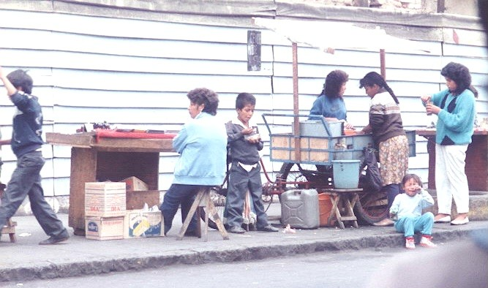

The vendors and shops stopped at what was probably the high water mark. The buildings were on pilings that got taller as we descended into the flood plain of the Amazon. High water marks on the poles showed that the water line was 10-12 feet above the ground. Finally, there was no more road so the driver turned around and returned along the same route.
Apparently, everyone had to carry his/her own weight. An old man was crossing the street with an enormous stalk of bananas. He stumbled and dropped his load. Traffic stopped and several people helped him get the load back on his back, but no one offered any other assistance.

*****
By the time we got back to the Plaza de Armas, it was 9 o'clock, and the stores were open. I bought another video tape and two more rolls of film. Half a block from the hotel, we found a shop that sold local handicrafts. Items included local jewelry, stuffed piranhas, and pictures on tapa cloth (Mulberry bark), postcards, and pottery. There were also some of the Inca pottery and wool items from the mountains. We picked out our treasures and returned to the hotel to checkout and meet our guide.
Across the street from the hotel was the Maloka restaurant that looked out over the Amazon. It wasn't open but we walked over to look at their view. Bananas, taro and miscellaneous vines and shrubs rushed down the steep river bank down to the mud flats. The river was about twenty feet low since June is the middle of the Amazon winter dry season. Rice had been broadcast over the mud flats which were turning lush green.

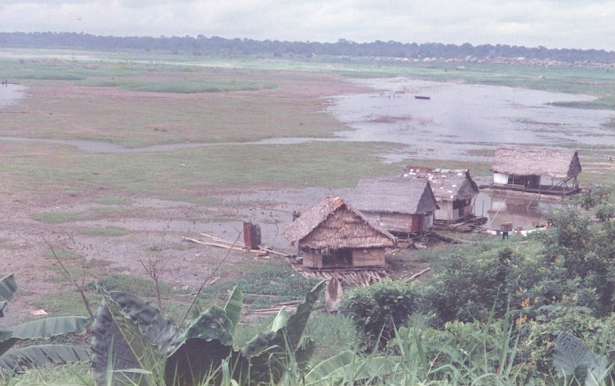

BELEM

Called the Venice of the Amazon
Belem is built mud, and stilts and
of floating homes that ground
on the mudflats of the Amazon summer.

Roofs thatched and patched with tin,
electric lines strung on trees and
on poles shared with vultures.

A raft of logs serves as a lawn
where children play,
and planks are sidewalks
floating on a sea of mud.
*****
Thatch roofed houseboats had been grounded in various locations. Their 24 VDC or 240 VAC electricity was delivered by wires tied or nailed to poles pushed into the mud. Most of these power poles had a vulture perched on the poles' top. Two large flocks of vultures were gathered on the mud for separate feasts.
Log platforms formed the front yard of some of the houses. Catwalks made of logs on top of the mud lead to water deep enough to float a boat. Some of the thatched roofs were patched with tin sheets. Several structures that looked like privies were located on some of the catwalks some distance from the houses.

*****
Transportation arrived at 10 AM. It was the same old Ford that had transported us to the hotel on the previous night. The tour people would pick up the bags later and deliver them to the M/V Rio Amazonas.
The Ford drove down the morning's route, then farther to a dock on the Nanay River. The road was a single lane, rutted trail that ran right to the water's edge. Temporary tin covered sheds lined the road. Users of the landing had the opportunity to purchase snow cones, fruit, vegetables, fish, etc. fresh or cooked by local vendors. The water had receded another five feet since the sheds had been installed. Flotsam identified the water line - plastic, citrus peels and other trash. Modern floodlight standards along the road were a contrast to the otherwise primitive third-world setting.
Children and dogs played in the potholes full of water and along the edge of the river. Several children were paddling small canoes in the shallow water.

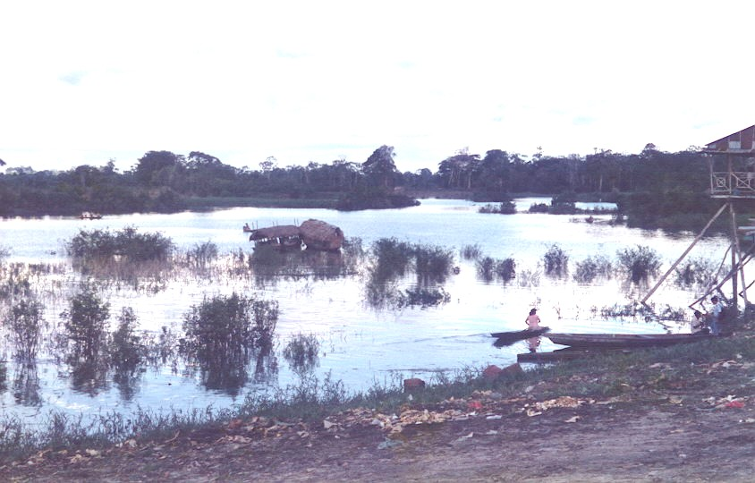
We crossed down the muddy incline and boarded the ferry to the Amazon Camp. Up the gang plank and duck under the thatched roof of the boat. The boat was about 6 feet wide and 25 feet long with a square stern and a 25 hp OMC motor.
*****
The boat backed out, and we started up the Nanay River. We passed a local oil refinery and a ship yard, past the country club and its golf course and another half hour up the brown Nanay River to the Amazon Camp. We overtook several small canoes with fishermen pulling gill nets along the rivers' edge. A number of other canoes using the river contained family groups and produce on the way to or from market.
Amazon Camp came into sight as a pair of thatched roofs in the trees. Constructed of large floating logs with some planks lashed to their tops, the boat landing floated on the water rising and falling with the flow of the river. We off-loaded and climbed twenty feet up a wooden stair to a large, thatch-covered room with only a guard rail for walls. Here we met our guide, a spider monkey and a marmoset. A green parrot and a Scarlet Macaw (Ara macao) were also present but not very sociable. The monkeys were immediately into everything anyone left unattended.
Lunch consisted of fried fish, taro, palm salad, slices of banana and mango. Iced tea or Inca Cola was available to drink. After lunch, the guide briefed us on our upcoming short trek through the jungle.
On the edge of the river bank and out over the river were three-foot long purse-shaped nests of Green Oropendola (Psarocolius viridis) hanging from the branches of a tall Cecropia tree (Cecropia sp). Parrots were screaming in the distance across the river.

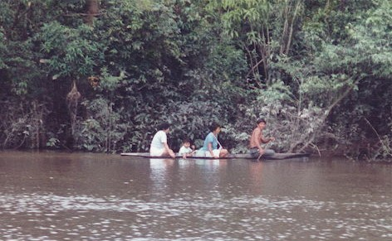
A canoe with four armed soldiers motored past up river. A few minutes later, a long canoe came down stream containing five adults and several children. It also contained several plastic coolers filled with fish and many bunches of green bananas.

*****
As we gathered in a clearing behind the dining room, the guide pointed out various trees - banana, Cecropia, red kapok (Ceiba pentandra), etc. A vulture with wings spread was sunning itself in the top of a large red kapok tree.
The spider monkey decided to come along for the walk. He wanted to be carried. Since no one would carry him, he climbed vines and jumped on everyone. The path or trail lead first, through second growth jungle. A slash and burn field was slowly becoming jungle again. The jungle was absorbing relic banana plants, ginger and other field and door-yard plants crops. The path was well worn and lead to a village about a quarter mile from the camp.
The village consisted of four thatched structures. Each house consisted of a covered platform raised on poles about five feet off the ground. A notched log served as a stair. The house consisted of an enclosed room about eight by twelve feet wide and a roofed open space about ten by twelve feet. The walls were made of light weight poles of a local mallow plant. The roof was made of overlapping layers of nippa palm fibers. There were about seven courses of the fibers capped with a ridge cap of woven palm leaves. The open area was protected by railings of wood lashed to the uprights. A separate small cook shack behind the main structure provided a place to safely store and prepares food without danger of burning the house down.
Dogs, hogs, and chickens rested under the houses out of the sun. Clothing hung on the railings and on lines strung across the porch. Children played in a hammock slung on the porch. Additional hammocks hung triced up waiting for nightfall.
We continued through the village to an open field. Indians in native dress met us with native jewelry, blowguns and other items for trade. One of the men demonstrated how to handle a blowgun and let us try. He hit the banana tree target two out of three shots. I hit the base of the target on the second try.
The monkey tried to get at the trade goods strung on a line, and the children did their best to keep him away. They harassed the monkey, and the monkey responded by climbing our legs rather than up the nearby trees.
A quick walk and we were back at the camp. We passed through another field being taken back by the jungle. Some small trees were appearing along the edge of the field but swordgrass was taking over most of the open areas. Swordgrass would probably remain the dominant vegetation for some time.
*****
Back at the camp, everyone rehydrated and enjoyed a coke or beer. We relaxed, bought souvenirs and got acquainted while waiting for the transportation back to Iquitos to board the M/V Rio Amazonas.
An addition to our group was a school teacher from Ft. Worth. She had been staying at the camp. She had made several trips to the area and was photographing and collecting artifacts for a book on primitive art.
The trip back down the Nanay was uneventful. We off-loaded into several vintage automobiles and went to the main dock area. The M/V Rio Amazonas and several local ferry boats snuggled together. They were connected to the shore and each other by a series of planks.

*****
We boarded the ship and were shown to our room. Our luggage was in the room on the bunks. The suite consisted of three spaces. There was an 8 X 10 foot room with two bunks, shelves for life preservers and two 28 volt lamps. The bath was 4 X 6.5 feet and serviced by river water. A two liter bottle of potable water was provided for drinking. The bathroom had a 220 VAC receptacle. The entrance hall was 3.5 X 4 feet and contained two air conditioning ducts in the ceiling. We had a porthole covered with a cloth shade.
A get acquainted meeting was held in the lounge. We were introduced to the captain and crew and to our guide, Beder Chavez. Other passengers included an Army Reserve Colonel Story and his wife from New Orleans, a couple from New York, an engineer from New Jersey, the school teacher from Ft Worth, a retired Amazon riverboat captain and his wife and a German national and his Peruvian girl friend.
We left the dock just before sunset and watched the sun disappear into red and orange clouds over the skyline of Iquitos and the Eiffel Hotel. Dinner was at 8 PM.
*****
14 June. Down the Amazon. I was up at 0500, before the sun. I took a camera up to the bow to photograph the Amazon sunrise. The Rio Amazonas was moored to a tree near the mouth of the Rio Apayacu. I was a little surprised there were no mosquitoes or black flies. The temperature was about 72 degrees F. I did some yoga stretching and went through the first three Shotokan katas twice.
It was just getting light and the world was still and pastel. The sun was fighting its way through a cloud bank. It finally lit up the tree tops then rapidly painted the world with sunshine down to the very river.

Amazon Morning

From the bow the Amazon River
Was flat as a mirror.
Not a breath stirs in the false dawn.

The sun fights its way
Through a cloud bank and
The first bright rays
Lit up the tree tops.

Along the rivers edge
A lone fisherman tended his nets
From a dugout canoe.
A vee-shaped wake
Points to a canoe with a man and woman.
The dipping paddles just audible
Across the water.
*****
In the distance drifted a canoe with a fisherman working the edge of an island in the river. Another canoe paddled by a man and woman crossed the river 200 yards off our bow, leaving a sharp Vee of ripples to mark its passage.
*****
By the time the sun came out, everyone was up and ready for an 0600 birding trip up the Rio Apayacu. We loaded into two aluminum boats for the trip. The water was so still and flat it was difficult to tell the water from the sky.
We were out for about an hour and saw a number of birds. The Oropendola or weaver bird always builds its nest hanging over the water. Wattled Jacanas (Jacana jacana) were walking on vegetation at the water's edge. There were also Yellow-backed Oriole (Icterus chrysater), a Black–Collared Hawk (Busarellus nigricollis) and a Gray Hawk (Buteo nitidus). Several Ring-billed Kingfishers (Ceryle torquata) flew across the river while Gray-capped Flycatcher (Myiozetetes grandensis) and Black-tailed Flycatcher (Myiobus articaudus) made looping forays against blackflies. A Hermit Hummingbird family (Phaethornis sp.) worked its way along the river bank looking for flowers. Several pairs of Yellow-Headed Parrots (Amazona ochrocephala) and Toucanettes (Aulacorhynchus sulcatus) flew over; the parrots were always seen flying in pairs. An Oven Bird (Seiurus aurocapillus) was building a nest on a small branch out over the water. We heard several Horned Screamers (Anhima cornuta). Their calls reverberated through the trees and carried a long way on the still air.
A single sloth was spotted on this trip. It was high in the small limbs of a Cecropia tree and visible only as a dark silhouette against the light gray sky. It moved slowly. It took a short time to tell that it had moved.
Many trees grew along the river. Most of them had the ability to grow partially submerged for part of the year. The trees are covered with vines and epiphytes. Bromeliads, aroids, orchids, and Philidendron abound. Members of the Melastomaceae, Piperaceae, Discorea, Marantaceae, Passiflora, and Gesneriaceae were common.
*****
We caught up with the Rio Amazonas and had breakfast while steaming up the Apayacu River to our next stop. This was the village of Pucaurquillo shared by the Bora and Huitoto Indians. These two tribes were closely related like cousins and have similar but distinct customs and languages. They both migrated from the state of Amazonas in Columbia in the 1930's where the Indians had been virtual slaves to the rubber barons. They were paid little to collect wild rubber from the jungle, but were harshly punished for not meeting stiff quotas. Penalties included disfigurement and mutilation. The Peruvians were probably not much better as humanitarians than the Colombians but whole tribes did not migrate to Colombia.
Our guide escorted us into the village through a field of grass and chiggers. We passed thatched huts on either side of a graded dirt road. Sisal fiber hung on poles drying in the sun. Most of the houses were as described for the village near the Amazon Camp. One of the houses was unusual in that it had a second story. Also, several sheets of corrugated metal roofing formed part of its siding.

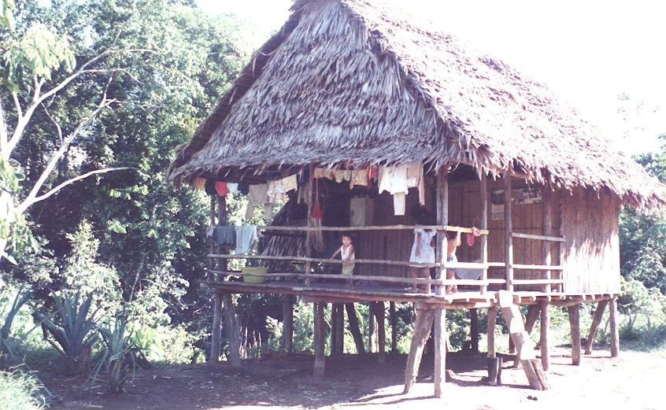

A few children walked down the street with us. We stopped by several of the houses where children swung in hammocks as their mothers looked on. All the children appreciated chocolate and one member of our party obliged them with M&M's.
Our guide led us to a large, circular pole framed building with a thatched roof. Most of the villagers were waiting for us with trade goods on display. The structure covered about 4000 square feet. The walls were of straight saplings spaced and tied about an inch apart. The eight foot wide gate was similarly constructed. The gable ends were open and oriented to catch any transient breezes.
Trade goods included carved gourds (Kataka or penis guards) and handmade jewelry made of feathers, seeds, clam shells, piranha jaws, etc., strung on sisal fibers. There were also pictures of birds and animals drawn with natural dyes on the inner bark of a ficus tree and carved parrots. Some of the pictures we saw later contained unnatural colors that came from a felt-tip pen. Baskets and items such as canoe paddles and blow guns were also for sale or trade. They mostly wanted to trade for dollars. We bought a several items and I traded baseball caps for a few other items.
One of the most common necklace materials was the tall skinny acai (Euterpe oleracea) a palm raised for food and herbal properties. Another was the Pau-Brazil (Caesalpinia echinata) a timber tree.
A couple of girls about ten had dressed up and put on some lipstick they had traded for. I let them to look at the playback through the camcorder. They were tickled to see themselves on tape.
Most of the Bora adults wore native attire. Men wore a loin cloth and headband. The women wore only a knee-length skirt. The material was the inner bark of the ficus tree. Decorations on the ficus bark cloth was brown vegetable dye and looked like a geometric coiled snake.
These Indians appeared to be in good physical condition. They were brown-skinned, small - 5'4" or less - and thin with straight black hair. They had few scars from accidents or disease but no tattoos or ceremonial scars. All had the mongoloid mark, a bluish area over the kidneys. Many of the adults had broken or missing teeth.

*****
The MEDCAP had reported an outbreak of dengue began in the Punchaua port area near Iquitos in April. Between 100,000 and 150,000 cases were reported to the World Health Organization along with several hundred cases of hemorrhagic dengue fever from southwest Venezuela. Besides dengue, the DVDP noted three types of malaria, yellow fever and several internal parasitic infections including leishmenisis are endemic to the upper Amazon. None of these were obvious in these people.
We had our shots updated before we left - yellow fever, tetanus, typhoid, cholera, polio and plague - and had a gamaglobulin shot for good measure. A course of weekly chloroquine tablets for malaria was started two weeks before we left San Antonio and would continue this for a month after we left the Amazon. Fansidar tablets were also available in our emergency supplies in case of onset of malaria symptoms. These emergency supplies also included Pepto tablets, DEET insect repellent, Neosporin ointment, Bactine spray, an itch reliever and SPF 15 sun screen.
*****

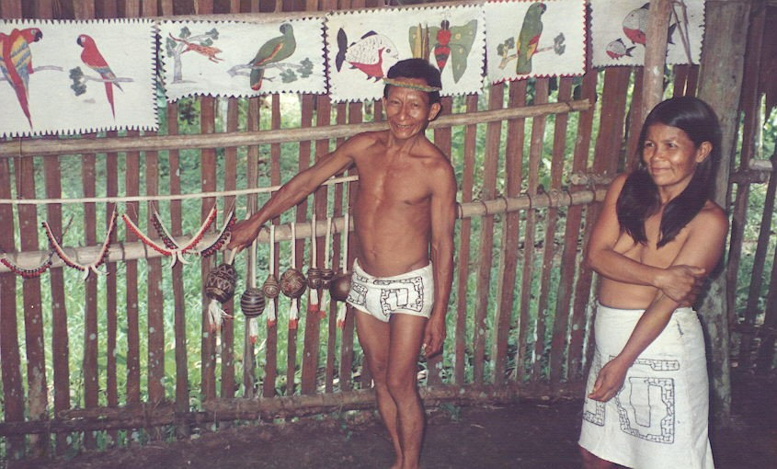

*****
After the trading session, we were taken to the Huitoto village. On the way, we passed the local general store with its thatched roof. It had 1 X 10 board siding painted bright blue and a corrugated tin awning. The windows had no screens but did have wooden shutters. The street in front of the store was dirt but had been graded to provide drainage along the edges but there was no tractor or any other vehicle in sight. A sign in Spanish advertised cerveza (beer), gaseosa (sodas) and curichi (snacks). Near the store were several children dressed in conventional shirts or T- shirts and shorts or jeans. The one adult male was shirtless, slightly potbellied and wearing shorts. At least two pre-teen girls were carrying big, healthy looking babies around. They all looked healthy.
We walked across a field of grass used to pasture carabou and for soccer games. The field covered about ten acres. There were no mosquitoes but chiggers were present. DEET on the ankles and socks worked well to prevent chiggers.

General Store

On a bluff above the Apayacu River
A few miles from the Amazon
Sits a lone general store.

Bright blue planks and a thatch roof,
A corrugated tin awning and no window screens
They sell cerveza, gaseosa and curichi
But no chocolates.
*****
In the village of the Huitoto, we entered similar thatched meeting hall for an exhibition of their native songs and dances. The Bora and Huitoto alternated in holding the dances and craft sales.

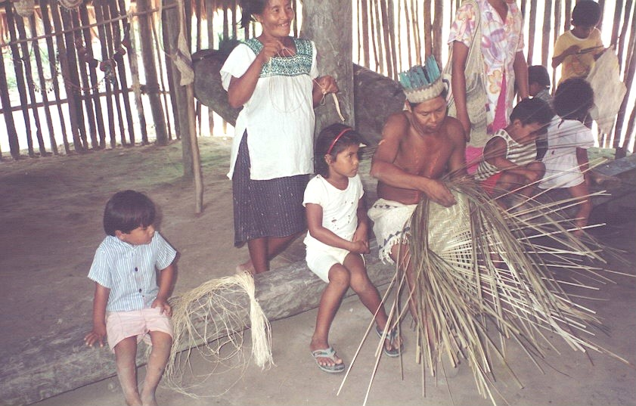

The Huitoto native dress was of the same material as that of the Bora. Men wore the loin cloth but the females wore sleeveless dresses that extended half way down the thigh. Their tapa clothing had a fringe and the decoration consisted of geometric figured stripes and edging. The women had painted ankle and wrist bands of white with brown trim. The men were had white dots in a curving line on each side of the chest from shoulder to hip. Several of the men had scars in the same pattern instead of the white dots. Both men and women wore head bands of tapa cloth and feathers except one man who had a snake skin that trailed down his back.
One old woman had moved with the tribe from the Putumayo River area of Columbia when she was six. At seventy, she was still very active and right in the middle of the dancing exhibition.
The Huitoto had some trade goods but their primary concern was demonstrating crafts and the folk dances. They sang and danced three dances for us. One dance was about a turtle. Another was about an anaconda and involved stepping in a springy log about thirty feet long. The third dance was neither announced nor discussed but looked and sounded much like the others.
After the demonstration, we started back down the dirt road toward the field. A turn off the road lead to an incline studded with logs leading down to the river. Near the bottom of this cord road was a large house on stilts. This was probably the main landing during high water. Several little boys were playing in boats tied to the shore. A covered log raft was loaded with sawed lumber was tied to the shore nearby.

*****
We boarded the Rio Amazonas and sailed on down the Apayacu for a couple miles. The next stop was for a trip into the jungle. There was a house at the boat landing in which an Indian woman of indeterminate age was preparing supper. She was asked about preparing manioc and demonstrated how to peel and prepare it for cooking.
The jungle trip began with a short walk through a field that was going back to the jungle. Bananas and two kinds of ginger were relicts of man's activity. Several other dooryard plants were also visible but would soon be crowded out by native growth.
At the edge of the jungle we saw the flower and seed of the Amazon Lily (Eucharis grandiflora) and many of the plants found in plant shops as specimen plants - Marantas, Calatheas, Heliconia, Miconia, ariods like Diffenbachia, etc.
A convoy of leaf-cutter ants was speeding along a vine with large pieces of leaf to transport back to their nest hanging above high water.

Leafcutter Ants

Half inch ants in tandem
at half inch intervals
each with a large leaf umbrella
their life is never dull.
Down a branch to the trees trunk
onto a wavering vine to a nest on a limb
they shred the leaves and add fungi
and tend their gardens above high water.
*******

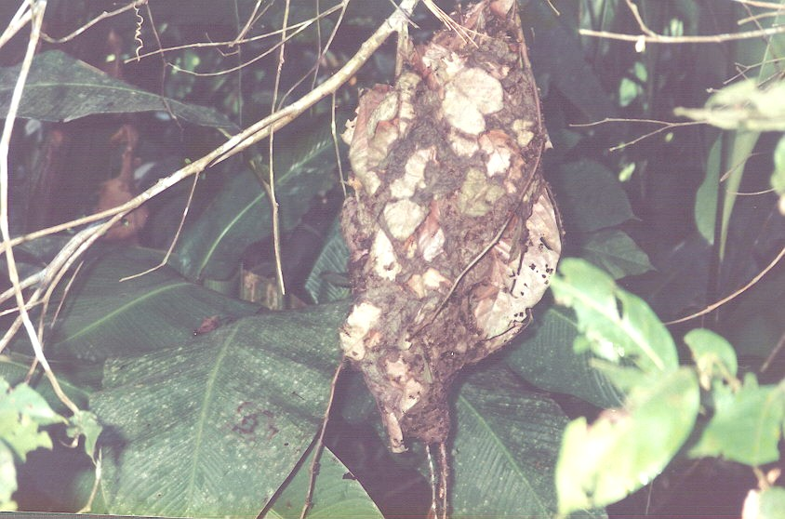

A large nest of very touchy ants was hanging from a limb near the trail. A group of plastic looking, tough textured, salmon colored cup fungi were growing out of decaying vegetation on the jungle floor. A termite nest surrounded a tree trunk about ten feet above the ground. One tree supported a population of mean ants that lived in the plant's hollow spines. These ants kept the tree and the ground around its base free of competition from other terrestrial plants, parasitic plants and insect pests.
We encountered an army ant trail by stepping in it. Several people received painful bites. The trail was several inches wide and disappeared into the jungle in both directions.

Army Ants

I had heard stories of Army Ants
Charging through the jungle
Devouring everything in their path.

A gross exaggeration
But the are vicious.
A three inch trail disappears
Into the jungle in a few feet both ways.

A misstep on the trail
Resulted in three quick bites
And quick forays by the ants
To see if there were anything to eat.
*****
A vine grew with spiral form of leaf growth to prevent shading its own leaves. A plant called the Upside Down Tree was a screw pine. It had more bulk in its spiny buttress roots than in the vegetative growth that extended twenty feet into the air.
This was where I spotted a small black and red lizard; and we captured a Dead-Leaf Toad that looked like a dead leaf. I was disappointed at the lack of butterflies but it may have been the wrong season.

Jungle Drinking Water

Most natives drink directly from the Amazon
Instead of boiling or filtering the water.
Then they drink some juice of the ficus tree
Twice a year as a purgative just like they ought to
To kill the internal parasites from the river.
No tea or fuel to boil the water.
*****
Bedar showed us a ficus tree whose buttressed trunk was twenty five feet across at ground level. This tree's poisonous sap was used by the natives to purge the internal parasites accumulated from drinking the raw river water. About once or twice a year, everyone takes the cure rather than boil the water. He also showed us a plant that was supposed to cure snake bite. He claimed his father had been zapped by a Fer-de-lance and lived thanks to this plant.
We finally entered another recently abandoned field that was grown over with swordgrass. As we passed a big breadfruit tree a chorus of frogs piped our way into the clearing near where the boat was moored.

*****
We sailed down the Amazon past the major town of Pevas where we turned back upstream and docked for a customs check. While we waited for the local authority, we watched a herd of carabou on the mud flat. Cattle egrets were eating ticks, etc., off of them.
While we waited, a local ferry pulled in for their customs check. This was two hulls fastened together with one engine. The deck was covered but otherwise opens to the elements. Hammocks were hung and people were in them or on the deck. A woman came back to the stern and pulled up a bucket of water from the river. She poured this over her head and down inside her dress. Then she combed her hair and was ready to go ashore.
A canoe with two women and a large pot paddled up to the stern port quarter of the ferry. The pot contained soup which was sold by the bowl. A single plastic bowl was rinsed in the river and refilled for the next customer. One of the women noticed the boat was taking on water. She used the bowl to bail out the boat before filling it for the next customer.

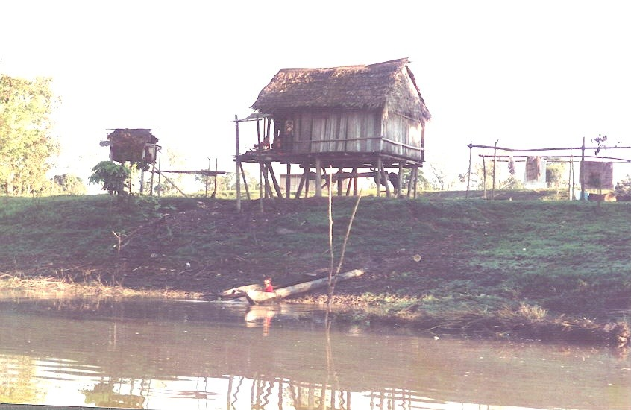

Pevas Fast Food

We stopped at Ft Pevas on the Amazon
For a passport check.
I watched a local ferry with people sleeping
In hammocks and on the crowded deck.

A dugout pulled up beside the ferry
Two women and a pot of stew
The stew was sold from a single bowl
Rinsed in the Amazon just for you.

One woman noticed the dugout
Was taking on a little water.
She used the bowl to bail it out
Before serving the next customer.
*****
Finally, a young Peruvian Army captain, complete with sword, came down from the compound accompanied by three men in flight suits. They boarded and inspected the documents and walked around the ship. After the official inspection was over, there was a little time for socializing. The ones in flight suits were two officers and a sergeant from a helicopter squadron of Hueys that supported this and the other river forts. They had trained with the US Navy.
*****
Leaving the check point we backed into the main stream of the Amazon and stopped at a river camp near the Yana Yacu River.
After supper, we went out to hunt caiman. Two boats went out. Our boat spotted a pair of red eyes but they disappeared before we got close. The mosquitoes were not out in force and did not bother unless we were close to the shore. A few minutes later, we spotted another pair of eyes. The boat drove into the cane along the shore. Bader grabbed and came up with a caiman about four feet long. We looked at it and shot pictures. Then, we showed it to the other boat and released it back to the river. One good point about the caiman is that it controls the Piranha population.
On the return trip we made a detour up a small stream to sit for a few minutes and listen to the jungle. Several species of frogs and toads were calling, and several night birds added unique punctuations to the stillness. We bumped a patch of water lettuce in the dark. It lit up with hundreds of fluorescent spots of cold blue light.
Several species of fireflies were blinking ancestral coded messages to potential mates. I asked Bader if he had ever called fireflies. He said he had never heard of doing that so I explained the process. With a little practice he could be the most popular firefly on the river.

*****
15 June. Farther Down the Amazon. It was overcast and barely light. The entire group was up and ready at 0600 for trip to see the Victoria Regina water lilies. This lily is the largest floating plant in the world. The buoyant, circular leaves can support up to twenty pounds. Its stark white blossoms are more than a foot across and weigh several pounds. Growing in many botanical gardens and private lily ponds, the Victoria Regina occurs naturally in backwater ponds along the upper Amazon.
Our two aluminum boats raced over small waves and through flotillas of water lettuce (Pistia stratiotes) and rafts of water hyacinth (Eichornia crassipes). Of the three species of water hyacinths along the Amazon, this species has violet flowers with a distinctive yellow spot on a bluish field and inflated leaf petioles. Large trees, with a satellite mass of plant material, floated like small islands. They were a menace to navigation.

CROSSING THE AMAZON

The John boat bounced over a low chop
Storm clouds spawned rain in the distance
The sunshine had stopped
The water was grey-brown and 18 miles wide
After a 30 foot winter drop
No land in sight but rafts of hyacinths and pistia
And trees with epiphytes hanging sideways
In their tops
********
The sun was late in appearing. It was hiding behind a cloud bank that was spawning rain showers in the distance. We were fortunate that none of the showers was in our path. Thin patches of blue stained the uneven white-gray stratus clouds.

*****
The camcorder decided its internal humidity was too great and would not work. Keeping it in our cool stateroom caused condensate and a malfunction. It had to warm up and dry out before it would work properly. It was kept in the engine room at outside temperature to avoid this problem.
*****
We beached the boats on the mud and climbed a steep, six-foot alluvial berm up to the mud flat. A prostrate water primrose (Jussiaea sp?) was sprouting and spreading on the mud surface. It would become one of the dominant plants on the mud flat. Myriads of young toads the size of a nickel were roaming the mud flat consuming gnats and blackflies. Again, it was surprising that mosquitoes were not a problem.

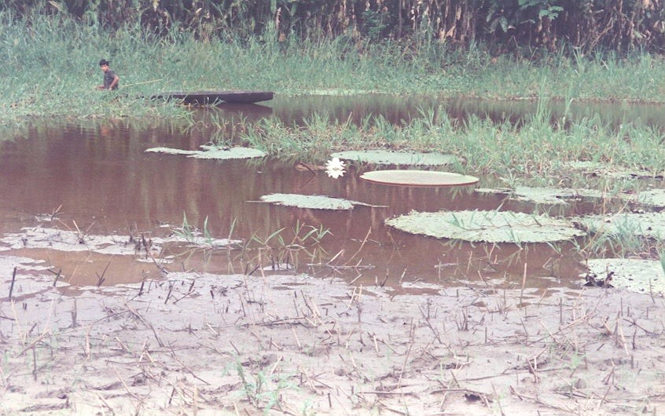

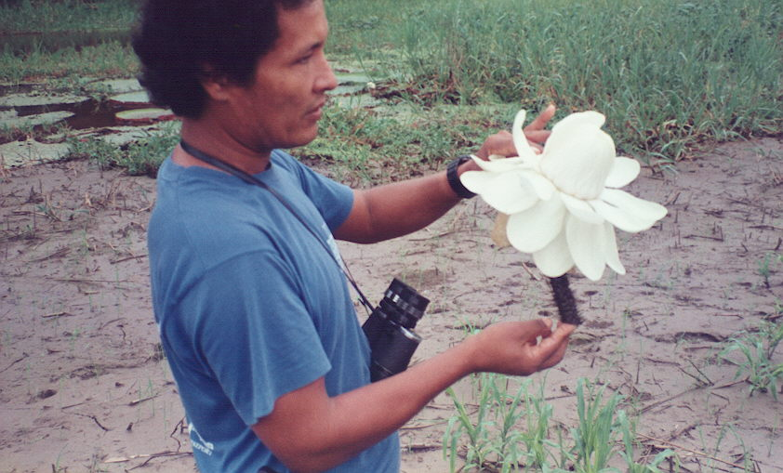

Rice had been broadcast on the mud flat. This field (?) covered about fifty acres. Sowing rice by broadcasting the seed on the mud as the water recedes differs from the Asian process of sprouting and sprigging rice in paddies. Along the Amazon, no water management is available and paddy culture would be near impossible. There is a scarcity of labor and machinery and seasonal changes of the water level along the Amazon may be thirty feet or more.
We followed a path across the rice field to avoid trampling any more rice than necessary. The field got muddier as we went until we stopped on a high spot near a pond. These backwater ponds are locally called "igarapes". Bedar waded out barefooted and cut a lily flower and a section of leaf and stem.
The flower bud was beginning to open with several large white petals unfurled. The bud was the size of a quart jar. It was a pinkish hue on the outside or underside of the petals. The stem was an inch in diameter and covered with sharp, half-inch long spines. The leaf top was flat and green and about four to five foot in diameter with an upturned rim about two inches high. The underside of the leaf was reddish purple. Modified veins of the leaf were flattened vertically forming flotation compartments on the bottom of the leaf. The veins and ribs were covered with spines. Many pinhead size white eggs of something were attached to the base of the spines. The leaf petiole or stem was up to twenty feet long which allowed the leaf to float when the river rose. These plants have few enemies except the manatee that does not seem to mind the prickles.
On the pond was a young man standing in his dugout canoe spearing fish. He had three carp-like fish with a total live weight of about five pounds. He offered them for sale and they were purchased for lunch.

*****
Back on the Rio Amazonas, we had just finished breakfast when porpoise began breaking water. We were near the confluence where the Rio Atacuari emptied its dark organic water into the chocolate brown Amazon. Peru was on the west bank and Columbia was on the east. Individual porpoise were pink, pink and gray or all gray. The popular theory was that these dolphins were stranded almost a thousand miles up stream from the Pacific in what became the upper Amazon about 70 million years ago when the Andes rose. The porpoise and several other relict marine or estuarine species currently found in the upper Amazon adapted to fresh water and the food supply on the river. I never did get a good picture of them.
*****
After lunch, we prepared to go fishing for Piranha. We each had a hand line with a small weight and a strong foot-long wire leader attached to a half-inch hook. Each boat was supplied with a pound of raw meat cut into small chunks. The boats proceeded to a small backwater and tied up to some overhanging branches. Canoe paddles and tree branches were used to beat on the water surface to attract the Piranha. Then we baited our hooks and dropped them into the river. Everyone lost bait as small fish hit and ran.
It was difficult to get the bait down to where the larger fish were. I managed to catch two fish. One was what was locally called a red piranha and the other one a white piranha. These fish belong to a sub-family of predatory Disc Characins or the Characidae, called the Serrasalminae. They are high bodied, strongly compressed laterally and the belly is edged with saw-like toothed scales. They are ferocious carnivores. The most common genera are Pygocentrus, Rooseveltiella and Serrasalmo.
The red piranha appeared to be Serrasalmo rhombeus or spotted piranha. It has 16-19 dorsal rays, 31-36 anal rays, 30-33 tooth scales, a soft adipose fin and very small scales. Breeding colors are dull silver with many irregular gray spots. This fish can get to two feet long and live on shoals.

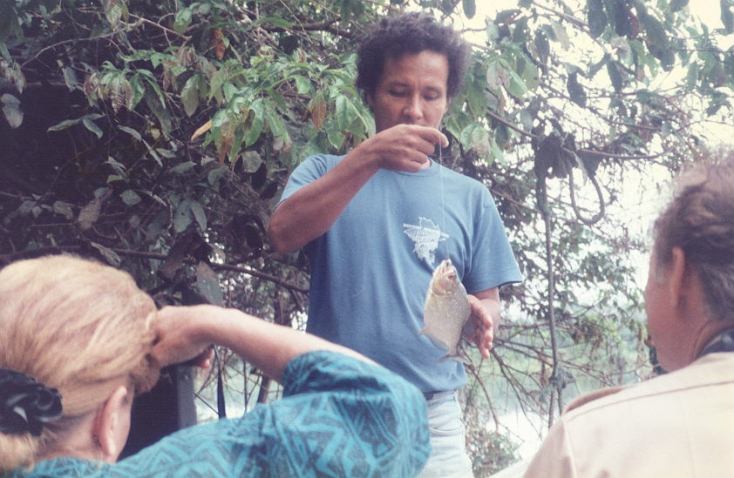

The white piranha was in the sharp-nosed piranha group possibly Pygocentrus piraya. It has 17-18 dorsal and 31-32 anal spines a shorter skull with a steeply arched forehead and overdeveloped protruding jaws. It is a blue-green with small light and darker dots. Each was about eight inches long. They both had protruding jaws with a number of sharp teeth. The dorsal and tail fins were ragged where pieces had been bitten out. This is a solitary fish attacking from ambush. It commonly feeds on fins of other fish
A total of fifteen piranha and a couple small catfish were caught. These were taken back to the ship and served for lunch.
Although they have a bad reputation, the piranha is not a major problem. They do not attack large warm-blooded animals so swimming with them is not dangerous. Caiman, river otters, catfish and larger piranha usually keep the populations in check. The river is even safe for swimming so long as there is no blood and thrashing of the water.

*****
Later in the day, we entered the Caballo Cocha River. We passed the town of Caballo Cocha and entered into Lake Caballo Cocha. When the ship turned around and went back to dock at Caballo Cocha, we loaded up the small boats went up the Rio Palo Seco to look for sloth and other wildlife.

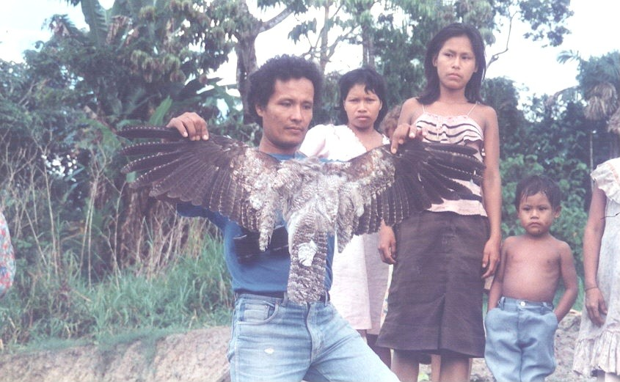

On the trip up stream, we were hailed from the bank by a woman with three children. She wanted to show Bedar a bird that looked much like an owl from a distance. On inspection, it was a Greater Potoo (Nyctibius grandis) . It belongs to the Camprimulgidae family along with the goatsuckers and nighthawks. The bird was well equipped for night flying with large eyes and a large gaping mouth to scoop up flying insects. It had been killed by her husband with a shotgun. They would either sell it to us or have it for supper. We did not buy it.
There was a Brazil- or Para-nut tree (Berthollrtia excelsa) where we pulled in. This tree was smooth barked for about forty feet. The pod of nuts was about 6 inches in diameter with a hard thick wall. It weighted about a kilo containing 18-24 triangular 2 inch nuts.
We saw several pairs of parrots in the tree tops and many Jacana on the mud flats. A large raft of water hyacinths was partially floating and partially stranded on the mud. This was something I had wanted to see in its native habitat. However, we saw no sloth and no snakes.

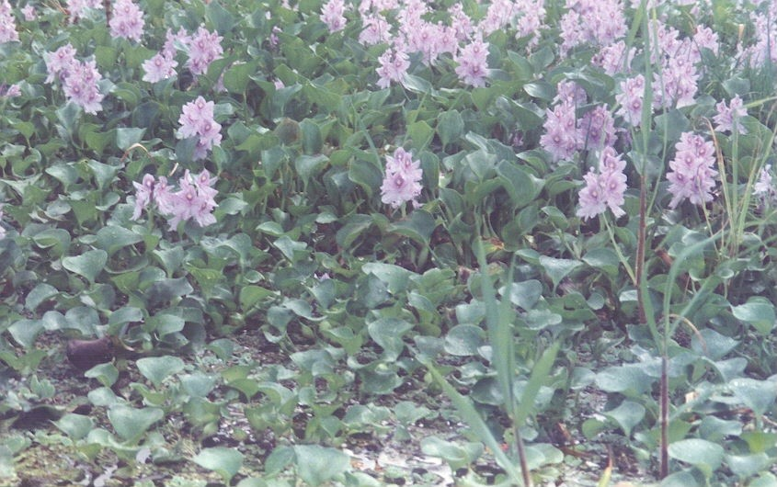

On the way back, the driver and I both spotted a sloth high in a Cecropia tree. We disturbed his beauty sleep by bumping the tree. Over the course of several minutes, he climbed higher into even smaller branches. By the way, the sloth is one of the favorite foods of the Jaguar.

*****
The boats stopped at the landing at the foot of the main street of the town of Caballo Cocha. It was a town of maybe 1000 people. It had a square with a war memorial. At one end of the square were the Catholic Church and the municipal building was at the other end. A general store, several bars, at least two small restaurants, two pantadaria or bakeries occupied the remaining sides of the square. Along the road to the mooring were several upper class homes. Several public housing complexes made of cast concrete were located just off the square. A community power plant produced electricity which was available to the street lights and houses four hours a night. We could hear radios and see the flashing light of TVs playing in some of the houses.
The general store stocked sodas, beer, and a few necessities but there was neither much variety nor supply. No chocolate or even cookies.
All the kids wanted to look through binoculars and cameras. Some wore thongs but most were barefoot. One young lady had glasses.
Some of the young teen males did not appear to like tourists in general. They were dressed in modish clothing, at least, for the village and they hung out together like teens everywhere.
Several old men had large open wounds on the face that looked like leishmanisis. There were, also, a two blind people sitting in the square.

Caballo Cocha

A major trading point on Rio Caballo Cocha
500 people and electricity four hours a day.
Two pantaderias and a general store
But no chocolate.

Most of the kids were barefoot
And wanted to look through the binoculars
And see themselves on the camcorder.
Typical kids.

Several teens in modish dress
Hanging out together
Avoiding us tourists.
How you gonna keep them up the Amazon?

Old men, blind or with leshmanisis
Sat in the square in the setting sun.
*****
We made our way back to the ship and left the dock as the sun set. Mosquitos of several species came out of the tall grass along the river.
We had supper and watched the National Geographic special on the lower Amazon as we sailed down the Rio Caballo Cocha back to the Amazon.
*****
16 June. Offload at Leticia and Back to Lima. We awoke early and found the Rio Amazonas tied to the southern (Peruvian) shore of the Amazon. The city of Leticia, Colombia, lay across the river. We finished packing and took the bags to the lounge. Breakfast was served, and we said farewell to the crew. I left my copy of Ridgley's "A Guide to the Birds of Panama" with Bedar. He did not have a copy, and I could get another copy if necessary.
While waiting for the boats to shuttle us to Leticia, I noticed that we had passed through a termite swarm during the night. Hundreds of conenose termites were running around on the deck. On closer inspection, these were a number of queens being followed closely by one or more males. It looked like little convoys of eighteen-wheelers. I asked Bedar if he had seen this before. He had seen termite swarms but did not recognize the significance. I briefly explained the life cycle of the termite to add to his store of knowledge.

Termite Swarm

An Amazon conenose termite swarm
Filled the night sky.
At dawn they had shed their wings
And the larger queens ran about
With several males following
Like a convoy of 18 wheelers
*****
We boarded the aluminum boats for the last time for the trip to Leticia and Tabatinga, Brazil. The baggage would come on a later trip.
As we were pulling away from the Rio Amazonas, I watched the crew take all the garbage from the trip and throw it into the river.

Counterpoint

After three days of environmental saturation
We left the M/V Rio Amazonas
At Leticia Columbia.
From our ferry crossing the Amazon
We watched the crew
Dump our refuse into the Amazon.
*****
*****
It took half an hour to cover the three miles across the river. We disembarked and waited until the luggage showed up. We identified each of our bags and loaded the bags on three vehicles for transportation to the Rio Amazonas' office in Leticia.
A fuel truck was parked nearby. It was a primitive arrangement of a valve and a hose from the bottom of the tank. This probably resulted in the customer getting all the condensate and muck that settled out of the fuel. A sight valve consisted of an open Tygon tube from a fitting in the bottom of the tank tied to the top of the tank by a piece of wire.
A Colombian gunboat was moored to the dock. Armament was two .30 cal machine guns and what looked like a 20mm gun all covered with canvas. We passed the ship and continued along a one-lane asphalt road to town. The billets of the local militia and the Columbian officers club faced this road.
Just as we entered town from the port road, a new Bronco stalled on the corner. The four jock-types in the vehicle gave us a good looking over complete with pictures. The vehicle magically started and disappeared. I don't know whose files we are in, but we're on somebody's list.

*****
We left our hand baggage at the Rio Amazonas office on the Plaza de Armas and took a walking tour of Leticia. The shuttle bus to the Tabatinga airport would leave in about two hours. We wandered around town with no Colombian money. The moneychangers really did not want Intes and were offering only half of the official exchange rate. Where are the black marketers when you need them? We did not want to cash even a $20 traveler’s check for a pile of Colombian money just for Cokes. I finally found Cokes at the hotel bar for one US dollar each.
Leticia probably contained about 5000 inhabitants. It was cleaner than its Peruvian counterparts. I guess this was because of the availability of money. It was a little after 0900 and there was little of interest in the few shops that were open. A toyshop selling European metal model cars and trucks was overpriced. Indian crafts were scarce, and the items available were very poor quality, very expensive or both. I had expected to find gem stones and was surprised to find only some geodes and some pink quartz.
The Colombian city of Leticia exists as a historical footnote. Prior to 1930, it belonged to Peru. By several international treaties, the Amazon was designated as an international waterway. Colombia did not have a port on the Amazon. The river was only twenty miles away from the rubber producing areas of southwestern Colombia. The presidents of Peru and Colombia got together in 1922 and arranged for transfer of Leticia to Columbia to take place in 1930. But, by 1930, there had been a revolution and the old president, Leguia, was overthrown. A half-breed soldier, Sanchez Cerro, had claimed the presidency. He changed his mind and re-annexed Leticia without notifying Colombia so Colombia declared war.
Cerro was murdered in 1933. During that three-year interval, Colombia bought several WWI warships, declared an unofficial war on Peru and blockaded the Amazon. The fleet was based at Tarapaca on the Rio Putumayo about 500 miles north of Leticia. The dispute went on including an attempt to take Iquitos. The League of Nations finally decided this foolishness had gone on long enough. After Cerro died, an international commission was sent to Leticia for a meeting with the two countries. The matter was settled in 1933, and Leticia became part of Colombia.
A monument in the Plaza de Armas located Leticia at 4 degrees 13 minutes south Latitude and 69 degrees 8 minutes west latitude. Elevation was 96 meters (316 feet). Average temperature was 27 degrees Celsius (78 degrees F). Rainfall averaged 2731 mm (175 in.). The average relative humidity was 84.4 percent.

*****
Transportation to the airport arrived. People and bags were loaded on two old VW vans for the ride across the border to Tabatinga, Brazil. There was no customs' check to mark the border. Like Iquitos, everything came in by river or air. However, the existence of the border was plain. Roads and architecture went from bad to worse when we crossed into Brazil.
Tabatinga had existed as a military town with a joint-use airport since WWII. The civilian population had little in the way of luxuries. Many of the buildings along the way were concrete block painted apple green, fuchsia or some other bright (?), gaudy (?), gay (?) color. There were groups of people listening to the World Cup soccer game on radios turned up as high as possible.
The van swayed dodging potholes along what was supposed to be a two lane road. The Brazilian government was and, probably still is, building a new concrete, four lane divided highway from Leticia to the airport. Only about half of one half of one side was finished, and we drove on smooth concrete for less than a mile. The driver said this much construction had taken eight years so far. There was no evidence of equipment or recent construction. Once on the concrete, there was no way off until we reached the end. There was a drop-off of a foot or more on either side of the concrete.
The airport terminal building was old but serviceable. It looked like a WWII US military hanger. There were a few seats and a snack bar but no shops. Customs was primarily a passport check to make sure visas had been purchased. The requirement for yellow fever shots was ignored since they did not look at the shot records.
The World Cup soccer finals were on TV. Brazil was one of the contestants so the flight was delayed until after the game was completed. Most of the passengers and, probably, the crew appeared to be more willing to miss the flight than the end of the game.
For some reason, there were several people in Red Cross T-shirts and several Brazilian Army troops on duty at the airport. I guess they take soccer seriously.
*****
A boy about eight years old was mixing with the crowd. He was outstanding because he had a marmoset sitting on his head or shoulder. The marmoset had a string tied around its waist that the boy held in his hand.

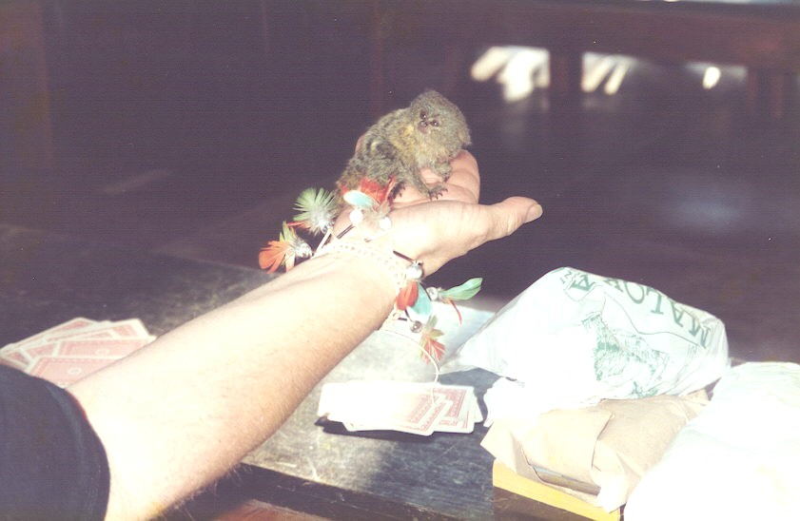

After customs, we were herded into the waiting area. If the terminal was Spartan then the international waiting room was a stoics' dream. There was barely standing room, no lights except the dirty windows and not even a drinking fountain. There were no smokers or it would not have been tolerable.
The Brazillian Varig airliner was cleaner and better appointed than even Aeroperu's international route planes. The cabin crew was also a couple quantum steps above the Aeroperu crews. They looked and acted much more professional.
We flew over the jungle in the daylight. The slash and burn farmsteads were clearly visible. The jungle was reclaiming many of the areas. I could not get to a window to shoot video and only managed a couple of still shots.
*****
We arrived at Iquitos an hour late. This, however, made little difference since our Aeroperu flight to Lima had not left from Lima yet. The flight was to be delayed at least six hours. We were taken into town to the Rio Amazonas office to wait. We had missed lunch so the first item on our agenda was lunch. We checked our bags and were off to the Maloka restaurant for lunch and more shopping.

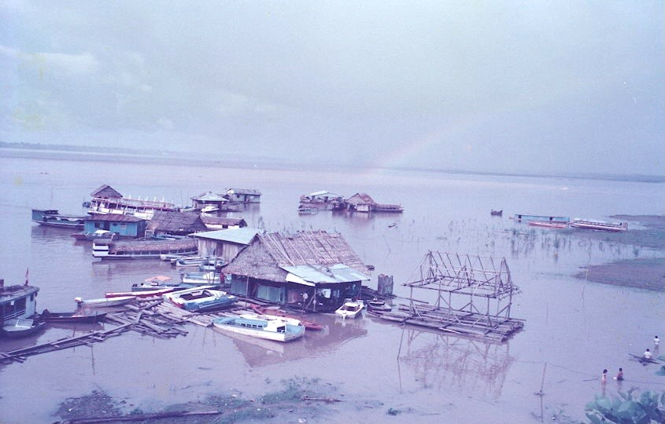

Lunch was very enjoyable. We sat on a veranda overlooking the Amazon. I had Piacayu (the largest, bony fresh water fish known) with manioc and plantains, a papaya, a Coke, an Incacola and a lemonade. I had not realized how dehydrated I had become. Carol had steak but the rest was the same.
The colonel and his wife from New Orleans joined us about half way through our lunch. We discussed the trip and watched a rain cloud drift across the river leaving a beautiful rainbow behind.
Some Japanese tourists were feeding a couple of monkeys in a big cage on the restaurants veranda. The monkeys were offered edible food like banana and inedible items like a slice of lime. The monkeys were smarter than you might think. They learned fast which ones fed them and who tried to fool them.

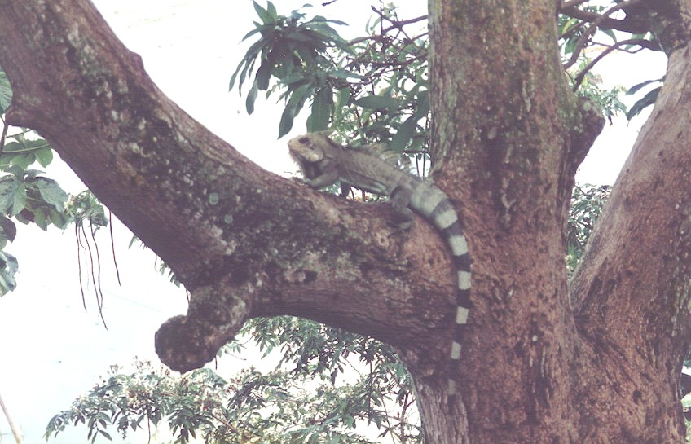

As we left the Maloka, we spotted a four-foot long green iguana on a limb next to the veranda. Looking carefully, we spotted four more of the lizards in various parts of the tree. The first one we saw was a large male that displayed beautifully several times before slowly disappearing into the leaves near the end of a branch. Another large iguana was higher and less visible. The other three were 18 - 24 inch juveniles. We shot a lot of pictures of them with the Amazon in the background.
The Rio Amazonas gift shop was open when we returned from lunch. Jewelry made from scales of the Piacayu fish, wooden bowls and dolphin carvings, blow guns, Indian paintings and such were for sale. Our group almost bought out their inventory.

*****
Finally, our luggage and tickets were taken out to the airport. As we were waiting, Carol played solitaire while I watched the people and traffic passing in front of the office. A raspa salesman passed. A truck stopped to off-load several blocks of ice to deliver somewhere nearby. A young girl selling sliced oranges and watermelon stopped in and tried to make a sale.
One young man came in and offered to sell us a marmoset for one US dollar. The marmoset looked like it was barely weaned and would probably starve. The salesman insisted that we could stick it in a pocket, and it would be in fine shape when we got it to America. The poor little thing would not survive the cold drafts and the altitude changes of the airplane trip even if it were healthy. There is also six-month quarantine in Miami at the owner's expense. We told him, "Thank you, but no thanks."
The center of the Plaza de Armas was occupied by a fountain with a statue of the pink dolphin in its center. The fountain no longer works but the life size dolphin remained a landmark. I asked about the significance of the pink dolphin and this statue in particular. No one seemed to know except that the dolphin was the symbol of the city. On one side of the square was the "Iron House" designed and built by Dr Eiffel for the Great Exhibition in Paris for the turn of the century. It was bought, disassembled and moved to Iquitos by one of the rich rubber barons.
About 6 PM, we left the Rio Amazonas office for the airport. The sun was setting, and the jungle sounds were just beginning.
Aeroperu was ready about 8 and arrived in Lima at 9:40. A short uneventful ride to the Sheraton allowed us to check in by 11 PM for another short, high priced night in Lima.
Our Amazon adventure was over. On to Buenos Aires.

*****
17 June. Lima to Buenos Aires. We were up at 5 AM. We packed and were ready for our ride to the airport through the early dawn. There had been one of the rare showers in Lima, and the atmosphere was heavier than usual. The omnipresent dust had become a thin, slippery coating on everything.
We were surprised to find that the Aeroperu flight to Santiago and Buenos Aires was on time. Customs was no trouble this time. They briefly looked in the bags and strapped a yellow plastic band around each bag. The waiting and luggage identification were the same as before.
The flight to Chile was almost dull. We jumped into the clouds and stayed out over the cold Pacific until we began to let down for the short stop in Santiago. The approach was over undeveloped, mountainous land and terminated at a joint-use military airfield. Our plane did not taxi close enough to the military side to get a good look at the Chilean Air Force. However, several C-130s were visible in the distance.
Santiago was built near the geographical center of Chile. It was established in 1541 by the conquistador, Pedro de Valdiva. He had been sent by Pizarro to explore and colonize Chile. Valdiva left Cuzco in January, 1540. A year later, after crossing the high, dry desert of northern Chile, he discovered the Central Valley. Here, he traced out the main streets and sited the major buildings of Santiago. Over the next twelve years, he explored and colonized Chile in spite of the constant harassment of the Araucanian Indians. The leader of the Araucanians, Lautaro, had learned to raise and handle horses and devised several strategies to defeat the Spanish cavalry. Valdiva was captured by the Araucanians in 1554 and executed. This protracted war became the theme of an epic poem, La Araucana, written by a Spanish officer, Alonso de Ercilla in the 1560s. It has been a rallying point ever since.
About 50 passengers deplaned in Chile, and about the same number boarded for the trip to Buenos Aires. We were not allowed to leave the plane. We did not have a visa for Chile and, with the recent political climate in Chile, I was not too disappointed.

*****
After an hours' stop, we were in the air again.
Takeoff was about 5 PM. We headed east, out of the sun and clouds. The snow on Andes was beautiful in the late afternoon sun.

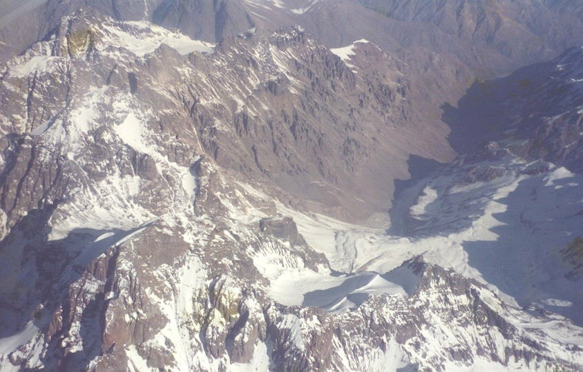

We were out of the mountains and Chile in a few minutes, since Santiago was less than fifty miles from the Argentine border. Our track lead out over a land of low hills. They ran parallel to the mountains like ripples on a pond. To the south was the Rio San Juan Desaguadero that ran south. It had two reservoirs backed up by hydroelectric dams. A white ring around the lakes showed that they were about 20 feet below their normal water level. These lakes were located on the extreme western border of Argentina. The electricity generated by the dams probably serviced Santiago and eastern Chile, as well as the nearby cities of Mercedes, Mendoza and San Luis in western Argentina.

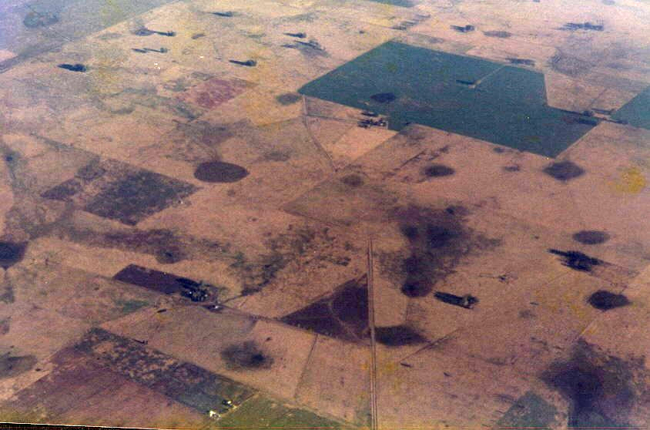

We flew steadily eastward into the gathering dusk. Although over the Argentine wine country, I saw no vineyards or any farming activity.
The hills gradually disappeared. Flat plains studded with playa lakes replaced the hills. All of the playas were dry. The area looked similar to the Texas Panhandle near Lubbock.
Several settlements came into sight and disappeared under the wing. These settlements were round groves of trees surrounding a series of buildings which, in turn, surrounded a central round corral. These settlements looked like they were associated with fields of winter grain. The fields had circular irrigation systems set in a grid of cross roads. This looked similar to grain fields in Kansas and eastern Colorado.
Sunlight disappeared, and the land changed beneath us. More trees and houses became visible on the plains as we approached Buenos Aires from the south. Orchards became common. Finally, we passed over a large residential area and landed.
*****
The Ezeiza Airport was located about thirty miles south of Buenos Aires. Encroachment by housing areas must present a problem but it is not considered pressing in areas other than the U.S.
We deplaned into a large warehouse of a reception area and were processed through customs. Another wait and we found our luggage. I noticed my big folding bag had one outside pocket unzipped up to the yellow customs band. I checked and found my electric razor missing. There were no officials in sight to report this to, but both the airline and customs people said I should have reported the theft immediately. Our guide helped straighten this out, but I would have to report the loss to the Aeroperu office on Tuesday morning.
Our guide was a grey-haired German lady who was accompanied by
a male German driver about the same age. We drove through the night on a modern freeway to downtown Buenos Aires and the hotel. The freeway was called the Pisia and was part of the original Pan-AM highway.
At the hotel an armed guard was in the lobby and a there was a guard near the elevator on each floor. Our room was on the fourth floor. It had lockable closets with a safe. There were bars on the windows backed up by a metal roll up window cover. The room was the most fortified place I'd slept in years. Some how all this security did not promote a sense of security.
*****
Some background information on Argentina, in general, and Buenos Aires, in particular, is in order. The explorer, Juan Diaz de Solis, discovered the Plata River and estuary in 1516 and was killed by the Indians. The English explorer, Sebastian Cabot, entered the estuary in 1526 and built a fort. He found no gold or silver, and the Indians burned his fort so he returned to Spain. Emperor Charles V of Spain sent Pedro de Mendoza to the Plata in 1535 to build forts and find a route to Peru. Mendoza established a port city of Santa Maria del Buen Aire on the site of the present capitol. The town was surrounded by the local Indians and starved out. The town was finally evacuated in 1541. Argentina dates from 1553 with its first permanent settlers and spent its first 224 years under the Viceroy of Peru in Lima. The administrative center for Argentina was located at Santiago del Estero, then at Tucuman and, finally, at Cordoba. A new viceroyalty was erected in 1777 that ruled all of Argentina, Uruguay, Paraguay, and southern Bolivia from its new capitol at Buenos Aires.
A combination of regionalism, the vice regal tradition, authoritarianism, church-state power base and government fraud and favoritism made independence a difficult goal. In 1806/7, England invaded Argentina and was repulsed. An epic poem entitled "The Argentine Victory" gave the term "Argentine" prominence and the first hint of unity. In 1808, Napoleon invaded Spain, forced the abdication of the king and set his brother on the throne. Spanish America set up "caretaker" governments in the administrative centers. Argentina, at the cabildo abierto or town meeting, declared independence from Spain on 9 July, 1816.
A hero of Argentina, Jose de San Martin, led a force over the Andes to help the Chilean patriots drive out the Spanish royalists. San Martin was assisted by the Chilean navy under the direction of a renegade British admiral, Lord Cochrane. Political instability prevailed. Paraguay became independent in 1814, Bolivia in 1825 and Uruguay in 1828.
Bernardino Rivadavia tried to unite and Europeanize the country beginning in 1820 but was overthrown in 1826 by Juan Manuel de Rosas. Rosas, the son of a Buenos Aires patrician, instigated a Creole revolt in Buenos Aires. He gradually took over the entire country since the country preferred order to liberty. With a strong-arm gang called the Mazorca, his dictatorship lasted until 1852. His army, under General Justo Jose de Urquiza, revolted and, assisted by an invasion from Brazil and Uruguay, Rosas was deposed.
A new constitution, adopted in 1853, was based on the Constitution of the United States. Another 20 years of internal conflict tired and, finally, stabilized the government, and Buenos Aires become a kind of federal district. This, and the opening of the pampas by the crushing defeat of the Indians by General Julio A. Roca in 1879, resulted in relative peace until 1916.
Social change was initiated by the rapid economic development in the second half of the nineteenth century, the rise of the urban middle class and the depression of 1890. The Radical Party was founded as an opposition party but the conservative oligarchy remained in power. A member of the oligarchy, Roque Saenz Pena pushed through reforms including the Electoral Law. This change permitted the first elected president in 1912. The first elected Radical president was Hipolito Irigoyen.
Irigoyen, described as "muddleheaded" and "as autocratic as any caudillo", made some social changes. Minimum wages, maximum working hours, etc. were proposed. But the president meddled in provincial affairs, showed no respect for Congress and, gradually, appointed a group of corrupt friends to administrative posts. By 1930, it was evident that he could not deal with the effects of a world-wide depression. There was no serious opposition to a military coup d'‚tat on September 4, 1930.
General Jose E. Uriburu, believing the Army's mission was to regenerate the nation, had led the coup. But Uriburu's dictatorship lasted only about a year. He was overthrown by General Agustin P. Justo, who believed in a nonpolitical Army.
General Justo won the called election in 1931 and ruled until 1938. Roberto Ortiz won the election in 1938 but resigned in 1940 because of diabetes. His vice-president, Ramon Castillo, became president. Castillo used the attack on Pearl Harbor as an excuse to declare near martial law in Argentina. Castillo was removed by the Army coup on June 4, 1943. This coup eventually leads to the rise to power of Juan Peron.
Colonel Juan D. Peron had served as military attaché to Italy during the term of Mussolini and had seen the importance of the trade unions, industrialization, nationalization and Five-Year Economic Plans, etc. To gain the support of the long neglected masses of the lower class and of the labor community, he knew he would have to help them improve their lot. As a party to the coup, Peron took the office of Secretary of Labor. From this position, he encouraged labor reforms and promoted unionization. He got money for public housing and legislation for compulsory paid holidays. A macho image was cultivated, and he became patron of athletes and entertainment stars and shared their glory. One special entertainer was Eva Duarte, a singer and radio personality.
He was arrested in 1945 but was freed as a result of a virtual revolution by the descamisados- the men in shirt-sleeves. He was released on October 17, 1945 and married Eva "Evita" Duarte. Peron did not take any office himself but did place his friends in key positions while he prepared for the election in February 1946. His supporters created a political party, the Partido Laborista, and Peron was nominated for president.
With the support of the Catholic Church and the labor unions, Peron won the presidency, most of the seats in the Chamber of Deputies and all but two seats in the Senate. He and Evita ruled and brought Argentina into the industrialized world. He broke the estancieros power but retained land values.
Evita died in 1952, and the regime deteriorated. Corruption, rising living costs, and other troubles led to a coup in September 1955. The provisional garrisons lead their troops against Buenos Aires, and the Navy blockaded the Plata. Peron took refuge on a Paraguayan gunboat and went into exile.
*****
The military removed the Peronistas from the military, federal and state governments, judiciary and universities and put the trade unions under military interventores. Elections were called in 1958 but the Peronists were not allowed to nominate a candidate. A Radical, Arturo Frondizi, won with the help of the Peronists.
Frondizi allowed foreign oil leases, ordered a general wage increase and a general amnesty for political prisoners and allowed Peronistas to vote in the March 1962 elections. Many of the Peronistas won, and the military, under General Raul Poggi, deposed Frondizi and annulled the election results. Senate President Jose Maria Guido was sworn into office to prevent Poggi from becoming president and a new election was called for July 7, 1963.
Dr. Arturo Illia was elected president. He was indecisive and a weak president. He was removed from office by the military and General Ongania took over. And on it goes.
At the time of our trip, the city of Buenos Aires had a population of twelve million, over half the total population of Argentina. Population density for the country was roughly 16 per square mile. The ethnic composition was about 90 per cent white, 9 per cent mestizo, 1-2 percent Indian with a couple hundred Negroes. The figures are a little misleading since Argentina's liberal definition of white was anyone not obviously non-white.
*****
Argentina never had much of a black population, and the Indians were effectively eliminated by General Roca, the "last of the conquistadores," in the pampas pacification campaign of 1879. For the next hundred years, immigrants from southern Europe populated the rural areas. This contributed to the whiteness of the population and the European or Creole culture of the country. This also accounts, in part, for the predominant 52 per cent of the population classified as middle class.
The large immigrant influx resulted in an integration problem. Many of the third and fourth-generation Germans, Italians, English and Spanish still think of themselves as Germans, Italians, English or Spanish. Like Californians, there are few native Argentines.
By popular Argentine definition, Creole means the Spanish cultural core modified by native Indian traditions. The primary symbol of the Creole culture was the gaucho or Argentine cowboy. He descended from the Indians that had taken the Spaniards horses when Buenos Aires was evacuated in 1541. He was a mestizo living on the plains on horseback chasing wild cattle and bad Indians. Gaucho traits like drinking mate (a native tea from Holley leaves) and eating asado (barbecued whole cow) are dying out except in literature. The tango, a Creole folk dance, still survives in the tango clubs of the Baja and in the movies. This is much like our own cowboys and Indians.
*****

18 June. Buenos Aires. Buenos Aires is about 35 degrees south latitude and 58 degrees west longitude. San Antonio was about 6000 miles northwest at roughly 29 degrees north and 99 degrees west.
It was mid winter with the low temperature in the mid 30's and the high expected in the mid 50's. The sky was overcast and there was a brisk breeze.
We had breakfast in the hotel dining room. Our guide called to tell us that our tour of Buenos Aires was rescheduled for the afternoon and we had the morning free. They neglected to tell us that this was a national holiday, Flag Day, and that nothing was open. Our travel agent struck again.

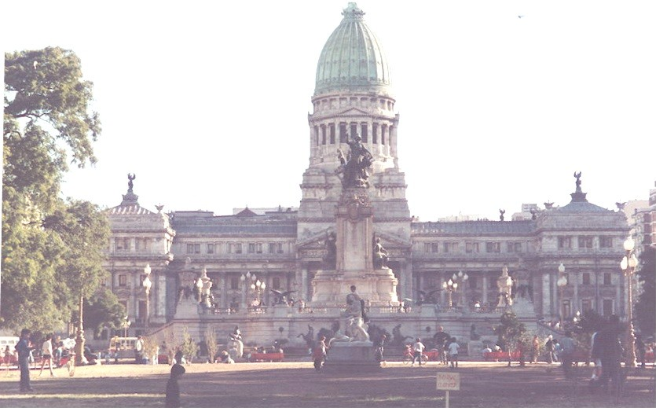

After double locking the room, we checked the camcorder and other valuables in at the front desk and went for a walk. The downtown area of Buenos Aires was like most big cities as the city wakes up. Windows were full of merchandise and our hotel was in the gallery district with many art galleries. We headed over to the mall area in case anything would open and arrived as the doors opened. Most of the mall stores ignored the holiday and were open as usual.
We spent the morning in and out of a hundred shops. We looked a lot and only bought a few things. Carol bought a nice leather coat and we bought a leather bag and some jewelry and looked some more. Several of the shops had signs in English or signs that they spoke English. The signs in English were usually in Spanish word order and looked much like some of our one case Spanish. Some of the spoken English was American but most was high school. Those who spoke English were eager to practice.
Lunch was in one of the restaurants recommended by our guide. The owner had been in show business and there were pictures of him with many of the celebrities of WW II and postwar South America. Service was interminable. The menu consisted of several combinations of steak and fried potatoes. The choice was beef frito or chorrizo. The frito meant grilled steak. The chorrizo was not sausage as in Texas but a roast or grilled filet two inches thick. This was typical Argentine fare.

*****
We returned to the hotel to go on our tour of the city. The tour group was mixed - six Japanese who spoke English, several Mexican citizens and us. We passed the cathedral which was closed, the Pink House or capitol, the treasury and the national bank. We crossed Avenida Libertador, the widest main street in the world (600 feet wide, 12 lanes with three wide, vegetated medians) and passed the statues of Jose de San Martin, Don Quixote and others.
The tour passed the port area. It was much like other ports around the world with a lot of warehouses, grain elevators and processing plants in various states of repair. The port itself and most of the ships were out of sight behind these buildings. The port was on the Rio de la Plata or Silver River. The Plata was known as the widest river in the world but there is debate whether the Plata is, indeed, a river and not an estuary. The Parana and Uruguay Rivers come together and enter the Plata about 50 miles north of Buenos Aires where Argentina and Uruguay meet on the Argentine border. These rivers and the largest railway system in Latin America transported wheat and sugar from the Chaco to the north, and wine from Mendoza to the west. Beef, mutton, leather and wool came from the Patagonia. Sugar from Tucuman and linseed oil from Entre Rios and Corrientes came to Buenos Aires for shipment to Europe.
The ferry terminal offered a three hour conventional ferry ride or ninety minute hydrofoil service to Montevideo, Uruguay. Montevideo was a hundred miles to the east on the north side of the Rio Plata.
The tour then entered the Boca area. The Boca area was low lying swampy beach near the port where many WWI immigrants from Italy settled. Argentina did nothing to support these invisible settlers until they tried to claim it as an independent country. The houses were built cheaply of concrete blocks. The structures were painted bright colors reminiscent of the voodoo or santero cultures. The Tango, as an international symbol for Argentina was originated in this part of town and several Tango clubs advertised nightclub acts of Tango and other Latin dances. One of Argentina’s outstanding artists was born and raised in Boca and much of his money went to improve the lot of the Boca people.

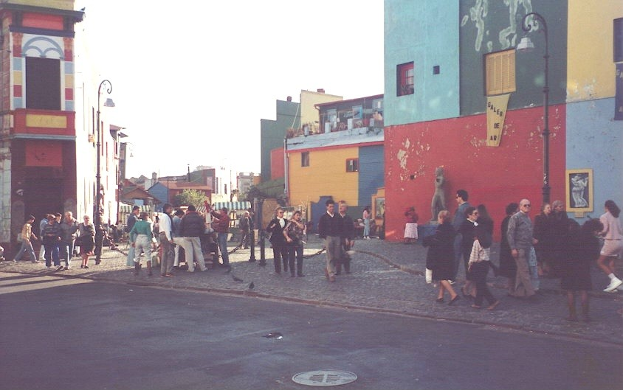

The tour passed the largest shopping mall in Argentina. Then on to one of the city park where most of the people of Buenos Aires seemed to be on this holiday afternoon. We passed several large art museums and galleries, all of which were closed for the day.
*****
On return to the hotel, we thought we had a choice of a tour of the tango clubs or going out for a good meal. We found that the Tango tours were all booked. The concierge made reservations for us at a five star Argentine restaurant, the Au Bin Fin, for some authentic Argentine food. We dressed for dinner and had the doorman hail a taxi and give the driver instructions on how to get there.
I don't know what the instructions were but it cost about ten dollars get there and only about two dollars to get back. Looking on a map the next day we only went about ten blocks from the hotel.
The restaurant was a former upper class home. The dining rooms were the house's rooms and still decorated with imported fabric wall coverings, fire places, art and tapestries of the 1890s. The menu was continental haute cuisine and mostly French. The meal, wine list and service was outstanding but nothing memorable.

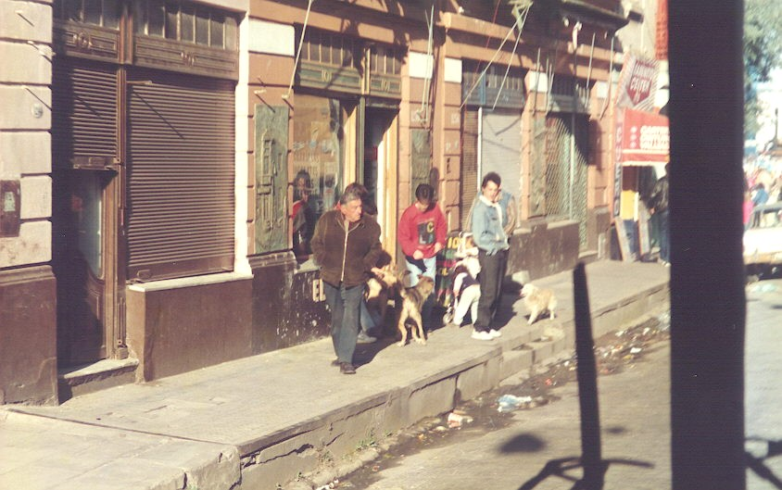

The Argentines we had seen so far did not seem to be a happy people. There was no laughing or joking in the mall or the restaurants. Everyone seemed serious. As one author said they looked back to the happier times in the early twentieth century when Argentina was neither poor nor misgoverned. They did not want to face the present and no leadership or plan how to prepare for the future. Anti-Peronists, including the military whom Peron had used, the upper class from whom much had been taken and the middle class that had been wrecked by megainflation, said it was Peron's fault. Labor and the lower classes, for whom Peron had robbed the upper and middle classes, said it was the fault of the anti-Peronist coalition that had failed to solve the problems after removing Peron.
Back at the hotel, we spent a couple hours sorting and packing for the return trip to Lima the next afternoon.
*****

19 June. Buenos Aires and Return to Lima. The morning air was cool--in the 40's. It was 0900 and time for a walk. We had breakfasted at the hotel, finished packing and checked the baggage with the concierge until plane time. Our appointment with the Aeroperu airline office was at 1000 to settle the claim of my stolen razor.
We walked the eight blocks to the Aeorperu office and spent another twenty minutes window shopping. The office opened and we were directed to see a young lady that spoke fair English. We explained our case. She said she could only give us one kilo credit or roughly ten US dollars. However, if we would see the office in Miami, we could surely settle for the entire amount. This sounded like a brush-off but there was not use arguing. The Pissarro’s idiot children’s airline was not concerned that their employees were accused of theft or about the sloppy security of Peruvian customs or the international airport. I really did not understand their position. When we returned to San Antonio and contacted Aeroperu in Miami they did not answer the mail and we never heard from them.
We spent the rest of the morning window shopping and visited several art galleries and antique dealers. There are some outstanding young Argentine artists, most of which live in Europe or elsewhere. They send some of their work back home to Argentina for sale. Buenos Aires has had a long reputation as a home for the arts in Latin America.
The galleries had many old European works in marble, bronze, porcelain and oil. Most of the work was Spanish or Italian and I did not recognize any of the artists.
Very few of the antiques were of gaucho or creole origin. There were a few spur rowels and a few fancy silver sheathed knives and mat'e sets of questionable authenticity. Toys of the 40's and 50's were at a premium. Turn of the century lamps, marble mantels and glassware and Ching Dynasty porcelain were common items.
Typical souvenirs of Argentina were bolas, gaucho capes and hats, and replica mat'e cups and daggers. These were priced beyond the range of casual souvenirs with prices of 30-150 US dollars. Best buys were leather goods such as coats, skirts, handbags and luggage.
I asked in one shop that had minerals in the window if they had Argentine mineral specimens or fossils. The clerks had no knowledge other than the stuff was for sale at the marked price. There were trilobites and fish from Wyoming, geodes from Brazil, amber from the Baltic and shells from the Philippines but nothing from Argentina.
*****
We had lunch at one of the popular restaurants. It had the air of a working class downtown eatery that turned over the crowd as fast as possible. The menu was various meat dishes with fried potatoes. Since we had fried steak the previous day, we tried chorizo. This turned out to be an inch-thick grilled filet instead of thin frying steaks. Thick sliced fried potatoes came with the meal and I saw no other vegetable available. One person was eating what looked like fish but I did not recognize it on the menu. There was a choice of Coke, Fanta orange or coffee for drinks.
We found no place served the national beverage, mat'e. Mat'e is a tea made from the leaf of a holly tree. I asked in several places and at the hotel. Our guide said it might be found in a few places but it was not popular. I did not even see packaged mat'e for sale. Hot chocolate, however, was popular. It was served with a kind of chocolate cookie called a churo.
*****
Back at the hotel, we paid our bill and gathered up the luggage shortly before transportation arrived. The driver was the same old German that had picked us up at the airport. Our guide, however, was a young Argentine lady who spoke English with a Spanish accent.
On the way to the airport, we discussed our stay in Argentina. One subject of particular interest was inflation. Our guide said that she had received her paycheck one Friday when the government decided to devalue the currency by one thousand to one. This meant that on Saturday her week's check would not buy bus fare. People were allowed to withdraw and convert one hundred new dollars per week per family. People literally starved and died because of lack of medicine. Actually what happened was what the government called “pisification”. The government converted all funds to Argentine pesos at 75% devaluation. A $100 US suddenly became 23 pesos.
The Argentine inflation rate was about 400 per cent per year at the time we were there. Peru's inflation rate was 1600 per cent and Brazil's 3000 per cent.
We were cruising along on the inside lane of the freeway towards the airport when a truck broke down in the outer lane and a car cut in front of us. Our driver tried to stop but hit the car. Both vehicles pulled off the road and the drivers traded information. No one was hurt and neither vehicle was badly damaged. We were back on the road in about fifteen minutes. The driver said he had not had an accident in twenty five years. He said he could have avoided hitting the car but if he had hit the brakes, a truck behind us would have hit us hard and probably done a lot more damage.
*****
Aeroperu left about on time, 6 PM, and arrived in Lima on time, about 10 PM. However, the 11 PM departure for Miami did not leave until 2 AM. So far on the trip Aeroperu was on time four times and late four.
Altogether, the tour was pretty good. Tara Tours could not be held liable for Aeroperu's failure to keep its schedule but it might be blamed for using Aeroperu at all. Our travel agent was a wealth of misinformation and bad planning. She scheduled us on Aeroperu, missed the market day in Cuzco and sent us to Peru during the national election and to Buenos Aires over a national holiday. We missed tours of Lima and Iquitos. We were there for a bomb blast in Cuzco, lots of guns in Peru, theft of my electric razor and a car wreck in Buenos Aires. But the weather was reasonable, there were no major health or language problems. We, also, shot a lot of film and video tape and experienced a lot to talk about.

*****
20 - 23 June. Lima to Miami to Orlando and San Antonio. The plane got off at 0200 for Miami. We flew for a long time around weather with lightening ripping the sky over Colombia. The sky began to lighten with the false dawn while we were over Lake Maracaibo and the Gulf of Venezuela. The Paraguano Peninsula with the islands of Aruba and Curacao was back-lighted and stood out ghost-like against the dark sea.
Another half hour the yellow-orange band of brightness expanded and contracted between the red, bottom-lighted clouds and the dark sea. The sky shifted from a dark gray to a pale green, then to a nothing color that became a light blue as a bright golden sun peeked over the horizon. The yellow band shrunk and lavender bands of clouds crossed an expanding light blue band that pushed away the night. Mountains appeared dark against dark gray sea as we passed over the Dominican Republic and Haiti.
Early daylight cast shadows of cirrus clouds on the cottony stratus clouds below that hid Puerto Rico. Mountainous cumulus morning thunderheads penetrated the stratus layer marking the shallow water and island masses of the Bahamas Island chain. We were still at altitude with an almost black sky as Exuma Island and the Tongue of the Ocean Island came into view. Andros Island, with its pine forest, was visible from a much lower flight level. We passed to the south of Bimini and straight west into Miami International Airport, about two hours late.
*****
Customs and immigration were no problem. Being late, we missed the United flight to Orlando and had to wait two hours for a US Air flight. We arrived in Orlando a little after lunch. Carol checked out a car while I rounded up the luggage. In short order, we were off for the motel at Disney World.
The next morning we were up early and arrived at the Epcot Center as it opened and spent the day and more, until 11 PM, in Tomorrowland. There were a lot of people but there was no sensation of being crowded. With jet lag and sensory overload, not much was memorable in Tomorrowland. We had lunch in a German beer hall and supper in a Norse castle.
The next morning, we took the Disney studio tour. The only really memorable ride was one built like a flight simulator. That, the Temple of Doom demonstration set and the good weather were the highlights. Carol dozed through the canons firing in the Temple of Doom program and by noon she was ready to go home.
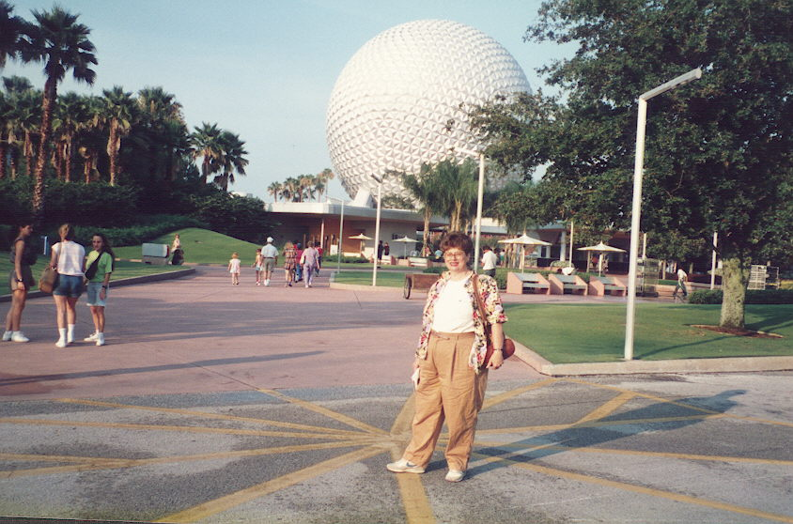

We still had Saturday morning and a pair of Disney tickets. It was raining so instead of Disney World, we hit a big discount mall on the way to the airport in the rain.
It was 1100 and, again, United wasn't ready when we were. After about an hour overdue, they announced that the plane had not left Palm Beach because of mechanical problems. About three hours later the flight was cancelled. Those going to Los Angeles were rerouted and a special plane was sent to take all the Houston passengers to Houston. We left Orlando for Houston about the time we were supposed to arrive in San Antonio.
There was a two hour layover in Houston so I called Dr Harry and discussed the trip. We finally arrived in San Antonio about 7 PM.
*****

Afterthoughts. After a trip is over is the time to reflect on the trip, things to do different and things to forget before the trip becomes dulled with time.
One thing we probably will not do again is take a trip where half the time is spent orbiting around airports and airplanes. Tension, boredom, discomfort, irregular meals and lack of good sleep are some of the disadvantages. The limited time someplace is divided between the desire to see everything and the urge to rest, sleep, take a hot shower and change clothes, eat a good meal - the reasons for taking a vacation are at odds with survival.
If we use a tour agent again it will be one that has time for clients and is not out to luncheons or business meetings all the time. We might get a call back in a few days and no one else in the office had any information on our questions.
Instead of a tour we will probably book passage and hotels and take local tours rather than packages that are rushed.
All future trips will be planned and scheduled by us. I may never take a packaged tour again except for day trips. The trip planner should know the area to be visited through research. The planner should check on weather, holidays, transportation, legal requirements, and activities available. The trip should be planned in a flexible way that will adapt to unexpected occurrences.
Been there. Done that.

Birds/Herps/Fish of South America

Herps
tree frog MachuPichu
red and black lizard Amazon
dead leaf toad Amazon

Fish
red piranha (Serrasalmo rhombeus) Amazon
sharp-nosed piranha group Pygocentrus piraya Amazon

Birds
Least Terns(Sterna albifrons), Machu Pichu
small sparrow-like birds Machu Pichu
Mountain Wren (Troglodytes solstitalis) Machu Pichu
Greater Ani (Crotophaga major) Iquitos/Amazon
White-capped Flycatcher Iquitos
Black Vultures (Coragyps aratus) Iquitos
Turkey Vulture (Cathartes aura) Amazon
Green Oropendola (Psarocolius viridis) Amazon
Yellow-Headed Parrots (Amazona ochrocephala) Amazon
Scarlet Macaw (Ara macao) Amazon
Wattled Jacanas (Jacana jacana) Amazon
Yellow-backed Oriole (Icterus chrysater) Amazon
Black –Collared Hawk (Busarellus nigricollis) Amazon
Gray Hawk (Buteo nitidus) Amazon
Ring-billed Kingfishers (Ceryle torquata) Amazon
Gray-capped Flycatcher (Myiozetetes grandensis) Amazon
Black-tailed Flycatcher (Myiobus articaudus) Amazon
Hermit Hummingbird (Phaethornis sp.) Amazon
Toucanette (Aulacorhynchus sulcatus) Amazon
Oven Bird (Seiurus aurocapillus) Amazon
Horned Screamers (Anhima cornuta) Amazon
Greater Potoo (Nyctibius grandis) Amazon

Animals
Spider monkey Amazon
Marmoset Amazon
Pink Dolphin Amazon

Trees and plants

Eucalyptus trees Lima and Cuzco
Trees they locally called "Retama" planted on the medians Cuzco
A grass from Kenya Cuzco
dandelions Cuzco and MachuPichu
pepperweed Cuzco
Cerus peruvianas Valley to Machu Pichu Puya red bromeliads, Puya alpestris, Near Machu Pichu
Peach trees MachuPichu
strawberries MachuPichu
several native beans MachuPichu
mosses MachuPichu
liverworts MachuPichu
lichens MachuPichu
ferns like Boston fern MachuPichu
Venus flytrap plants, Dionaea sp. MachuPichu
Gladiolas (introduced) MachuPichu
Begonia Begonias (B. coccinea?) MachuPichu
The potato, Solanum tuberosum MachuPichu
Solanum, S. muricatum called Pepino MachuPichu
small yellow mallows MachuPichu
small yellow composites MachuPichu
Pentstemmon MachuPichu
Calceolarius MachuPichu
Fuchsia magellanica MachuPichu
several orchids MachuPichu
Lapageria sp. or a large cigarette flower MachuPichu
Hydrocotyle MachuPichu
Three species of Oxalis (probably O. carnosa, MachuPichu
O. hedysaroides MachuPichu
O. herrerae) MachuPichu
Clover (?) MachuPichu
sow thistle (?) MachuPichu
Acanthaceae - shrimp plant (Belopherone sp.) MachuPichu
Coffee berries(Coffea sp.) MachuPichu
ferns similar to Bracken (Pteridium sp.) MachuPichu.
delicate evening primrose
with perfect half-inch pink flowers. MachuPichu
A vine with four inch long heart-shaped leaves sprouted
two-inch purple flowers. MachuPichu
Red Indian Paint Brush (Castilleja sp.) MachuPichu
Kapok (Ceiba pentandra) MachuPichu
Bread fruit (Artocarpus atilis) MachuPichu
Pummello (Citrus grandis) MachuPichu
Papaya (Carica Papaya) MachuPichu
African Tulip tree (Spathodea campanulata) Iquitos/Amazon
Manilla and other palms Iquitos/Amazon
Red Hibiscus (Hibiscus rosa-sinensis) Iquitos
Bananas (Musa spp) Iquitos/Amazon
Taro (Colocasia esculenta) Iquitos/Amazon
Cecropia tree (Cecropia sp). Amazon
red kapok (Ceiba pentandra) Amazon
Nipa Palm(Nipa fruticans) Amazon
Swordgrass Amazon
Brazil- or Para-nut tree (Berthollrtia excelsa) Amazon
Acai (Euterpe oleracea) Amazon
Pau-Brazil (Caesalpinia echinata) Amazon

See the world while you can. See the best parts twice.
I’d like to see the Amazon in the wet season someday.
Carl

