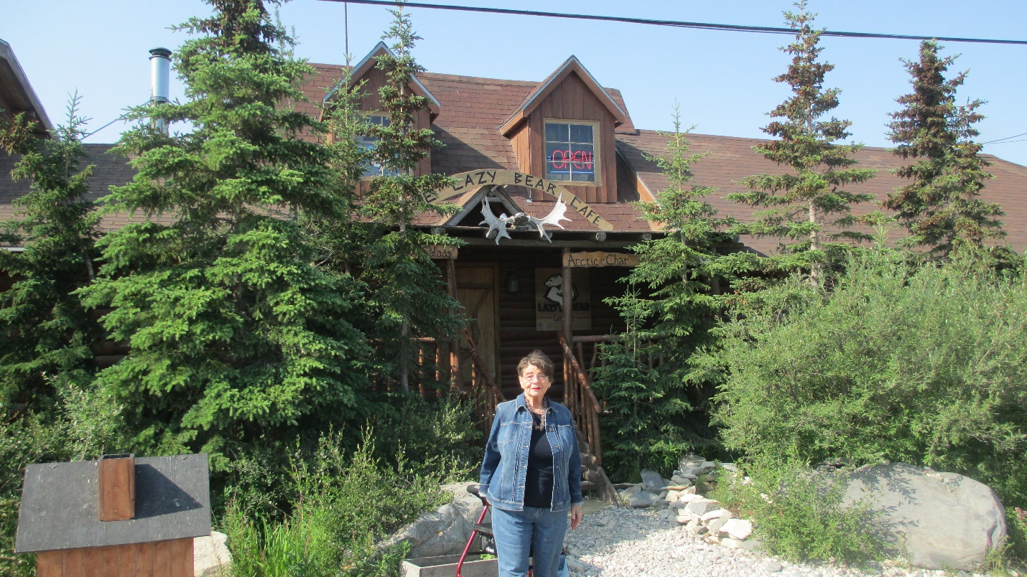

Carol’s
Birthday Poems

Carl Lahser

Another Fine Birthday
Eighty-one Steps
Wishes for Another Year
Butchart Gardens
The Belem Market
Cat Street, Hong Kong
Peanut Man
Historical Perspective on Athen’s Weather
Sing
Ha Long Bay
Old Enough

Another Fine Birthday
The painter Constable said,
“Nothing is ugly in this old world. “

Shouting girls from one side of the street
exude sexual defiance
in the way they challenge boys across the way
with their tinkling laughter.

Two mustached nuns dressed like penguins
walking side-by-side like penguins
in a flat-footed way
wave shyly as a passing Lowrider toots its horn.

A homeless woman sitting on a bus bench
eating potato chips out of her purse
mumbles to anyone and
holds up a finger to a passing police car.

A snotty infant paddles rapidly along the sidewalk
in a T-shirt, screaming:
his sister runs after him waving a diaper,
shouting for him to come back this very minute.

Time races and creeps and crawls
Minute by minute
Until another year has passed.
carl

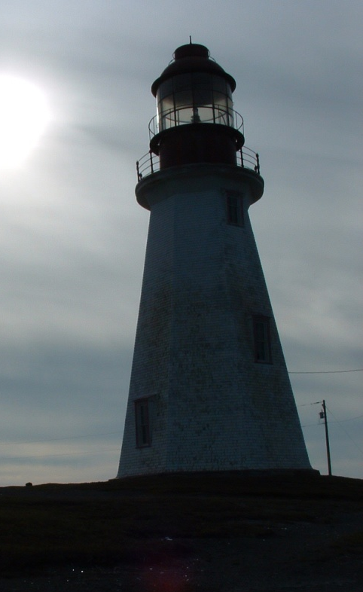

Eighty-one steps

Eighty-one steps
Up the spiral stairs
Each passing near its origin
But always charging upwards
To the widow’s walk
To view the future
Amongst the clouds
And changing fortune
Carl

Wishes for Another year
81 Birthday Wishes
A evening walk in your neighborhood
In the evening cool as the sun sets

A morning walk along a beach
with a rising sun and scattered shells
hand in hand

A volume of verses
And a hot chocolate
When the cool winds blow

Happy Birthday
carl.

Butchart Gardens

“What can we do with a borrow pit
After the limestone has been mined out”
Asked Mr. Butchart.
“Well”, says his wife.
“I think I will plant a garden”
She found the plants.
She scaled the walls.
She moved the rocks.
She planted her garden
And her dream came true.
So, will yours.
*****

The Belem Market

People everywhere in the cool of dawn,
produce to market and products back home
carried on the backs or heads of Indians and Creoles
before it gets hot and the sun, humidity and flies rise.

Displayed on palm leaf mats, everything you need-
fish, chicken, rice, bananas, voodoo charms
and they can fix your motorbike too.

Cat Street, Hong Kong

Just off Hollywood Road in Hong Kong
Cat Street where, shoulder to shoulder,
we wandered the crowded flea market.
Our son spotted a bright red jacket
which he wanted to try on.
The old woman handed him a blue one
but our son insisted on the red.
In broken English, she explained the red
was the color for girl-children,
and she would not sell a red jacket
to a boy and allow him to be subject to ridicule.
In a world of the poor, a principled merchant.

Peanut Man

Whooeeete
Whooeeete
In the dusk
Out of the gathering night
Whooeeete

Hola!
Hola! Hola!
Cacahuetes caliente!
Cacahuetes picante!
(Peanuts hot and spicey)

Dogs howl
Children gather to follow the peanut man
Through warm dusty streets
Un centavo here
Dos centavos there
The small black steam engine
Is pulled along the village streets

His route ends at the town’s cantina
Where he sells most of his cacahuetes
And washes the dust from his throat
With a cerveza fresco
A nice cold beer.

Historical Perspective on Athen’s Weather

A cold April mist blowing off the Hymettas Hills
veiled the other side of the airport
as we stood waiting to board our flight
in the year of 1997.

In April of the year 1841
Hans Christian Andersen made a note’
“Heavy rain clouds hung
across the mountains of Hymettos:
the weather was gray and cold.”

Politics may change but not the weather.
*****

Sing
Recall ancient wars and the stories of old
sing songs of protest and martyrs bold
sing of storms and weather fine
sing happy songs of love and wine
sing summer songs when the days are cold.
Sing!
*****

Hą Long Bay
Hą Long Bay, Vietnam
Vįnh Ha Long
Bay of the Descending Dragons
The 2,000 emerald karst islets
Were spit out by protective dragons
And jewels and jade
Sprang up in front of enemy ships

Hą Long – the place where mother dragon lived
Bάi Tú Long – where lived her children
Islets swathed in a hundred kinds of trees
Protecting Haiphong
Protecting Vietnam

A quiet night on the Bay
Watching Scorpio overhead
Hearing halyards slapping the mast
Listening to the creaking wooden hull
Quiet and a pot of tea.
Carl 28Oct11

Old Enough
Old enough to kiss a boy
Old enough to save or spend
Old enough to choose your life
Old enough to see the world
Old enough to stop counting
¡feliz cumpleaños¡
Happy Birthday

Happy abirthday

Happy Birthday

Happy Birthday

Happy Birthday

