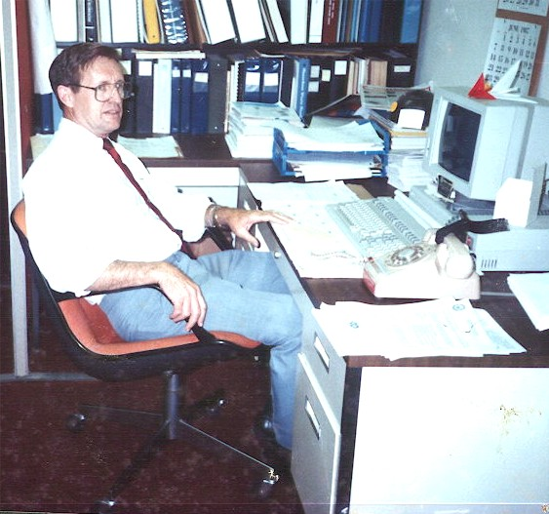
un Jubilación
A blueprint for my Retirement
Carl Lahser

Un jubilacion is the Spanish term for retirement or a pension. Since I retired, I have written several poems that on the subject of my retirements from the US Air Force and Federal Civil Service. Since then time has flown. Hammocks. Shade. Walks around the block.

Blueprint for Jubilación
(My Retirement)

1: Birthday morning
2: Night time
3: Wheels – An old man’s Time Machine
4: Heat
5: Glimpses
6: How to Embarrass the Kids
7: Hong Kong Chestnuts, 1978
8: Hą Long Bay, 28 Oct 2011
9: General Store, May 2000
10: Night
11: Jamaica Palace

12: Maybe there is a God –A Daydream

13: Summer Madness is Finally Here

Un jubilacion:1

Birthday Morning

I woke up with the sun
the beginning of year 77
on the 4th of November 2013

I was up but the sun
was still hiding
Behind jet stream clouds
blowing in from Mexico

For breakfast
the panaderia down the street
sold me a small tres Leches cake.
en mi jardin

I put on A Jazz Tape
sliced the cake
squeezed a glass of cold orange juice
and sang Happy Birthday to me

A blue jay joined in
along with a Monarch butterfly
heading south for the winter.
the sun broke out
heralding a good, good new year.
CARL 4/11/13

Jubilación :2

Night time – Ticking of the Clock
Dozing before the TV was pointless
so it’s off to bed at 10 pm
but I’m awake at 1:13 am.
Then the lying clock says its 3:21
and my bladder agrees
and gird chips in that supper is talking back.
I answer the call and take a few Tums.
Then it’s back to bed
til 4:37 when the clock lies again
and again at 5:27 when my bladder
issues a first warning.
A loudmouth mocking birds begins
atop a tree out front
making the rounds, marking his territory
Suddenly it’s 6:46
when the school bus begins its growling run
and I used to get up for work.
Now it’s 7:47 when I once sat down at my desk.
My bladder gives a final warning.
I throw off the covers and my feet hit the floor.
Time to put out the trash,
pick up the paper
and figure out what to do today.
Is this what I have to look forward to
for the next thirty years?
Carl Jan 2003

Jubilación :3

Wheels – An Old Man’s Time Machine

Driving home from my volunteer work
I came up behind a time machine,
like the Delorean in “Back to the Future” -
A white Ford Shelby Cobra GT 500 convertible.
Top down.
Driven by a cool blond
It took me back 60 years.

Back then I was driving a jade ’49 Ford convertible
with pinstripe trim
along the new Los Angeles Freeway.
She left me in her engine’s rumble
at the exit for Hollywood

The blond ???
The Cobra, however, was a new $60K machine.
What would I do if I had caught it?
Carl 07/14/15

Jubilación :4

Heat
As a kid on the Rio Grande in Texas
summer nights began at 90 degrees plus.

North African mornings
began at 113º with flies and 80% humidity.

A Thule Phase hit -30ºF,
70 mile winds pushing horizontal snow
and zero visibility.

In SW Arizona afternoon heat reached
117º and humidity at a dry -3%.

Considering this sampling
Where would I like to spend eternity?
I will probably stay right here.
Carl 24 Feb 2013

Jubilación :5

Glimpses

I saw her in a Christmas crowd
but she vanished in a sea of bobbing heads
I called to her in the Plaka in Athens
but she turned and spoke to me in Bulgarian

I bought her favorite drink from across a bar in St Louis
but she was gone before the waiter arrived

Countless glimpses of her over sixty years
in airports, on busy city streets, on passing busses

She must be gone
Consumed by time
Absorbed in space
Existing only in a tiny corner of memory
Unchanged in all these years
As I grow older

Jubilación :6

How to Embarrass the Kids
In late November it’s still warm
One afternoon a blue-black cloud forms in the north
A Blue Norther’s on the way
Quickly wrap the pipes
Water the garden
Lock up the chickens
Take a jacket to school for the kids
“How embarrassing,” say the kids
(But how good it feels)
Carl 111213

Jubilación :7

Hong Kong Chestnuts, 1978
Part of my retirement plan is to sit in the shade
Watching the leaves rustle against the clear blue sky
Looking back, reliving memories.

For instance a walk down Nathan Street in Hang Kong at dawn past Kowloon Park with my wife and son.
No one is in sight except a chestnut vendor a block away
warming his hands as his chestnuts begin to roast.
No one else is out in the cool white morn.

The chestnut man eyes us warily
and greets us in English with a Shanghai accent.
I show off and reply in Mandarin and warm my hands.
Then I purchase a bag of hot chestnuts
and put one hot nut in each of my son's jacket pockets.
The old man grins and wishes us well.

Carl20150808

Jubilación :8

Hą Long Bay
28 Oct 2011

In the fall of the year,
after the monsoon
my wife and I cruised Hą Long Bay, Vietnam.

Vįnh Ha Long
Bay of the Descending Dragons
2,000 emerald karst islets spit out by protective parents-
jewels and jade that sprang up as temptation
before an enemy fleet.

Hą Long – the place where mother dragon lived

Bάi Tú Long – where her children lived

A quiet black night on the Bay
watching Scorpio wheel overhead.
hearing halyards slapping the wooden mast.
listening to the creaking wooden hull.

Quiet and a pot of tea.

Jubilación :9

Amazon General Store
May 2000

Memories of a trip down the Amazon
For an anniversary

On a bluff 30 feet above the Apayacu River
a few miles from the Amazon
sits a lone general store.

Bright blue planks and a thatch roof,
a corrugated tin walls and awning
no window screens.
A sign says they sell
cerveza, gaseosa and curichi
but no chocolates.

Log steps lead up from the river
Where kids splashed in the muddy water
And played in beached pirogues.

In the distance a thatched house
with hammocks full of kids hung on the porch.
Pigs and chickens lived under the house
to keep snakes at bay.

Mosquitoes fill the air
and chiggers fill the grass.

The sky looks like it migh t rain.

Jubilación :10

Night

Night enters through my window
Altering the velvet blackness of the walls.
It dilutes the inside darkness
This invading night adding
1% starlight,
3% light of a sliver moon,
20% stray ribbons of coolness,
10% sounds of a distant train,
7% rustling of unseen night life
and stirring gently.

Barely illuminating pictures hanging on the wall:
framed views of an alien world of light,
snapshots of people and lighted landscapes
the alien night sucks up all but the frames.

Perhaps I should go out into the night,
bathe in the night,
inhale the song of a mockingbird atop a mesquite tree,
join the unseen life in the night,
instead of lying here immersed in darkness
warm and waiting for the dawn

Jubilación :11

Jamaica Palace
A new eatery opened in the mall
Jamaican cuisine and drinks
Jerk Chicken
Curry goat
Green bananas
Ginger beer
On Saturday, Ackee rice and salt cod
Bob Marley music
Who could want better?

I asked the cook if he had any Belafonte music
He said he had never heard of Belafonte
I said I had several calypso albums
He said he had no phonograph
And went back to the kitchen
Never heard of Belafonte?
Lord Invader?
Mighty Zebra?

The waitress said her grandmother
Loved Harry Belafonte
And the other calypso singers
And had a record player!

Goodness! Am I that old?
Or is this cultural erosion?

Jubilación :12
Maybe there is a God - a Daydream

I went out this morning
to put out the weekly trash
when a neighbors junkyard dog
ran out ready to bite my ass

One of my hot rodding neighbors,
just then, came roaring by
and put that ornery junkyard dog
into the big kennel in the sky

The car jumped the curb and bent its frame
and he was hoppin' mad.
No more will he roar by at 50+
and that makes me really sad.

In one fell swoop the cars off the street
and the dog is under the sod.
There is neighborhood peace and quiet again.
Maybe there is a God.

Jubilación :13

Summer Madness Is Finally Here

It looks likes a long, hot summer already.
The temperature has started to climb.
Militants have started to riot.
The destitute are turning to crime.
It’s too hot to sleep or work
And they'd kill you for only a dime
If it wasn't so damned hot.
Maybe some other time.

The weather is dry.
The sidewalks fry.
Lawns and trees cry.
Cold weather's a lie.
I want ice cream pie

I've run out of rhymes and patience so
Ihopetheycanfixmydamdedairconditioner NOW!!

Thank heaven for ice water and mesquite tree shade
While I wait for the bad news.

$500!!!
It better be one Hell hot summer or I'm gonna be mad.

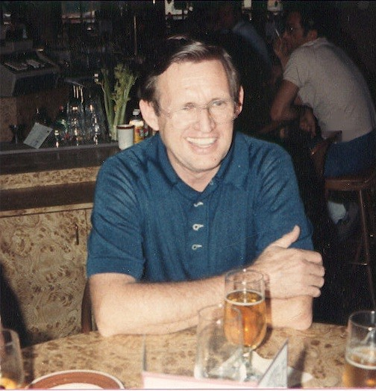
Retired!

