Vancouver, Victoria, and the Inside Passage
14-25 Aug 05

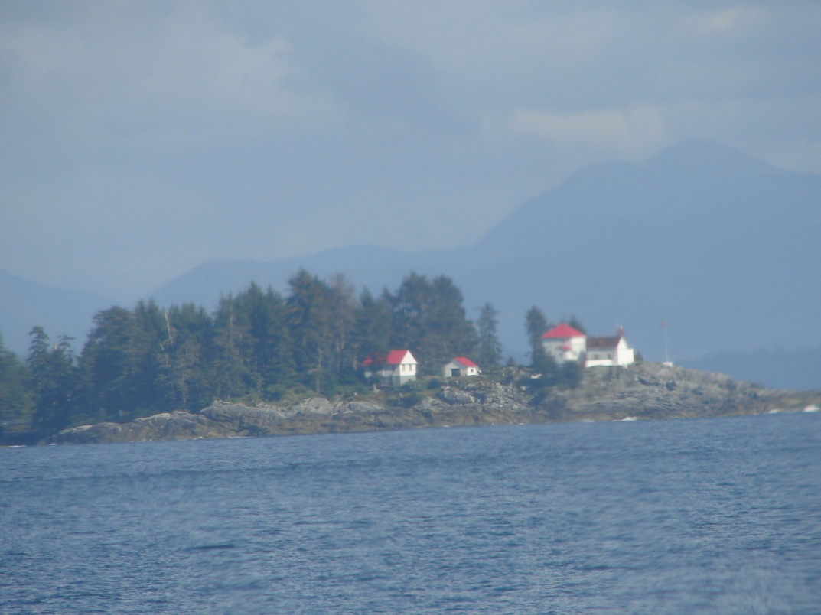

Carl Lahser

Vancouver, Victoria, and the Inside Passage
14-25 Aug 05

Bird Strike 2005 was scheduled for 15-18 August, 2005, in Vancouver, British Columbia. This was a conference to discuss the latest developments in keeping birds and airplanes separated. I wanted to see who was still in the field, what was new, and to look for possible work. I had attended the BASH meeting here in 1998.
My wife, Carol, wanted to come along to Vancouver so we decided to expand the trip to include a trip to Victoria, then up to Port Hardy, and a round trip up the Inside Passage to Prince Rupert on the BC Ferry, Queen of the North.
The least expensive transportation we found was on Southwest Airlines from San Antonio to Seattle and return. We booked a bus trip from Seattle to Vancouver and a ferry trip from Victoria to Seattle.
Seattle, Vancouver, and Victoria are all major historic sites with a long and rich history. Fur trading, fishing, gold rushes, mining, shipping, railroads are right there along with plagues of small pox, swindling the aboriginals, disenfranchising the Chinese population, and political intrigues. The weather is generally mild and agriculture flourishes. Population, wages, real estate costs, and crime are rapidly rising.

August 14th
A taxi took us to the airport at 0500 to arrive two hours early for a 0710 flight. However, the ticket counter did not open until 0540. The flight got off ten minutes late into an overcast sky. We arrived in Phoenix on time with the weather looking like it would rain. The Phoenix area was green as a result of the monsoon rains of the previous month. Takeoff was delayed 20 minutes but we made up fifteen minutes and arrived in Seattle only 5 minutes late. Seattle weather was cool and clear and the snow-covered mountains were spectacular.
We had an hour to wait for the bus to Vancouver. The bus left the airport at 1530 and stopped in downtown Seattle below the Space Needle for more passengers. Leaving we passed a place with a couple of WWII amphibious DUWKs for harbor rides.
The plastic windows of the bus were flexible and a distorted mess not suited for photography so no Seattle pictures.
Trees along US1 were mostly conifers with occasional False Acacia (Robinia) and other broad leaf trees like Mountain Ash (Sorbus scopulina) with its bunches of red-orange fruit. There were bunches of Lady Fern (Althyrium filix-femina) but most of the grass in the median was brown. There were a few Madrones (Arbutus menzeii) and a number of dead spruce trees probably from budworm.
A ’59 Buick convertible floated by on US 1 heading north .
All of the sycamore trees appear to have anthracnose.
We picked up a few more passengers at the Everett AMTRAC station. A commuter train called the Sounder was sitting in the station probably waiting for tomorrow’s crowd.
Few flowers were in bloom. I saw patches of bloomed out Fireweed (Epilobium angustifolium) and patches of blackberries (Rubus sp). One field had a patch of Perennial Sow Thistle (Sonchus arvensis). Cattails (Typha latifolia) that had already shed the female flowers were growing in wet swales along the highway.
There were several Western Meadowlarks (Sternella neglecta) perched on the power lines and a flock of sparrows of some kind dashed out of a tree and into an abandoned brown field.
We made a short stop for Canadian customs and immigration at the border. Common Plantain (Plantago major), Ribwort Plantain (Plantago lanceolata), and Common Dandilion (Taraxicum officinalis) were growing in pavement joints.
Across the border in Canada were several more small flocks of sparrows and a few starlings and crows.
A large greenhouse operation was for sale or lease. There were fields of potatoes, cabbage, half grown corn, Vidalia onions, and herds of cattle and flocks of sheep.
Vancouver came into view with lots of grain elevators. We passed a Tim Horton so we were officially in Canada. About half of the population of British Columbia lives around Vancouver.
The bus arrived at the Vancouver airport about 1930. We got our bags and caught shuttle to the Richmond Hotel and Convention Center. Six years ago this was a couple of miles from the bus line but now it was right down town sharing a parking lot with the Marriott.
Wow. A 7th floor room with a balcony and a good view. Could hardly believe it. We went down for supper about 2100. The restaurant in our hotel was closing so we went next door to the Marriott. Nothing to rave about. Less than 4 ounces of halibut for $21C.
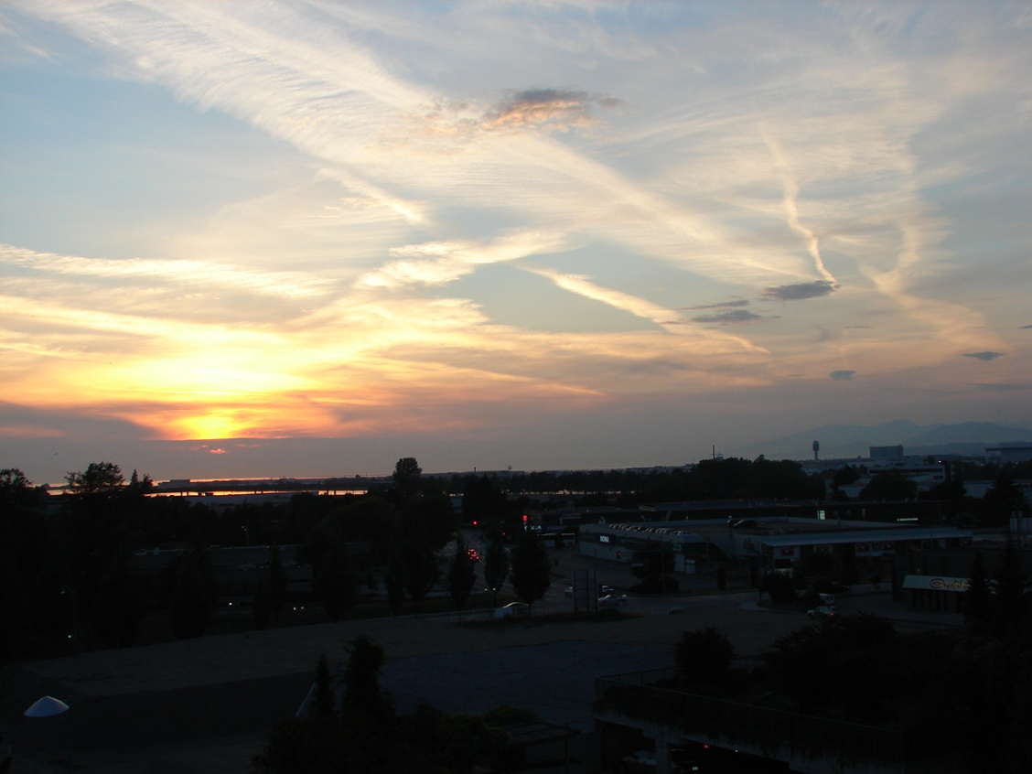
Sunset
August 15th
Monday began by waking up at 0430 local time. I finally got up about 0700. It was clear and 18°C. out on the balcony. The hotel buffet was $12.95 so I went across the street for $6 pancakes.
I registered for the conference about 0830 and sat through the presentations while Carol took the bus down town.
Monday evening was a reception. A number of old acquaintances were present. I talked to Ron Merritt and discussed doing my BASH play at the BBQ Tuesday night.

August 16th
Tuesday morning was overcast and 18°C. It had rained during the night and Whistler and the other mountains to the north were lost in fog. I went to the meeting while Carol went to the hairdresser.

Disappearing Whistler

Last night Whistler Mountain
Stood out over Vancouver.
Silhouetted against the twilight sky
Dawn broke to the tinkle of raindrops
Whistler and Vancouver were gone.
*****
There was an afternoon field trip to the George C. Reifel Migratory Bird Sanctuary on Westham Island Tuesday afternoon. The refuge was near the town of Ladner. It had been the Reifel family farm where they had produced sugar beet seeds for WWII. They converted it to a bird sanctuary in the 1960s. The busses left the hotel about 1330 for a half hour ride to the Sanctuary. As we approached the entrance there was a Bald Eagle waiting for us in a tree along the river. We had a 90-minute guided tour along levees that defines wetland and pond areas. This was followed by a visit to their museum with a mounted bird collection and a stop at their gift shop and bookstore. Lots of geese. Blue-wing Teal. Northern Shovelers. Several Western Sandpiper, Lesser Yellow-legs, and Willets. Several Redwing Blackbirds. A few Great Blue Herons. The bellow of Bullfrogs and the chirp of tree frogs. Turtles sunning on a log. Purple Loosestrife. Goldenrod. Invasive Himalayan Blackberries with pale pink flowers. Holly. Pearly Everlasting.
The busses returned us to the hotel about 1630. About 1800 we began our 15-minute walk through the park to the BBQ site. Beer. Chicken. Salmon. Beer. Potato salad. Beer. Ron Merritt and Gene LeBoeuf played guitars and sang. I presented my BASH play with audience participation. Interesting what beer and spontaneous reactions can produce.

August 17th
Wednesday I played hooky for the morning session and went down town with Carol.
Richmond had really changed in six years. It had been out in the country beyond the bus line and was largely into truck crops such as potatoes, onions and cabbage. It still produced a lot of vegetables and had several wineries but had urbanized. It was now the largest oriental community in Canada and the third largest Chinatown in North America after San Francisco and New York.
Vancouver was the largest metropolitan area in western Canada. City planners exported their Vancouver model where they plan complete high-density communities within the city. Each was complete with all the necessities such as food, entertainment, education, housing and business spaces. Areas were Downtown with museums and parks including Stanley Park), Gastown (gentrified old buildings along the river), Chinatown (oldest in Canada, Dr. Sun-Yat-sen home and classical Ming garden that I visited last trip), Westend ( includes the gay community), Yaletown (up-scale), South Granville, Richmond (the island that became a city), and North Shore with Grouse Mountain Park and the Capilano Suspension Bridge. With excellent transportation, leisure and sporting facilities this was slated to be the home of the 2010 winter Olympic Games. We did not have time to see much.
An articulated 80 passenger bus took us for a 45 minute ride to Harbour Centre for $3.25. We passed numerous spas and gyms and signs in Chinese, Vietnamese and Punjabi.
Real estate was high. A 1500 sf in Richmond ran about $400K. In Downtown the same house would be a million bucks plus.

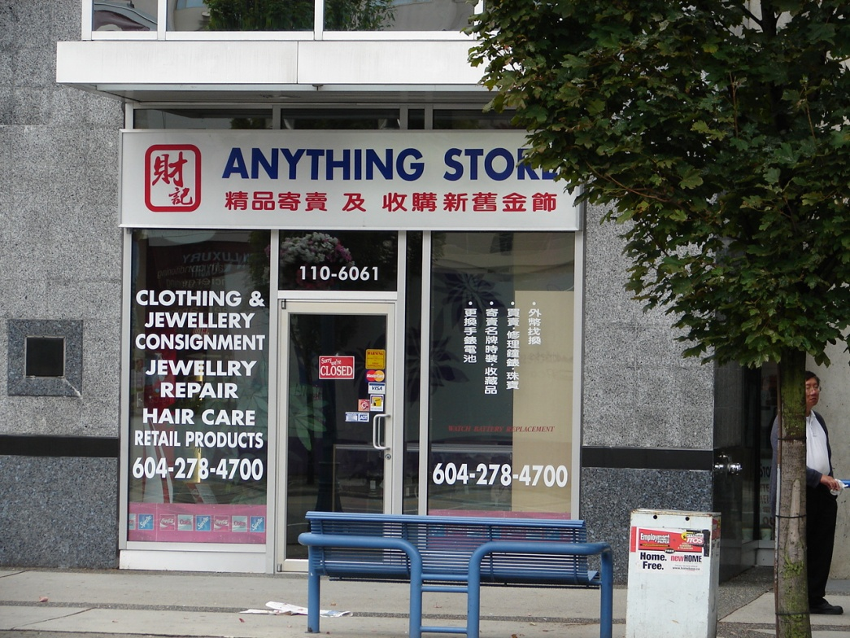
Anything Store

We walked past the harbor and into Gastown with its old steam powered clock. Flower baskets hung from the lampposts. Up one side of the street and back on the other. Hills aboriginal art was the only one I remembered from last trip. We had Italian for lunch at a sidewalk restaurant.

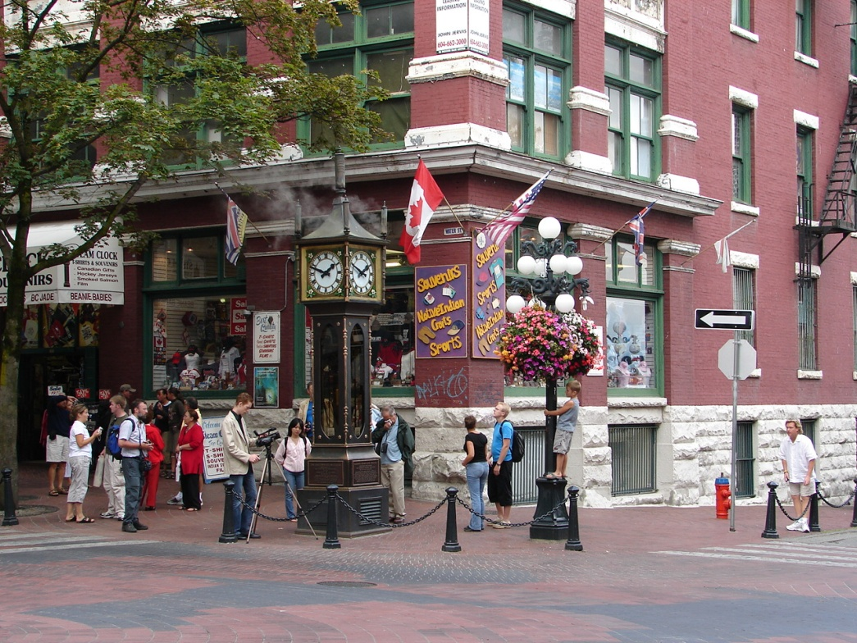

Gastown Steam Clock

Toot! Toot! Toot! Toot!
The steam clock tooted the quarter
This 19th century wonder
Is almost buried in the hanging flowers.
*****

We stopped to see Storyeum. This was a relatively new living history production covering a square block in underground Vancouver. Well done.
After lunch we walked to Yaletown for art galleries. About 5:30 we arrived at a restaurant called “C” on the waterfront. Good food, outstanding service, and a really high bill.
We were back at the hotel by 9PM.

August 18th
The Grayline shuttle picked us up at 0830 for a ferry ride to Victoria. The bus drove on board and we got off to enjoy the ride. The driver said that most of the retired weathermen in Canada retired to Victoria since the weather is the same every day. Over half the population of Vancouver Island (700,000) lived around Victoria.
The weather was clear and mild and the tide was out exposing pink starfish on the pilings. During the trip I saw other ferries, seaplanes, container ships, sailboats of different sizes, several kinds of fishing boats, and a Canadian Coast Guard cutter but no whales, eagles, or seals.
We reboarded the bus, debarked, and began a half-hour drive to Butchart Gardens. The Garden had been a quarry for the Buchart concrete works that provided concrete for the developing Victoria in the late 1800s. When the limestone quarry was mined out in about 1900 Mrs. Butchart decided the old quarry would make a fine garden. She imported plants from around the world and personally oversaw the development and planting of the various gardens. A few of her friends began visiting to admire her handiwork. After a few years the visitors numbered in the thousands and an admission was charged. The garden is still privately owned. Admission was $11 US. The garden had landscape lighting for summer evenings and fireworks displays on Saturday nights.
We had an hour and a half – not nearly enough. The walk began passing the visitor center and coffee shop and through Waterwheel Square. There was a display of cyclamens and fushias. A half-mile trail lead around and through the former quarry with ponds, hills, a fountain and numerous trees and flower beds. Next was a concert lawn and stage, a pair of large totem poles, the Sturgeon fountain and the rose garden. We wandered through the Japanese Garden, passed the Star Pond and entered the Italian Garden. There were two restaurants, an ice cream shop, a display greenhouse, a plant identification office, and a Mediterranean garden. It was all handicapped accessible. I shot about 80 pictures.
Most memorable were beds of begonias of mixed colors and the rose beds planted with contrasting tall blue larkspur. I was a little disappointed in the selection of books in the book store. Their ice cream was made on site and delicious.

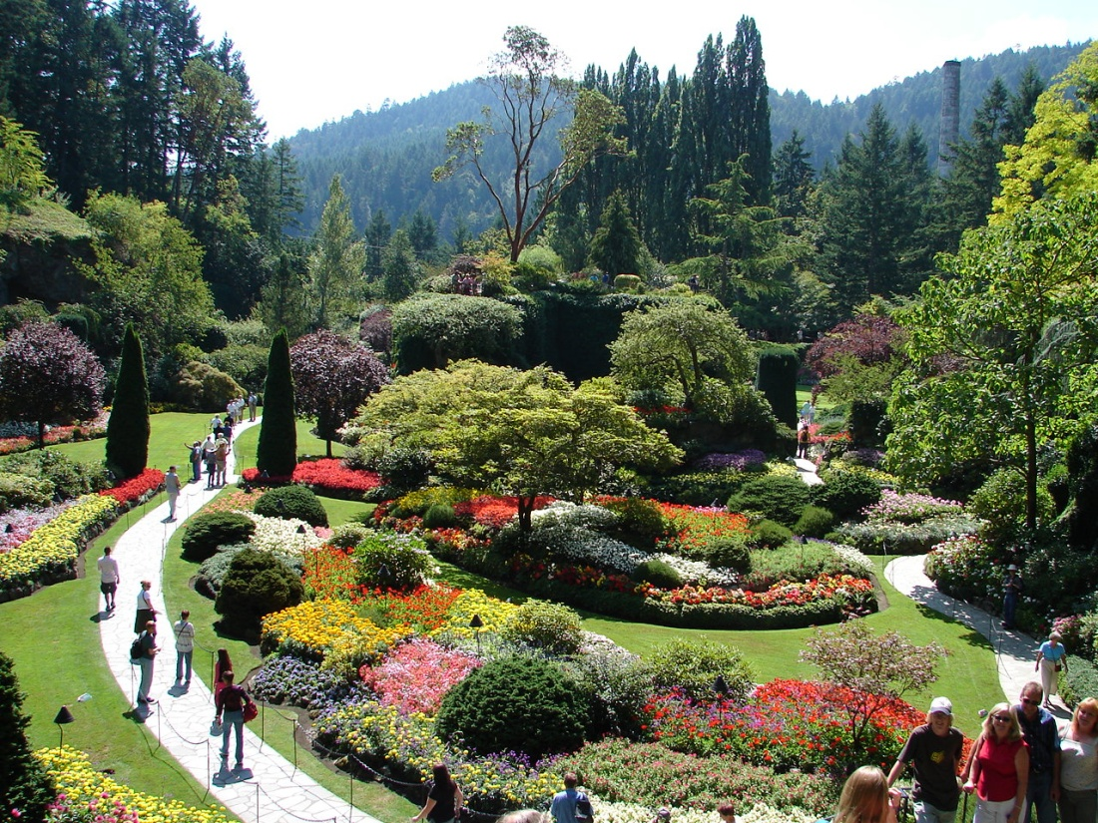

Butchart Gardens

“What can we do with a borrow pit
After the limestone has been mined out”
Asked Mr. Butchart.
“Well”, says his wife.
“I think I will plant a garden”
She found the plants.
She scaled the walls.
She moved the rocks.
She planted her garden
And her dream came true.
*****

The bus pulled through an exclusive high-end subdivision with multimillion-dollar 5,000-10,000 sf homes along the bay. Francis Rattenbury, who won the design competition for the legislative buildings and the Empress Hotel, designed and built many of them.
After seeing Mile Zero on the Trans Canada Highway the bus dropped everyone off at the various hotels. We had reservations at the Laurel Point Inn and arrived about 1800. After checking in we walked towards downtown for supper.
A couple of blocks along a pedicab stopped and offered a quick tour of town and several good restaurant recommendations. We took the tour passing the government buildings and the museum and Thunderbird Park then up Government St. with its candy shops, galleries and the worlds only McDonalds with a two-story crystal chandelier. We passed the Bastion Square (site of old Fort Victoria), Market Square (the heart of Old Town), and Bay Center (used to be the Hudson’s Bay Company), the Christmas store and city hall.
We finally arrived at the gate to Chinatown, the Gate of Harmonious Interest, and Fan Tan Alley. Here even the dragon shaped street lights are privately owned. He showed us the Chinese school, little alleys where gambling and opium dens were once located and explained the half addresses where a hidden floor was built between the window top of the first floor and the second floor to avoid taxes.

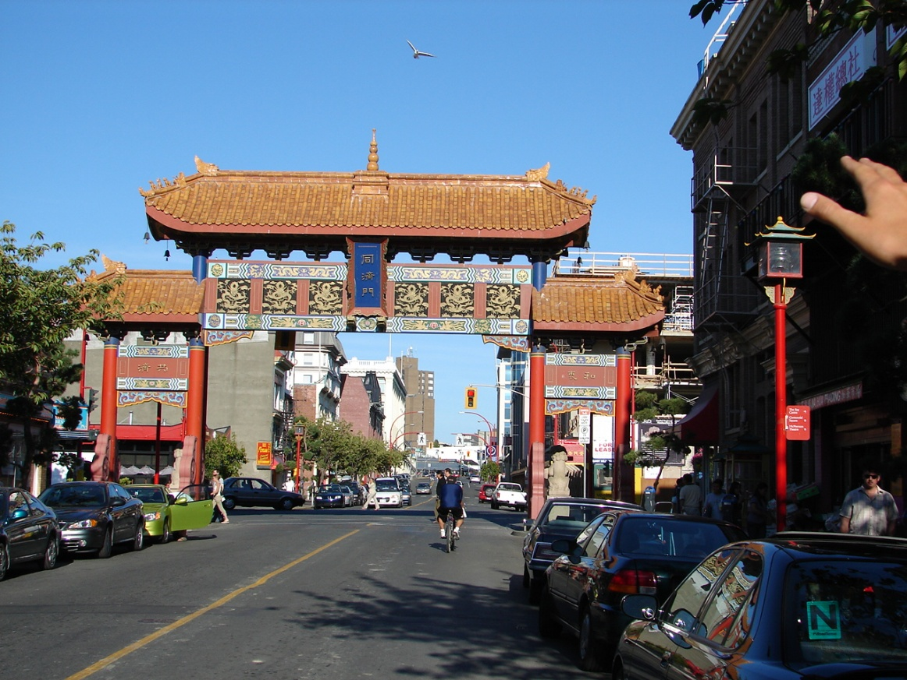

He next peddled back along Wharf St. and recommended several restaurants with harbor views. We ate at the Bravo. I had elk and Carol had steak but both were tough and chewy and the service was less than I expected considering the price. Or, maybe, because of the price.

Victoria Views

Sea planes.
Water taxis.
The Empress Hotel.
Pedicabs.
Clear blue skies.
*****
We walked back to the hotel along Wharf St. to Government St. passing the Empress Hotel. The Empress was built on an old swamp that had been filled with refuse and rubble. It has settled several feet over the past hundred years and still sinking.

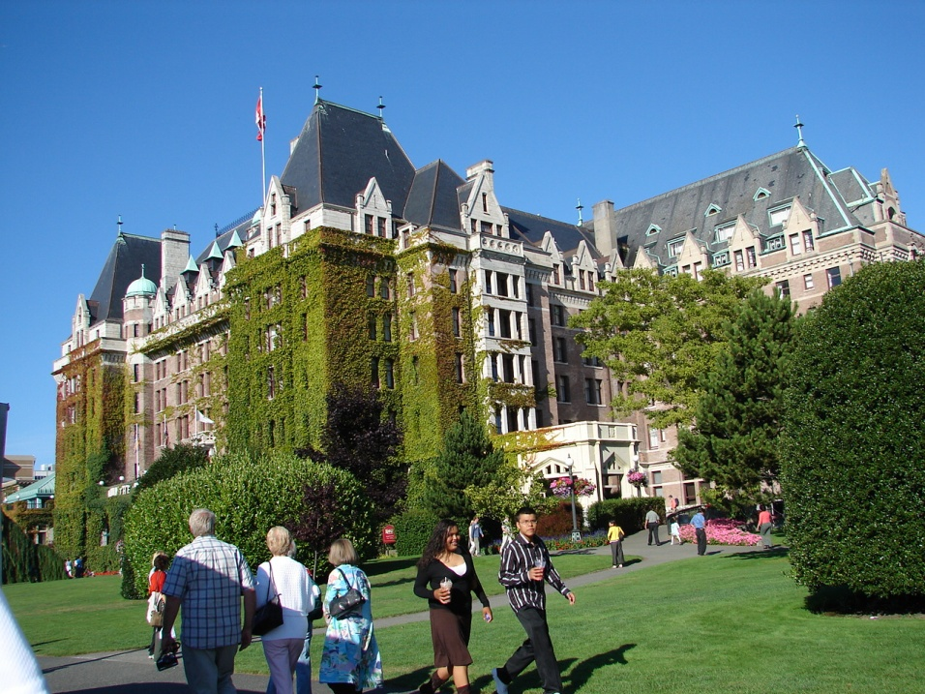

The Empress Hotel

Built on a swamp
It continues to sink
The Empress Hotel
It’s not what you think.

A giant hotel
Covered with vines
Formal High Tea is still served
Just like in old times.

Its sits there alone
Looking over the bay
Hoping you will return
To Victoria someday.
*****
We turned at Belleville St along the harbor where carvers, jugglers, and singers entertained the tourists. We were back at street level near the wax museum and the ferry docks. The full moon was just rising over the harbor.
Victoria had numerous parks and historical sites but we were leaving next morning. It also had diving tours, an underwater garden display and whale watching tours.

August 19th
I was up at sunrise and went for a walk. The tide was out but the rock were not accessible being 7-10 feet below the headwall. The mud was silty and the rocks were covered with green algae (Enteromorpha sp. and Ulva sp.) Beach Isopods (Alloniscus perconvexus) and Speckled Pillbugs (Cirolana harfordi) plowed through the seaweed and debris. Spot-bellied Rock Crabs (Cancer antennarius and Porcelain Crabs (Petrolisthes cinctipes) glided smoothly over the rocks covered by a couple inches of clear water. Carapaces of Shield-backed Kelp Crabs (Pugettia producta) and strands of Giant Kelp (Macrocystis pyrifera) lay amidst the rocks. There were broken shells of California Mussels (Mytilus californicus), Chubby Mya (Platyodon candellatus), Giant Pacific Oyster (Crassostrea gigas) and Pacific Oysters (Ostrea lurida). Acorn Barnacles (Balanus glandula) and Little Brown Barnacles (Cthamalus dalli) and several species if limpets encrusted the rocks.
Bright and early this Friday morning we were checked out and waiting for the tour bus at 0815. After a couple more passenger stops we were on our way to Port Hardy 500km north.
On the way to the village of Duncan we passed over the top of a 1000-foot ridge called Mount Todd. It had been a barrier to getting to Victoria and the southern part of the island from the northern part of the island. A highway was constructed in the 1920s and is part of the Trans Canada Highway leading the official ferry crossing at Nanaimo.
The first leg of the trip was to Duncan in the Cowichan Valley. The valley is famous for its agricultural products. The town is a bedroom community for Victoria and home to about 2500 of the First Nation Cowichan Band. There was a Native Heritage Center with historical displays and craftsmen demonstrations of carving and weaving. They advertised excellent fishing in the Cowichan and Koksilah Rivers and tours of several of the local wineries. The poet, Robert Service, once lived in the area. We got a windshield tour of town and saw many of the 85 totem poles that grace the town. The preferred term is story poles since they tell a story and are not worshipped. This town has no chain eateries.

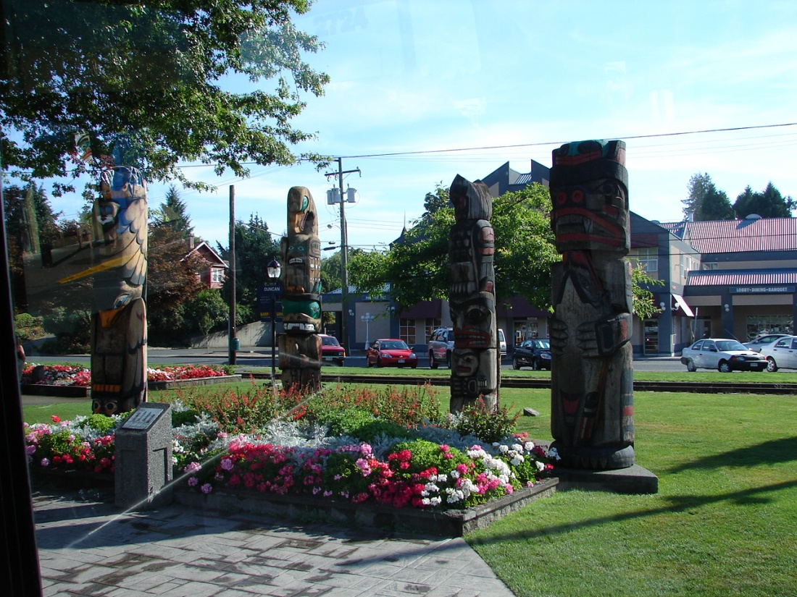
Story Poles

Along the roadside were a number of intrusive Scotch Broom plants without leaves or blooms. This plant was first introduced about 1850. It has been highly invasive all over the Northwest.
It was easy to identify the First Nation reserves. They were not subject to Provincial restrictions and had fast food outlets, bill boards and cigarette shops.
Columbia Forest Museum Park was north of Duncan. This 100 acre park had a 1.5 mile narrow gage railroad that took visitors on a tour of a 19th century lumber operation.
The next stop was Chemainus. This village (pop. 400) had been about to die when the sawmill closed in the 1982. The citizens came up with a plan to paint murals on some of the buildings. This drew visitors. Galleries and other tourist trade shops opened. More murals were commissioned and there were currently 35 murals plus large wooden carvings. Population had increased to about 5000. They began presenting plays and had built a new theatre. The lumber business had also returned.

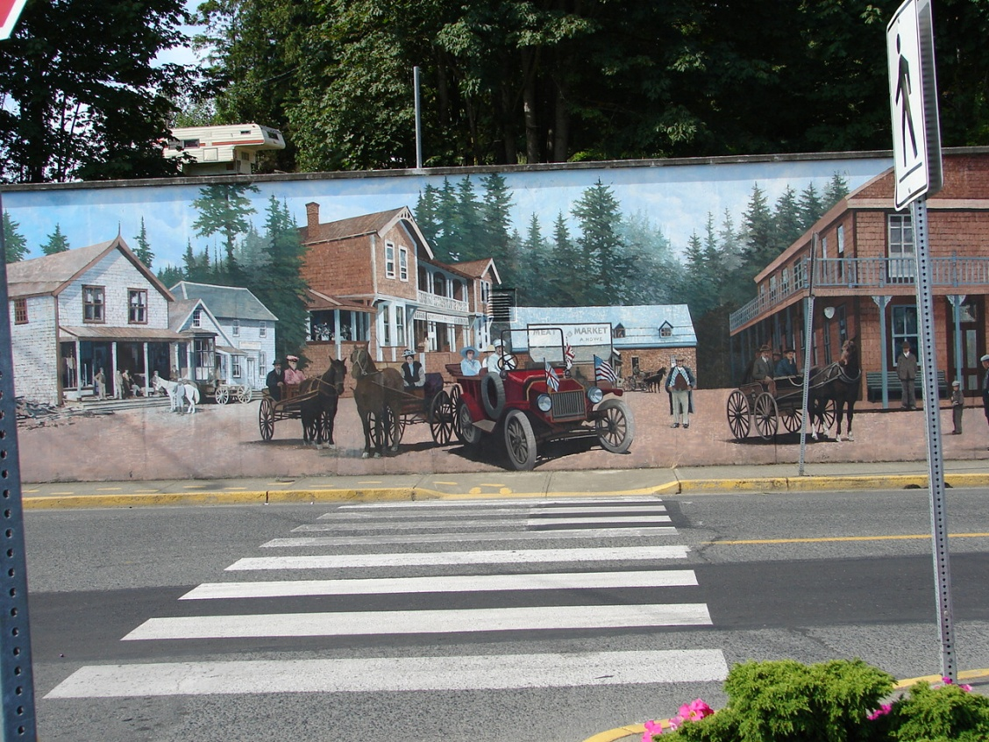
Mural

Another few minutes north we bypassed a 140-foot bungee jump into the Nanaimo River gorge. We also bypassed Nanaimo, Vancouver Islands second largest city and major ferry port. It was an important 19th century coal mining area. Off the coast lies Newcastle Island that was the source of coal for the Canadian-Pacific Steamship Company. The island is now one of the many Provincial Marine Parks. There were numerous trailer parks and golf courses. Nanaimo had a shipyard and was the official ferry continuation of the Trans Canada Highway from Victoria to Vancouver. The highway number highway north changed from Canada 1 to Canada 19.
We saw a lot of logs floating at Nanaimo but there was not much new timber cutting along the highway. The cut areas were mostly clear cuts. There were a few cuts where seed tree stands had been left. The most areas had not been burned or replanted. No ferns. No young trees. Piles of slash. Maples, alder, and aspen growth were getting thick. There were several planted areas where young pines were maybe 8-10 years old. Some areas had been planted in hemlock since it grew faster and brought a better price. Apparently there were few natural wildfires since there was not much lightning.
A few minutes later we turned off the highway into Qualicum vollage to drop a family off at the railroad station. This was the end of the passenger line. This was a nice looking retirement town with fishing and golf. Qualicum Beach was several miles from downtown and was several miles of granite sand. Lots of picnickers and clam diggers.

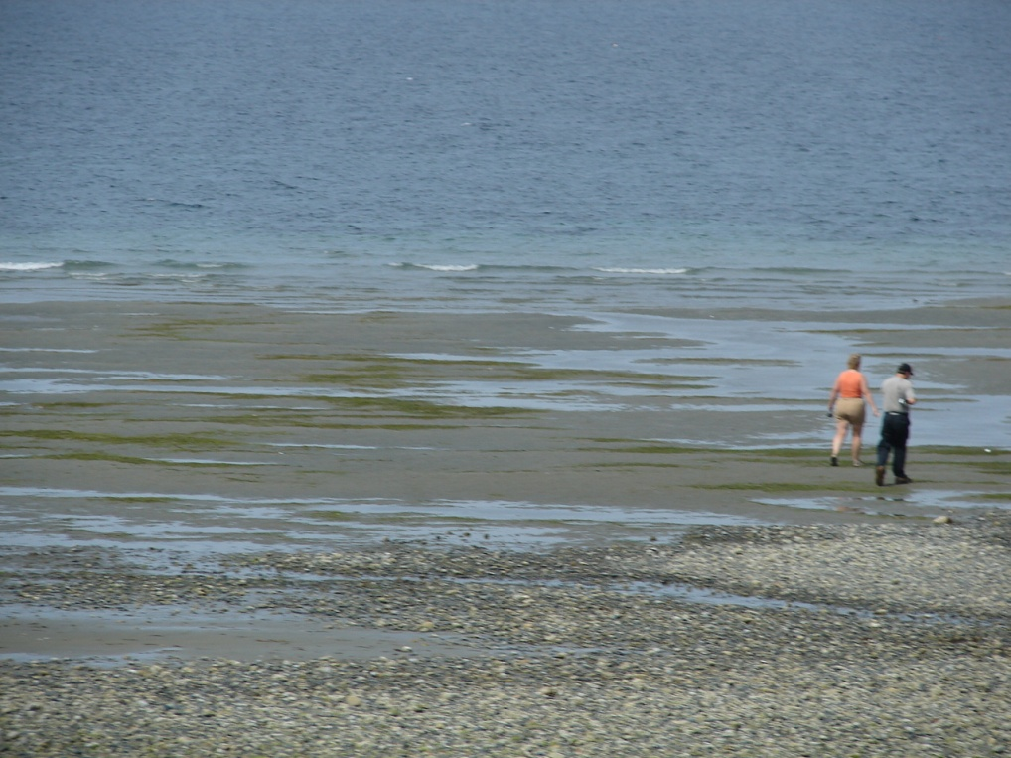
Granite Sand Beach

We stopped at a rest stop. I was surprised to see an Artic Lupine, and a lilac bush in bloom in August.
A six-foot deer fence was installed along the highway. This was supposed to keep deer and elk off the highway.
Lunch was at the Old Country Market at Coombs. This was unique in that the roof was sodded and goats were grazing on the roof. We had lunch and bought some fresh cherries and black berries. There were several tourist shops, an antique shop, and a wild-west trading post. Kids were kept occupied by an old VW hulk and a play castle.
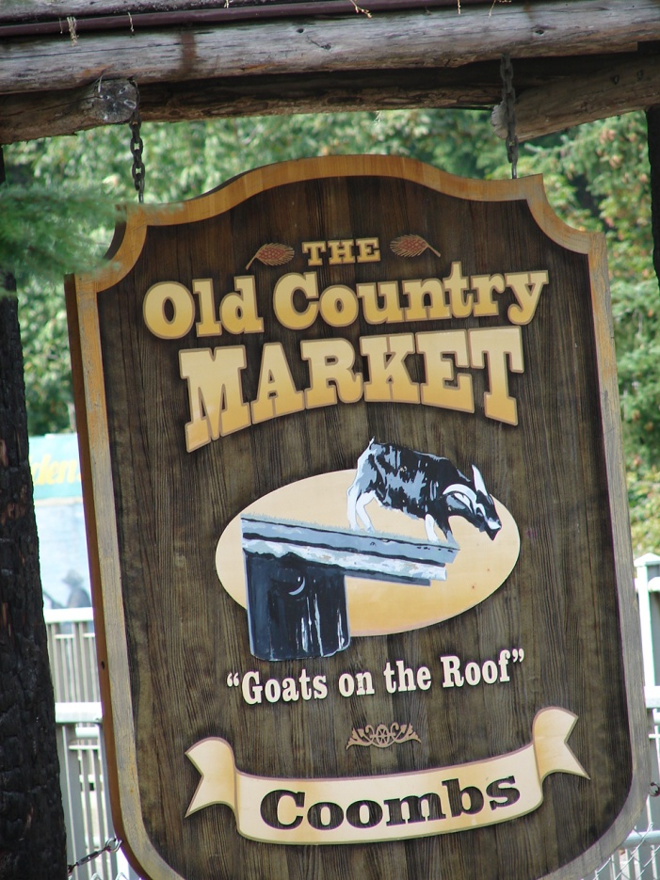
Coombs Store

Mid afternoon break was at the Cable House restaurant in the Comox valley. The building was been built by a Mr. Duncan. He wrapped 8000 feet of old 2-inch lumber cable around a metal frame.

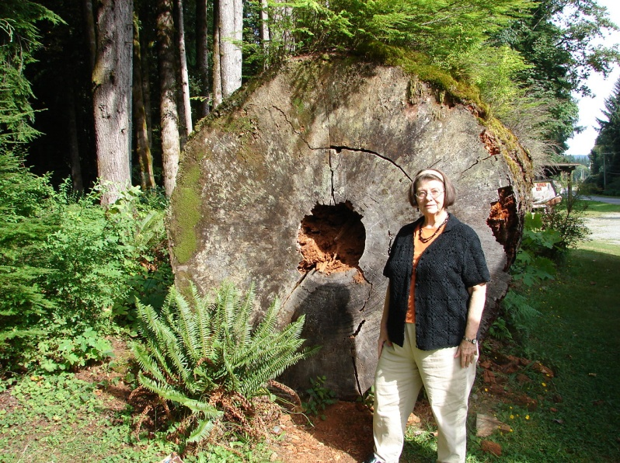
Nurse tree

There were a number of ancient rusting vehicles of various kinds, metal sculptures, and several outhouse style buildings with scenes painted on them. Good fresh pie and hot chocolate. There was also a gift shop. A large downed tree trunk called a nurse tree was all punky lay and covered with seedling conifers.

.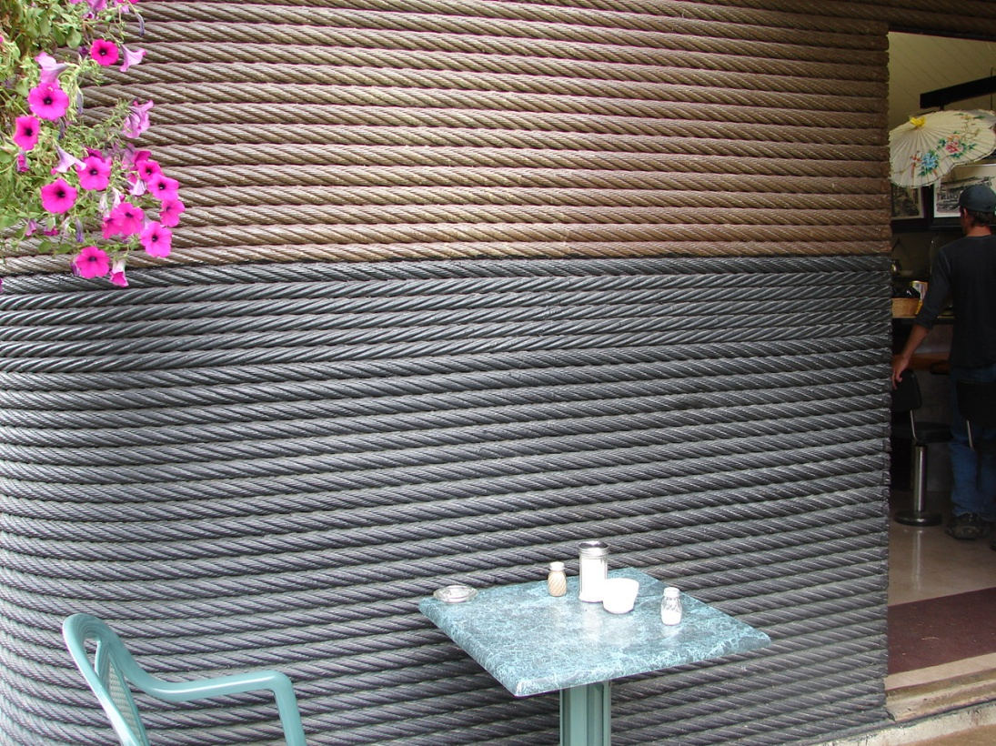
Cable House

We passed through Cortney and bypassed the RCAF base at Comox and the turnoff to the Mount Washington Ski Resort.
It began to drizzle and about half hour from Port Hardy we saw a couple black bears. The Quarterdeck Motel was away from down town and had its own marina and restaurant. A couple of years ago a black bear had brought a salmon for lunch into the hotel and plopped down on the rug in the lobby. They ran it off several times and finally had to shoot it as a dangerous pest. They said they had to clean the rug several times to get the odor out.
I took a walk in the drizzle along the beach at low tide. The rocks were slippery with algae (Enteromorpha sp). There were a few broken shells but nothing fresh. Little Brown Barnacle (Cthamalus dalli). California Shield Limpet (Collisella pelta). Common Blue Mussel (Mytilus edulis). Fine-ribbed Cardita (Cyclocardia cribricostata). Common Washington Clam (Saxidomus nuttalli). Bentnose Macoma (Macoma nastua). Smooth Pacific Venus (Chione fluctifraga). Frilled California Venus (Chione undatella). Some of the shells were broken and could have come from the restaurant. Some may not be native.

August 20th
It was still misty at sunup. We packed up, checked out and waited for the shuttle to the ferry.
The ferry at Bear Harbor was pulled up with the bow open. We walked on with a number of other passengers. Some passengers were going to Prince Rupert or Queen Charlotte Island while others were going catch the train to Calgary. There were a few cars and trucks for passengers who would drive to Calgary.
We found our stateroom – two bunks and a shower and adequate storage. Main problem was it was on deck seven with no elevator to that deck.
I went topside to watch the departure. Land disappeared quickly into the mist as we entered Queen Charlotte Strait. Pacific White-sided Dolphin (Lagenorhynchus obliquidens) escorted us out.
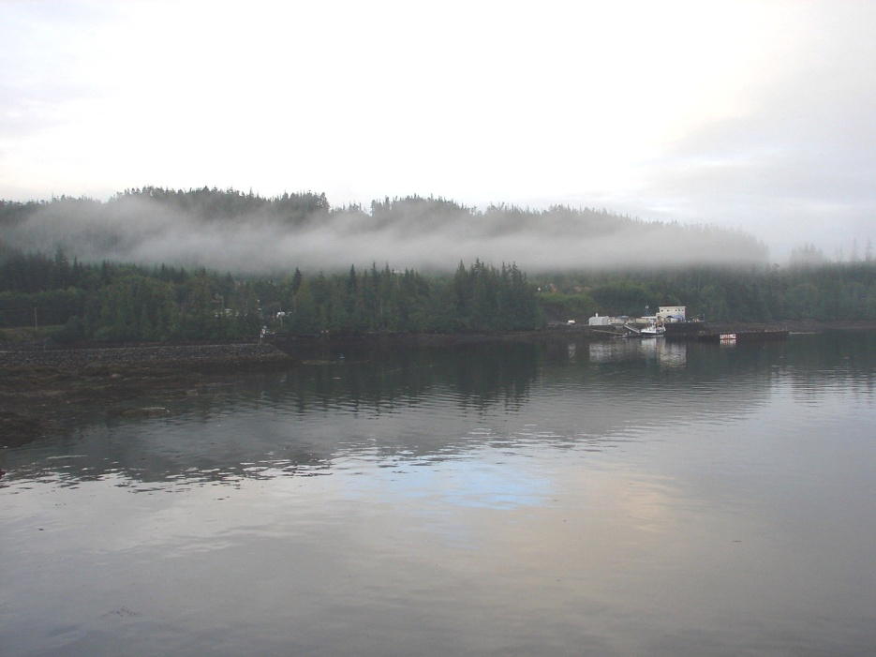
Inland Passage

Several small islands drifted by as dark shadows as we crossed about a hundred miles of open water across Queen Charlotte Sound. This was open to the Pacific. We finally ducked behind Calvert Island and into Fitz Hugh Sound and the Inland Passage.
We passed several houses and little white structures that were navigation signal lights. We passed a small community of Namu then passed between King and Hunter Islands. Further north were an abandoned Hudson’s Bay trading post and a community called Bella
Bella.

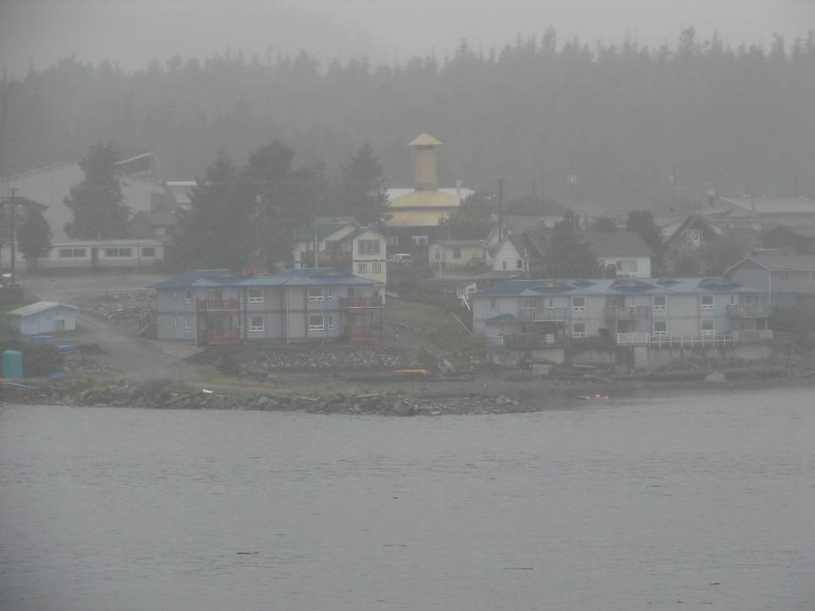
Namu Village

There was an abandoned sawmill at Swanson Bay. A few pilings and a tall red brick smokestack was still standing.
Next came an abandoned salmon cannery at Middale on Princess Island.
Several types of fishing boats cruised the waterway. Trawlers. Seiners. Crabbers with piles of traps. There were also tugs with one or more barges.

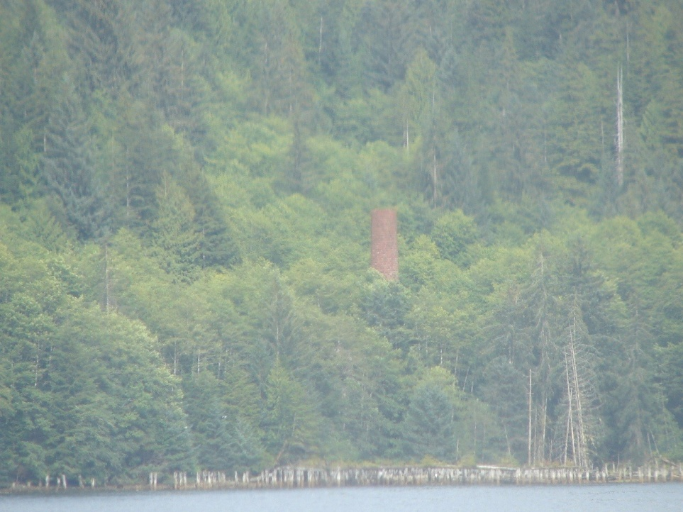
Swansons Bay

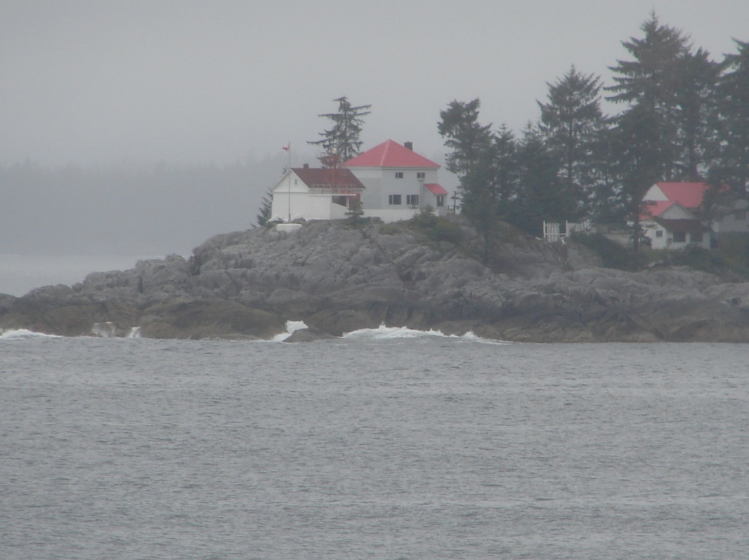
Lighthouse

Pink salmon were jumping and a black bear was spotted. Many waterfalls cascaded in several stages onto the beach.

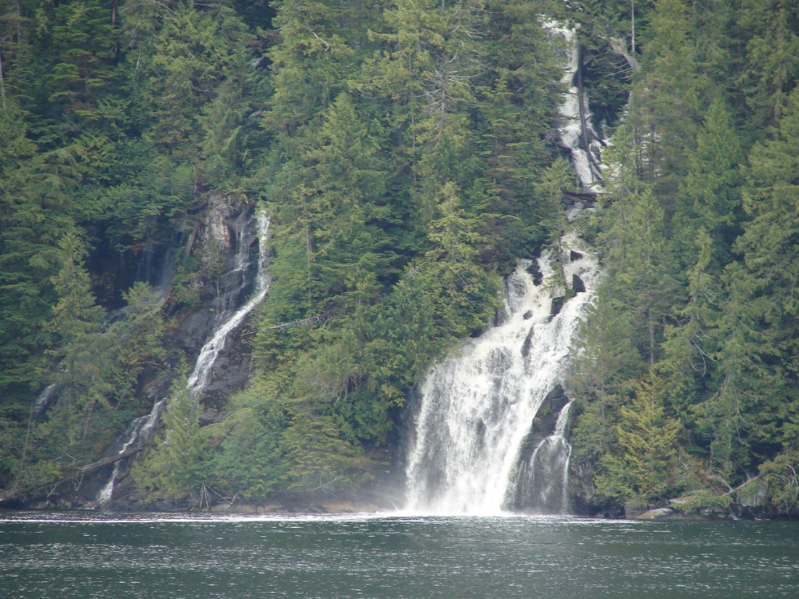
Waterfalls

We went to supper as the sun was disappearing in the overcast. It was a nice buffet with BBQ, lamb and roast beef with Yorkshire pudding. I tried one of the local beers but it had too much hops for my taste. We talked with a veterinarian and his wife from Australia and the waitress from Newfoundland.
About 2100 we passed a coal and wheat loading port and the proposed site for a new container port connecting to the railroad to service primarily Chinese ships. We docked at Prince Rupert at 2230 stern first.
Prince Rupert sits at the mouth of the Skeena River on mainland British Columbia. It is 450 miles by road or rail to Prince George and then another 500 miles to Calgary. This was supposed to be one of the best deep water port sites in North America. There was a ferry to Queen Charlotte Island the home of the First Nation Haida Band.
I don’t know what downtown looked like. The dock was south of town and it was the middle of the night.
We lowered the top bunk and crashed. The mattresses were about 18 inches wide and about an inch thick.

August 21st
I was up about 0500 and went down to the car deck to talk to the guy on watch. When he was relieved and I went ashore with him. He had been in the area over 30 years. His wife and kids had left and gone to the States. He said he had worked on the renovation of this ferry. It had been a Swedish party boat with a big hot tub on the car deck and sixteen bars scattered across the ship. Now he works on it. He also fished and cut wood. He said they had expected a couple million in the salmon run but only about ten percent had arrived. Those were mostly the pink salmon that we had seen.
He said there was a big museum in Prince Rupert, the Museum of Northern British Columbia, in half of a working cannery. There were also a couple nice sand beaches.
I walked along the parking lot and railroad track to the harbor full of fishing boats. There was a lot of grass, alder scrub, dandelion, and oxeye daisy (Leucanthemum vulgare). I took several pictures of Prince Rupert strung along the shore. Weather was about 14°C and about 100% humidity.
The tide was out and the beach steep and rocky. About 0630 they began loading passengers. A Belted Kingfisher (Megaceryle alcyon) went airborne from under the dock.
The ship left on time in the early sun. It was relatively clear and got better during the day.

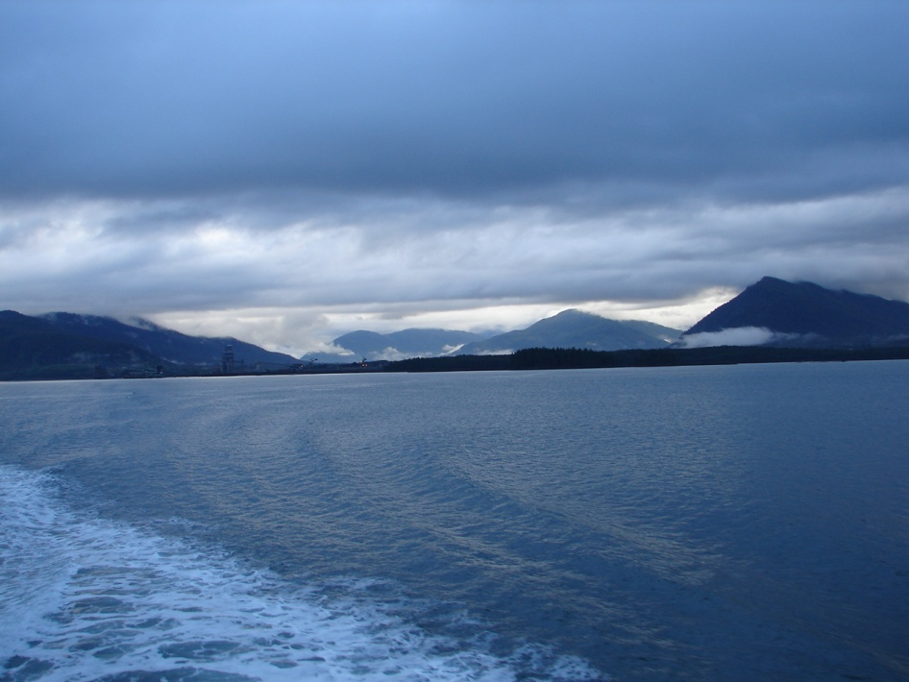
Inland Passage
The islands and their trees were now visible. There were large quartz outcroppings and numerous waterfalls. Sun and clouds played over the trees. The dark spruce and lighter green pine and large areas of hemlock covered the islands. There were low fog banks and clouds were rising from spots in the woods
We talked with a young aboriginal who worked as a logger cutting trees. He was going to Vancouver Island to cut big trees for $450 a day. He said it was more dangerous and five men had been killed this year already. His baggage included several large chain saws.
There was also an aboriginal teenager who talked about computer games, skate boards, hunting and mischief just like a teenagers elsewhere.
In mid afternoon a humpback whale was spotted. I got several pictures. Another had been spotted earlier and an Orca had been spotted the day before that I had not seen. Isolated gulls and occasional terns passed by. Some of the logs floating in the waterway were resting places for several gull or terns.
We had burgers for lunch and I requested a tour of the bridge and engine room. The bridge was modern with radar and GPS. The engine room was all diesel with variable pitch props. There was an environmental unit (wastewater) with holding tanks and treatment before discharging overboard.

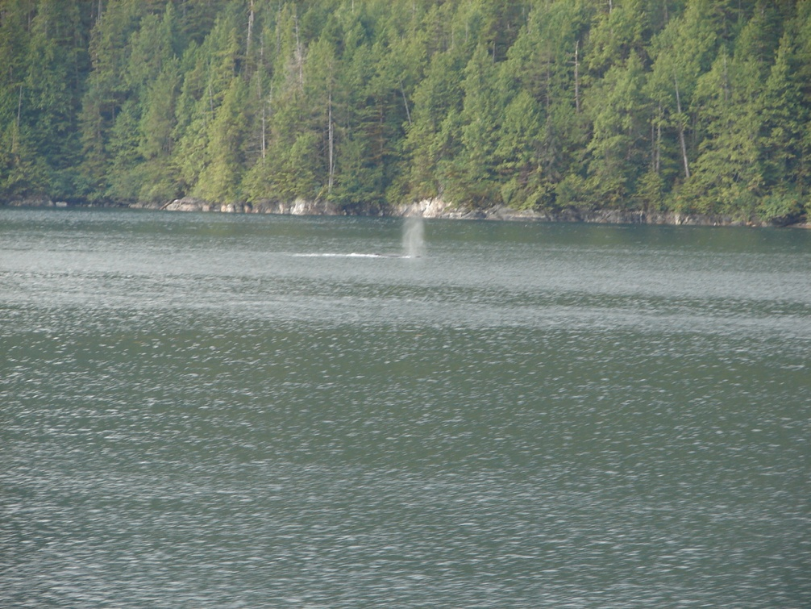
We met a cruise ship heading north, the Norwegian Cruise Line Norwegian Spirit.

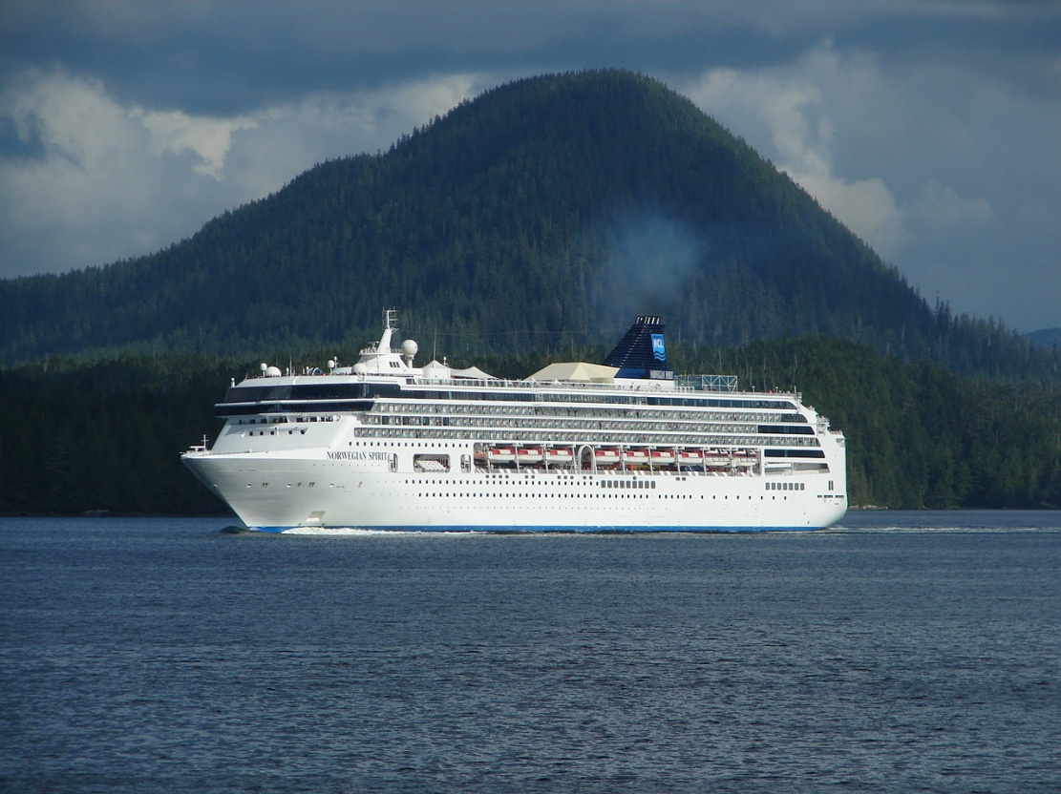
Norwegian Spirit

We hit the buffet for supper. Salmon with dill sauce. Lamb and rice. Prime rib.
The sun set and we were to dock about 2200. The shuttle bus was waiting and dropped us off at the same motel we stayed in on the way up.
We were picked up the next morning and began the trip back to Victoria. The same stops were made in reverse order and we arrived in Victoria about sunset. The driver said a 1500 sf home in Port Hardy would run about $70,000. In Duncan it would run $200,000 and in Victoria it would run $400,000.
A taxi took us from the hotel to Chinatown and dinner at the Don Mee, a big chrome upstairs restaurant with everyone dressed in tuxes (Taiwan modern). I had squid and a Tsing Tao beer. Good food. We walked back and got to the harbor in time to see the lights on the capitol building.

Victoria Legislative Building

Built of brown granite and almost ugly
Well proportioned with
A copper dome and gold statue
A fairy tale of lights at night.
*****

August 22nd
We were up and had breakfast in time to leave about 0900. Carol was going shopping while I went to the Royal British Columbia Museum archives. We would meet at 1200 for lunch.
The archives in Calgary had told me the mining claims registered in 1898 in the gold rush were stored in Victoria. The Victoria archives said, “What?”. If they were there we could not find them. I also looked for any information on Mrs. Brown and her baby born at Fort McPherson on Christmas 1898. Again, no luck but there was a death certificate for a Sara Brown about the right age.
I asked about my aboriginal masks and was told to see the curator in charge. She told me there were several grades – tourist, museum, collector, and ceremonial. Mine were tourist grade.
Lunch was in the Sticky Wicket. Carol had a Scezshuan burger and I had an oyster sandwich and a LaBatt Blue. Fortified, we walked several miles looking at antiques and galleries and returned to the hotel in mid afternoon. I dozed out in the hotel’s Japanese garden watching the seaplanes and other harbor traffic.

Japanese Garden at the Laurel Point Inn in Victoria

Quarter acre pond
Surrounded by cherry trees
Irises and Japanese
Red maples, topiary
Black Pines, traditional
Islands in still water.
*****
August 23rd
Next morning we were to catch the ferry to Seattle at 1030. I took a short walk to look at the house boats moored a couple blocks away.
We took a cab to the ferry landing instead of hauling everything several blocks. Customs took a couple minutes and we boarded the ferry for a two hour ride.
The ride was unexciting except for passing a large container ship. We debarked and picked up the bags. A few minutes in line and we were through US immigration and customs. We caught a taxi to the hotel then went out to look at several galleries and antique shops.
We had supper at McCormick’s Fish House. I had a selection of oysters from several bays and Sacramento River sturgeon. Carol had steak.

August 24th
We caught a limo out to SeaTac airport for an 1100 Southwest flight. We were home about 2100. Good trip.

INVERTS

Alloniscus perconvexus Beach Isopods Vic/PH
Cirolana harfordi Speckled Pillbugs Vic/PH
Cancer antennarius Spot-bellied Rock Crabs Vic
Petrolisthes cinctipes Porcelain Crabs Vic
Pugettia producta Shield-backed Kelp Crabs Vic
Mytilus californicus California Mussels Vic
Mytilus edulis Common Blue Mussel PH
Crassostrea gigas Giant Pacific Oyster Vic
Ostrea lurida Pacific Oysters Vic
Cyclocardia cribricostata Fine-ribbed Cardita PH
Saxidomus nuttalli Common Washington Clam PH
Macoma nastua Bentnose Macoma PH
Chione fluctifraga Smooth Pacific Venus PH
Chione undatella Frilled California Venus PH
Balanus glandula Acorn Barnacles Vic/PH
Cthamalus dalli Little Brown Barnacle Vic/PH
Mytilus californicus California Mussels Vic
Collisella pelta California Shield Limpet PH
several species of limpets
Strongylocentrotus purpuratus Purple Sea Urchin
Pisaster giganteus Southern 2-color starfish
Banana Slug

BIRDS

Alcidinidae – Kingfishers
Megaceryle alcyon Belted Kingfisher Prince Rupert

Anatidae – Ducks
Anas americana American Wigeon Reifel
Anas clypeata Northern Shoveler Reifel
Anas disors Blue-winged Teal Reifel
Branta Canadensis Canadian Goose all

Ardeidae – Herons
Ardea herodias Great Blue Heron all

Buteoninae – Eagles
Haliaetus leucocephalus Bald Eagle Reifel

Cathartidae – Vultures

Cathartes aura Turkey Vulture Vancouver Is

Corvidae – Jays and Crows
Corvus caurinus Northwestern Crow all

Fringillidae – Sparrows
Passerculus sandwichensis Savannah Sparrow Vancouver

Gaviidae – Loons
Gavia immer Common Loon Reifel

Icteridae – Orioles
Agelaius phoeniceus Red-winged Blackbird Reifel

Sternella neglecta Western Meadowlarks Vancouver

Laridae – Gulls and Terns
Sterna hirundo Commom Tern all

Larus argentatus Herring Gull all

Larus hyperboreus Gluacous Gull all

Ploceidae – Weaver Finches

Passer domesticus House Sparrow all

Scolopacidae – Sandpipers
Calidris mauri Western Sandpiper Reifel
Catoptrophorus semipalmatus Willet Reifel

Tringa flavipes Lesser Yellowlegs Reifel

Sturnidae – Starlings
Sturnis vulgaris Starling Vancouver

OTHER VERTEBRATES

Whales

Megaptera novaengliae Humpback Whale

Lagenorhynchus obliquidens Pacific White-sided Dolphin

Grampus orca Orca or Killer Whale

Mammals

Ursa major Black Bear

Herps

Rana catesbiancha Bullfrog

Hyla regilla Pacific Tree frog

PLANTS

These are plants seen that I could identify.

GREEN ALGAE
Enteromorpha sp. Sea lettuce
Ulva sp.

BROWN ALGAE
Macrocystis pyrifera Giant Kelp

RED ALGAE
Porphyra sp. Nori or Laver

FERNS
Althyrium filix-femina Lady Fern

GYMNOSPERMS

CUPRESSACEAE Cypress Family
Thuja plicata western redcedar

PINACEAE Pine Family

Abies ambilis amabilis fir

Picea marina black spruce

Picea sitchensis Sitka spruce

Pinus contorta var contorta shore pine
Pseudotsuga menziesii Douglas fir
Tsuga heterophylla western hemlock

DICOTYLEDONS

ACERACEAE Maple Family
Acer macrophyllum big leaf maple

APIACEAE Carrot Family
Heracleum maximum cow parsnip
Osmorhiza berteroi sweet-cicely

AQUIFOLIACEAE Holly Family

Ilex aquifolium English holly

ASTERACEAE Aster Family

Anaphalis margaritacea pearly everlasting

Cichorium intybus chicory

Cirsium arvense Canada thistle

Erigeron sp fleabane

Grindelia integrifolia entire-leaved gumweed

Hieracium gracile slender hawkweed

Lactucus muralis wall lettuce

Leucanthemum vulgare oxeye daisy

Petasites frigida coltsfoot

Solidago Canadensis Canada goldenrod

Sonchus asper prickly sow-thistle

BETULACEAE Birch Family
Alnus rubra red alder
Betula papyrifera paper or white birch

BRASSICACEAE Mustard Family

Lepidium virginicum tall pepper grass

CAPRIFOLIACEAE Honeysuckle Family

Synphoricarpos albus snowberry

CARYOPHYLLACEAE Pink Family
Stellaria media chickweed

ERICACEAE Heath Family

Arbutus menzeii Pacific Madrone, Arbutus

FABACEAE Pea Family

Lupinus articus arctic lupine

Melilotus alba white sweet clover

Robinia pseudoacacia golden leaf false acacia

Trifolium repens white clover

FAGACEAE Beech Family
Quercus garryana Garry Oak

GERANIACEAE Geranium Family

Geramium bicknellii Bicknell’s cranesbill

ONAGRACEAE Evening-Primrose Family
Epilobium angustifloium fireweed

PAPAVERACEAE Poppy Family

Eschscholziz californica California poppy

PLANTAGINACEAE Plantain Family

Plantago lanceolata ribwort plantain

Plantago major common plantain

POLYGONACEAE Buckwheat Family
Rumex crispus curly dock

RANUNCULACEAE Buttercup Family
Ranunculus repens creeping buttercup

ROSACEAE Rose Family

Comarum (Potentilla) palustris marsh cinquefoil

Malus fusca Pacific crabapple

Rubus discolor Himalayan blackberry

Sorbus sitchensis Sitka mountain ash

SALICACEAE Willow Family

Populus balsamifera ssp tricocarpa black cottonwood

Populus tremuloides trembling aspen

TYPHACEAE Cattail Family
Typha latifolia Cattail

INVASIVE SPECIES
Cytisus scoparius scotch broom
Lythrum salicaria purple loosestrife

